**Exercise 1: Control Structures**

**Customer Table:**

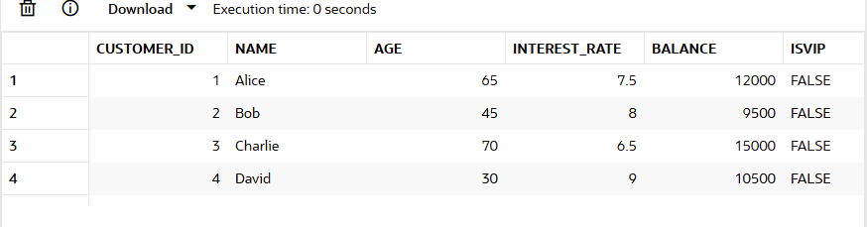

**Loan Table:**

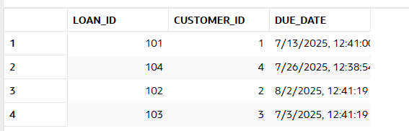

**Scenario 1:** The bank wants to apply a discount to loan interest rates for customers above 60 years old.

* + **Question:** Write a PL/SQL block that loops through all customers, checks their age, and if they are above 60, apply a 1% discount to their current loan interest rates.

**Solution:**

**Code:**

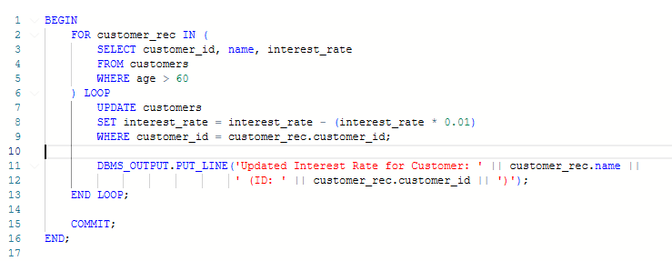

**Output:**

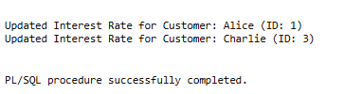

**Logic:**

* Use a FOR loop to **iterate through all customers** whose age > 60.
* For each, update the interest rate by subtracting **1% of the current rate**.
* Use DBMS_OUTPUT.PUT_LINE to print which customers were updated.

**Scenario 2:** A customer can be promoted to VIP status based on their balance.

* + **Question:** Write a PL/SQL block that iterates through all customers and sets a flag IsVIP to TRUE for those with a balance over $10,000.

**Solution:**

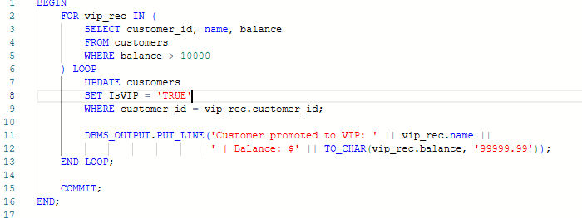

**Output:**

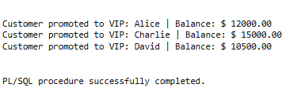

**Scenario 3:** The bank wants to send reminders to customers whose loans are due within the next 30 days.

* + **Question:** Write a PL/SQL block that fetches all loans due in the next 30 days and prints a reminder message for each customer.

Code:

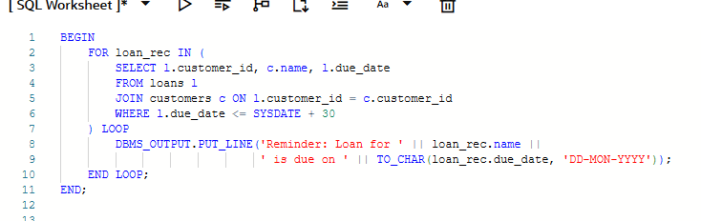

**Output:**

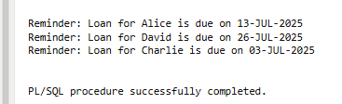

**Logic:**

* Join the customers and loans tables.
* Select loans with due_date <= SYSDATE + 30.
* Print a reminder using DBMS_OUTPUT.PUT_LINE**.**

**Exercise 2: Error Handling**

**Account Table:**

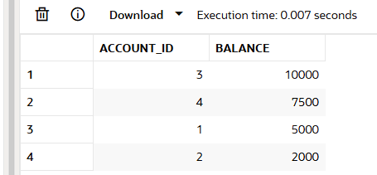

**Customer table:**

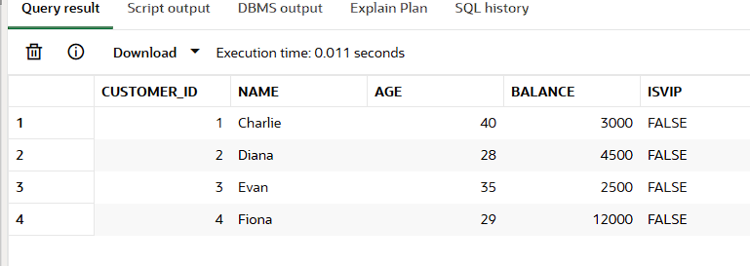

**Employee Table:**

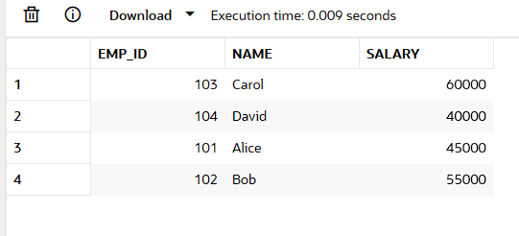

**Scenario 1: Handle exceptions during fund transfers between accounts.**

* + Question: Write a stored procedure SafeTransferFunds that transfers funds between two accounts. Ensure that if any error occurs (e.g., insufficient funds), an appropriate error message is logged and the transaction is rolled back.

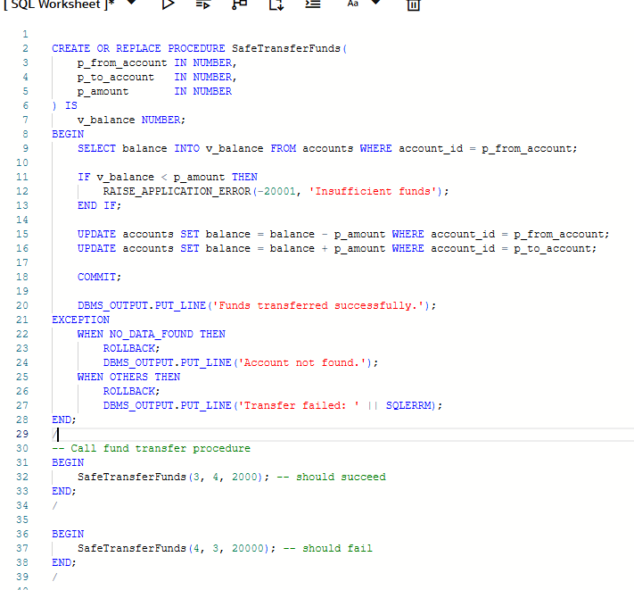

**Output:**

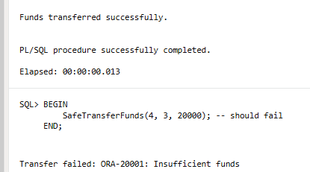

**Scenario 2: Manage errors when updating employee salaries.**

* + **Question: Write a stored procedure UpdateSalary that increases the salary of an employee by a given percentage. If the employee ID does not exist, handle the exception and log an error message.**

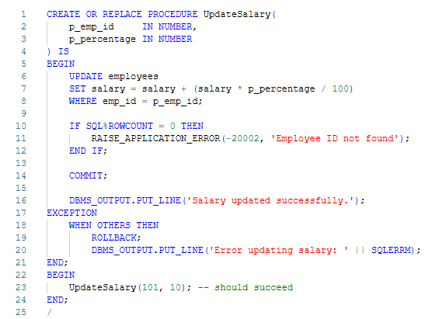

**Output:**

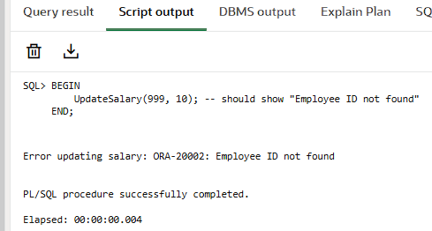

**Scenario 3: Ensure data integrity when adding a new customer.**

* + **Question: Write a stored procedure AddNewCustomer that inserts a new customer into the Customers table. If a customer with the same ID already exists, handle the exception by logging an error and preventing the insertion.**

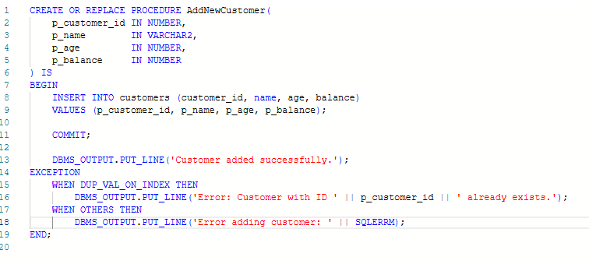

**Output:**

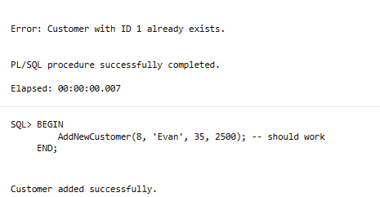

**TABLE FOR EXCERSICE 3,4,5**

**Customer Table:**

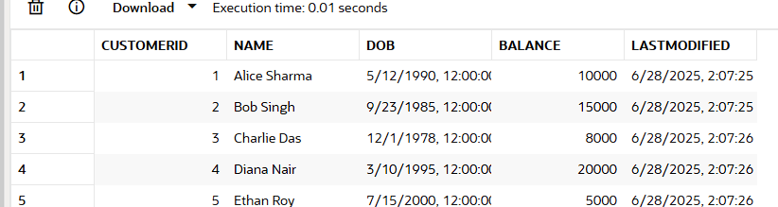

**Accounts Table:**

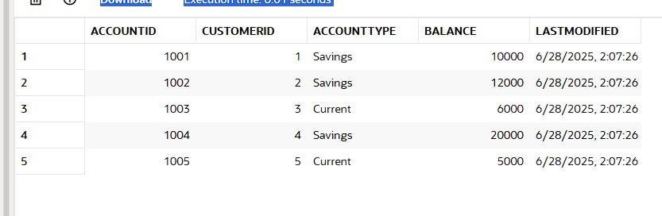

**Transactions Table:**

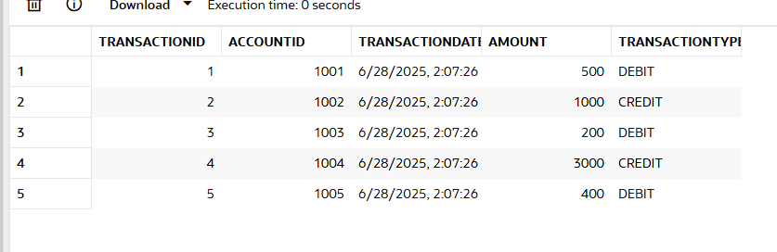

**Loans Table:**

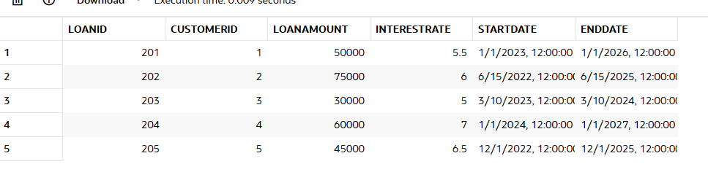

**Employees Table:**

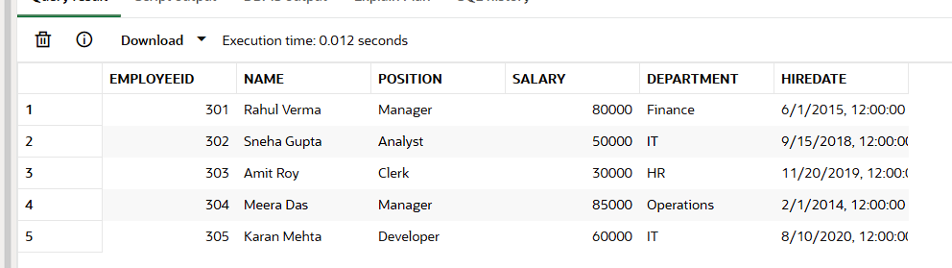

**Exercise 3: Stored Procedures**

**Scenario 1: The bank needs to process monthly interest for all savings accounts.**

* + **Question: Write a stored procedure ProcessMonthlyInterest that calculates and updates the balance of all savings accounts by applying an interest rate of 1% to the current balance.**

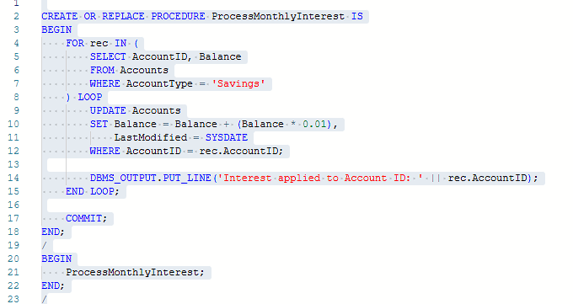

**Output:**

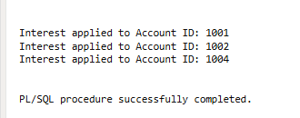

**Scenario 2: The bank wants to implement a bonus scheme for employees based on their performance.**

* + **Question: Write a stored procedure UpdateEmployeeBonus that updates the salary of employees in a given department by adding a bonus percentage passed as a parameter.**

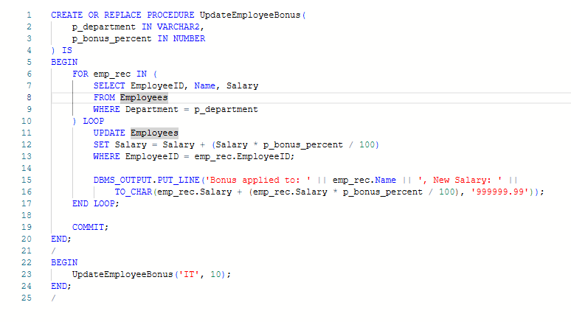

**Output:**

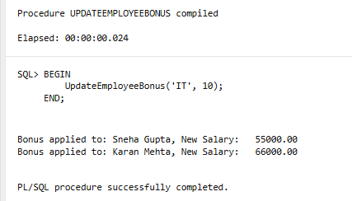

**Scenario 3: Customers should be able to transfer funds between their accounts.**

* + **Question: Write a stored procedure TransferFunds that transfers a specified amount from one account to another, checking that the source account has sufficient balance before making the transfer.**

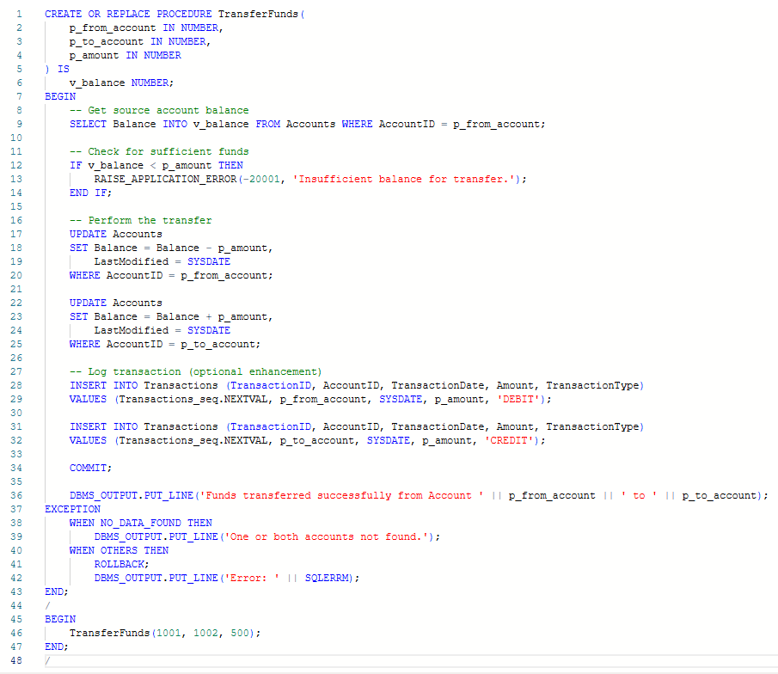

**Output:**

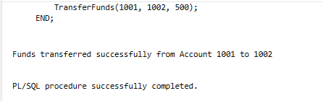

**Exercise 4: Functions**

**Scenario 1: Calculate the age of customers for eligibility checks.**

* + **Question: Write a function CalculateAge that takes a customer's date of birth as input and returns their age in years.**

**Solution:**

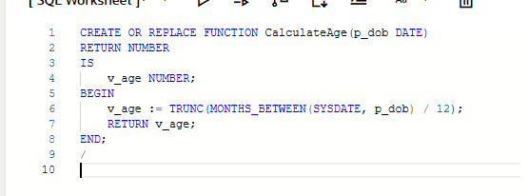

**Output:**

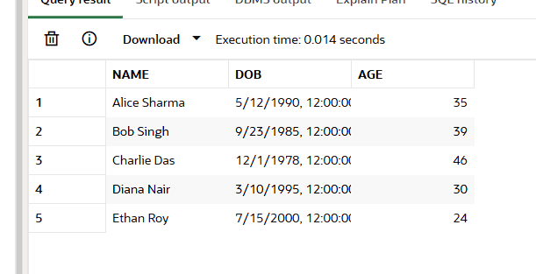

**Scenario 2: The bank needs to compute the monthly installment for a loan.**

* + **Question: Write a function CalculateMonthlyInstallment that takes the loan amount, interest rate, and loan duration in years as input and returns the monthly installment amount.**

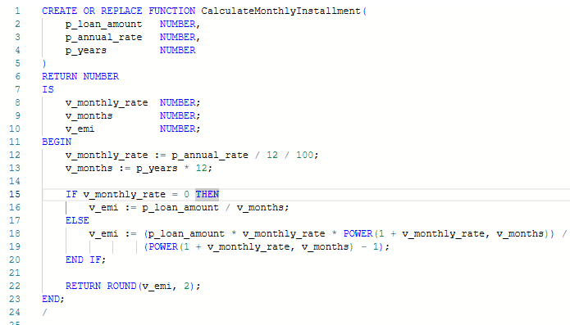

**Output:**

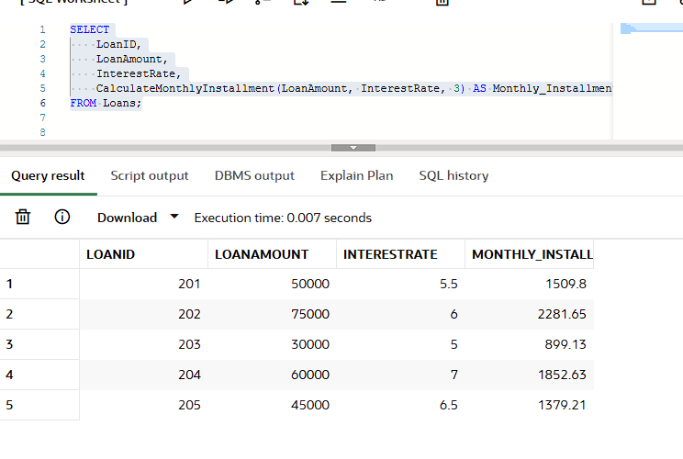

**Scenario 3: Check if a customer has sufficient balance before making a transaction.**

* + **Question: Write a function HasSufficientBalance that takes an account ID and an amount as input and returns a boolean indicating whether the account has at least the specified amount.**

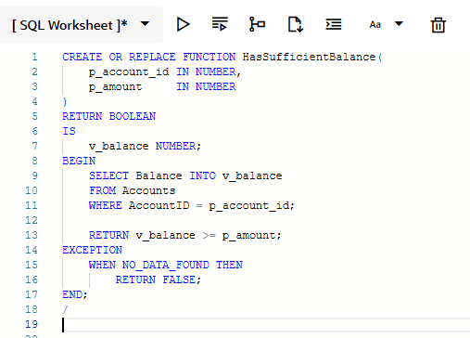

**Output:**



**Exercise 5: Triggers**

**Scenario 1: Automatically update the last modified date when a customer's record is updated.**

* + **Question: Write a trigger UpdateCustomerLastModified that updates the LastModified column of the Customers table to the current date whenever a customer's record is updated.**

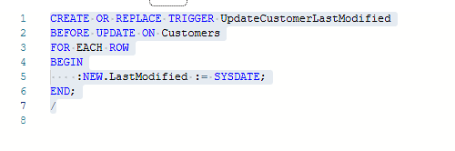

**Scenario 2: Maintain an audit log for all transactions.**

* + **Question: Write a trigger LogTransaction that inserts a record into an AuditLog table whenever a transaction is inserted into the Transactions table.**

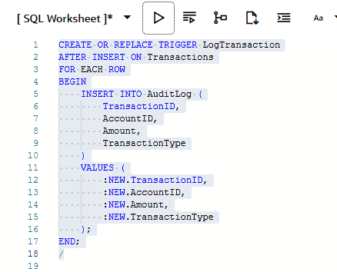

**Scenario 3: Enforce business rules on deposits and withdrawals.**

* + **Question: Write a trigger CheckTransactionRules that ensures withdrawals do not exceed the balance and deposits are positive before inserting a record into the Transactions table.**

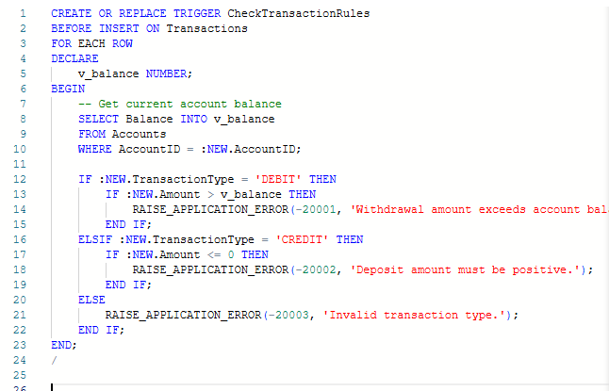

**Exercise 6: Cursors**

**Scenario 1: Generate monthly statements for all customers.**

* + **Question: Write a PL/SQL block using an explicit cursor GenerateMonthlyStatements that retrieves all transactions for the current month and prints a statement for each customer.**

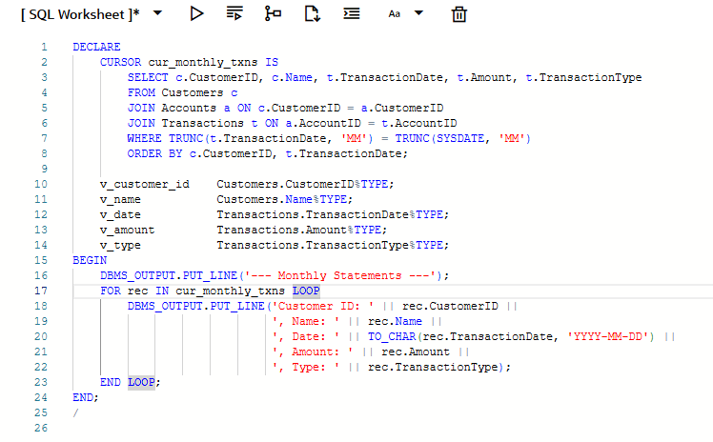

**Description:**

Retrieve and print all transactions from the current month for each customer using a cursor.

**Output:**

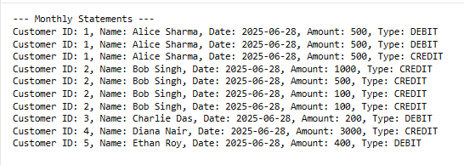

**Scenario 2: Apply annual fee to all accounts.**

* + **Question: Write a PL/SQL block using an explicit cursor ApplyAnnualFee that deducts an annual maintenance fee from the balance of all accounts.**

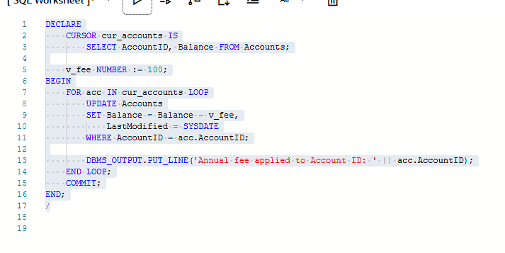

**Description:**

Deduct a fixed annual maintenance fee (e.g., ₹100) from all accounts.

**Output:**

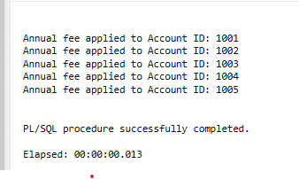

**Scenario 3: Update the interest rate for all loans based on a new policy.**

**Question: Write a PL/SQL block using an explicit cursor UpdateLoanInterestRates that fetches all loans and updates their interest rates based on the new policy**

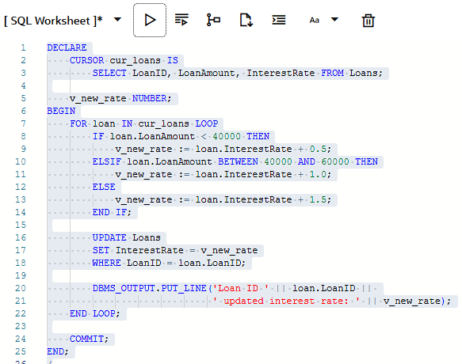

Policy:

* If LoanAmount < 40000 → increase by 0.5%
* If LoanAmount between 40000 and 60000 → increase by 1%
* If LoanAmount > 60000 → increase by 1.5%

**Output:**

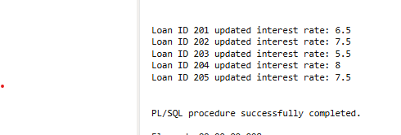

**Exercise 7: Packages**

**Scenario 1: Group all customer-related procedures and functions into a package.**

* + **Question: Create a package CustomerManagement with procedures for adding a new customer, updating customer details, and a function to get customer balance.**

**CustomerManagement package:**

**Package Specification**

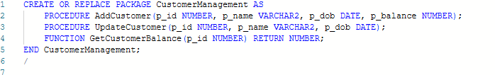

**Package Body**

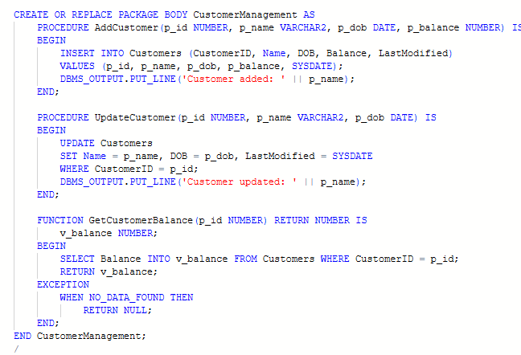

**Output:**

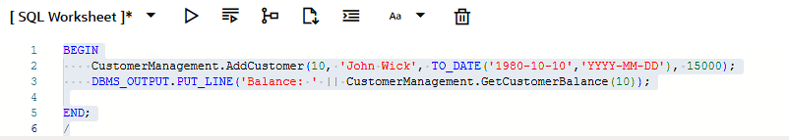

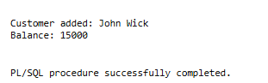

**Scenario 2: Create a package to manage employee data.**

* + **Question: Write a package EmployeeManagement with procedures to hire new employees, update employee details, and a function to calculate annual salary.**

**EmployeeManagement package:**

**Package Specification and body**

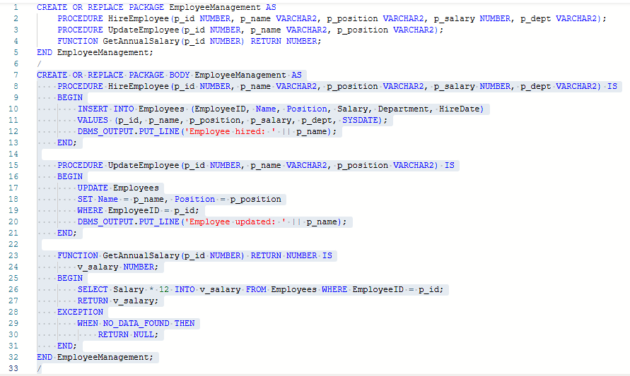

**Output:**

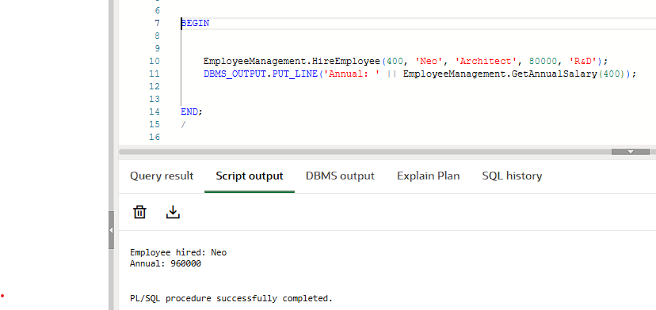

**Scenario 3: Group all account-related operations into a package.**

* + **Question: Create a package AccountOperations with procedures for opening a new account, closing an account, and a function to get the total balance of a customer across all accounts.**

**AccountOperations package**

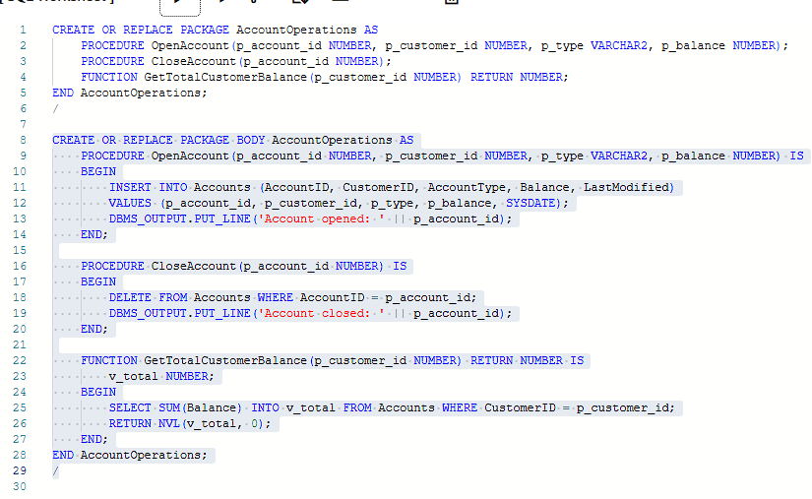

**Output:**

