**Exercise-3**

Create a React Application “eventexamplesapp” to handle various events of the form elements in

HTML.

1. Create “Increment” button to increase the value of the counter and “Decrement” button to decrease the value of the counter. The “Increase” button should invoke multiple methods.
   1. To increment the value
   2. Say Hello followed by a static message.

**App.js**

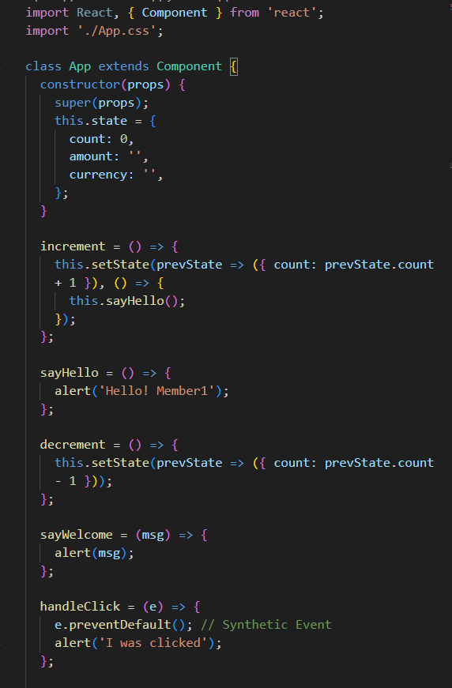

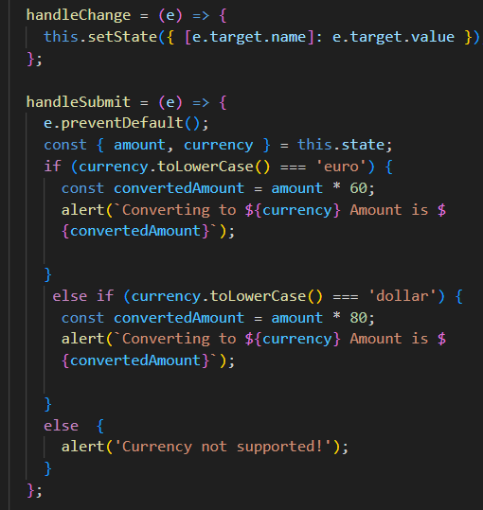

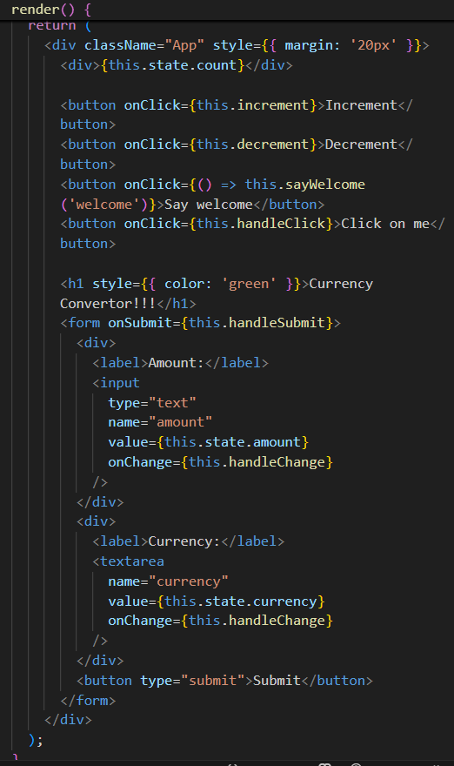

**App.css**

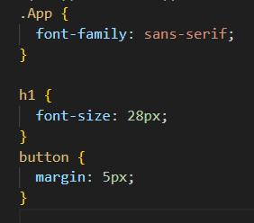

**Output:**

