**Exercise4**

Create a React Application named “ticketbookingapp” where the guest user can browse the page where the flight details are displayed whereas the logged in user only can book tickets.

The Login and Logout buttons should accordingly display different pages. Once the user is logged in the User page should be displayed. When the user clicks on Logout, the Guest page should be displayed.

**🔹 Features:**

* **Conditional Rendering** using isLoggedIn state
* **Login Button** → Displays User view (Welcome back)
* **Logout Button** → Displays Guest view (Please sign up)
* Greeting, LoginButton, LogoutButton, UserGreeting, and GuestGreeting components

**App.js**

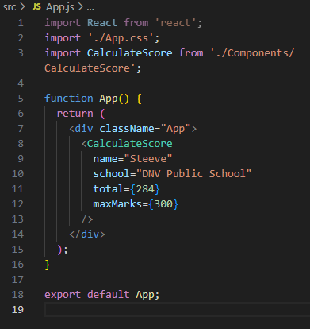

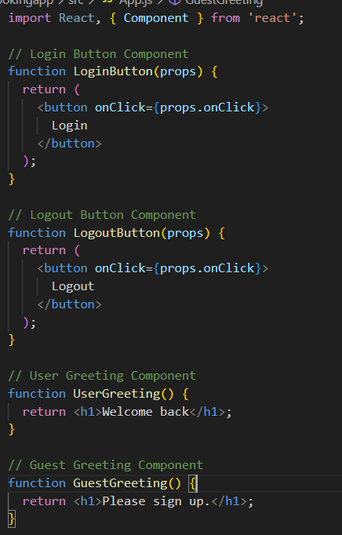

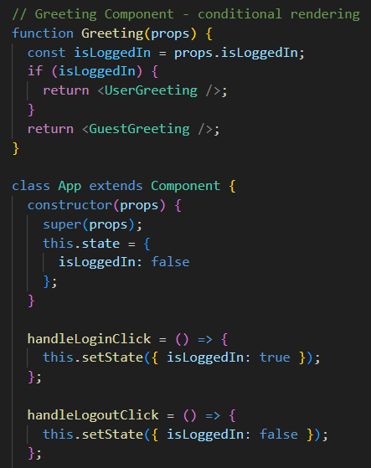

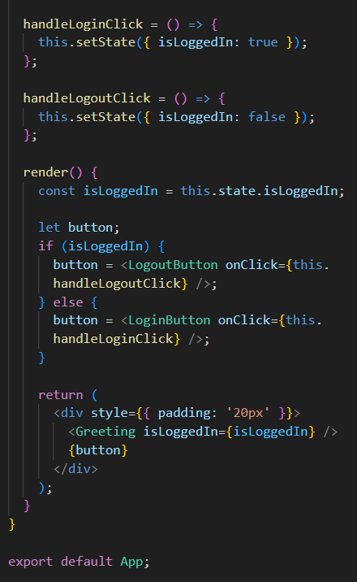

**Output:**

**Initially:**

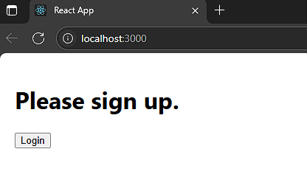

**After Clicking Login:**

