**Exercisse5:**

**Create a React App named “bloggerapp” in with 3 components.**

1. **Book Details**
2. **Blog Details**
3. **Course Details**

**Implement this with as many ways possible of Conditional Rendering.**

Components:

* BookDetails – Uses map() with key prop.
* BlogDetails – Demonstrates conditional rendering inside JSX.
* CourseDetails – Demonstrates conditional rendering using logical &&.

src/data/books.js

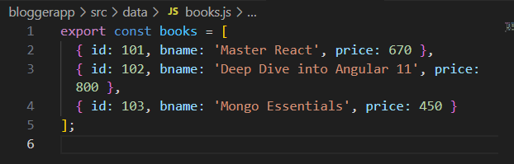

src/data/blogs.js

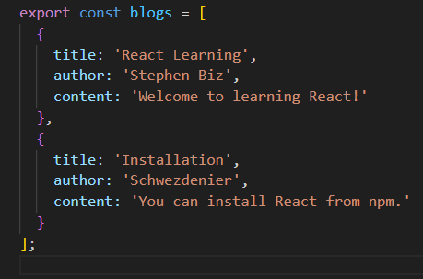

src/data/courses.js

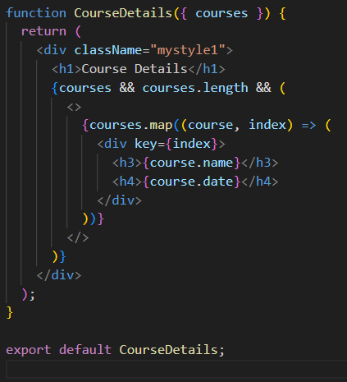

src/components/BookDetails.js

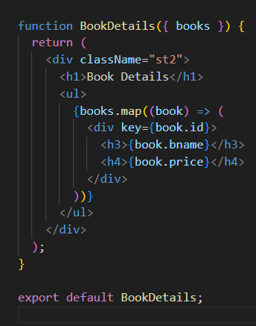

src/components/BlogDetails.js

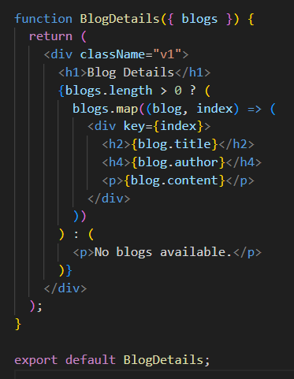

src/components/CourseDetails.js



App.js

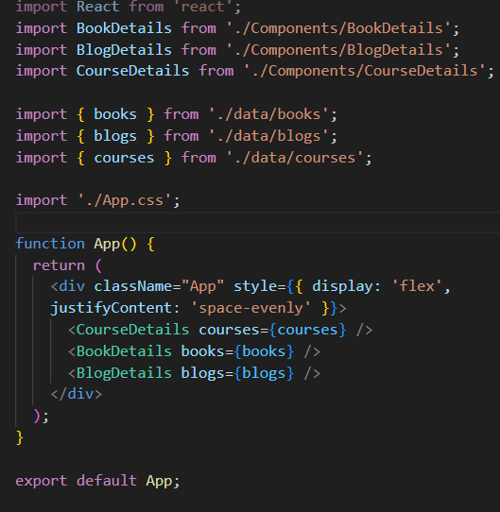

App.css

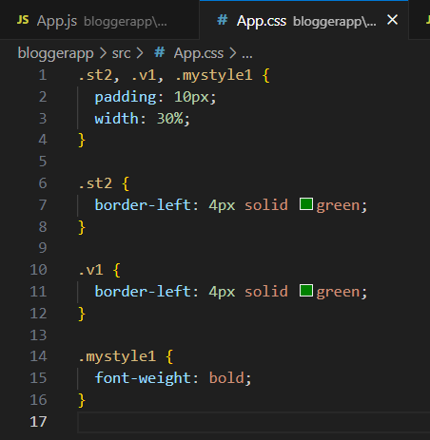

Output:

