**Exercise-1**

**Step 1: Setup your machine with Git Configuration**

To create a new repository, signup with GitLab and register your credentials

Login to GitLab and create a “GitDemo” project

1. To check if Git client is installed properly: Open Git bash shell and execute



1. .To configure user level configuration of user ID and email ID execute



1. .To check if the configuration is properly set, execute the following command.

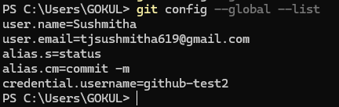

**Step 2: Integrate notepad++.exe to Git and make it a default editor**

1. To check, if notepad++.exe execute from Git bash

