Exercise3

**Branching:**

Step 1: Create a new branch

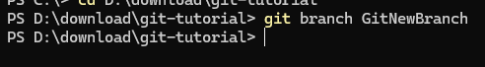

List all the local and remote branches available in the current trunk. Observe the “*” mark which denote the current pointing branch

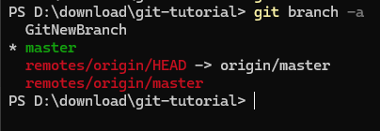

Switch to the newly created branch. Add some files to it with some contents.

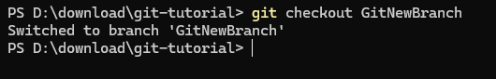



Commit the changes to the branch.

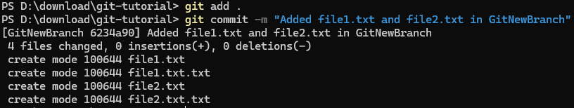

Check the status with **“git status”** command.



**Merging:**

Step 1: Switch to master

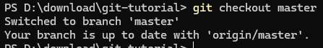

Step 2: Show CLI differences

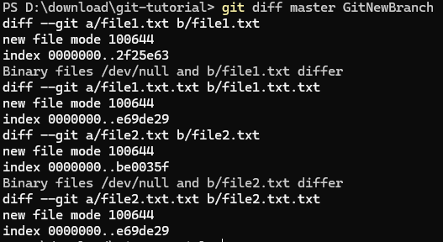

Step 3: Show visual differences (P4Merge)

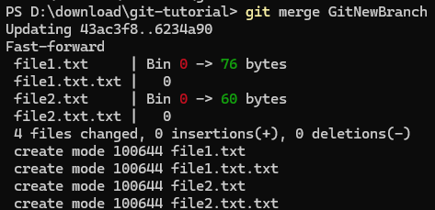

Step 5: View merge history

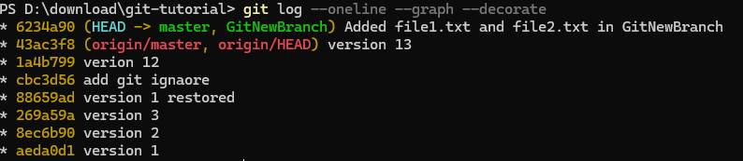

Step 6: Delete the branch



Step 7: Status check

