Exercise -4:

1. Verify master is in a clean state

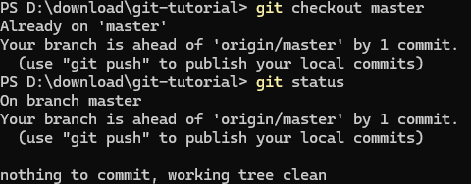

1. Create a branch GitWork and add hello.xml

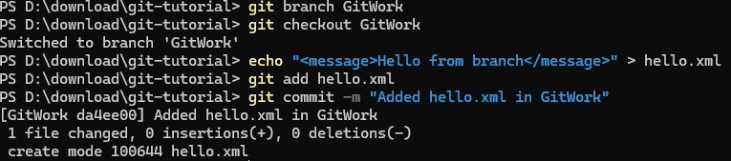

1. Update content in hello.xml (branch side)

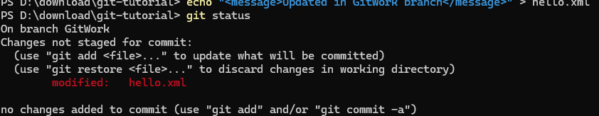

1. Commit the update in branch

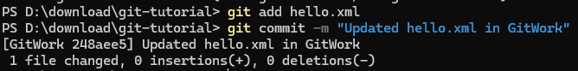

1. Switch to master

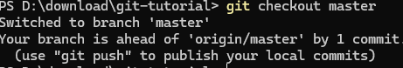

1. Add hello.xml in master with different content

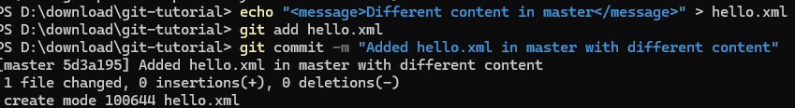

1. Observe log (all branches)

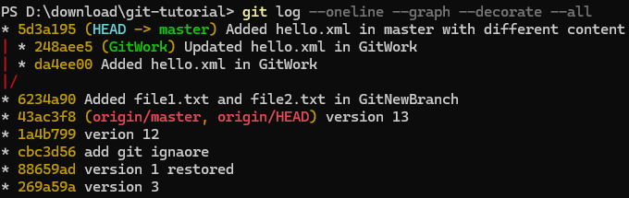

1. Check CLI differences

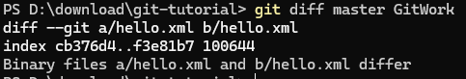

1. Visualize differences in P4Merge



**10. Merge branch into master (conflict occurs)**

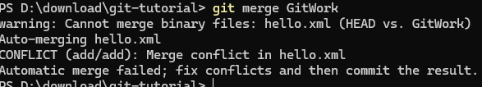

1. View conflict markup in hello.xml

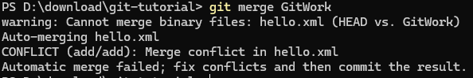

View conflict markup in hello.xml

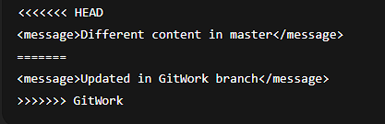

1. Use 3-way merge tool (P4Merge example)



**13. Resolve conflict and commit**

After editing hello.xml to:



14. Add .gitignore for backup files

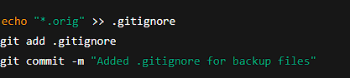

**15. List branches**

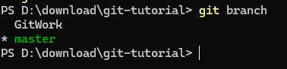

16. Delete merged branch

git branch -d GitWork



17. Final log after merge

