Exercise5:

1. Verify if master is in a clean state

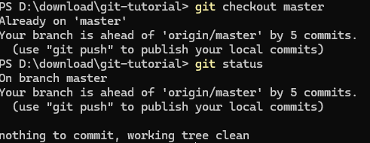

1. List out all available branches

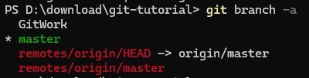

1. Pull the remote repository into master

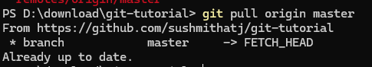

1. Push pending changes from previous lab

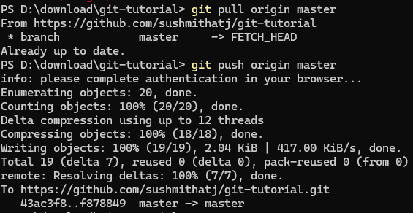

1. Verify changes are reflected on remote repository

