INSTALL MVN ON UBUNTU

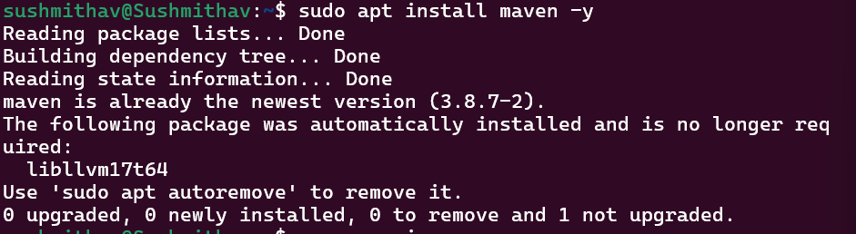

MVN VERSION AND UPDATE

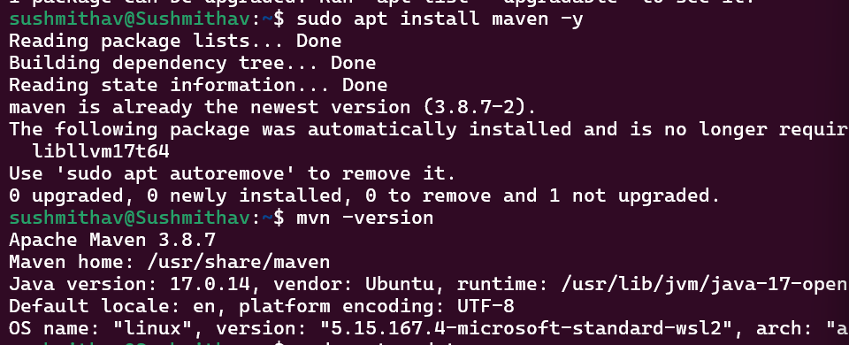

INSTALL JDK

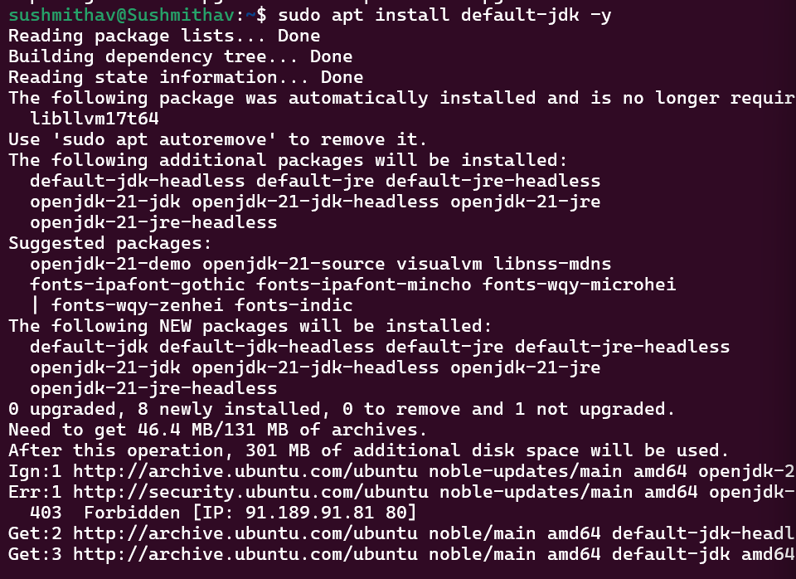

JAVA VERSION

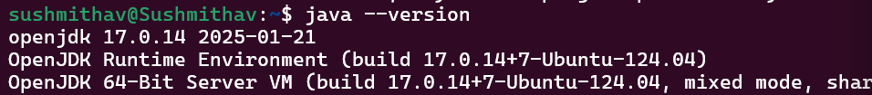

CONNECTING TO APACHE ORG

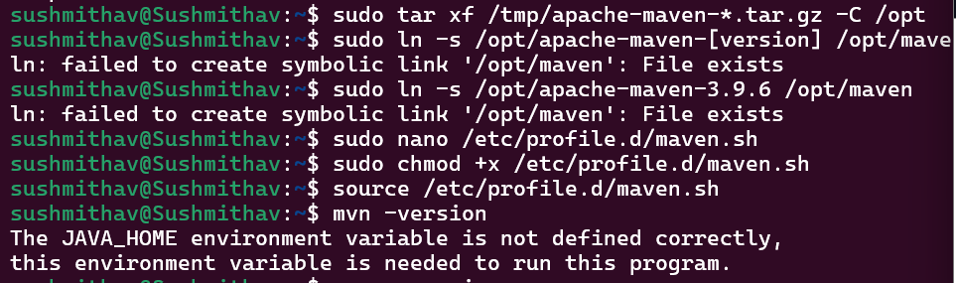

MVN VERSION

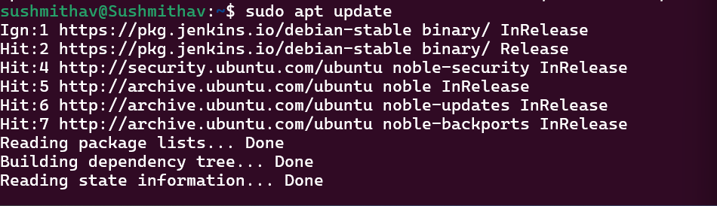

JENKINS STATUS

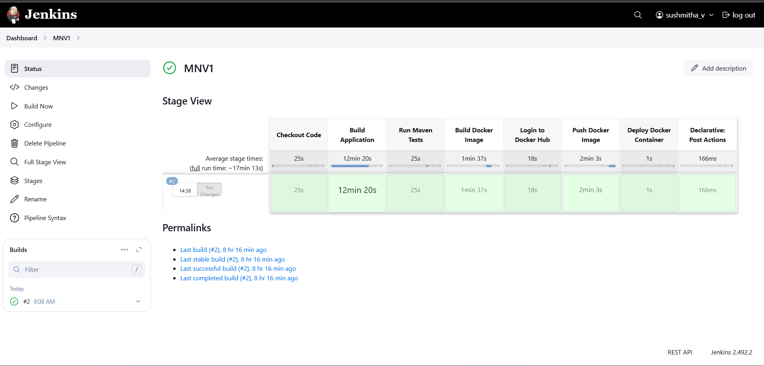

JENKINS CONSOLE OUTPUT

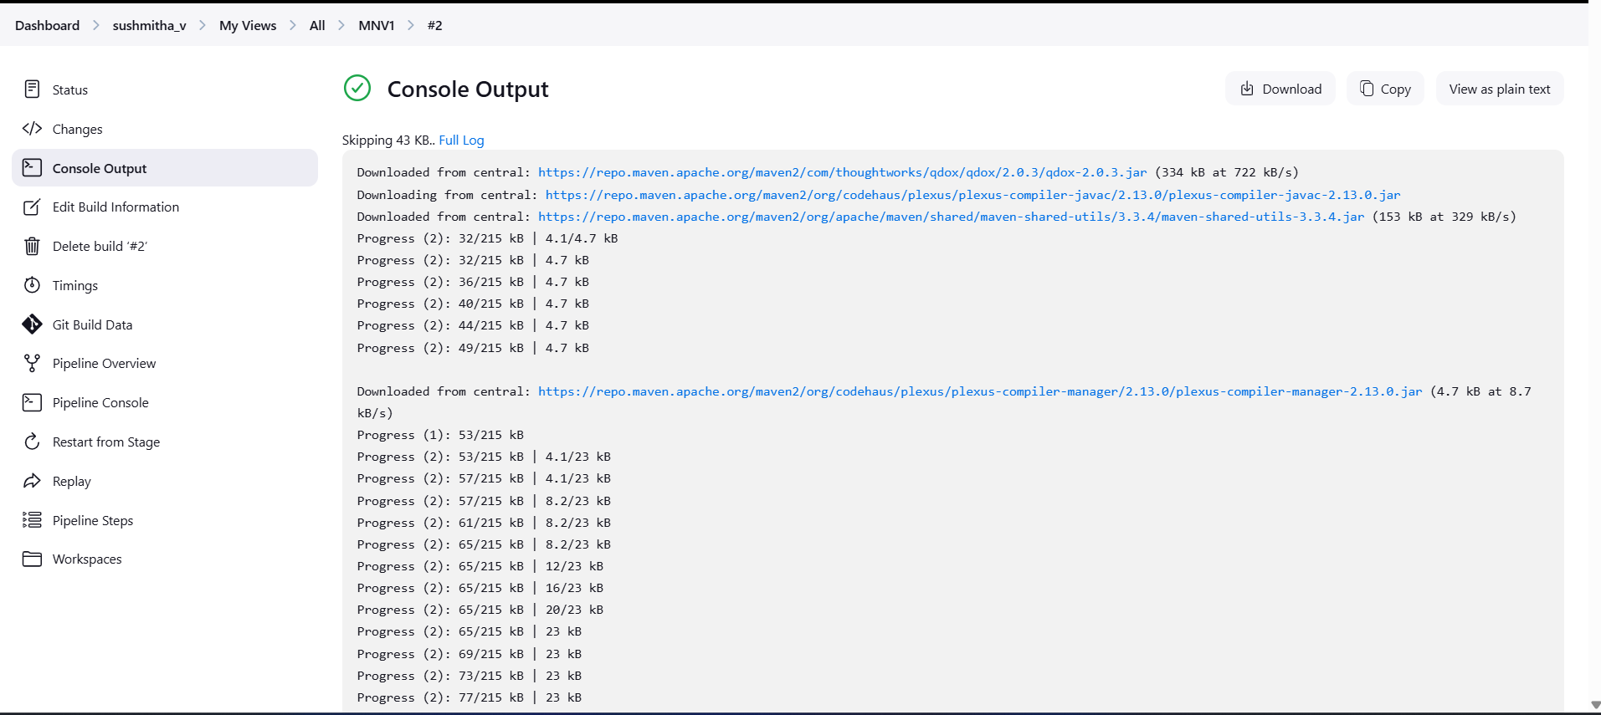

DEPLOYMENT SUCCESSFULL

