ABSTRACT*:* Tulsi leaves are considered as holy plants in our country. Tulsi belongs to the Ocimum genus and family Lamiaceae. The tulsi plant or Indian basil occupies an important place in the Hindu religion. It is not only used as a holy plant, but is also used for medicinal uses. It is used for curing many diseases like cold, ulcer, hepatic injuries and so on. In this project, the flavonoids present in various tulsi leaves are extracted and this property is compared with the features observed by image processing. A comparative study on the variety of tulsi leaves based on the flavonoid property in extracted and used for the ayurvedic medicine preparations. The samples of tulsi leaves are taken from different Tulsi plants. It includes the geographic conditions, colour and texture. The leaves have different types of flavonoid with various pharmalogical properties. The main objective of the current study is to examine and compare the flavonoid qualitatively and quantitatively present in tulsi leaves based on their colour, shape and texture and grouping them according to the image feature. The main objective of this research is to examine and compare total flavonoid, phenol, antioxidant content in any of the five different species of O. tenuiflorum along with identification and characterization of flavonoids.

Contents

1. INTRODUCTION
   1. MEDICINAL PROPERITIES
   2. EXISTING SYSTEM
   3. PROPSED SYSTEM
2. COLLECTION AND IDENTIFICATION OF PLANT MATERIALS
3. EXPERIMENTAL PROCEDURE

3.1. EXTRACTION PROCESS

3.2. SPECTRAL ANALYSIS

3.2.1. UV-VISIBLE SPECTROPHOTOMETER

3.2.2. UV-VISIBLE SPECTRUM

3.2.3. MODERN APPLICATIONS OF UV SPECTROSCOPY

3.2.4. RESULTS OF UV AND INFRARED SPECTRAL ANALYSIS

OF TULSI LEAVES

3.3. DETERMINATIOIN OF FLAVONIOD CONTENT

3.4. DIGITAL IMAGE PROCESSING

3.4.1. INTRODUCTION

3.4.2. DIGITAL IMAGE FUNDAMENTALS

3.4.3. DIGITAL IMAGE ANALYSIS

3.4.4. IMAGE PROCESSING

3.4.5. FEATURE EXTRACTION

3.4.5.1. ANALYSIS OF FEATURE EXTRACTION

3.4.5.2. COLOR FEATURES

3.4.5.3. TEXTURE FEATURES

3.4.5.4. SHAPE FEAUTRES

3.4.5.5. TEXTURAL FEATURES BASED ON GLCM

3.4.5.6. EXTRACTION OF TEXTURE FEATURES OF IMAGE

3.4.6. OBTAINED RESULTS OF FEATURE EXTRACTION OF TULSI LEAVES

3.4.7. COMBINATIONAL FEAUTRE VECTORS

3.5 COMPARISION OF EXTRACTED FLAVONOID WITH THE RESULTS OF IMAGE PROCESSING

1.INTRODUCTION:

Plants are potent biochemists and have been components of phytomedicine since times immemorial; man is able to obtain from them a wondrous assortment of industrial chemicals. A rich heritage of knowledge on preventive and curative medicines was available in ancient scholastic work included in the Atharvaveda (an Indian religious book), Ayurveda (Indian traditional system of medicine) and so on. An estimate suggests that about 13000 plant species worldwide are known to have been used as drugs. Plant-based natural constituents can be derived from any part of the plant like bark, leaves, flowers, roots, fruits, seeds and so on,[[1](https://www.ncbi.nlm.nih.gov/pmc/articles/PMC3249909/#ref1)] that is any part of the plant may contain active components. The beneficial medicinal effects of plant materials typically result from the combinations of secondary products present in the plant. The medicinal actions of plants are unique to particular plant species or groups are consistent with this concept as the combination of secondary products in a particular plant is taxonomically distinct. The systematic screening of plant species with the purpose of discovering new bioactive compounds is a routine activity in many laboratories. The research on the medicinal plants should be extended with the identification of the active principles in the plants. Scientific examination of the remedies could lead to standardization and quality control of the products to ensure their safety. It is after such evaluation that they can be approved for use in the primary health care. Such research activities could also lead to the development of new drugs as in the past. Conventional anti-asthmatic compounds such as sodium cromolyn and sodium cromoglycate are some of the examples of the lead prepared from the analogs of the naturally occurring furanochromone khelline (Visammin). Exploration of the chemical constituents of the plants and pharmacological screening will thus provide us the basis for developing new life-saving drugs.

NUTRITION VALUE:

Contains vitamin C and A, and minerals like calcium, zinc and iron, as well as chlorophyll and many other phytonutrients. Also enhances the efficient digestion, absorption and use of nutrients from food and other herbs. Protein: 30 Kcal, 4.2 g; Fat: 0.5 g; Carbohydrate 2.3 g; Calcium: 25 mg; Phosphorus 287 mg; Iron: 15.1 mg and Edible portion 25 mg vitamin C per 100 g.

PHYTOCHEMICAL CNSTITUENTS:

The chemical composition of Tulsi is highly complex, containing many nutrients and other biologically active compounds, the proportions of which may vary considerably between strains and even among plants within the same field. Furthermore, the quantity of many of these constituents is significantly affected by differing growing, harvesting, processing and storage conditions that are not yet well understood. The nutritional and pharmacological properties of the whole herb in its natural form, as it has been traditionally used, result from synergistic interactions of many different active phytochemicals. Consequently, the overall effects of Tulsi cannot be fully duplicated with isolated compounds or extracts. Because of its inherent botanical and biochemical complexity, Tulsi standardization has, so far, eluded modern science. The leaf volatile oil contains eugenol (1-hydroxy-2-methoxy-4-allylbenzene), euginal (also called eugenic acid), urosolic acid(2,3,4,5,6,6a,7,8,8a,,10,11,12,13,14b-tetradecahydro-1H-picene-4a-carboxylic acid ), carvacrol (5-isopropyl-2-methylphenol ), linalool (3,7-dimethylocta-1,6-dien-3-ol ), limatrol, caryophyllene (4,11,11-trimethyl-8-methylene-bicyclo[7.2.0]undec-4-ene ), methyl carvicol (also called Estragol: 1-allyl-4-methoxybenzene ) while the seed volatile oil have fatty acids and sitosterol; in addition, the seed mucilage contains some levels of sugars and the anthocyans are present in green leaves. The sugars are composed of xylose and polysaccharides.

Although Tulsi is known as a general vitalizer and increases physical endurance, it contains no caffeine or other stimulants. The stem and leaves of holy basil contain a variety of constituents that may have biological activity, including saponins, flavonoids, triterpenoids, and tannins. In addition, the following phenolic actives have been identified, which also exhibit antioxidant and anti-inflammatory activities, Rosmarinic acid ((2R)-2-[[(2E)-3-(3,4-Dihydroxyphenyl)-1-oxo-2-propenyl]]oxy]-3-(3,4-dihydroxyphenyl) propanoic acid ), apigenin (5,7-dihydroxy-2-(4-hydroxyphenyl)-4H-1-benzopyran-4-one ), cirsimaritin (5,4’-dihydroxy-6,7-dimethoxyflavone), isothymusin (6,7-dimethoxy-5,8,4’-trihydroxyflavone) and isothymonin. Two water-soluble flavonoids: Orientin (8-C-beta-glucopyranosyl-3’,4’,5,7-tetrahydroxyflav-2-en-3-one) and Vicenin (6-C-beta-D-xylopyranosyl-8-C-beta-D-glucopyranosyl apigenin), have shown to provide protection against radiation-induced chromosomal damage in human blood lymphocytes.

Ocimum sanctum L. (also known as Ocimum tenuiflorum, Tulsi) has been used for thousands of years in Ayurveda for its diverse healing properties. Tulsi, the Queen of herbs, the legendary ‘Incomparable one’ of India, is one of the holiest and most cherished of the many healing and healthy giving herbs of the orient. The sacred basil, Tulsi, is renowned for its religious and spiritual sanctity, as well as for its important role in the traditional Ayurvedic and Unani system of holistic health and herbal medicine of the East. It is mentioned by Charaka in the Charaka Samhita; an Ayurvedic text. Tulsi is considered to be an adaptogen, balancing different processes in the body, and helpful for adapting to stress. Marked by its strong aroma and astringent taste, it is regarded in Ayurveda as a kind of ‘elixir of life’ and believed to promote longevity. Tulsi extracts are used in Ayurvedic remedies for common colds, headaches, stomach disorders, inflammation, heart disease, various forms of poisoning and malaria. Traditionally, O. sanctum L. is taken in many forms, as herbal tea, dried power or fresh leaf. For centuries, the dried leaves of Tulsi have been mixed with stored grains to repel insects. Among the plants known for medicinal value, the plants of genus Ocimum belonging to family Labiatae are very important for their therapeutic potentials. *Ocimum sanctum* L. (Tulsi), *Ocimum gratissium* (Ram Tulsi), *Ocimum canum* (Dulal Tulsi), *Ocimum basilicum* (Ban Tulsi), *Ocimum kilimandscharicum, Ocimum ammericanum, Ocimum camphora, Ocimum minimum* L., *Ocimum tenuiflorum* L. and *Ocimum micranthum* are examples of known important species of genus Ocimum which grow in different parts of the world and are known to have medicinal properties. *Ocimum sanctum* L*.,* known as ‘Tulsi’ in Hindi and ‘Holy Basil’ in English, is an erect softy hairy aromatic herb or under shrub found throughout India. Tulsi plant is a shrub reaching a height of 0.5 to 1.5 m. The leaves are 2-4 cm in length. *Ocimum basilicum* is an important symbol in the Hindu religious tradition and is worshipped in the morning and evening by Hindus at large. In traditional systems of medicine the Indian medicinal plants have been used in successful management of various disease conditions like bronchial asthma, chromic fever, cold cough, malaria, dysentery, convulsions, arthritis, emetic syndrome, skin diseases, insect bite etc and in the treatment of gastric, hepatic, cardiovascular and immunological disorders.

The holy basil is an herbal remedy for a lot of common ailments such as healing power, fever, common cold coughs, sore throat, respiratory disorder, kidney stone, heart and vascular protection, children's ailments, stress, mouth infections, insect bites, skin disorders, teeth disorder, headaches, eye disorders, liver support, lung and bronchial support, radiation protection, immunity tune-up, anti-inflammatory Action, antibiotic protection, nutrition, high safety margin, food additive and perfume etc. Herein, studies on the medicinal properties of Tulsi and how they can be used for diseases and thereafter the extended work that is to be proposed are discussed in the below sections.

Flavonoids are polyphenolic compounds possessing 15carbon atoms, two benzene rings joined by a linear three carbon chain having the carbon skeleton C6-C3-C6 and they are having polar nature and is soluble in methanol and water. Flavonoids constitute one of the most characteristic classes of compounds in higher plants. Many flavonoids are easily recognised as lower pigments in most angiosperm families. Flavonoids acts like antioxidants. How effectively they are depends on their molecular structural characteristics. Some flavonoids in hops and beer have been found to have better antioxidant effects than tea or red wine; most flalvonoids are found in fruits , vegetables ,teas and other drinks. Flavonoids have been known to have antiviral, antiallergic, antiplatelet, anti-inflammatory, antitumor and anti oxidant activities.

1.1 MEDICINAL PROPERITIES:

***ANTIDIABATIC***:

Ethanolic extract of O. sanctum L. significantly decreases the blood glucose, glycosylated hemoglobin and urea with a concomitant increase in glycogen, hemoglobin and protein in streptozotocin-induced diabetic rats. This extracts also resulted in an increase in insulin and peptide levels and glucose tolerance.

The constituents of O. sanctum L. leaf extracts have stimulatory effects on physiological pathways of insulin secretion, which may underlie its reported antidiabetic action.

Grovel et al. suggested that treatment with O. sanctum L. extract for 30 days to normal rats fed with fructose for 30 days significantly lowered serum glucose level in comparison with control group. However, O. sanctum L. extract has no significant effect on hyperinsulinemia.

***CARDIAC ACTIVITY:***

Oral feeding of hydroalcoholic extract of O. sanctum L. (100 mg/kg) to male Wister rats subjected to chronic-resistant stress (6 h/day for 21 days) significantly prevented the chronic-resistant stress/induced rise in plasma cAMP level, myocardial superoxide dismutase and catalase activities as well as the light microscopic changes in the myocardium.

Wister rats fed with fresh leaf homogenate of O. sanctum L. (50 and 100 mg/kg body weight) daily 30 days inhibit isoproterenol-induced changes in myocardial superoxide dismutase, glutathione peroxidase and reduced glutathione.

***RADIO-PROACTIVE EFFECT:***

Radio-protective effect of aqueous extract of O. sanctum L. (40 mg/kg, for 15 days) in mice exposed to high doses (3.7 MBq) of oral 131 iodine was investigated by studying the organ weights, lipid peroxidation and antioxidant defense enzyme in various target organs like liver, kidney, salivary glands and stomach at 24 h after exposure. Pretreatment with O. sanctum L. in radioiodine-exposed group showed significant reduction in lipid peroxidation in both kidney and salivary glands. In liver, reduced glutathione (GSH) levels showed significant reduction after radiation exposure while pretreatment with O. sanctum L. exhibited less depletion in GSH level even after 131 iodine exposure. However, no such changes were observed in the stomach. The results indicate the possibility of using aqueous extract of O. sanctum L. for ameliorating 131 iodine induced damage to the salivary glands.

### ***GENOTOXICITY:***

*In vivo* cytogenetic assay in Allium cepa root tip cells has been carried out to detect the modifying effect of *O. sanctum* L. aqueous leaf extract against chromium (Cr) and mercury (Hg)-induced genotoxicity. It was observed that the roots post-treated with the leaf extract showed highly significant recovery in mitotic index (MI) and chromosomal aberrations. When compared to pre-treated (Cr/Hg) samples, the lower doses of the leaf extract were found to be more effective than the higher doses.

Immu-21, a poly-herbal formulation containing *O. sanctum* L. and other herbal extracts when given at 100 mg per kg daily over 7 days and 300 mg/kg daily over 14 days inhibited both cyclophosphamide (40 mg/kg i.p.)-induced classical and non-classical chromosomal aberration (40–60% of control). This also reduces the increase in micronuclei in the bone marrow erythrocytes of mice treated with cyclophosphamide.

### ***EFFECT ON GENE TRANSCRIPTION:***

The genes that have direct role in artherogenesis include LDRL, LxRalpha, PPARs, CD-36 because these genes control lipid metabolism, cytotoxin production and cellular activity within the arterial wall. To know whether or not the polyphenols extracted from O. sanctum L. have any effect on the transcription of these genes, Kaul et al. cultured human mononuclear cells in the presence of polyphenols extracted from O. sanctum L. Transcriptional expression of these genes was measured by using RT-PCR and SCION IMAGE analysis software. These polyphenolic extracts were found to have the inherent capacity to inhibit the transcriptional expression of these genes.

***HEALING POWER:***

Tulsi has lot of medicinal characteristics and it can be used as a nerve tonic and sharpen memory. It encourages for the elimination of the catarrhal matter and phlegm from the bronchial tube. The extract of Tulsi significantly increased the wound breaking strength, wound epithelializes fast and wound contraction was significantly increased.

***USE IN COUGHS AND HEADACHE:***

Tulsi contains one of the important components which relieves from cold and flu after chewing the leaves. It also contains the components of many ayurvedic cough syrups that are expensive. Fresh juice of Tulsi leaves is employ in nasya karma. This technique helps to ease coughs and headache. Tulsi leaves act as nerving tonic.

***THROAT INFECTON:***

Tulsi is consumed in various forms according to the disease. Tulsi relieves throat infection when they are boiled in water and consumed after filtering the leaves. Leaves can either be chewed in order to cure the infection caused.

***USE IN FEVER & COMMON COLD:***

In case of acute fevers, a decoction of the leaves boiled with powdered cardamom in half a litre of water and mixed with sugar and milk brings down the temperature. The juice of tulsi leaves can be used to bring down fever. Tulsi leaves extract in fresh water should be given to children, it is every effective in bringing down the temperature.

***ANTI MICROBIAL ACTIVITY:***

Singh et al in his study suggested that higher content of linoleic acid in O. sanctum L. fixed oil could contribute towards its antibacterial activity. The oil show good antibacterial activity against Staphylococcus aureus, Bacillus pumius and Pseudomonas aeruginosa, where S. aureus was the most sensitive organism.

Geeta et al studied that the aqueous extract of O. sanctum L. (60 mg/kg) show wide zones of inhibition compared to alcoholic extract against Klebsiella, E. coli, Proteus, S. aureus and Candida albicans when studied by agar diffusion method. Alcoholic extract showed wider zone for Vibrio cholerae.

OT (Lamiaceae), unripe OT fruit extract was found highly effective against a resistant strain of *Staphylococcus aureus*. Its leaf extract in combination with chloramphenicol (C) and trimethoprim (Tm) strong antibacterial activity against drug resistant *S. enterica serovar* Typhi (*S. typhi*). EET, OS, leaf TLE, in combination with C and Tm, had synergistic activity for *S. typhi* isolates.Eugenol (1-hydroxy-2-methoxy-4-allylbenzene), the active constituent present in OS L., has been found to be largely responsible for the antimicrobial therapeutic potential of *Tulsi*.Solvents and water extracts of *Tulsi* have shown antibacterial activity multi-drug resistant *S. aureus* and MIC was noted 1.56-6.25 mg/ml, whereas higher values (6.25-25 mg/ml) were obtained against the multi-drug resistant isolates Klebsiella pneumoniaeand Escherichia coli*.* *Tulsi* (OS) extract was found active against Streptococcus mutans*.* Eugenol, methyl eugenol, linalool, and 1, 8-cineole, along with TEO *Tulsi* (OS Linn.) oils showed strong cytotoxicity to Candidaspecies . *Tulsi* (OS Linn) shows strong anti-microbial properties against many microbial strains, OT contains alkaloids and polyketides active against S. aureusATCC 29213 (MIC64 μg/ml). The colloidal solution of silver nanoparticles exhibits high antibacterial activity against three different strains of bacteria E. coli(Gram-negative), Corneybacterium (Gram-positive), Bacillus subtilis(spore forming).

*Ocimum* species EO showed antibacterial activity against 5 Gram-positive and 7 Gram-negative bacteria and antifungal (against 10 fungi) activities. The bacterial species Bacillus subtilis, S. aureus*,* S. mutans, and Enterococcusfaecalis, and the fungal species Epidermophyton floccosum*,* Microsporum gypseum, and Sporothrix schenckiiwere more sensitive to the EO. Oil from seeds of OS imparts antibacterial activity against S. aureus(Singh *et al*.). OS Leaf extract shows antibacterial activity against E. faecalisdentinal biofilm. *O. kilimandscharicum* Baker ex Güerke, commonly referred to as Kapur *Tulsi*, is a medicinal herb that belongs to the family of Lamiaceae. It is traditionally popular for its gastroprotective effects, including its use as a digestive and anti-diarrheal. The EO extract of OS showed antibacterial efficacy against E. faecalis*.*

***IMMUNOMODULATORY EFFECT:***

Immunotherapeutic potential of aqueous extract of O. sanctum L. leaf in bovine sub-clinical mastitis (SCM) was investigated after intramammary infusion of aqueous extract. The results revealed that the aqueous extract of O. sanctum L. treatment reduced the total bacterial count and increased neutrophil and lymphocyte counts with enhanced phagocytic activity and phagocytic index.

In another study, the immunomodulatory effect of O. sanctum L. seed oil (OSSO) was evaluated in both non-stressed and stressed animals. Osimum sanctum L. seed oil (3 ml/kg, Ip ) produced a significant increase in anti-sheep red blood cells (SRBC) antibody titer and a decrease in percentage histamine release from peritoneal mast cell of sensitized rats (humoral immune responses) and decrease in food pad thickness and percentage leucocyte migration inhibition (cell-mediated immune responses). Co-administration of diazepam (1 mg/kg, Sc), a benzodiazepine (BZD) with OSSO (1 mg/kg, IP) enhanced the effect of OSSO on resistant stress induced changes in both humoral and cell-mediated immune responses. Further, flumazenil (5 mg/kg, IP) a central BZD receptor antagonist inhibited the immunomodulatory action of OSSO on resistant stress induced immune responsiveness. Thus, OSSO apparatus to modulate both humoral and cell-mediated immune responsiveness and these immunomodulatory effects may be mediated by GABAnergic pathway.

Godhwani et al. investigated the immunoregulatory profile of methanolic extract and an aqueous suspension of O. sanctum L. leaves to antigenic challenge of Salmonella typhosa and sheep erythrocytes by quantifying agglutinating antibodies employing the Widal agglutination and sheep erythrocyte agglutination tests and E-rosette formation in albino rats. The data of the study indicate an immune stimulation of humoral immunogenic response as represented by an increase in antibody titer in both the Widal and sheep erythrocyte agglutination tests as well as by cellular immunologic response represented by E-rosette formation and lymphocytosis.

***ANTI-INFLAMMATORY:***

Methanolic extract of OS (*Tulsi*) leaves showed antiinflammation effect. The activities of 5-lipoxygenase and cycloxygenase-2 and levels of leukotriene B4 and thromboxane B2 were also elevated in ISP-treated rats, which were significantly decreased (*P* < 0.001) in extract pre-treated rats. It also shows antioxidant potential and cardioprotective effect which may be due to the high phenolic content of methanolic extract of OS leaves.

Holy basil (OS) fixed oil contains alpha-linolenic acid which showed anti-inflammatory activity and does significant inhibition of paw edema in the highest dose (3 ml/kg). OS oil bear higher alpha-linolenic acid content produced a greater inhibition of paw edema suggesting that modulation of the course of inflammatory disorders may be achieved by altering the eicosanoid precursor PUFA availability through dietary manipulation. OS Linn: Extracts and its phytochemical constituents show anti-inflammatory activity. The bioavailability of flurbiprofen with reference to orally administered flurbiprofen in albino rats was found to increase by 2.97, 3.80 and 5.56 times with transdermal patch formulation without enhancer, *Tulsi* and turpentine oil formulations, respectively. Tulsiand turpentine oil enhance penetration potential of transdermal delivery of flurbiprofen, a potent nonsteroidal anti-inflammatory. *Tulsi* leaves also show immunomodulatory effects such as modulation of cytokine secretion, histamine release, immunoglobulin secretion, class switching, cellular co-receptor expression, lymphocyte expression, and phagocytosis. OS contains phenolic compound eugenol (60 μg/mL) showed significant anti-inflammatory activity anti-inflammatory effect.

ANTI-ARTHRITIS:

OS Linn. oil has been found to be effective against formaldehyde or adjuvant induced arthritis and turpentine oil induced joint edema in animals. It is also used for the treatment of skin diseases and arthritis.

ANTISTRESS ACTIVITY:

Fresh leaves of OS cut down oxidative stress that led to a lesser depletion of reduced glutathione (28.80%) and plasma SOD (23.04%) in OS-treated rabbits. This antistressor activity of OS is partly attributable to its antioxidant properties.

ANTI-ATHEROGENIC AND ANTI-CVD:

OS, commonly known as Holy basil/*Tulsi*, has been traditionally used to treat cardiovascular diseases (CVD) and manage general cardiac health. OS leaves significantly change the blood lipid profile after a dose 1 g for 4 weeks in albino rabbit. This resulted in significant lowering in serum total cholesterol, triglyceride, phospholipid, and LDL-cholesterol levels and significant increase in the HDL-cholesterol and total fecal sterol contents. OS contains phenolic compounds and eugenol (EUG) which are traditionally used for treating CVD. *Tulsi* (OS polyphenolic extracts were found to have the inherent capacity to inhibit the transcriptional expression of genes, i.e., LDLR, LXR alpha, PPARs (alpha, gamma), CD-36 and c-myc which control lipid metabolism, cytokine production and cellular activity within the arterial wall.

ANTIAGING EFFECT:

TulsiOS Linn. contains UA and oleanolic acid (OA) as major constituents which account for many medicinal activities of the plant. Methods have been developed for rapid detection of UA, OA and their oxidation products from Tulsileaves. These acids are helpful is slow down of cell division and growth.

* 1. EXISTING SYSTEM:

Tulsi leaves of different species have different compounds and properties. Leaves cannot be identified by looking or sensing due to look alike. Leaves of different species are classified based on colour, shape and texture parameters. Using biological methods, compounds from plants are extracted. Different spectral analysis like UV and IR spectra of desired compound is observed. From the analysis, conclusion can be made whether the required compound exists or not.

In the existing methodology identification of leaf is done through image processing algorithm. Tulsi leaves are of various types like karun tulsi, karpoora tulsi and krishna tulsi. Here for the formation of database karun tulsi and karpoora tulsi are used, in which karun thulsi is like purple shaded leaf and Krishna tulsi is green leaf. These are used for various medicinal purpose like ailments, cosmetics, herbal medicines for cold. The leaf is classified and fed in to software which retrieves the related information about the leaf. The proposed network is made to be user-friendly. The image of the leaf is captured with the help of the digital camera with high megapixels of more than about 12 for better clarity. The image is taken under a white background for determining the sharp edges of the leaf. Once the image is captured and fed into the system, image pre-processing is done. Image pre-processing includes the conversion of image from color to gray level. This is done because the colour image works with various intensities which will be di_cult in programming. In order to overcome this problem the image is converted. The second phase of image pre-processing is image enhancement. In this technique, the image is enhanced for better appearance. The features are extracted which includes low level feature, curvature, image motion, shape, aspect ratio, compactness, entropy, skewness and etc. The third step is pattern recognition which includes pixelization, linear filtering, and quantization. The technique pixelization includes pixel by pixel operation in software. Pattern recognition is done by means of regional descriptors. Edge detection is done using a sobel operator which gives high signal to noise ratio. The last step is software implementation were the captured features are extracted and compared with the data base and the result is obtained. More samples are taken for identifying the parameters to get the exact match with the database. A computer algorithm is used for testing the leaf image, which gives the User Friendly relationship between the user and the PC. In this method of analysis various parameters are concentrated for getting a 100% result. The parameters like aspect ratio, entropy, skewness, krutoksis, edge detection, shape, texture, vein features etc. are considered. The method of venation can also be done for identification of leaves. It uses a set of classifiers for detecting vein. For determining the classifiers a pair of bounds is decided. When the pixel values are within the pair of bounds then it is classified as vein. The leaf with the closest similarity will be considered as the result.

Different phases of division process was finished. The database was created. Test leaves of tulsi were collected and compared with the database. The recognized leaf is to be labled and can be utilized for therapeutic reason. Histogram handling is done to the leaf which is utilized for better improvement. The surface parameters incorporate data about mean difference moment, sum average, sum entropy, sum variance, difference variance. The centre portion of the leaf is considered as it has the clear shape and structure.

A class of tulsi leaf is taken here for medicinal quality authentication. Samples of 50 tulsi leaves are taken from various plants. For the formation of the database a set of 50 leaves were taken which includes a sample of 10 karun tulsi leaves. Using MATLAB the database is created, since it has a numerous toolboxes for image processing. When using image processing tool box the identification starts with capturing the image. Since here we are dealing with leaf identification morphological processing on image is done which uses image dilation and image erosion. Image dilation uses the structuring element. Dilation adds pixels to the boundaries of objects in an image, while erosion removes pixels on object boundaries. Addition and removal of pixels depend on the structuring element. When image pre-processing is done small hairy like scales present in tulsi leaf will not be seen since the color image is converted into gray-scale image. The geometric features used for the database will be also used for test features which will be done in future. The leaves are captured and are fed into the computer. The images are converted into JPEG images before processing. Once the image is transported to JPEG format it is then ready for pre-processing., shows the database formation set. One image from the database is taken. The image is converted into gray-level image. The parameters initially taken here is the aspect ratio, compactness, inverse difference moment. The vein parameters will be considered in future for the classification. The leaves vary in different manner with colour, size, shape etc. Using software the leaves are coded with a general specification. The width of the leaf is considered as the reference, the leaves are segmented and the program is coded. The edge detection done for the leaf. Sobel mask is used which has high signal to noise ratio and suppresses noise distortion. Morphological operation is performed such as dilation in order to get the continuity of the edges. The appearance of the leaf after the removal of holes is shown in . It is necessary to remove the holes for better result. The segmented portion of the leaf. The geometric parameters are taken as the column heading for the segmentation process. When chosen sum entropy, inverse moment and other features the result will be better to be compared with the test features. In tulsi leaf the centre portion is concentrated since it has the larger area compared with the other parts of the leaf. Once the database is formed it has to be compared with the test samples, by giving the accuracy of the closest match.

* 1. PROPOSED SYSTEM:

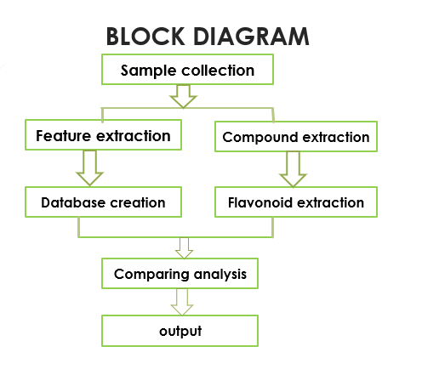Samples of species rama, Krishna, gayatri tulsi leaves are taken for experimental procedure. Three types of samples are extracted to identify the flavonoid compounds using spectral analysis. Image processing of all the three samples are to be done for extracting features like colour, shape and texture. Comparing the extracted features from image processing with the results obtained from spectral analysis of Rama, Gayatri and Krishna tulsi leaves. The parameter obtained from spectral analysis for comparing extraction features is wavelength.

2.COLLECTION AND IDENIFICATION OF PLANT MATERIALS:

The Genus *Ocimum* belongs to Lamiaceae family. There are large number of distinct species and varieties falls in this genus. It is widespread over Asia,

Africa, Central and Southern America. There are many kinds of *Ocimum sanctum*/ *tenuiflorum* available, in these experimental procedure we are taking three varieties of tulsi leaves.The Purple variety is called Krishna Tulsi , Green variety is called Sri Tulsi and the perennial ,woody bush basil is called gayatri tulsi and the common name is Holy basil. The more exuberantly flavoured purple holy basil has dark green leaves with reddish purple stems and a purplish cast on the younger leaves known as Krishna Tulsi, while the milder green variety has medium green leaves with very light green, almost white stems known as Sri Tulsi, and the slightly hairy green leaves with strong clove scent and spicy flavour known as gayatri tulsi and their chemical constituents are similar, and also have common medicinal properties.

Morphologically it is an erect, much branched shrub which is of about 30-60

cm tall with hairy stems and simple opposite green leaves that are strongly scented.

Leaves have petioles, and are ovate, up to 5 cm long, usually slightly toothed. Leaf

color ranges from light green (Sri Tulsi) to dark purple (Krishna tulsi). Flowers are

purplish in elongate racemes in close whorls. Seeds are round to oval, brown, 0.1 cm long, slightly notched at the base, no odour with pungent taste and slightly mucilaginous. *OcimumtenuiflorumL*.Green , *OcimumtenuiflorumL*.Purple, Ocimumgratissimum plants were collected from Green leaf garden-prop, madipakkam, Chennai, Tamilnadu. Below are the images of the samples of gayatri tulsi, Krishna tulsi and ram tulsi.

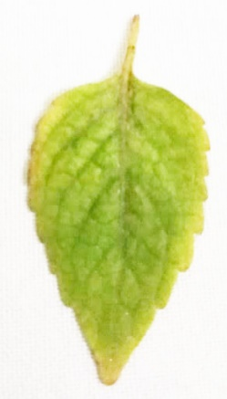 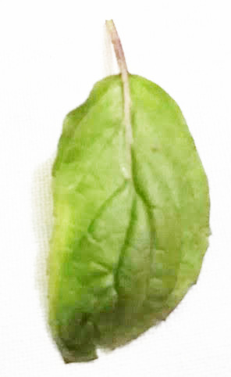 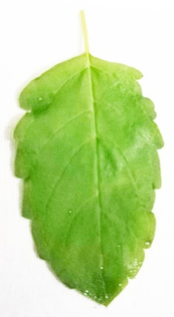

Scientific classification:

Kingdom: Plantae

Division: Magnoliophyta

Order: Lamiales

Family: Lamiaceae

Genus: *Ocimum*

Species*: tenuiflorum*

Binomial name: *Ocimum tenuiflorum* L. Fig 2.1

*Ocimum tenuiflorum* L.Green

Common name: Sri Tulsi (Green)

Scientific classification:

Kingdom: Plantae

Division: Magnoliophyta

Order: Lamiales

Family: Lamiaceae

Genus: *Ocimum*

Species: *tenuiflorum*

Binomial name: *Ocimum tenuiflorum* L.

Fig 2.2

Ocimum tenuiflorumL. Purple Common name: Krishna Tulsi (purple)

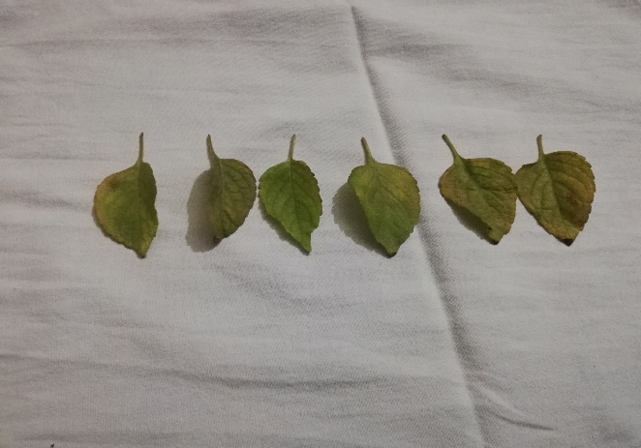Scientific classification:

Kingdom: Plantae

Division: Magnoliophyta

Order: Lamiales

Family: Lamiaceae

Genus: Ocimum

Fig 2.3

Species: Gratissimum Ocimum gratissimum

Binomial name: Ocimum sanctum

Common name: Gayatri tulsi

3.EXPERIMENTAL PROCEDURE:

3.1 EXTRACTION PROCESS:

Three types of leaves i. e, rama, Krishna, gayatri tulsi leaves are collected and washed with water to remove mud. The washed leaves are air dried completely for one week and finely powered. The dried powder of *Ocimumbasilicum* (50 g for each) was subjected to extract separately and exhaustively in Soxhlet apparatus with methanol. The process of extracting of leaves is repeated continuously till the amount of methanol is evaporated completely which approximately takes eight cycles.

A Soxhlet extractor is lab equipment designed for processing certain kinds of solids. These devices allow for continuous treatment of a sample with a solvent over a period of hours or days to extract compounds of interest. Typically, a Soxhlet extraction is only required where the desired compound has a limited solubility in a solvent, and the impurity is insoluble in that solvent. So methanol is used as first solvent for extraction purpose to look bioactives in medicinal plants and is a polar solvent which can dissolve some non-polar molecules as well. Therefore methanol is commonly used for extraction of bioactive compounds. Bioactive compounds from plants belong to various chemical groups such as tannins, alkaloids, glycosides, lignans , terpinoids ,flavonoids etc. But if these compounds are strictly hydrophobic then either a mixture of methanol and chloroform alone is used for extraction bioactive compounds. Moreover methanol among all the alcohols has low boiling point just 65 degree Celsius. So extraction of bioactive compounds (flavonoids) is easy by using Soxhlet extraction.

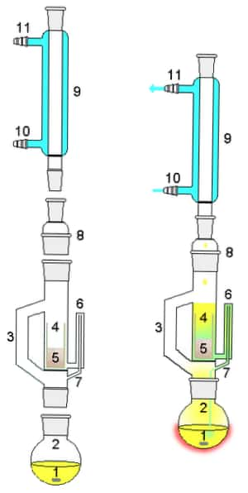

Fig 3.1

Soxhlet apparatus

3.2 SPECTRAL ANALYSIS:

Spectral analysis is a analysis interms of a spectrum f frequencies or related quantites such as energies, eigenvalues etc. In these experimental procedure the spectral analysis used is UV-visible spectra analysis.

**Example 1 – Spectral Analysis**

This section presents an example of how to do a spectral analysis of a time series. The Spots variable in the

Sunspot dataset will be used.

You may follow along here by making the appropriate entries or load the completed template **Example 1** by

clicking on Open Example Template from the File menu of the Spectral Analysis window.

**1 Open the Sunspot dataset.**

• From the File menu of the NCSS Data window, select **Open Example Data**.

• Click on the file **Sunspot.NCSS**.

• Click **Open**.

**2 Open the Spectral Analysis window.**

• Using the Analysis menu or the Procedure Navigator, find and select the **Spectral Analysis** procedure.

• On the menus, select **File**, then **New Template**. This will fill the procedure with the default template.

**3 Specify the variables.**

• On the Spectral Analysis window, select the **Variables tab**.

• Double-click in the **Time Series Variable** box. This will bring up the variable selection window.

• Select **Spots** from the list of variables and then click **Ok**.

**4 Run the procedure.**

• From the Run menu, select **Run Procedure**. Alternatively, just click the green Run button.

3.2.1 UV-VISIBLE SPECTROMETER:

UV-visible spectrometers can be used to measure the absorbance of ultra violet or visible light by a sample ,either at a single wavelength or perform a scan over a range in the spectrum. The UV region ranges from 190 to 400 nm and the visible region from 400 to 800 nm .The technique can be used both quantitatively and qualitatively. A schematic diagram of a UV-visible spectrometer is shown below.

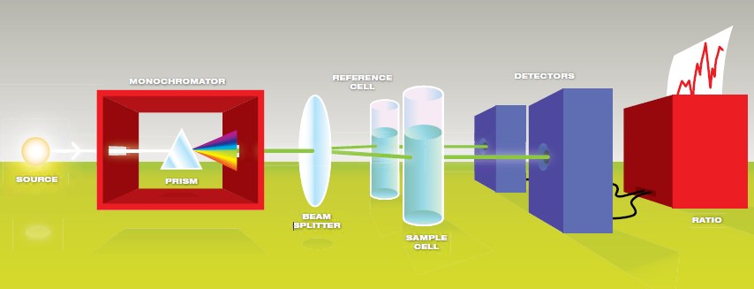

Fig 3.2.1.1

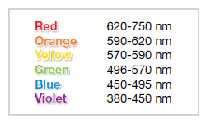

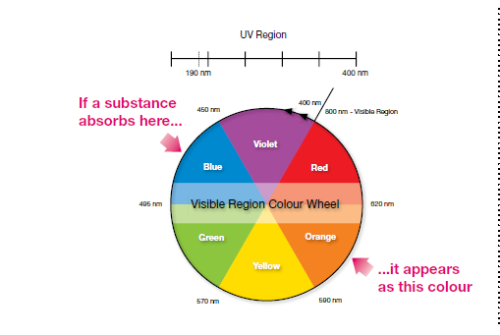

Fig 3.2.1.2

The light source (a combination of tungsten/halogen and deuterium lamps) provides the visible and near ultraviolet radiation covering the 200 – 800 nm .The output from the light source is focused onto the diffraction grating which splits the incoming light into its component colours of different wavelengths ,like a prism (shown below) but more efficiently.

For liquids the sample is held in an optically flat, transparent container called a **cell** or **cuvette**. The reference cell or cuvette contains the solvent in which the sample is dissolved and this is commonly referred to as the **blank** .For each wavelength the intensity of light passing through both a reference cell (**Io**) and the sample cell (**I**) is measured. If **I** is less than **Io**, then the sample has absorbed some of the light.

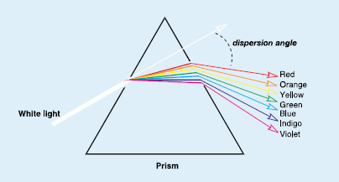

Fig 3.2.1.3

The absorbance (A) of the sample is related to **I** and **Io** according to the following equation:

A= log10(I0/I)

The detector converts the incoming light into a current, the higher the current the greater the intensity. The chart recorder usually plots the absorbance against wavelength (nm) in the UV and visible section of the electromagnetic

spectrum. *(Note: absorbance does not have any units).*

*Fig 3.2.1.4*



Fig 3.2.1.5

3.2.2 UV-VISIBLE SPECTRUM:

The diagram below shows a simple UV-visible absorption spectrum for buta-1,3-diene. Absorbance (on the vertical axis) is just a measure of the amount of light absorbed. One can readily see what wavelengths of light are absorbed (peaks), and what wavelengths of light are transmitted (troughs). The higher the value, the more of a particular wavelength is being absorbed. The absorption peak at a value of 217 nm, is in the ultra-violet region, and so there would be no visible sign of any light being absorbed making buta-1,3-diene colourless. The wavelength that corresponds to the highest absorption is usually referred to as “**lambda-max**” (lmax). The spectrum for the blue copper complex shows that the complementary yellow light is absorbed.

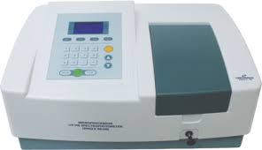

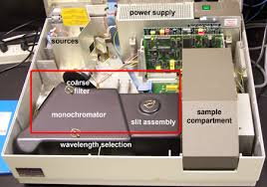

Fig 3.2.2.1

Spectrofluorophotometer

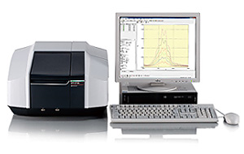

Fig 3.2.2.2

UV-Vis Spectrophotometer

3.2.3. MODERN APPLICATIONS OF UV SPECTROSCOPY:

UV-visible spectroscopy is a technique that readily allows one to determine the concentrations of substances and therefore enables scientists to study the rates of reactions, and determine rate equations for reactions, from which a mechanism can be proposed. As such UV spectroscopy is used extensively in teaching, research and analytical laboratories for the quantitative analysis of all molecules that absorb ultraviolet and visible electromagnetic radiation.

Other applications include the following:

* In clinical chemistry UV-visible spectroscopy is used extensively in the study of enzyme kinetics. Enzymes cannot be studied directly but their activity can be studied by analysing the speed of the reactions which they catalyse. Reagents or labels can also be attached to molecules to permit indirect detection and measurement of enzyme activity. The widest use in the field of clinical diagnostics is as an indicator of tissue damage. When cells are damaged by disease, enzymes leak into the bloodstream and the amount present indicates the severity of the tissue damage. The relative proportions of different enzymes can be used to diagnose disease, say of the liver, pancreas or other organs which otherwise exhibit similar symptom.
* UV-visible spectroscopy is used for dissolution testing of tablets and products in the pharmaceutical industry. Dissolution is a characterisation test commonly used by the pharmaceutical industry to guide formulation design and control product quality. It is also the only test that measures the rate of *in-vitro* drug release as a function of time, which can reflect either reproducibility of the product manufacturing process or, in limited cases, *in-vivo* drug release.
* In the biochemical and genetic fields UV-visible spectroscopy is used in the quantification of DNA and protein/enzyme activity as well as the thermal denaturation of DNA.
* In the dye, ink and paint industries UV-visible spectroscopy is used in the quality control in the development and production of dyeing reagents, inks and paints and the analysis of intermediate dyeing reagents.
* In environmental and agricultural fields the quantification of organic materials and heavy metals in fresh water can be carried out using UV-visible spectroscopy.

3.2.4. RESULTS OF UV AND INFRARED SPECTRAL ANALYSIS OF GAYATRI, KRISHNA AND RAM TULSI

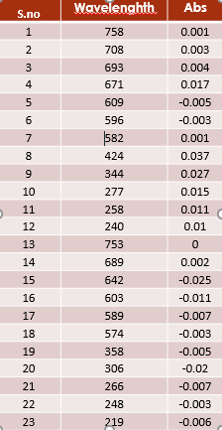 **RAMA TULSI**

Fig 3.2.4.1 Table 3.2.4.1

**KRISHNA TULSI**



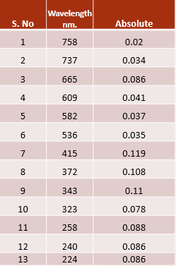

Fig 3.2.4.2 Table 3.2.4.2

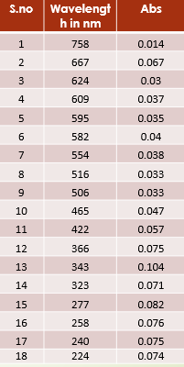 **GAYATRI TULSI**



Fig 3.2.4.3 Table 3.2.4.3

3.3. DETERMINATION OF FLAVONIOD CONTENT:

*Test for flavonoids*: The extract were dissolved in ethanol, filtered and subjected to following tests. The dried extracts were dissolved in 95% ethanol (5ml) and few drops of concentrated hydrochloric acid (HCL) were added. Then the magnesium turnings were put into the solution and observed for appearances of pink color. Lead acetate solution test : To small quantity of above residue , lead acetate solution was added and observed for appearance of formation of yellow colored precipiates.

Flavonoids and their examples:

Flavone: luteolin, apigenin, tangeriti.

Flavonol: Quercetin, kaempferol, myricetin, fisetin, isorhamnetin, pachypodol, rhamnazin.

Flavanone: hesperetin, naringenin, eriodicty, homoerodictyol.

Flavanonol: Taxifolin, dihydrokaempferol

The flavonoids content was determined by extracted solvent with methanol as reference compound. Each type of extracted solvent was mixed with methanol of 1ml to dissolve. After incubation at room temparture for 5-10mins, the absorbance of the mixture solution was obtained in the range 400-470nm (flavonoids) using spectrophotometer. The range between 200-400 is kerotin. The range between 400-470 is flavonoid compound. The range between 500-700 is chlorophyll. The results for total flavonoids content in each sample are presented below with spectral analysis graph and table.

3.4. DIGITAL IMAGE PROCESSING:

3.4.1 INTRODUCTION:

Nowadays image processing is becoming an important assisting tool in many branches of science such as computer science, electrical and electronic engineering, robotics, physics, chemistry, environmental science, biology, and psychology. Digital image technology is rapidly developing, multidisciplinary technology which uses the knowledge from different fields to produce a system, which could be used in different areas of human activities, for example in medicine, biology, chemistry, engineering, industrial automatization and inspection, security, criminology. Digital image technology includes image acquisition, image digitalization which means its transformation into digital image, digital image processing and digital image analyses. This technology could be used in all those cases where decisions are based on qualitative or quantitative information extracted from the image.

One typical example is a particle classification, where particles on the

image have to be classified based on an individual particle's morphological

parameter (area, perimeter, circularity index or something similar). Input information to such system is image of various particles taken by video camera through some appropriate camera lens. Output information are distributions of particle's parameters. Moreover, the system could recognize each individual particle, if some knowledge about particle's typical parameters values are implemented into system's knowledge base.

For material classification and recognition the information about texture

could be used, pathological cells could be detected and recognized using information about colour and shape, object irregularities on the production line could be identified comparing it with the regular one, in order to exclude false products from the production line. All these tasks could be carried out today using sophisticated hardware and software, with a higher degree of speed and accuracy. It is important to know that the cost of such sophisticated and complex equipment is not any more so high as it was until recently. Couple of years ago those equipment were affordable only to well-founded research laboratories, but today also small routine laboratories can afford and use all benefits of digital image processing and analyses.

3.4.2. DIGITAL IMAGE FUNDAMENTALS:

An image can be a photograph, a painting, or even a dream, but in the world of computers, it is a collection of dots called "pixels". Such image is usually known as d*igital image* and formally defined as an array of pixels whose values indicate the light intensity of the flux on the picture element represented by that pixel. Each pixel has its horizontal and vertical position and its value. Positions and value are nonnegative scalars whose range depends on the digitalization unit characteristics. For example, frame grabber supplied with CHRONOLAB Color Vision software produces digital image with 512 x 512pixels (in ordinary mode), so x and y coordinates could be nonnegative scalars 0 and 511. Also each frame grabber channel has 8-bit analog to digital conversion, so each pixel value could be between 0 and 255, 0 representing the darkest intensity, and 255 the lightest intensity.

Image processing basically includes the following three steps:

* Importing the image via image acquisition tools;
* Analysing and manipulating the image;
* Output in which result can be altered image or report that is based on image analysis.

There are two types of methods used for image processing namely, analogue and digital image processing. Analogue image processing can be used for the hard copies like printouts and photographs. Image analysts use various fundamentals of interpretation while using these visual techniques. Digital image processing techniques help in manipulation of the digital images by using computers. The three general phases that all types of data have to undergo while using digital technique are pre-processing, enhancement, and display, information extraction.

Three different kinds of digital images could be distinguished:

• Black and white image,

• Gray value image, and

• Color image.

Each pixel of black & white image, or sometimes called binary image,

could have one of two possible values, for example for 0 or 255, but usually it

is expressed by logical 0 and 1 values. This is the most simple image where

objects are represented by their areas. Most of object measurements could be

performed only on this kind of digital image. Binary image could be obtained

from gray value image or colour image by process called segmentation.

The pixel values of gray value digital imagecould be a nonnegative

scalar from the range determined by analog-to-digital conversion unit. Typical

range is from 0 to 255 (256 gray values), where 0 means black and 255 means

white. Gray value digital images could be obtained from monochrome cameras or

by colour-mono conversion from colour digital images. Subjective perception of

gray values is not linear, and correspond to a curve known as gamma correction.

Colour digital imageshave three image planes, each of them corresponding to one primary colour: red (R), green (G), and blue (B). Each image pixel of colour image is conceived of three colour pixels: red pixel, green pixel and blue pixel, each of them having appropriate intensity value. Red, green or blue colour planes have the same structure as gray value image plane typically 256 intensities for each colour. Combining various intensities of RGB pixels each image pixel could give one of 256 x 256 x 256 = 16,777.216 different colour values. When defining value of colour image pixel at location (x,y) a triplet must be given in the form (red, green, blue), for example (0, 255, 255), which means minimum intensity for red and maximal intensities for green and blue, and that corresponds to pure yellow hue. Colour image pixel will seem as gray value pixel if all primary colours have the same intensity value: Black correspond to (R,G,B) = (0,0,0), white to (R,G,B) = (255, 255, 255), and for example (R,G,B) = (127, 127,127) will give some medium gray intensity.

Sometimes, it is more convenient to express the image pixel values not

by primary colours red, green and blue, but by transformed values hue (H),

saturation (S) and intensity (I). Huecorresponds to pure colour information. The

whole spectrum is covered by the hue values from 0 to 360 (red 0, green 120,

blue 240). Saturationdetermines the colour closeness to gray values. The pure

colour has saturation equal to 1 and the gray value has the saturation equal to 0.

The intensity or luminancemeasures the overall light intensity. It could be

between 0 and 255, or in relative intensity system between 0 and 1. The

intensity of an object is independent of the intensity of the surrounding objects.

The intensity is the objective measure of the light distribution in the image. The

subjective measure of the light distribution in the image is the brightnessor

sometimes called apparent brightness. The brightness of an object is the

perceived luminance and depends on the luminance of the surround. Two

objects with different surroundings could have identical luminance but different

brightness.

The RGB colour space could be schematically shown by colour cube. Cube corners correspond to elementary colours (red, green, blue), their complements (cyan, magenta, yellow) and black and white. Gray values are

located on main diagonal. The HSI colour space could be schematically shown by double cones. Bottom and top vertexes correspond to black and white, and gray values are located on line between them (saturation = 0). Pure colours are located on outer circles.

Each colour image pixel value could be found inside RGB cube or HSI

double cone. shows for one typical colour image. If the image is gray value one, all pixel values lie on gray value lines. Pure colours are located on outer surfaces of RGB cube or HSI double cone.

One of the weakness of the RGB model, and partly of HSI model for

specifying colour image is its nonuniform nature; equal distance in the RGB colour space does not generally correspond to equal difference in colour perception. Because of that some other colour models are purposed. One of them is YIQ colour model of American NTSC standard for composite video signal, which is essentially a linear transformation of the RGB model with luminance information coded into the Y component and chrominance into I and Q.

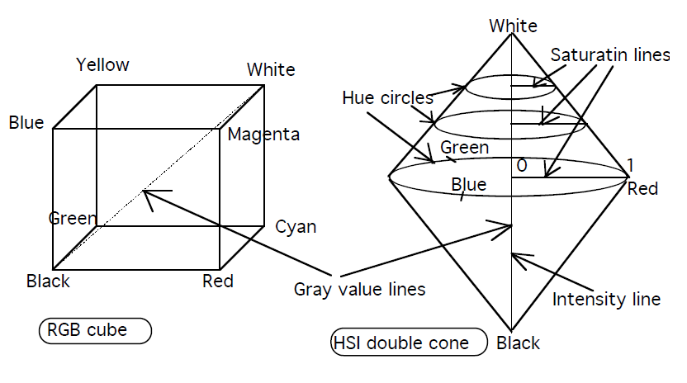

Fig.3.4.2.1. Schematic representation of RGB and HSI space

This allows colour video signal to be shown on black-and-white monitors by using Y component. The I parameter carries orange-cyan hue information, while the Q parameter carries green-magenta hues. Quite similar is a colour model of European PAL colour video standard.

Video memory for storing colour digital images must be three times bigger than video memory for storing gray value digital images with the same number of intensity levels. For example, one gray value digital image 512 x 512 pixels with 256 levels of gray needs approximately 262 Kbytes of video memory, and colour digital image needs 786 Kbytes of video memory. Also processing time is three times longer for colour images, and because of that colour digital video

systems are more complicated and more expensive.

Digital image processing alters values of digital images stored in video memory in order to prepare them for image analysis. The processing of digital image data could be categorized into two main categories:

• Monadic operations which act on one image pixel value in one time

moment, and

• Dyadic operations which act on multiple pixel values of one image or of

a few images in one time moment.

**Monadic point-by-point operations:**

Monadic point by point operations are the simplest or most elementary

image processing operations. General rule applied to all image pixel intensities

is:Change the image pixel value from p to q, regardless to its location in image.

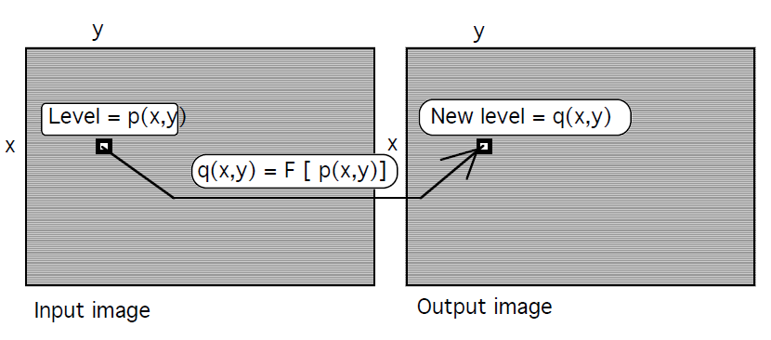

Fig 3.4.2.2

Monadic point by point operation

Point by point operation could be graphically represented by x-y diagram, where x-axis corresponds to input image intensities p, and y-axis to output image intensities. shows one typical point by point operationcalled contrast

enhancement.

Contrast enhancement is a linear point by point operation, used to improve image quality when the image contrast is too weak. In that case intensity values are not uniformly spread through all intensity range. They are limited to a portion of possible range. That could be easily noticed from input image histograms as Fig.10. shows. Input image histogram is used for calculation of clipping values p1 and p2. p1 corresponds to the darkest value in the image and p2 to the brightest value. Applying contrast enhancement operator, input image intensities between p1 and p2 are spread in output image over all intensity range. The dynamic range in output image that results from this calculation is distributed over the maximum possible intensity values of the system. For color images contrast enhancement with different clipping values for each primary color could be performed separately or the same clipping values calculated from the intensity histogram could be applied for all primary color planes. The effect of applying gray value and color contrast enhancement operator is shown on plates at the end of this Introduction.

Contrast enhancement is more powerful operation than simple contrastadjustmentwhich can be performed by using similar operator function. Bycontrast adjustment image pixels value range is stretched or squeezed aroundmidpoint. shows the difference between contrast enhancement andcontrast adjustment. Clipping values of contrast enhancement could be anyvalue, taking into account that p1 < p2. In contrast adjustment p1 and p2, aresymmetrically positioned around midpoint of input intensities . For example, ifwe have 256 different input intensities (8-bit gray value input image) thanmidpoint intensity is 128. If p1 is chosen as 50, than p2 must be 128 + (128 -50) = 206. Contrast adjustment increases contrast around midtowns, andcontrast enhancement around any input intensity value. Also contrastadjustment has the possibility of contrast reduction. Contrast increase (stretching) is used when an image looks too flat, without strong light or dark colors. Contrast reduction (squeezing) is used when lights and darks of an image are too extreme.

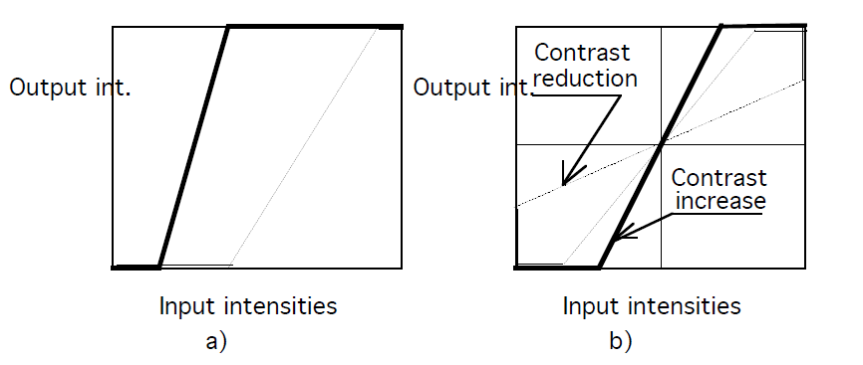

Fig 3.4.2.3

Difference between contrast enhancement a) and contrast

adjustment b).

**Dyadic point-by-point operations:**

Dyadic point-by-point operations use essentially the same procedure

except that a new image is generated taking two or more input pixels and F is a

function of multiple variables:

q(x,y) = F[ p1(x1, y1), p2(x2, y2), p3(x3,y3),...]

Pixels p1, p2, p3, ... could either belong to two or more different images or to

the same image.

In the first case the procedure is known as image arithmetic. Pixel

positions of input images are the same for all input images (x=x1=x2=x3=..., y=y1=y2=y3=...), and F could be any mathematical operation: addition, subtraction, multiplication, division, maximum, minimum, logical AND, or, XOR or any other function that can be devised. Care must be taken that the function contains an appropriate scaling factor to keep the magnitude of the output value within the intensity range to avoid an overflow, negative value or non-integer value. Image additioncan be used to reduce the effect of noise in the data, because it can average the data in two input images. If one of the input images is constant, the result image will be lighter overall image which will appear as a shift in the image histogram. Image subtraction can be used to filter out differences in images, to detect changes between two images, to eliminate background influence and alike. If two images are taken in different times, than subtraction can be used to detect movement. Image multiplicationis used to correct the sensor nonlinearities or to extract specific areas of an image by region of interest window. Image pixels are multiplied by window pixels which are 0 outside the window and 1 inside the window. Logical operationsare particularly used for manipulating binary images.

As specially important applications of image arithmetic let us mention background subtraction and flat field correction. For a given temperature, all CCD cameras exhibit an offset, consisting of preamplifier bias and dark charge. The preamplifier bias appears as a constant level for a given readout rate. The dark charge generally has some structure due to small variations in pixel response. the combined effect of these offsets is a fixed background for the image. Sometimes it is necessary to remove this unwanted background from the image. To do this, the user must first to acquire background image using the same camera temperature, readout rate and exposure time covering the camera objective or switching off the microscope illumination. This background image must be saved in one of the video memories and then subtracted from the original image.

Flatfielding is another powerful tool to correct for system response variations. System response nonuniformity is caused both by variations in the incident light source, which may not be uniform across the field of view, and by the response of the camera, which normally has small variations from pixel to pixel. To correct for these nonuniformites, the user first stores the image from a uniform light source. This image, minus the background, is the Flatfield image. Subsequent images are first background subtracted and then divided by the flatfield image to obtain flatfield corrected images.

3.4.3 DIGITAL IMAGE ANALYSIS:

There is a great difference between processing of digital image itself, described in details in Image Processing chapter and digital processing of image information, which will be described in this chapter. The latter is known as Digital Image Analysis. An image is analyzed when the information contained in the image is evaluated.

The final results of digital image analysis are normally numeric, such as image topological characteristics (number of separate objects in the image), geometrical characteristics of image objects (area, perimeter, circularity), densitometric characteristic and texture of image objects or image itself, but the result of digital image analysis could be also another image with identified image structures (edges, boundaries, regions, objects). This second kind of digital image analysis is usually performed before quantitative image evaluation. Digital image analysis usually consists of a number of procedures which first prepare the image for quantitative evaluation, and after that the image is quantitatively analyzed. For example, for certain geometric or topological image analyses, color or gray scale image is first converted in binary image, using one of segmentation methods, and after that, when objects are marked as white areas in comparison with background which is black, the image is quantitatively analyzed and evaluated. Some other image measurements, like measurement of distances and angles or single object characteristics, when its boundaries are manually or automatically traced, do not need image transformation into binary one. They can be performed on original, color or gray scale image. The same situation is with measurement of image luminescence features, like luminescence profiles. They don't need any kind of transformation because in that case original luminescence information will be lost.

Digital image analysis could be interactive manual, interactive automatic or fully automatic. The interactive**,** manual orsemi-automatic digital image analysis is used in applications which are not labor or time intensive, or when fully automatic image analysis procedures are so complex that the effort in preparing them is not economically viable. Interactive image analysis takes the advantage of the user’s experience in recognizing even the most complex structures. The user applies all analysis procedures one by one, for example edge extraction - segmentation by edges - binary image optimization – objects measurements. The time required for these measurements depends on the skill and knowledge of the operator. In interactive manual analysis measurement are performed by tracking contours of objects with a cursor on the screen. The measurement and evaluation are supported by quick measuring algorithms, data processing and data management.

In interactive automatic analysis user interactively apply all image processing procedures: image optimization, image segmentation, binary image optimization,

but when the image is ready for measurement, the whole image field is automatically measured and evaluated. Typical examples are automatic object counting, object recognition, image field measurement and similar. For more rapid routine analysis, fully automatic image analysis could be applied. All steps, from image acquisition to data evaluation, are automatic. User only creates conclusions. Due to the complexity of the image this can be in lot of situations achieved only with great difficulty using economically realistic equipment. Therefore, a modular system offers an ideal solution to users who need to analyze images under various conditions. The basic configuration offers interactive automatic image acquisition and analysis, and if necessary it could be upgraded to a fully automatic image analysis system. chronlab Digital Video Microscopy is an example of such a system. In its basic configuration which includes basic CHRONOLAB Color Vision Ver 1.0 software, it offers all processing and analysis functions for, interactive manual or automatic

application, but in its advanced version, a special macro language will be included. Using them a sequence of operations could be created for a particular image analysis tasks, and then performed automatically.

Before any measurements the calibration procedurehave to be done. There are two kind of calibrations: geometric calibration and densitometric calibration. In geometric calibrationa correspondence between original scene linear dimensions and digital image linear dimensions are defined. The elementary geometric element of a digital image is a pixel. Typical digital image has 512 pixels in horizontal and 512 pixels in vertical dimension. All digital image linear dimensions are primarily measured in pixels and each pixel of digital image corresponds to certain linear dimension of original image. The ratio between them is a function of overall system magnification, and it is determined during the calibration procedure. Calibration is usually performed separately for horizontal and vertical dimension, because digital image could be distorted if cameras pixel elements do not correspond to digital image pixel elements. Calibration consists of defining how many digital image pixels have horizontal or vertical line whose dimension is well known. A horizontal ruler is incorporated in original image, its real length is defined and connected with length of a line manually drawn over the ruler in digital image. If it is necessary, the same procedure could be done for vertical dimension. Transformation ratios could be previously defined if the system and its magnification is well known, for example in the case of light microscopy workstations.

3.4.4 IMAGE PROCESSING:

The term "image processing" refers to the procedures whereby the

information contained in an image is altered, changed, usually to visually restore

or optimize the image. Typical examples are correction of image sharpening

caused by poor focusing, correction of lenses optical errors, correction of

contrast, intensity or brightness, colour correction, image structure enhancement

to emphasize elements which are not easily seen in original image, subtraction of

background noise and similar. Image processing prepare images for image

analyze, both manual or automatic. This means that images could be analyzed

even in cases this was previously impossible due to poor quality or to its

complexity.

Today’s hardware allows implementation of a lot of sophisticated

image processing functions, but it is much more important to get the original

image as better as possible. The main emphasis must be on adjustment of

illumination and image optimization during acquisition, and then to make, if it is

necessary the final, small adjustments by digital image processing functions.

3.4.5. FEATURE EXTRACTION:

There is no universal or exact definition of what constitutes a feature for sign recognition (George Caridakis et al., 2008). It often depends on the problem or the type of language. A feature is defined as an “interesting” part of an image, and is used as a starting point in main primitives for subsequent algorithms. The overall algorithm will often only be as good as its feature detector. Consequently, the desirable property for a feature detector is its repeatability: whether or not the same feature will be detected in two or more different images of the same scene. The most important types of features which can be considered when trying to identify the signs are spatial, temporal and textural. The feature extraction stage is built and designed to process real images (Ryszard S. Choras, 2007). The algorithms used in these systems arecommonly divided into three tasks: extraction, selection and classification. For a valid classification, there has to be a rational nexus between the features and it is the most critical assignment because the particular features made available for discrimination directly influence the efficacy of the classification task. The end result of feature extraction is a set of features, commonly called a feature vector, which constitutes a representation of an image.

3.4.5.1 ANALYSIS OF FEATURE EXTRACTION:

The feature is defined as a function of one or more measurements, each of

which specifies some quantifiable property of an object, and is computed such that it quantifies some significant characteristics of the object. The various features classified and currently employed are

• General features: Independent features such as colour, texture, and shape

According to the abstraction level, they can be further divided into:

- Pixel-level features: Features calculated at each pixel, e.g. colour, location.

- Local features: Features calculated over the results of subdivision of the image

band of an image segmentation or edge detection (Thawar Arif, et al., 2009).

- Global features: Features calculated over the entire image or just regular

sub-area of an image.

• Domain-specific features: Application of dependent features such as human faces,

fingerprints and conceptual ones.

All features can be coarsely classified into low-level features and high-level

features. Low-level features can be extracted directly from the original images,

whereas high-level feature extraction depends on low level features.

The issue of choosing the features from the extracted vector should be guided

by the following concerns:

* the features should carry enough information about the image and should not require any domain-specific knowledge for their extraction.
* they should be easy to compute in order to approach the feasibility of a large image collection and rapid retrieval.
* they should relate well to the human perceptual characteristics since users

finally determine the suitability of the images retrieved.

3.4.5.2 COLOR FEATURES:

The colour feature is one of the most widely used visual features in image

classification. Images characterized by colour features have many advantages (Ryszard S. Choras, 2007), namely,

• Robustness: The colour histogram is invariant to rotation of the image on the view

axis, and changes in small steps when rotated otherwise or scaled.

• Effectiveness: There is high percentage of relevance between the query image and

the extracted matching images.

• Implementation simplicity: The construction of the colour histogram is a direct

process, including scanning the image, assigning colour values to the resolution of the histogram, and building the histogram using colour components as indices.

• Computational simplicity: The histogram computation has O (x, y) complexity for

images of size x × y. The complexity for a single image match is linear, O(n), where

*n* represents the number of different colours, or resolution of the histogram.

• Low storage requirements: The colour histogram size is significantly smaller than the itself, assuming colour quantisation.

3.4.5.3 TEXTURE FEATURES:

Texture is an important property of image and is a powerful regional descriptor that helps in the retrieval process (Jong Kook Kim and Hyun Wook Park, 1999). Texture, on its own does not have the capability of finding similar images, but it can be used to classify textured images from non-textured ones and then be combined with another visual attribute like colour to make the retrieval more effective (Abdul kadir etal., 2011).

Textural features are

o Statistical measures

• Entropy

• Homogeneity

• Contrast

o Wavelet

o Fractals

3.4.5.4.SHAPE FEATURES:

Shape is an important visual feature and one of the primitive features for image

content description. Shape content description cannot be defined exactly because

measuring the similarity between shapes is difficult (Morteza Zahedi et al., 2006).

Therefore, two steps are essential in shape based image retrieval, they are: feature

extraction and similarity measurement between the extracted features. Shape

descriptors can be divided into two main categories: region-based which use the whole area of an object for shape description and contour based which use local features as boundary segments.

3.4.5.5 TEXTURAL FEATURES BASED ON GLCM:

Selected computable textural features based on gray-tone spatial dependencies

illustrate their application in sign language recognition. Gray level co-occurrence

matrix is one of the most known texture analysis methods that estimate image

properties related to second order statistics. Each entry (i, j), GLCM is correspond to the number of occurrences of the pair of gray levels i and j which are a distance d, apart in original image. GLCM is done by calculating how often a pixel with the

intensity (gray-level) value *i* occurs in a specific spatial relationship to a pixel with the value *j*. Each element (*i, j*) in the resultant GLCM is simply the sum of the number of times that the pixel with value *i* occurred in the specified spatial relationship to a pixel with value *j* in the input image. The number of gray levels determines the size of the GLCM. The gray-level co-occurrence matrix can also reveal certain properties about the spatial distribution of the gray levels in the texture image .



Fig 3.4.5.5.1

Spatial arrangements of pixels

Co-occurrence matrices are defined as a relative separation vector and it uses

each pair of pixels separated by the vector as matrix indices and the matrix element is incremented. Shape characterises the texture by factors derived from it. Cooccurrence, in general, can be specified in a matrix of relative frequencies P(i; j; d; θ) with which two neighboring texture elements are separated by distance d at orientation θ that occur in the image, one with property i and the other with property j. In gray level co-occurrence, as a special case, texture elements are pixels and properties are gray levels. A sample gray level matrix is given in figure.



Fig 3.4.5.5.2 (a) 4x4 image with gray levels 0-3. (b) General form of co-occurrencematrices P(i, j, d, θ) for gray levels 0-3 where #(i ,j) stands for number of times gray level i and j have been neighbours.

3.4.5.6. EXTRACTION OF TEXTURE FEATURES OF IMAGE:

Gray Level Co-Occurrence Matrix (GLCM) has proved to be a popular statistical method of extracting textural feature from images. According to co-occurrence matrix, Haralick defines fourteen textural features measured from the probability matrix to extract the characteristics of texture statistics of remote sensing images. In this paper various important features, namely Angular Second Moment (energy), Correlation, Entropy, Inverse Difference Moment, Contrast, Homogeneity, Variance, Sum Average, Sum Variance, Sum Entropy, Sum of Squares Variance, Difference Variance, Difference Entropy, Information Correlation are selected for implementation using MATLAB.

1. ***ANGULAR SECOND MOMENT:***

The ASM is known as uniformity or energy. It measures the uniformity of an image. When pixels are very similar, the ASM value will be large.

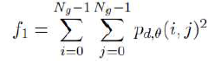

1. ***CONTRAST:***

Contrast is a measure of intensity or gray-level variations between the reference pixel and its neighbor. In the visual perception of the real world, contrast is determined by the difference in the color and brightness of the object and other objects within the of same field of view.

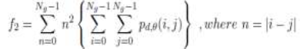

When i and j are equal, the cell is on the diagonal and i- j = 0. These values represent pixels entirely similar to their neighbour, so they are given a weight of 0. If i and j differ by 1, there is a small contrast, and the weight is 1. If i and j differ by 2, the contrast is increasing and the weight is 4. The weights continue to increase exponentially as (i,j) increases.

1. ***ENTROPY:***

Entropy is a difficult term to define. The concept comes from thermodynamics; it refers to the quantity of energy that is permanently lost to heat every time a reaction or a physical transformation occurs. Entropy cannot be recovered to do useful work. Because of this, the term can be understood as amount of irremediable chaos or disorder. The equation of entropy is:

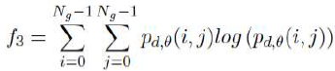

1. ***VARIANCE:***

Variance is a measure of the dispersion of the values around the mean of combinations of reference and neighbour pixels.

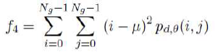

1. ***INVERSE DIFFERENCE MOMENT:***

IDM is usually called homogeneity that measures the local homogeneity of an image. IDM feature obtains the measures of the closeness of the distribution of the GLCM elements to the GLCM diagonal.

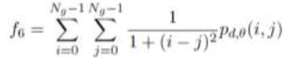

1. ***CORRELATION:***

Correlation feature shows the linear dependency of gray level values in the co-occurrence matrix. It presents how a reference pixel is related to its neighbor, 0 is uncorrelated, 1 perfectly correlated.

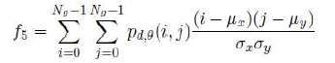

1. ***SUM AVERAGE:***



Where,



1. **SUM VARIANCE:**



1. ***SUM ENTROPY:***



1. ***DIFFERENCE VARIANCE:***



Where,



1. ***DIFFEERENCE ENTROPY:***



1. ***HOMOGENEITY:***

Homogeneity is which it measures the closeness of the distribution of elements

in the gray level matrix. The distribution parameter is also high when compared with the evaluated methods indeed this helps in better segmentation. To quantitatively characterise the homogeneous texture regions for similarity it is done using local spatial statistics of the texture which is obtained by scale and orientation selective Gabor filtering. The image is thus partitioned into a set of homogeneous texture regions, and then the texture features associated with the regions are indexed in the image data. GLCM Homogeneity are calculated for four direction (i.e. Ө= 0◦, 45◦, 90◦ or 135◦). A feature vector of size 4 is created for the image. Homogeneity is computed as



Homogeneity measures the similarity of pixels. A diagonal gray level co-occurrence matrix gives homogeneity of 1. It becomes large if local textures only have minimal changes.

1. ***ENERGY:***

Energy also means uniformity, or angular second moment (ASM). The more homogeneous the image is, the larger the value. When energy equals to 1, the image is believed to be a constant image.



3.4.6. OBTAINED RESULTS OF FEATURE EXTRACTION OF TULSI LEAVES:

1. ***TEXTURE FEATURE EXTRACTION OF GAYATRI TULSI:***

The below table describes all the parameters that are defined above. For ten samples of gayatri tulsi parameters are calculated. These results are stored in database which are used for comparison with the spectral analysis result.

|  |  |  |  |  |  |  |  |  |  |  |
| --- | --- | --- | --- | --- | --- | --- | --- | --- | --- | --- |
| ***TEXTURE***  ***PARAMETERS*** | ***1*** | ***2*** | ***3*** | ***4*** | ***5*** | ***6*** | ***7*** | ***8*** | ***9*** | ***10*** |
| ***ENERGY*** | *0.873* | *0.267* | *0.252* | *0.836* | *0.614* | *0.529* | *0.513* | *0.806* | *0.370* | *0.334* |
| ***CORRELATION*** | *238.6* | *1018.2* | *1070.2* | *237.2* | *260.2* | *462.4* | *526.3* | *263.1* | *758.1* | *467.6* |
| ***SUM VARIANCE*** | *25.422* | *25.422* | *25.422* | *23.98* | *18.18* | *26.81* | *29.13* | *25.53* | *26.37* | *14.09* |
| ***INVARIANCE*** | *0.950* | *0.884* | *0.916* | *0.941* | *0.850* | *0.830* | *0.896* | *0.901* | *0.944* | *0.909* |
| ***SUM AVERAGE*** | *10.100* | *8.623* | *8.3646* | *9.820* | *8.522* | *10.31* | *10.77* | *10.12* | *10.23* | *6.76* |
| ***SUM VARIANCE*** | *93.16* | *55.35* | *51.48* | *87.15* | *58.30* | *83.12* | *94.73* | *90.43* | *80.96* | *37.81* |
| ***SUM ENTROPY*** | *0.456* | *1.768* | *1.813* | *0.496* | *0.917* | *1.251* | *1.087* | *0.629* | *1.344* | *1.556* |
| ***ENTROPY*** | *0.524* | *1.963* | *1.908* | *0.577* | *1.124* | *1.565* | *1.230* | *0.766* | *1.415* | *1.675* |
| ***DIFFERENCE***  ***INVARIANCE*** | *0.0035* | *0.0290* | *0.0289* | *0.005* | *0.019* | *0.018* | *0.024* | *0.006* | *0.032* | *0.026* |
| ***INFORMATION***  ***MEASURE OF CORRELATION 1&2*** | *-0.024* | *0.015* | *0.0136* | *-0.02* | *-0.008* | *0.004* | *-0.005* | *-0.018* | *-0.001* | *0.007* |

Table 3.4.5.1

1. ***TEXTURE FEATURE EXTRACTION OF KRISHNA TULSI:***

The below table describes all the parameters that are defined above. For ten samples of krishna tulsi parameters are calculated. These results are stored in database which are used for comparison with the spectral analysis result.

|  |  |  |  |  |  |  |  |  |  |  |
| --- | --- | --- | --- | --- | --- | --- | --- | --- | --- | --- |
| ***TEXTURE***  ***PARAMETERS*** | ***1*** | ***2*** | ***3*** | ***4*** | ***5*** | ***6*** | ***7*** | ***8*** | ***9*** | ***10*** |
| ***ENERGY*** | *0.326* | *0.338* | *0.300* | *0.268* | *0.425* | *0.269* | *0.528* | *0.226* | *0.413* | *0.316* |
| ***CORRELATION*** | *696.8* | *651.3* | *859.2* | *907.9* | *684.8* | *772.1* | *391.9* | *1262.4* | *524.4* | *469* |
| ***SUM VARIANCE*** | *19.94* | *19.86* | *21.44* | *18.53* | *29.27* | *15.80* | *22.48* | *18.22* | *21.73* | *12.98* |
| ***INVARIANCE*** | *0.865* | *0.931* | *0.927* | *0.925* | *0.914* | *0.916* | *0.934* | *0.868* | *0.902* | *0.909* |
| ***SUM AVERAGE*** | *8.522* | *8.27* | *8.68* | *7.932* | *10.69* | *7.385* | *9.473* | *7.955* | *9.188* | *6.639* |
| ***SUM VARIANCE*** | *52.18* | *59.00* | *62.40* | *51.34* | *90.25* | *41.66* | *71.63* | *46.71* | *62.80* | *33.46* |
| ***SUM ENTROPY*** | *1.878* | *1.380* | *1.516* | *1.640* | *1.381* | *1.718* | *1.066* | *1.930* | *1.407* | *1.566* |
| ***ENTROPY*** | *2.068* | *1.456* | *1.632* | *1.766* | *1.529* | *1.863* | *1.156* | *2.146* | *1.540* | *1.743* |
| ***DIFFERENCE***  ***INVARIANCE*** | *0.017* | *0.035* | *0.029* | *0.023* | *0.020* | *0.026* | *0.020* | *0.020* | *0.026* | *0.0267* |
| ***INFORMATION***  ***MEASURE OF CORRELATION 1&2*** | *0.018* | *0.001* | *0.006* | *0.009* | *0.003* | *0.012* | *-0.073* | *0.0202* | *0.0034* | *0.0090* |

Table 3.4.5.2

1. ***TEXTURE FEATURE EXTRACTON OF RAMA TULSI:***

The below table describes all the parameters that are defined above. For ten samples of ram tulsi parameters are calculated. These results are stored in database which are used for comparison with the spectral analysis result.

|  |  |  |  |  |  |  |  |  |  |  |
| --- | --- | --- | --- | --- | --- | --- | --- | --- | --- | --- |
| ***TEXTURE***  ***PARAMETERS*** | ***1*** | ***2*** | ***3*** | ***4*** | ***5*** | ***6*** | ***7*** | ***8*** | ***9*** | ***10*** |
| ***ENERGY*** | *0.297* | *0.486* | *0.326* | *0.538* | *0.799* | *0.542* | *0.402* | *0.358* | *0.293* | *0.643* |
| ***CORRELATION*** | *545.2* | *181.9* | *368.6* | *521.9* | *359.2* | *160.7* | *535.8* | *285.7* | *807.8* | *306.06* |
| ***SUM VARIANCE*** | *13.06* | *9.419* | *10.67* | *30.72* | *34.66* | *9.798* | *21.19* | *9.618* | *19.41* | *22.55* |
| ***INVARIANCE*** | *0.879* | *0.917* | *0.912* | *0.929* | *0.920* | *0.918* | *0.896* | *0.880* | *0.917* | *0.9332* |
| ***SUM AVERAGE*** | *6.939* | *5.648* | *6.059* | *10.96* | *11.77* | *5.624* | *9.051* | *5.800* | *8.178* | *9.461* |
| ***SUM VARIANCE*** | *32.78* | *25.48* | *25.83* | *99.54* | *125.5* | *27.24* | *60.10* | *23.49* | *54.37* | *74.24* |
| ***SUM ENTROPY*** | *1.772* | *1.242* | *1.602* | *1.162* | *0.578* | *1.147* | *1.524* | *1.502* | *1.622* | *0.9264* |
| ***ENTROPY*** | *1.967* | *1.400* | *1.772* | *1.286* | *0.687* | *1.224* | *1.686* | *1.767* | *1.731* | *1.0383* |
| ***DIFFERENCE***  ***INVARIANCE*** | *0.026* | *0.015* | *0.023* | *0.013* | *0.008* | *0.014* | *0.019* | *0.024* | *0.029* | *0.0102* |
| ***INFORMATION***  ***MEASURE OF CORRELATION 1&2*** | *0.0152* | *-0.0005* | *0.009* | *-0.0037* | *-0.020* | *-0.005* | *0.007* | *0.009* | *0.008* | *-0.0010* |

Table 3.4.5.3

3.4.7. COMBINATIONAL FEATURE VECTORS:

Although it is possible to extract a large set of features, only a small subset of

them is used in the classification due to the curse of dimensionality (Prasad Gabbur,

2003). It states that as the dimensionality increases, the amount of required training

data increases exponentially. Moreover, there might be a strong correlation between

different features and therefore, there is an incentive to combine the features to

produce a feature vector (Ulrich von Agris et al., 2008). The features are grouped into three following categories based on the information they provide. The important challenge in this step is to find the most proper representation(s) and select a subset of the features extracted from this representation(s).

* The structural features provide information about the size and shape of hands.
* The texturalfeatures provide information about the variation in the intensity

of a surface and quantify properties such as smoothness, coarseness, and

regularity.

* The intensity-basedfeatures provide information on the intensity (gray-level or color) histogram of the pixels located in hand shapes.

Feature vector consist of the combination of structural, textural and statistical

data. The vision data consists of the hand shape characteristics which are

experimented in various classifiers and recognizers.

Three image based feature extraction approaches are considered that are applied for different classification techniques and there is no precise method that would be the most suitable for all classification tasks. Methods used are 1. Region properties 2. Image statistics and 3. GLCM. Due to the fact that there is no well grounded strong theory that would help to build up an automated system, a decision support system that would accumulate separate facts, trends and dependencies between the data characteristics and output parameters of classification schemes are proposed and evaluated.

3.5.COMPARISION OF EXTRACTED FLAVONOID WITH THE RESULTS OF IMAGE PROCESSING:

Absorbance values obtained from the UV and infrared spsectral analysis are compared with the values of the parameters which are stored in the database. Graphical analysis is used for manual comparision of parameters and absorbance of all the species used in the proposed system. From the comparision analysis parameters are found. Obtained parameters differ from one leaf to the other. Below are the obtained results.

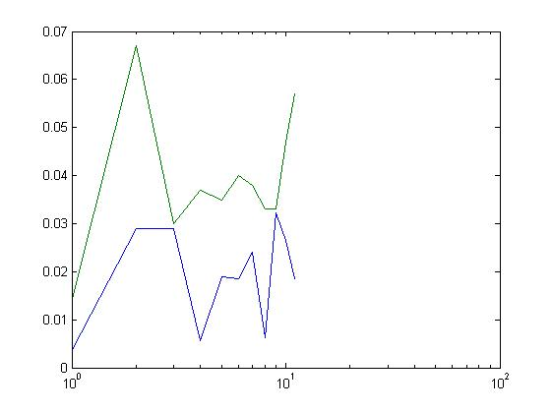***COMPARITIVE RESULTS OF GAYATRI TULSI*** 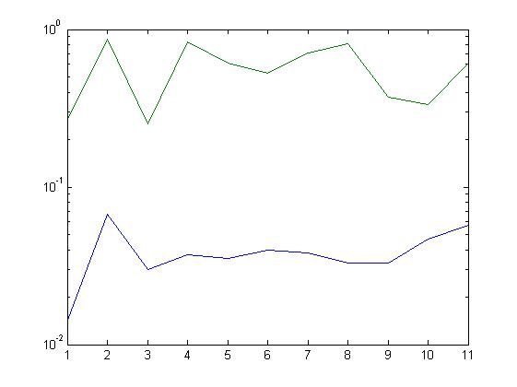

Fig 3.5.1 Fig 3.5.2

Difference invariance Energy

**COMPARITIVE RESULTS OF KRISHNA TULSI:**

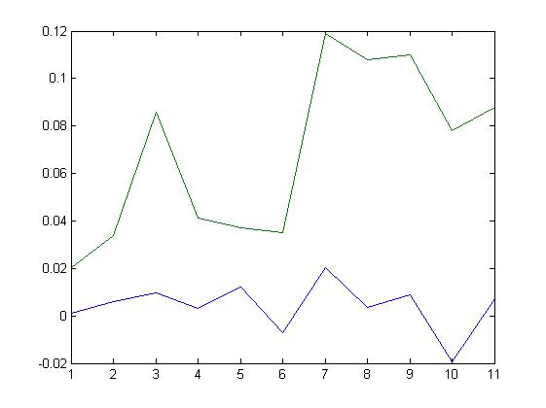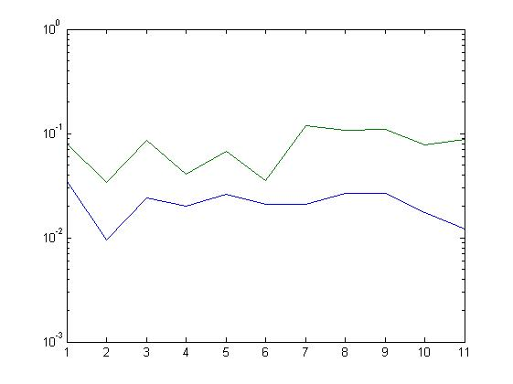

Fig 3.5.3 Fig 3.5.4

Difference invariance Correlation

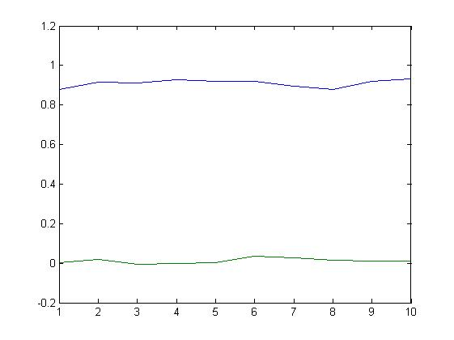**COMPARITIVE RESULTS OF RAMA TULSI**:

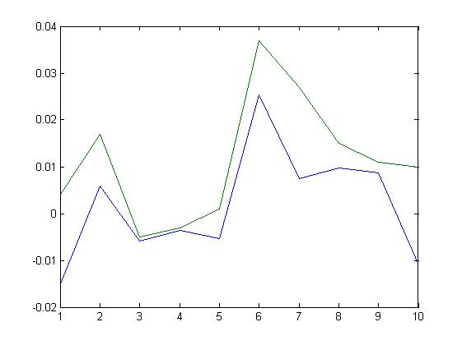

Fig 3.5.5 Fig 3.5.6

Invariance Entropy

4.RESULT:

From the comparision analysis difference invariance and energy are the parameters obtained for gayatri tulsi, difference invariance and correlation are the parameters obtained for krishna tulsi, invariance and entropy are the parameters obtained for rama tulsi. Using these parameters any tulsi leaf that belongs to gayatri tulsi, Krishna tulsi or ram tulsi, presence and type of flavonoid compounds are identified which helps researchers to use the results directly for pharmaceutical purpose or medicinal preparations without finding parameters and flavonoids every time of its use.

5.SUMMARY:

A sample of tulsi leaf whose species is known is taken. Using image processing difference invariance parameter is calculated. The obtained value is compared with the existing value from the database and then the flavonoid present in the given sample is calculated. The proposed system only gives the results for gayatri, Krishna and ram tulsi. The results obtained are accurate as various samples are analysed and database is created.

6.FUTURE WORK:

To make results even more accurate number of samples used are increased. Parameters of all the species of tulsi leaves are found so that any leaf can be found. The obtained results are stored in cloud so that anyone who is given access can use from anywhere. An application can be developed which on scanning the leaf describes the type of species it belongs to, type of flavonoid compound present in the leaf.

Samples attatched and summary written.