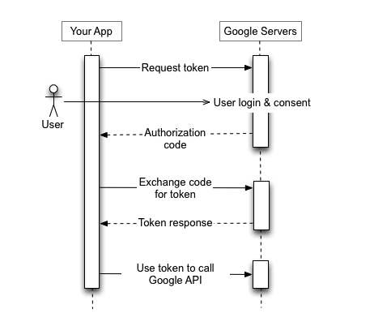

Figure :OAuth Authentication Process

1. React calls the google oauth api sending in the Google_Client_ID, redirectUrl and scope.

1. User inputs the login information and approves the consent screen.
2. The google cloud, then calls the redirect api, specified in the oauth credentials in google cloud console.
3. The redirect url needs to be in the same domain from where the initial oauth request was made (in this app’s case, frontend/react), otherwise error appears that specified that redirect url is incorrectly specified.
4. The redirect api call received in react contains the authorization code provided by google oauth service, react then calls the backend Django providing the authorization code.

1. Django receives the authorization code in a post call, then:
   1. Proceeds to call google oauth api to exchange the authorization code with the access token.
   2. Access Token is received along with refresh token, which can be used to get user’s information like their name, email, and so on.
   3. User is either created or updated in Django User table.
   4. JWT is created based on the user-id of the user and send back to the frontend.