**Git:** Git is a distributed version control system for tracking changes in source code during software development. It is designed for coordinating work among programmers, but it can be used to track changes in any set of files. Its goals include speed, data integrity, and support for distributed, non-linear workflows.   
  
**GitHub:** GitHub is a web-based Git repository hosting service, which offers all of the distributed revision control and source code management (SCM) functionality of Git as well as adding its own features.

Below is a table of differences between Git and GitHub:

| **S.No.** | **Git** | **GitHub** |
| --- | --- | --- |
| 1. | Git is a software. | GitHub is a service. |
| 2. | Git is a command-line tool | GitHub is a graphical user interface |
| 3. | Git is installed locally on the system | GitHub is hosted on the web |
| 4. | Git is maintained by linux. | GitHub is maintained by Microsoft. |
| 5. | Git is focused on version control and code sharing. | GitHub is focused on centralized source code hosting. |
| 6. | Git is a version control system to manage source code history. | GitHub is a hosting service for Git repositories. |
| 7. | Git was first released in 2005. | GitHub was launched in 2008. |
| 8. | Git has no user management feature. | GitHub has a built-in user management feature. |
| 9. | Git is open-source licensed. | GitHub includes a free-tier and pay-for-use tier. |
| 10. | Git has minimal external tool configuration. | GitHub has an active marketplace for tool integration. |

**cd <file path> command**

First, you have to create a file where your code will be stored on your pc. For that, you have to create a file on your desktop. After that open Git Bash and type cd <File directory> to go to file and branch.

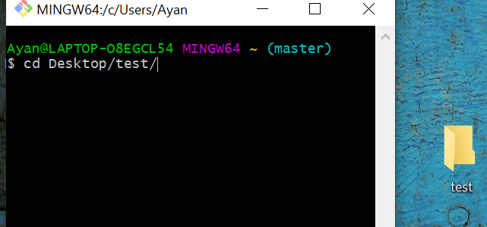

**git clone command**

If you want to open-source contribution. First, you have to copy an existing repository (the repository, where you want to contribute) on your local repository (Your repository). For that, you have to click the fork button on the repo of the existing repository on GitHub.

* **What is forking:**Forking any repository means make a copy of a real repository in your GitHub account and make changes in your copy. Thus, a real repository won’t get affected by your code changes. (After that you have to make a pull request to the real repository for merging your code change, we will come to that part later)
* **How to do fork*:*** Just go to the real repo and tap on the fork button

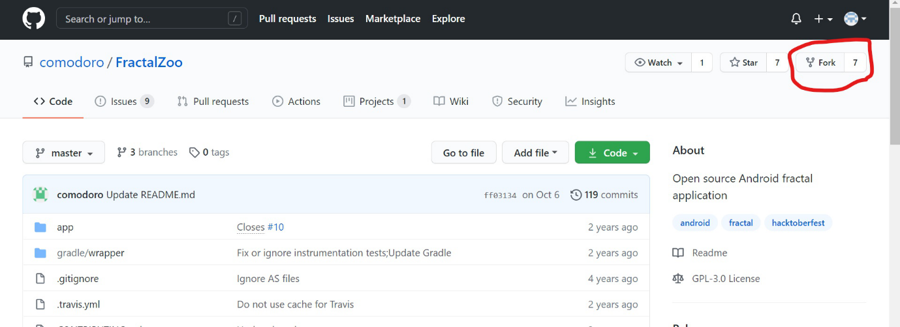

* **Copy URL:** Then a copy of real repository will be created in your local repository. After that, you have to copy the URL from your local repo. For doing that click to code and copy the URL.

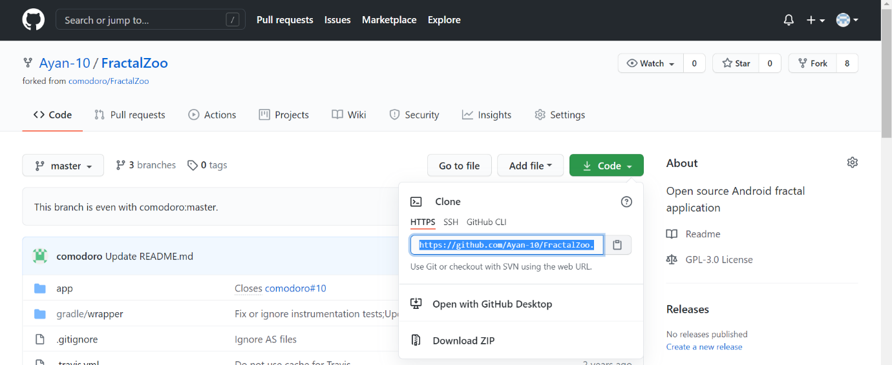

* After that, you have to create a file on your desktop. Then open Git Bash and go to the file using cd command and click enter and type git clone <copied url> to copy the code in your desktop file. With that, you are able to get the code on your desktop.

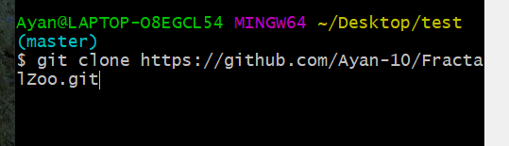

**git status command**

After making code changes you have to add the files for that you have to check which files are not added. For that use git status. The command git status can show you the status of your current file whether it is added or committed or pushed.

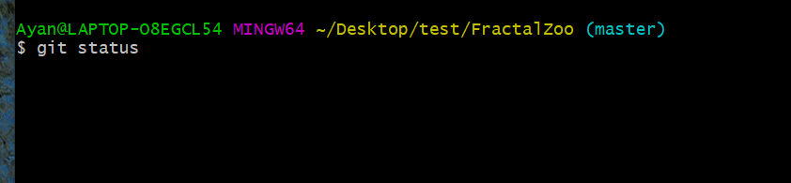

**git add <File name> command**

When you get to know which files are not added by typing git status(red-colored files are not added). Then type git add <file name> to add files.

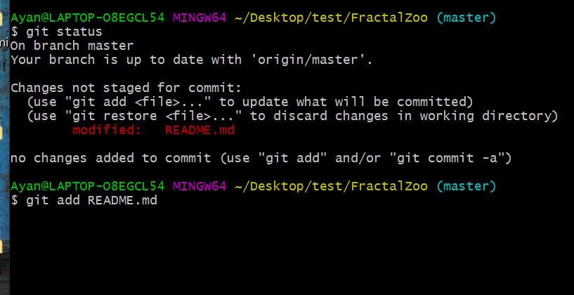

**git commit -m <message> or git commit -am<message> command**

After that, you have to commit those added files (type git status to check status, and green colored files are not yet committed). Type git commit -m <message> (message is nothing but a text that tells about what is changed in files) (there are many types of commit command you can check out git documentation in git official website).

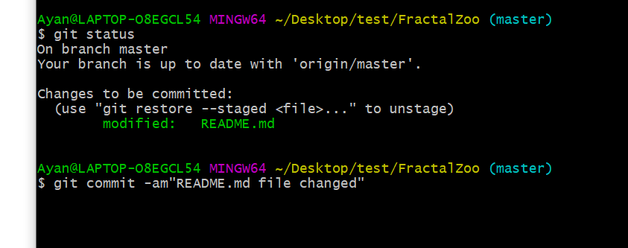

**git push command**

At last, you have to push your code changes in your local repo by typing git push and then make a pull request.

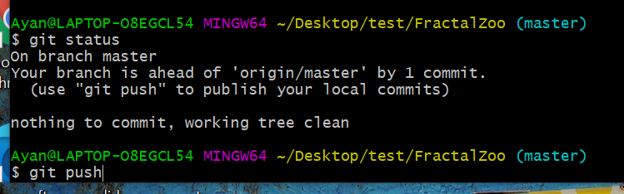

* **How to make a pull request:**After pushing your code to your local repository you have to make a pull request to merge your code to the real repository. To do that just go to your local repo and click on the pull request.

