**SCRUM**

Scrum is a framework used primarily in agile software development for managing and completing complex projects. It emphasizes teamwork, collaboration, and iterative progress toward a well-defined goal. The term "Scrum" originates from rugby, where it refers to a method of restarting play after an infringement.

In software development, Scrum operates on the principles of transparency, inspection, and adaptation.

In scrum project move forward with series of iteration that are called Sprints. Each sprint size is typically two to four weeks long. It is based on inspect and adaptive cycle. Produce product incrementally and iteratively, thus reduce risk and enhance visibility.

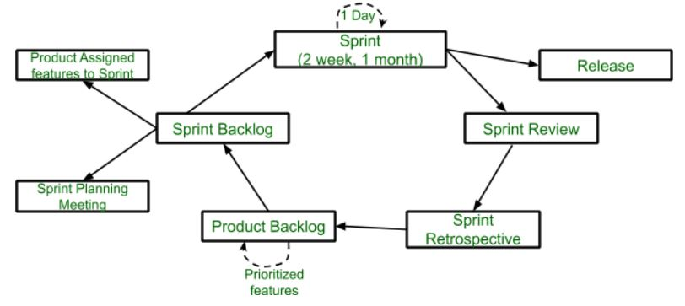

**1 Product Owner**

* Product Owner (PO) is client's representative, define features of product and decide release date and content
* Priorities features according to market value and be responsible for the profitability of product
* Accept or reject work items.

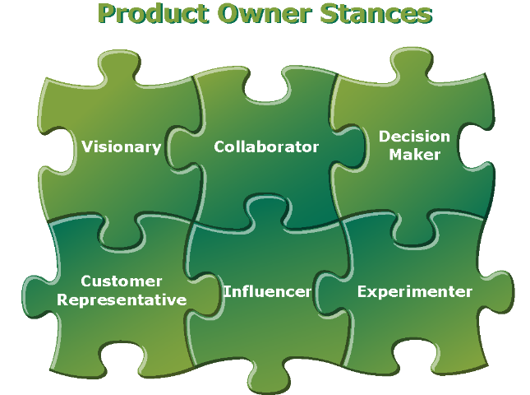

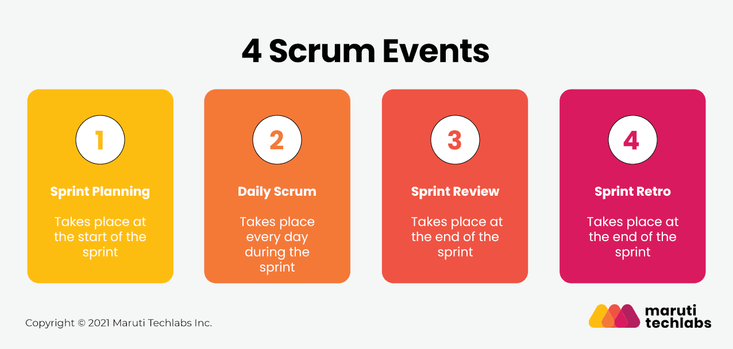

Scrum Activities:  
1. Sprint Planning  
2. Daily Scrum  
3. Sprint Review  
4. Sprint Retrospective  
5. Product Backlog Refinement  
  
**1 Sprint Planning:**  
       Goal: Team to plan and agree on backlog items they can complete and confirm the tasks required to support acceptance.

**2 Daily Scrum:**  
Goal: Plan for the day, Inspect and Adapt daily towards reaching the sprint goal.  
Description:

* Who: Scrum Team, Scrum Master, When: Daily throughout the sprint , Duration: 15 minutes maximum

**3 Sprint Review:**  
Goal: Get feedback on product development. Inspect and adapt on the product feature.  
Description:

**4 Sprint Retrospective:**  
Goal: To inspect and adapt to become more effective and efficient on process, people, culture aspect.  
Description:

* Participation in the discussion to inspect and adapt as scrum team.
* Scrum master play vital role in sprint retrospective, Scrum master bring in the culture of openness, trust and respect as people discuss the improvement areas, facilitate and focus on improvement and changes that pointing fingers at others.
* This is platform to scrum master to help team resolve ineffectiveness in the systems
* Inspect and Adapt: Try everything that makes sense, reject things that didn’t work even after repeated trails. Shape your culture, process and practice.
* Duration: 2 hours for a 2 week sprint, Who: Scrum Team , When: Last day of sprint

**5 Product Backlog Refinement:**  
Goal: Keep product backlog items ready, uncertainty to certainty  
Description:

* Product owner provide clarity on each product backlog item (All uncertainty clarified into certainty )
* Product owner Update product backlog. 100% be present and involve all team members
* Team understand, carefully listen to need of product owner, understand the acceptance criteria. Help product owner to order the backlog.
* Duration: 1-3 hours depending on the team’s need. Who: Scrum Team, Scrum master, PO, When: Continuous process, in between the sprints.

Scrum Artifacts:  
Below are Scrum Artifacts.  
1) Product Backlog,   2) Sprint Backlog, 3) Product Increment  
  
**1 Product Backlog**

This is an ordered list of ideas for the product, which can come from the product owner, team members, or stakeholders. A description and estimate of effort complement each product backlog item.  
  
The product backlog is ordered to maximize the value delivered by the Scrum team. The development team’s work comes from the product backlog, and nowhere else. Every feature, enhancement, bug fix, documentation requirement, every bit of work the team does comes from a product backlog item.  
  
The product backlog may begin as a large or short list. Typically it begins short and becomes longer and more defined as time goes on. Product backlog items slated for implementation soon will be "refined," which means they will further clarified, defined, and split into smaller chunks. Though the product owner is responsible for maintaining the product backlog, the development team helps produce and update it.

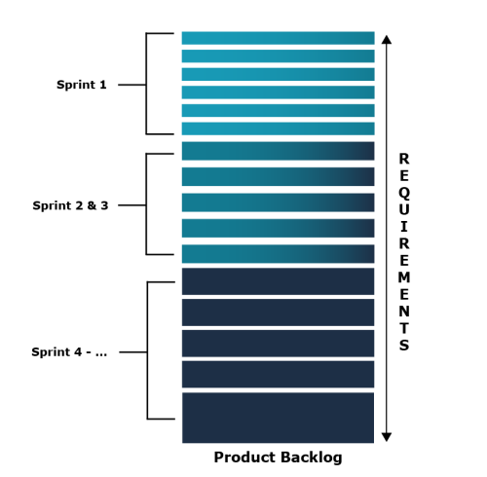

**2 Sprint Backlog**  
The sprint backlog is the list of refined product backlog items chosen for development in the current sprint, together with the team's plan for accomplishing the work. It reflects the team's forecast of what work can be completed. Once the sprint backlog is established, the development team begins work on the new product increment.  
  
**3 Product Increment**  
Every sprint produces a product increment, the most important Scrum artifact. A product Increment is the "goal line" for each sprint and, at the end of the sprint, it must:

* Be of high enough quality to be given to users
* Meet the Scrum team's current definition of done
* Be acceptable to the product owner

Difference between Agile and Waterfall model

There are numerous SDLC (Software Development Life Cycle) models that are followed during the software development phase. Each model follows a series of phases unique to its type to ensure success in the step of software development.

In this article, we are going to discuss two SDLC models that are Agile and Waterfall. Here, we will discuss both models separately, and then we will see the difference between them. Hope this article will be helpful to you in order to take information about the agile model, waterfall model, and their difference. So, without any delay, let's start the topic.

Agile Model

The Agile methodology promotes the continuous interaction of the development and testing during the SDLC process of any project. Unlike the waterfall model, the development and testing activities in the agile model are simultaneous. Agile methodology allows much communication between the customers, developers, testers, and managers.

In the Agile method, the entire project is divided into small incremental builds. All of these builds are provided in iterations, and each iteration lasts from one to three weeks.

ADVERTISEMENT

ADVERTISEMENT

Agile development methodology and testing practices have worked wonders for several organizations with positive aspects. The positive aspects of agile are not hidden. They are very much visible in organizations. There are some of the important points related to the agile model listed as follows -

ADVERTISEMENT

ADVERTISEMENT

* Agile focuses on customer feedback, collaboration, small and rapid releases.
* Its purpose is to manage complex projects.
* The Agile produces better application suites with the desired requirements. Moreover, it can quickly adapt according to the changes made on time during the project life.
* It has a small team size. Therefore, fewer people work on it so that they can move faster.
* The agile model is not a suitable model for small projects. The expenses of developing the small projects using agile are more than compared to other models.
* In agile methodology, the interaction of customers is very high, as after each iteration an incremental model is deployed to customers.

Now, let's move forward to the next model, i.e., the waterfall model.

Waterfall model

It is one of the easiest and traditional model to manage. Because of its traditional development nature, each phase has specific deliverables and a review process. The waterfall model works well in smaller size projects where requirements are easily understandable.

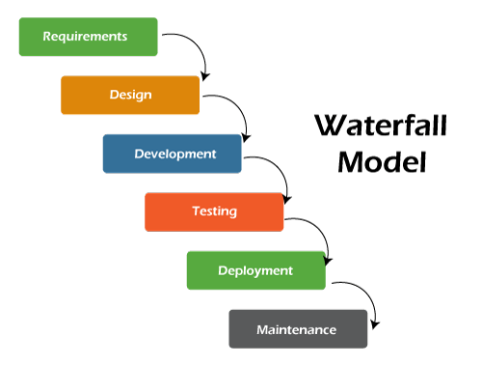

The waterfall model is a universally accepted SDLC model. In this method, the whole process of software development is divided into various phases. The development in the waterfall model is seen as flowing steadily downwards (like a waterfall) as it is a continuous software development model. This model is named "Waterfall Model", because its diagrammatic representation resembles a cascade of waterfalls. Some important points related to the waterfall model are listed as follows -

* Waterfall model is not an ideal model to develop a large scale project size.
* The requirements in the waterfall model should be clear cut at the beginning time; otherwise, it may lead to a less effective method.
* In the waterfall model, it is hard to move back in order to make changes in the previous phase.
* The testing process in the waterfall model starts after the completion of development. So, there is a high chance of bugs to be found later in the project development.

Now, let's look at the difference between both models.

Agile model v/s Waterfall model

