**Protocols**

**Pressure and Altitude sensor - I2C Protocol**

2C - **I²C** (**Inter-Integrated Circuit**), is a [multi-master, multi-slave](https://en.wikipedia.org/wiki/Master/slave_(technology)), [packet switched](https://en.wikipedia.org/wiki/Packet_switching), [single-ended](https://en.wikipedia.org/wiki/Single-ended_signaling), [serial](https://en.wikipedia.org/wiki/Serial_communications) [computer bus](https://en.wikipedia.org/wiki/Computer_bus) . It is typically used for attaching lower-speed peripheral [ICs](https://en.wikipedia.org/wiki/Integrated_circuit) to processors and [microcontrollers](https://en.wikipedia.org/wiki/Microcontroller) in short-distance, intra-board communication.

Almost all IoT devise use this protocol to communicate with each other in a closed network of sensors, hardware and cloud.

**Temperature and Humidity sensor- UART**

A **universal asynchronous receiver-transmitter** (**UART)** is a [computer hardware](https://en.wikipedia.org/wiki/Computer_hardware) device for [asynchronous serial communication](https://en.wikipedia.org/wiki/Asynchronous_serial_communication) in which the data format and transmission speeds are configurable. The electric signaling levels and methods are handled by a driver circuit external to the UART. A UART is usually an individual (or part of an) [integrated circuit](https://en.wikipedia.org/wiki/Integrated_circuit) (IC) used for [serial communications](https://en.wikipedia.org/wiki/Serial_communications) over a computer or peripheral device [serial port](https://en.wikipedia.org/wiki/Serial_port).

Single bus serial communication using UART:

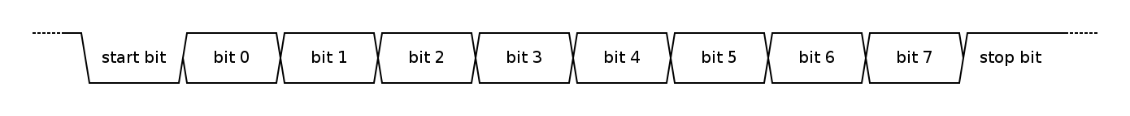

40 bits of data transmitted – from sensor

0-15 – Temperature(MSB – positive or negative) – 16 bits

16-31 – Humidity(MSB – positive or negative) - bits

32-39 – Checksum – 8 bits