**List of Abbreviations**

1. **MCC- Mobile Cloud Computing**
2. **MDC- Mobile Device Cloud**
3. **MAC –Mobile Ad hoc Cloud**
4. **SDN- Software Defined Networking**
5. **NV- Network Virtualization**
6. **Introduction**

With the advancements and increasing number of mobile users, mobile devices’ capabilities have increased over the years. Although they still possess limitations in terms of memory, bandwidth and battery power, Mobile Cloud Computing has helped in the execution of complex computation- intensive applications like face recognition, body language interpretation, speech and object recognition, and natural language processing[1] by enabling the devices to leverage the services and resources furnished by cloud computing. [2]

By utilizing the growth in capabilities of mobile platforms, Mobile Cloud brings together Mobile Cloud Computing (MCC) and wireless networks to interconnect mobile devices and become a cloud-like service provider.

With the number of devices connected to the Internet of Things projected to expand to somewhere between 20 and 46 billion by 2020[5], our future will connect nearly everything, from laptops and smartphones to home appliances, and actual people. The projected growth means that current wireless and mobile networks should evolve to become more ‘‘intelligent,'' efficient, secure and scalable too. SDN and Network Virtualization (NV) are two of the most prominent technologies to serve as key enablers for the IoT networks.

In this thesis, we consider two scenarios- an AODV routing based mobile ad hoc network and SDN-based mobile ad hoc network. We simulated and analyzed both the scenarios based on different evaluation criteria such as downtime, migration time, control overhead and packet delivery ratio.

**1.1 MAC- *a type of MCC***

MCC has three types of computing model to augment the resources of mobile devices: [2]

1. remote cloud;
2. server-based cloudlet
3. mobile ad-hoc cloud

When offloading to the cloud, mobile devices act as a thin client while accessing the cloud through wireless technologies which ensures low computation time, high computation power, and on-demand availability of resources [27, 28]. However, the application suffers from high latency, jitter, and packet losses [27]. Relying on the cloud server for application execution is not always feasible because of weak, intermittent network connectivity or no Internet availability at all. In such situations, Mobile ad hoc Clouds (MAC) are of immense importance. MACs also are energy efficient. Overall, offloading to a MAC registers up to 80% and 90% savings in time or energy respectively when compared to offloading to the cloud. Also, 20% and 35% savings in time or energy respectively can be achieved by offloading to a MAC when compared to a cloudlet. [1]

MAC is a type of Mobile Cloud Computing (MCC) typically deployed over Ad Hoc networks where a group of mobile devices in the neighborhood share resources. [3] MAC also allows the execution of compute-intensive applications by utilizing the resources of other mobile devices which are a part of the mobile cloud [4].

The main advantage of MAC is that it mitigates several bottlenecks of server-based cloudlet such as longer delay and low throughput. It could be useful even when there is no or poor connectivity to the cloud or server-based cloudlet. In MAC, mobile devices are expected to manage the cloud, authenticate the users, monitor the resources, and schedule the tasks besides executing the application.

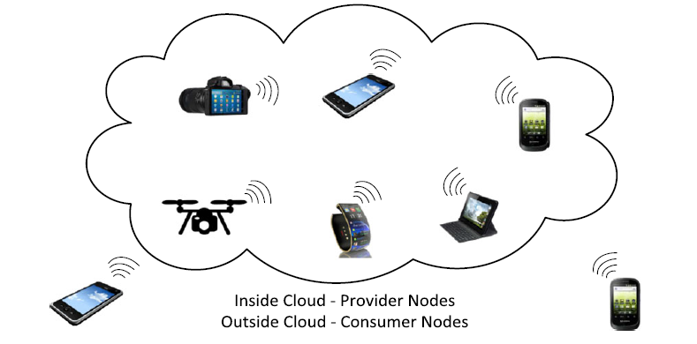

Figure 1: Mobile Adhoc Cloud. Source : [20]

**1.2 Software Defined Networking:**

Traditional IP networks are complex and hard to manage. Network operators need to configure each network device separately using low-level and often vendor-specific commands. Automatic reconfiguration and response mechanisms are nonexistent in traditional IP networks. The control plane which decides how to handle network traffic and the data plane that forwards traffic according to the decisions made by the control plane are bundled inside the networking devices, reducing the flexibility of the networking infrastructure. A clean-slate approach to change the Internet architecture like replacing IP is regarded as a task not feasible in practice [30], [31]. Ultimately, this situation has inflated the capital and operational expenses of running an IP network.

Software Defined Networking is an approach to computer networking in which consists of four innovations: separation of the control and data planes, centralization of the control plane, programmability of the control plane and standardization of APIs. SDN gives hope to change the limitations of current network infrastructures.

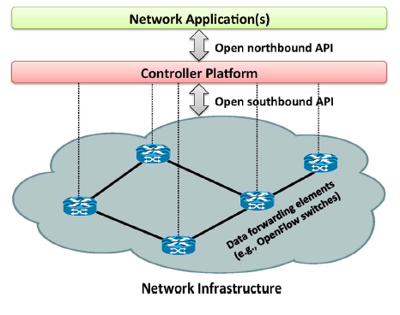

Figure 2: SDN- separation of data and control plane. Source: [33]

First, SDN breaks the vertical integration by separating the control plane and the data plane. The data plane is used for the data forwarding while the other is for the network traffic control. The separation enables faster configuration and provisioning of network connections. Second, with due to the separation of the control and data planes, network switches become simple forwarding devices [32].A network administrator can program the behavior of the network in a centralized way, instead of separately configuring each network device. SDN in wireless networks can bring the programmability and flexibility that is lacking. This also simplifies policy enforcement and network (re)configuration and evolution.

A well-defined programming interface between the switches and the SDN controller exists which ensures separation of the control plane and the data plane [33]. The controller exercises control over the state in the data plane elements through an application programming interface (API). The most notable example of such an API is OpenFlow [34]. An OpenFlow switch can be instructed by the controller to behave like a router, switch, firewall, or perform other roles (e.g., load balancer, traffic shaper) [33]. SDN and OpenFlow have gained significant traction in the industry over the past few years. Most vendors of commercial switches now include support for the OpenFlow API in their equipment. Google, for example, has deployed an SDN to interconnect its data centers across countries which have helped the company to improve operational efficiency and significantly reduce costs [35].

SDNs can be deployed on any traditional network environment, from home and enterprise networks to data centers and Internet exchange points. The variety of environments has led to a wide array of network applications. Most SDN applications can be grouped in one of five categories: traffic engineering, mobility and wireless, measurement and monitoring, security and dependability and data center networking. [33]The potential benefits of SDN in wireless and mobile are similar to that in wired-SDN systems. Traffic differentiation and intelligent routing where routing is not based on only source and destination are possible in SDN. With the introduction of SDN, traffic can be treated differently at the forwarding plane to deliver the required QoS while maintaining fairness.

1. **Related Works**

In the CloneCloud framework proposed by Chun et al.[26], a clone of the mobile device exists in the Cloud, which is used for computation of high-performance applications. CloneCloud does a static analysis by running the application once on the device to identify offloading would be beneficial or not. A study by Koyachey et al.[15] considers available memory, energy consumption and execution time as the key parameters for defining an adaptive offloading algorithm. Results prove that offloading is beneficial only when the computation is large.

The framework suggested by Cuervo et al. [25] offloads the code from mobile device to a nearby MAUI server. In MAUI, the developers have to mark a method of an application to be remote. To decide whether the method can be offloaded, MAUI profiler and solver are used in the device. The experimental results considering various RTT's (Round Trip Time) suggest that, as RTT values increase, the performance decreases.

B. Zhou et al. [8] have considered the context of the mobile devices to offload the applications to the cloud resources. The context means the network conditions, hardware conditions, etc. of the mobile devices. These change continuously as the device moves throughout the day. The context-aware system takes advantage of all the cloudlet, local mobile device network and public cloud. Kristensen et al. [19] proposed Scavenger framework to realize mobile ad hoc Cloud. In this study, clients offload their computation to surrogates. Surrogates are the mobile devices in mobile ad hoc Cloud within the vicinity of the mobile device (client). Clients take a decision to offload and send their request to surrogates for executing the code.

The proposed framework by A. Ravi et al. [18] has three functions: service discovery, offloading decision, and seamless service. The service discovery module helps the client device to find different devices accessible in the mobile ad hoc cloud. The module is connected between the client and device which discovers various services offered by the peer device. The seamless service modules of the client and the peer interact to decide on continuing the service based on the accessibility of connections. Applications and data can be offloaded either to the mobile ad hoc cloud or the default cloud for execution. Offloading decisions are made based on the parameters such as bandwidth, device, and application characteristics. The offloading module interacts with the service discovery and seamless service modules to take the appropriate offloading decision.

The paper by Sandeep Kaur et al.[12] suggests downtime and total migration time as two important metrics for performance evaluation of a VM migration technique in Cloud Computing. These parameters concern with service degradation and service unavailability time. T K. Refaat et al. [9] proposes a VMM framework for the vehicular cloud, named Vehicular Virtual Machine Migration (VVMM). Different migration techniques have been discussed such as VVMM- uniform, mobility aware and least workload.

I. Ku et al.[20] proposes an architecture which uses LTE link for control plane which can provide long range, and for data plane it is using Wi-Fi which has high bandwidth. Implementation of the SDN-based routing in mobile cloud architecture in done in the ns3 simulator and a comparison is done with traditional Mobile Ad Hoc Network (MANET) routing. The feasibility of the architecture is shown by achieving high packet delivery ratio with acceptable overhead.

A number of services can be offered by SDN assisted VANET [21], which include safety, surveillance and traffic management systems. In this scenario, vehicles can both communicate with each other (V2V communication) in an ad hoc manner, and with a fixed infrastructure that consists of either roadside transceivers or cellular base stations which is used to introduce added-value services.

Other works on wireless SDN include OpenFlow in smartphone as an application [22], OpenFlow in wireless sensor networks [23] and OpenFlow in wireless mesh environments [24].

References:

[1]- A. Mtibaa, K A. Harras, A. Fahim,”Towards Computational Offloading in Mobile Device Clouds”

[2]- Ibrar Yaqoob, Ejaz Ahmed, Abdullah Gani, Salimah Mokhtar, Muhammad Imran and S Guizani, “Mobile ad hoc cloud: A survey”

[3]- Zhang D, Xiong H, Hsu C-H, Vasilakos AV,” BASA: building mobile ad-hoc social networks on top of android.” IEEE Network 2014; 28(1): 4–9.

[4]- Zaghdoudi B, Ayed HK-B, Riabi I, “Ad hoc cloud as a service: a protocol for setting up an ad hoc cloud over MANETs.”

[5]- N.Bizanis and F.A.Kuipers, “SDN and Virtualization Solutions for the Internet of Things: A Survey.”

[6]- R. Jain and S. Paul , “Network Virtualization and Software Defined Networking for Cloud Computing: A Survey”.

[7]- N. Mckeown, “Software-defined networking.” INFOCOM keynote talk, Apr, 2009

[8]- B. Zhou, A. V. Dastjerdi, R. N. Calheiros, S. N. Srirama, and R. Buyya,”A context sensitive offloading scheme for mobile cloud computing service.''

[9]- T.K. Refaat, B. Kantarct, H. T. Mouftah. “Dynamic Virtual Machine Migration in a Vehicular Cloud”

[10]-Tiancheng Zhuang, Paul Baskett, Yi Shang.”Managing Ad Hoc Networks of Smartphones”.

[11]-Niloofar Khanghahi, Reza Ravanmehr,"Cloud Computing Performance Evaluation: Issues and Challenges."

[12]-Sandeep Kaur, Prof. Vaibhav Pandey,"A Survey of Virtual Machine Migration Techniques in Cloud Computing."

[13]-Petter Svard and Johan Tordsson, Benoit Hudzia, Erik Elmroth,"High-performance live migration through dynamic page transfer reordering and compression."

[14]-Niroshinie Fernando, Seng W. Loke and Wenny Rahayu,”Dynamic Mobile Cloud Computing: Ad Hoc and Opportunistic Job Sharing."

[15]-Dejan Kovachev, Yiwei Cao and Ralf Klamma,"Mobile Cloud Computing: A Comparison of Application Models."

[16]-Hitesh A. Bheda, Jignesh Lakhani,"Application Processing Approach for Smart Mobile Devices in Mobile Cloud Computing."

[17]-Subharthi Paul, Raj Jain,"OpenADN: Mobile Apps on Global Clouds Using OpenFlow and Software Defined Networking."

[18]-Anuradha Ravi, Sateesh K. Peddoju,"Energy Efficient Seamless Service Provisioning in Mobile Cloud Computing."

[19]-M.D. Kristensen, "Scavenger: Transparent development of efficient cyber foraging applications," in the proc. of the IEEE 8th intl. conf. On Pervasive Computing and Communications (PerCom), pp. 217-226, Apr. 2010.

[20]- I. Ku, "Software-defined Mobile Cloud."

[21]- I. Ku, Y. Lu, M. Gerla, R. L. Gomes, F. Ongaro, and E. Cerqueira,‘‘Towards software-defined VANET: Architecture and services,’.

[22] P. Baskett, Y. Shang, W. Zeng, and B. Guttersohn. "SDNAN: SoftwareDefined Networking in Ad hoc Networks of Smartphones," Consumer Communications and Networking Conference (CCNC), 2013 IEEE

[23] T. Luo, H. Tan, and T. Quek, "Sensor OpenFlow: Enabling software defined wireless sensor networks," Communications Letters, IEEE, Vol. 16, Issue: 11, 2012

[24]- P. Dely, A. Kassler, and N. Bayer. "OpenFlow for wireless mesh networks." In Proceedings of 20th International Conference on Computer Communications and Networks (ICCCN), pages 1{6. IEEE, 2011.

[25]- Eduardo Cuervo, Aruna Balasubramanian, Dae-ki Cho, Alec Wolman, Stefan Saroiu, Ranveer Chandra, Paramvir Bahl: June 2010.” MAUI-Making Smartphones Last Longer with Code Offload”

[26]- Chun BG, Ihm S, Maniatis P, Naik M, Patti. ”A.CloneCloud: elastic execution between mobile device and cloud."

[27]- Ahmed E, Akhunzada A, Whaiduzzaman M, Gani A, Hamid SHA, Buyya R. “Network-centric performance analysis of runtime application migration in mobile cloud computing. Simulation Modelling Practice and Theory 2015;” 50: 42–56.

[28]- Ahmed A, Ahmed E. A survey on mobile edge computing.In the Proceedings of the 10th IEEE International Conference on Intelligent Systems and Control (ISCO 2016)

[29]- Guo X, Liu L, Chang Z, Ristaniemi T, “Data offloading and task allocation for cloudlet-assisted ad hoc mobile clouds." Wireless Networks 1–10

[30]- B. Raghavan et al., ‘‘Software-defined internet architecture: Decoupling architecture from infrastructure."

[31]- A. Ghodsi et al., ‘‘Intelligent design enables architectural evolution,’’

[32]- H. Kim and N. Feamster, ‘‘Improving network management with software defined networking,’’

[33]- D Kreutz et al. “Software-defined networking a comprehensive survey."

[34]- Open Networking Foundation (ONF), [Online]. Available: https://www.opennetworking.org/

[35]- S. Jain et al. ‘‘B4: Experience with a globally-deployed software defined wan,’’ in Proc. ACM SIGCOMM Conference.

[36]-.