3. System Architecture

3.1 Overview
In this section, we describe our experiment platforms. The main purpose is to provide the experimental platform that allows the evaluation of different techniques and applications under the same environmental conditions. We propose to run several simulations with different configurations of mobile ad-hoc nodes under the same environmental conditions. In the following, we describe the environmental conditions to perform the simulations.

3.2 Experimental Setup

3.2.1 Host Setup:

For the AODV technique, each mobile device in the simulator models a wireless host with a wireless (802.11) card. These hosts also contain routing, mobility and battery components.They support the only IPv4 protocol, TCP and UDP as a transport protocol. These mobile nodes can participate in ad-hoc routing and may have TCP/UDP applications installed. The wireless card and wireless card type can be configured by the numRadios parameter.

While in the SDN technique, each SDN mobile device is equipped with two Wi-Fi interface cards – one is for the control plane and the other is for the data plane. An SDN mobile device can play the role of data forwarder (an agent) or routing-path arbitrator (a controller). No OpenFlow messaging is used in this kind of networks. Instead, a suite of control messages are defined to support the required SDN operations.

Fig- 3.1: Wireless ad -hoc device with one wireless interface card
Fig- 3.2: Wireless ad-hoc device with two wireless interface card
3.2.2 Routing:

The Ad hoc On-Demand Distance Vector protocol is both an on-demand and a table-driven
protocol that uses route requests and route replies to build a multi-hop route. The packet size in AODV is uniform. AODV supports multicasting and unicasting within a uniform framework. Each route has a lifetime after which the route expires if it is not used. A route is maintained only when it is used and hence old and expired routes are never used. AODV maintains only one route between a source-destination pair.

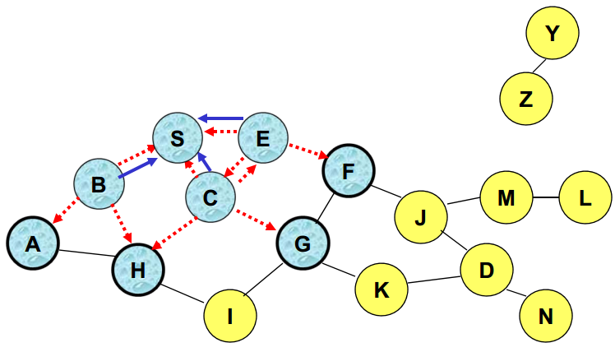
Fig - 3.3 : AODV routing implementation; red broken lines for RREQ and blur
solid lines for RREP

For the SDN technique, In the control plane, the routing decision is made by a traditional routing protocol AODV. In the data plane, the routing decision is made by the Leader Controller based on some criteria.This controller has the global view of the mobile ad-hoc network and periodically monitors the dynamics of network topology. With this capability, an SDN-style (e.g., centralized) routing mechanism can be applied to the controller. In other words, the controller plays the role of routing path arbitrator of an ad-hoc network. Users are able to evaluate the feasibility and performance of SDN-style routing mechanism on this platform.
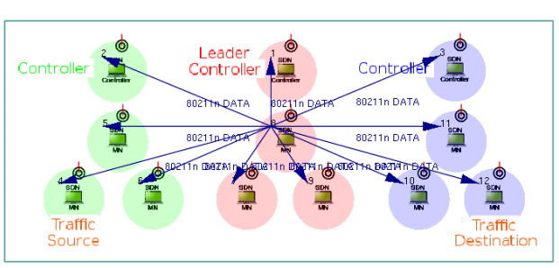
Fig- 3.4: SDN-style routing where controller plays the role of routing path arbitrator

3.2.3 Mobility:

For both the topology of AODV and SDN, Random Way Point Mobility model is used.In the Random Way Point mobility, the node moves in line segments. For each line segment, a random destination position (distributed uniformly over the constraint area) and a random speed are chosen. We can define a speed as a variate from which a new value will be drawn for each line segment; it is customary to specify it as uniform(minSpeed, maxSpeed). When the node reaches the target position, it waits for the time waitTime which can also be defined as a variate. After this time the algorithm calculates a new random position.

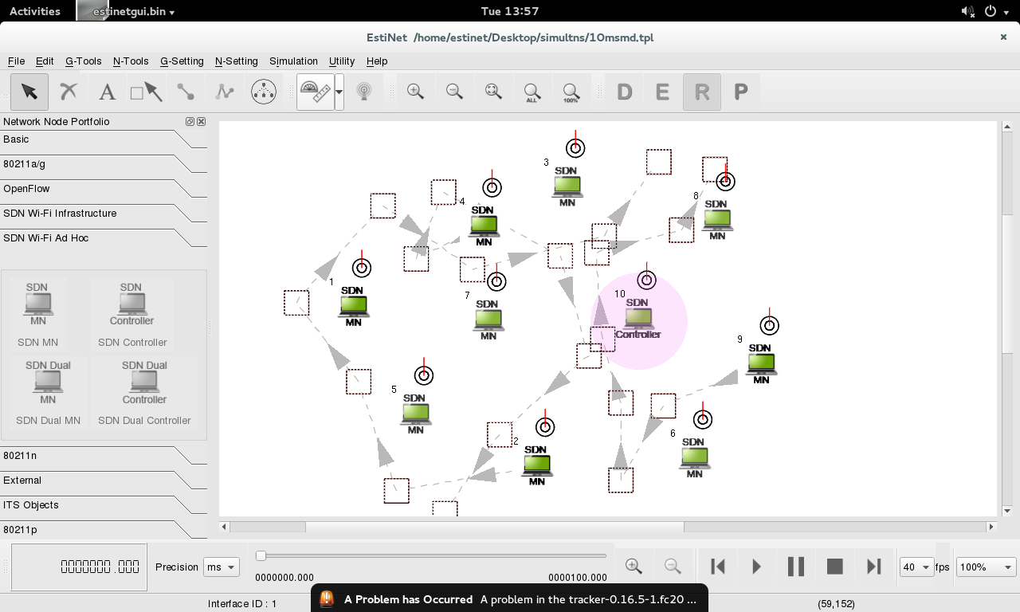
Fig- 3.5 : A SDN ad-hoc network with a mobility pattern of SDN mobile nodes
3.2.4 Other Paramaeters

The techniques used in the project requires other necessary parameters to define the experimental environment properly. The table lists a few of them.
Constraint X coordinates | 0-600m
Constraint Y coordinates | 0-500m
Carrier Frequency | 2GHz
Bandwidth | 2MHz
Transmitter Power | 1.4mW
Preamble Duration | 10us
Header Bit Length | 0 b
Sensitivity | -80 dbm
Energy Detection | 85dBm
SNIR Threshold | 4dB
Maximum Queue Size | 10 packets

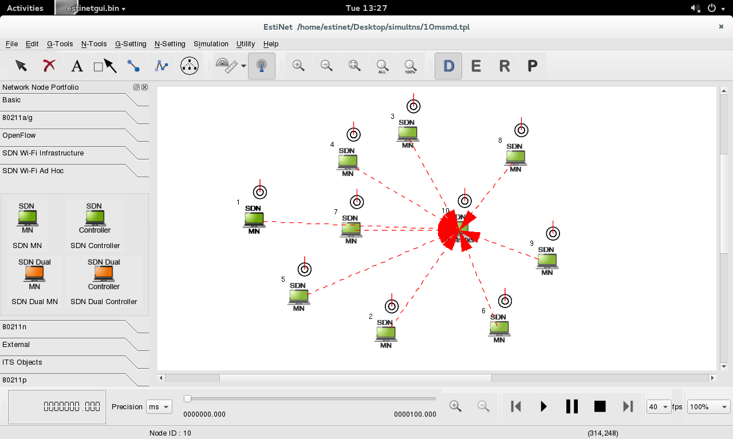
Fig - 3.6 : Receiving range of the SDN controller with sensitivity as defined

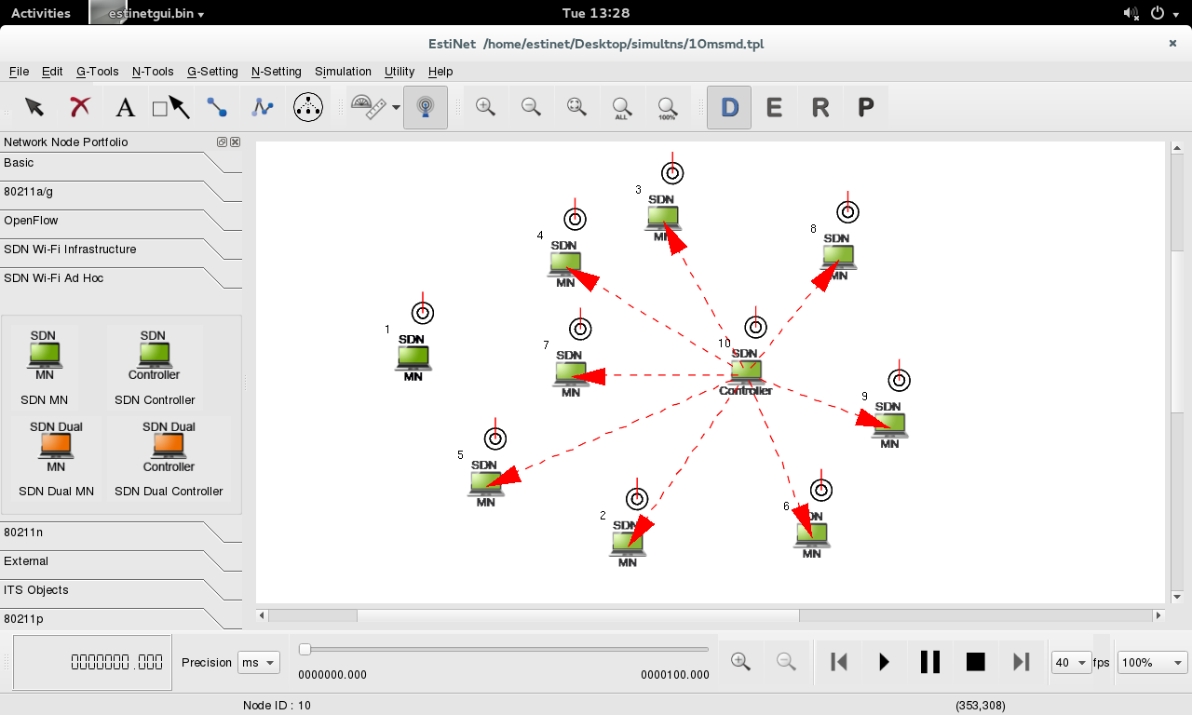
Fig - 3.7 - Transmitting range of SDN controller with power as defined above

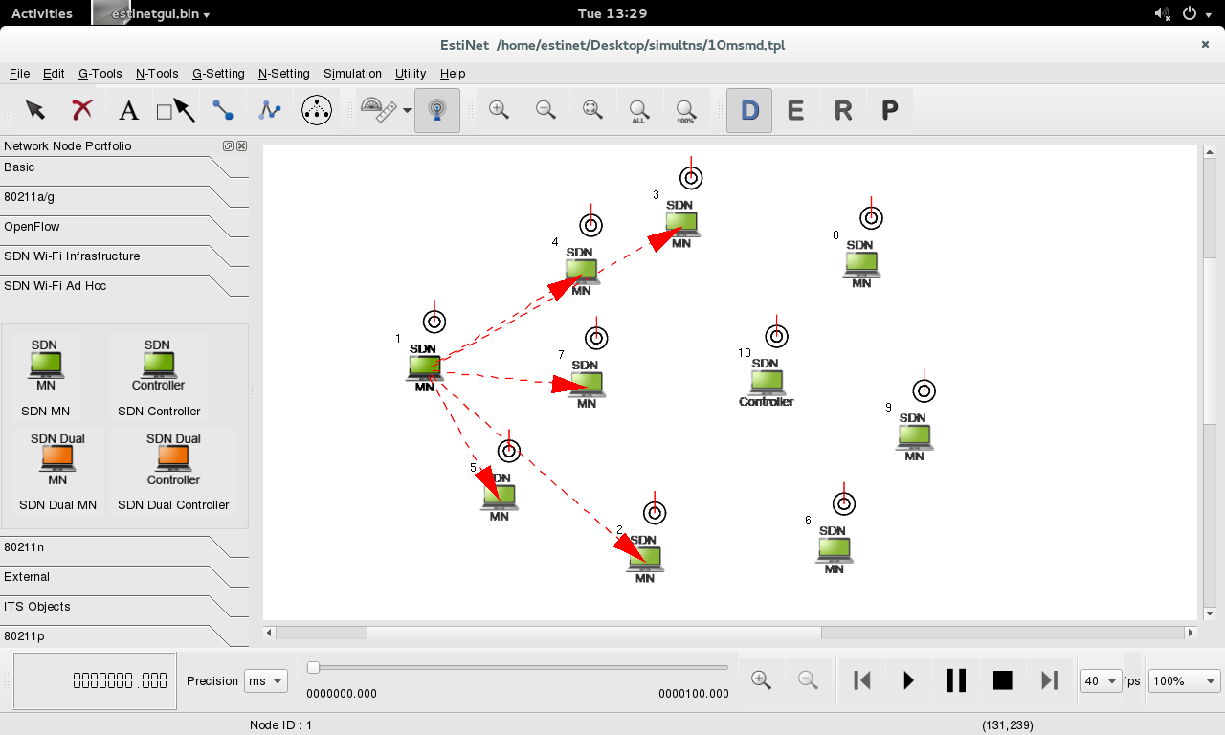
Fig- 3.8 Transmitting range of an SDN mobile node

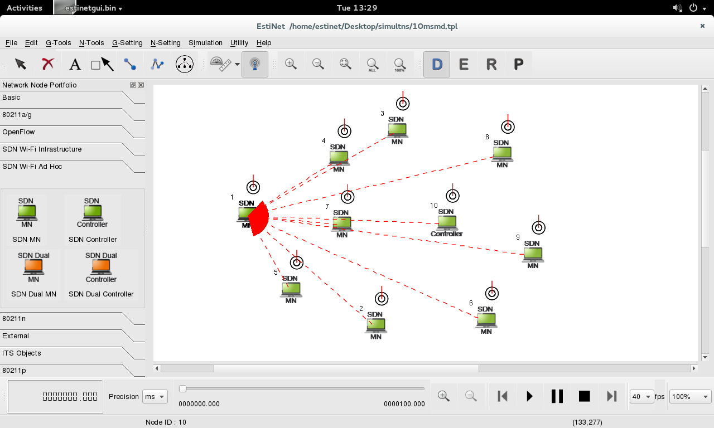
Fig - 3.9 : Receiving range of an SDN mobile node

4.1 Overview

In this chapter, we describe the algorithms used for the performance evaluation of the migration strategies. To perform the operation on an ad-hoc network Ad-Hoc On-Demand Vector Routing (AODV) and Software Defined Networking (SDN) are two techniques that have been used. We first describe the AODV techniques followed by the SDN.

4.2 Ad-hoc On-Demand Vector (AODV)

An ad-hoc network is the cooperative engagement of a collection of mobile nodes without the required intervention of any centralized access point or existing infrastructure. Ad-hoc On-Demand Distance Vector Routing (AODV) is an algorithm for the operation of such ad-hoc networks. Under the system, a node does not have to discover and maintain a route to another node until the two need to communicate unless the former node is offering its services as an intermediate forwarding station to maintain connectivity between two other nodes.

When the local connectivity of the mobile node is of interest, each mobile node can become aware of the other nodes in its neighborhood by the use of several techniques, including local broadcasts known as hello messages. The routing tables of the nodes within the neighborhood are organized to optimize response time to local movements and provide quick response time for requests for establishment of new routes.

The algorithm’s primary objectives are :
- To broadcast discovery packets only when necessary.
- To distinguish between local connectivity management and general topology maintenance
- To disseminate information about changes in local connectivity to those neighboring nodes that are likely to need the information.
4.2.1 Path Discovery

The Path Discovery process is initiated whenever a source node needs to communicate with another node for which it has no routing information in its table. Every node maintains two separate counters a node sequence number and a broadcast id.The source node initiates path discovery by broadcasting a route request RREQ packet to its neighbors. The RREQ contains the following fields :
< Source_address, Source_sequence, Broadcast_id, Destination_address , Destination_ sequence, Hop_count>
The pair <source addr, broadcast id> uniquely identifies an RREQ broadcast id is incremented when ever the source issues a new RREQ. Each neighbor either satisfies the RREQ by sending a route reply RREP back to the source or re-broadcasts the RREQ to its own neighbors after increasing the hop count. Notice that a node may receive multiple copies of the same route broadcast packet from various neighbors. When an intermediate node receives an RREQ and if it has already received an RREQ with the same broadcast id and source address it drops the redundant RREQ and does not rebroadcast it. If a node cannot satisfy the RREQ it keeps track of the following information in order to implement t the reverse path setup as well as the forward path setup that will accompany the transmission of the eventual RREP. An RREP contains the following fields:
< Destination_IP_address, Source_IP_address, Broadcast_id, Expiration_time_for_reverse_path_route_entry, Source_nodes_sequence_ number>

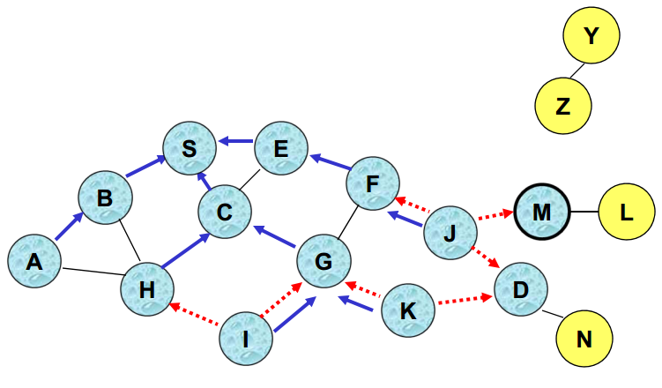
Fig - 4.1 : Reverse Path Setup in AODV

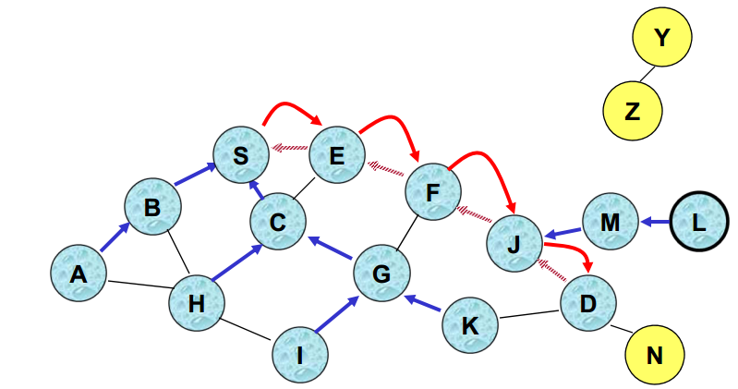
Fig- 4.2 Forward Path setup in AODV

4.2.2 Route Table Management

In addition to the source and destination sequence numbers other useful information is also stored in the route table entries. Associated with reverse path routing entries is a timer called the route request expiration timer. The purpose of this timer is to purge reverse path routing entries from those nodes that do not lie on the path from the source to the destination. The expiration time depends upon the size of the adhoc network. Another important parameter associated with routing entries is the route caching time out or the time after which the route is considered to be invalid.
A mobile node maintains a route table entry for each destination of interest. Each route table entry contains the following information:
- Destination
- Next Hop
- Number of hops (metric)
- Sequence number for the destination
- Active neighbors for this route
- Expiration time for the route table entry
If a new route is offered to a mobile node the mobile node compares the destination sequence number of the new route to the destination sequence number for the current route. The route with the greater sequence number is chosen. If the sequence numbers are the same then the new route is selected only if it has a smaller metric fewer number of hops to the destination.

4.2.3 Path Maintenance

Movement of nodes not lying along an active path does not affect the routing to that path’s destination. If the source node moves during an active session it can re-initiate the route discovery procedure to establish a new route to the destination. When either the destination or some intermediate node moves a special RREP is sent to the affected source nodes. Periodic hello messages can b e used to ensure symmetric links as well as to detect link failures in the network. Alternatively and with far less latency such failures could be detected by using linklayer acknowledgments (LLA CKS). A link failure is also indicated if attempts to forward a packet to the next hop fail.

4.2.4 Local Connectivity Management

Nodes learn of their neighbors in one of two ways. Whenever a node receives a broadcast from a neighbor, it updates its local connectivity information to ensure that it includes this neighbor. In the event that a node has not sent any packets to all of its active downstream neighbors within hello interval, it broadcasts to its neighbors a hello message (a special unsolicited RREP), containing its identity and sequence number. The nodes sequence number is not changed for hello message transmissions. This hello message is prevented from being rebroadcast outside the neighborhood of the node because it contains a time to live TTL value of 1. Neighbors that receive this packet update their local connectivity information to the node. Receiving a broadcast or a hello from a new neighbor, or failing to receive allowed hello loss consecutive hello messages from a node previously in the neighborhood is an indication that the local connectivity has changed. Failing to receive hello messages from inactive neighbors does not trigger any protocol action. If hello messages are not received from the next hop along an active path the active neighbors using that next hop are sent notification of link failure.

4.3 Software Defined Networking

The core concept of SDN is the separation between the control plane and the data plane. The latter is used for the data forwarding while the other is exploited for the network traffic control. This separation enables faster configuration and provisioning of network connections. Instead of individually accessing and configuring each network devices, a network administrator can program the behavior of the network in a centralized way. In addition to simplifying the deployment of new protocols and applications, SDN brings programmability that can enable a more efficient network.

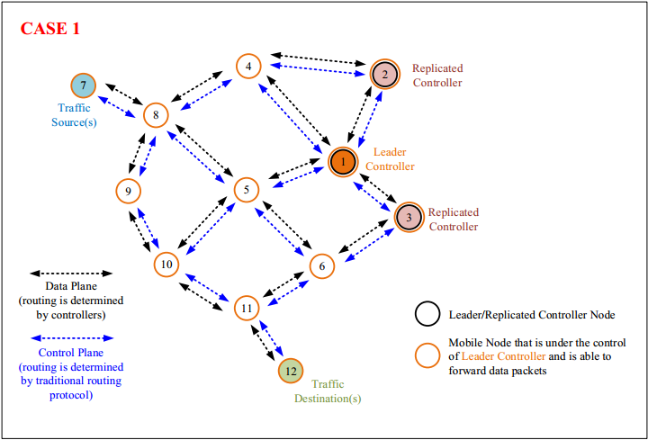
Fig - 4.3 : SDN control plane and SDN data plane are Wi-Fi adhoc mode
In the above figure, we can see that the control plane and data plane are logically separated. That means these two planes use the same wireless channel/medium to transmit messages but the routing decisions are made using different methods in each plane. In the control plane, the routing decision is made by a traditional routing protocol AODV. In the data plane, the routing decision is made by the Leader Controller based on some criteria.
If the network is IP-based, we can separate control plane and data plane using different IP subnet, for example, 1.0.1.x is for data plane while 1.0.2.x is for control plane. The figure below shows the designs of control node’s and mobile node’s protocol stacks used within Simulation Engine. In short, there is a routing mechanism, including routing algorithm and routing table, dedicated for control plane while another routing mechanism, including only routing table, dedicated for data plane. The routing algorithm for data plane is built on the SDN Controller. The SDN Controller sets a data plane routing table through the SDN Agent.

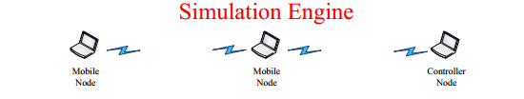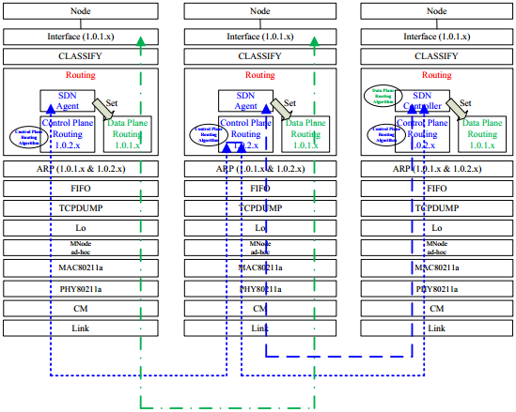
Fig- 4.3: Design of control nodes and mobile nodes protocol stacks
4.3.1 SDN Processing Flow

SDN_Agent and SDN_Controller modules belong to control plane routing modules. We explain the processing flow between these two.
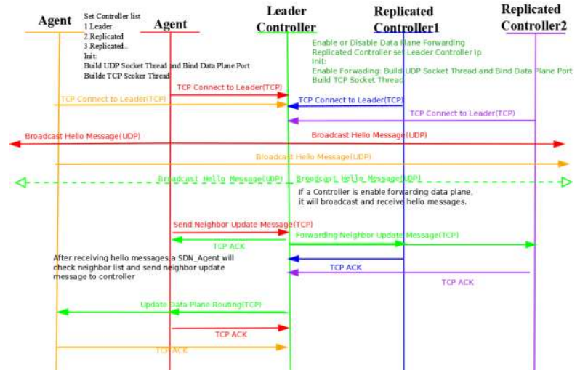
Fig- 4.3.1 : Processing flow between SDN_Agent and SDN_Controller Modules

- SDN Agent’s Processes:
An SDN_Agent module will do actions as below:
- Create a TCP/IP connection to leader SDN_Controller module for sending Neighbor Update messages and receiving Routing Change messages.
- Create an udp port for periodically broadcasting Hello messages and receiving a Hello message from other SDN_Agent or SDN_Controller modules.
- When receiving a Hello message, check its own neighbor list and send a Neighbor Update message to leader SDN_Controller module.
- When receiving a Routing Change message, set the routing table in the DataPlaneRouting module located on the same node.
- When the TCP connect to the leader SDN_Controller is broken, try to connect it again if it is reachable, otherwise, try another replicated SDN_Controller.

B. SDN Controller’s Processes :
An SDN_Controller module will do actions as below:
- Enable or Disable Data Plane Forwarding. If it enables data plane forwarding, it will do the same as SDN_Agent module.
- Decide to be one role replicated or leader controller.
- As a replicated controller, it creates a TCP/IP connection to leader controller for sending
Neighbor Update messages or transferring Neighbor Update messages that come from SDN_Agent modules.
- As a leader controller, when receives a Neighbor Update message, it sends one copy to each replicated controller expect the originating one.
- Check and Update its own network topology information when receiving a Neighbor Update message.
- When the network topology information is changed, it will calculate the routing rule by Dijkstra’s algorithm.
- Send Routing Change messages to those SDN_Agent modules under its control.
- If it enables data plane forwarding, set the routing table in the DataPlaneRouting module which located on the same node.

4.3.2 SDN Modules
- Module SDN_Agent :
- Neighbor List Maintenance
- Neighbor Record Out-of-date Interval:
The user can enter an integer time interval into this setting column. The unit of the time interval is microsecond, and it will keep the record of the neighbor list
until the specific time interval timeout.
- Hello Message Transmission Interval:
The user can enter an integer time interval into this setting column. The unit of the time interval is microsecond, and it will periodically broadcast Hello messages according the specific time.
- Controller IP List
The user can enable or disable the sequence controller IP address.

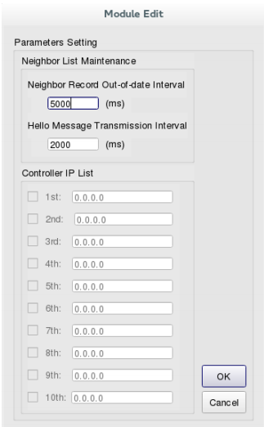
Fig - 4.3.2 : Module Edit for an SDN_Agent

- Module SDN_Controller :
- Enable Data Plane Forwarding
If a user wants the controller forwarding data plane packets, check enable this function, otherwise, uncheck disable this function. If a user checks “Enable Data Plane Forwarding”, then “Neighbor List Maintenance” also enable to set. And the parameters of “Neighbor List Maintenance” are same as SDN_Agent module.
- Role of Controller
The user decides which role (Leader or Replicated controller) that SDN_Controller want to be. As a Replicated controller, then you must set the Leader controller IP
address.
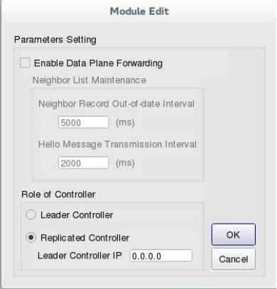
Fig - 4.3.3 : Module Edit for an SDN_Controller or an SDN_Replicated_Controller

