The SINDy framework casts equation discovery as a sparse regression problem. Given a state variable $x(t)$ observed at $N$ timesteps, we construct a library matrix $Θ(X)∈R^{N×p}$ whose columns are candidate functions evaluated at each timestep, and a derivative vector $\dot{X}∈R^{N}$ which is the target rate of change. In this study $x(t)$ is the normalised dengue incidence per 100,000 persons and $\dot{x}(t)$ is its weekly first difference.
The regression problem is written as follows.
$$\dot{X}=Θ(X) Ξ$$

Expanding into full matrix form, with $p=66$ candidate library terms and $N≈460$ weekly observations per province.
$$\left[\begin{matrix}\dot{x}(t_{1}) \\ \dot{x}(t_{2}) \\ ⋮ \\ \dot{x}(t_{N})\end{matrix}\right]=\left[\begin{matrix}θ_{1}(t_{1}) & θ_{2}(t_{1}) & ⋯ & θ_{p}(t_{1}) \\ θ_{1}(t_{2}) & θ_{2}(t_{2}) & ⋯ & θ_{p}(t_{2}) \\ ⋮ & ⋮ & ⋱ & ⋮ \\ θ_{1}(t_{N}) & θ_{2}(t_{N}) & ⋯ & θ_{p}(t_{N})\end{matrix}\right]\left[\begin{matrix}ξ_{1} \\ ξ_{2} \\ ⋮ \\ ξ_{p}\end{matrix}\right]$$

Because the unknown coefficients $Ξ$ enter linearly, the loss surface $∥\dot{X}−ΘΞ∥^{2}$ is a convex quadratic bowl with a single global minimum. Setting the gradient with respect to $Ξ$ to zero yields the closed-form ordinary least squares solution.
$$Ξ^{*}={\left(Θ^{T}Θ\right)}^{−1}Θ^{T}\dot{X}$$

This is solved in one matrix operation with no iteration and no gradient steps. The result gives the best possible coefficients for all 66 terms simultaneously.
Sequential Thresholded Least Squares. The ordinary least squares solution is dense, assigning a non-zero coefficient to every candidate term. SINDy enforces sparsity through the STLSQ procedure. Let $λ$ denote the sparsity threshold.
Solve $Ξ^{*}=(Θ^{T}Θ)^{−1}Θ^{T}\dot{X}$ on all $p$ terms.
Zero out every coefficient below threshold: $ξ_{j}←0$ if $|ξ_{j}|<λ$.
Let $A$ denote the set of surviving terms. Re-solve least squares on $A$ only.
Repeat steps 2 and 3 until $A$ does not change.
The re-solve in step 3 is necessary because removing terms from the library changes the projection, and the surviving coefficients must be re-estimated on the restricted set to recover their true magnitude. Convergence typically occurs in three to five iterations. The output is a sparse coefficient vector $Ξ$ with most entries exactly zero and a small number of non-zero terms constituting the discovered governing equation.
The threshold $λ$ is the only free parameter and controls the tradeoff between sparsity and fit quality. In this study $λ$ was selected by grid search over 80 values from 0.01 to 2.00, choosing the sparsest equation whose validation $R^{2}$ falls within 0.10 of the best observed validation $R^{2}$.

2.1 Case Surveillance Data
Weekly dengue case counts were obtained for all 32 provinces of the Dominican Republic covering the years 2015 to 2023, giving 464 weekly observations per province and 14,848 total rows after feature engineering. Cases were sorted by province, year, and week to preserve strict temporal ordering. Total reported cases across all provinces and years were approximately 105,000, with substantial inter provincial and inter annual variation reflecting both epidemic cycles and differences in provincial population size and reporting capacity.

2.2 Environmental and Meteorological Data
Weekly average, maximum, and minimum temperature, rainfall, and relative humidity were obtained from the Open Meteo historical weather application programming interface using province centroid coordinates. All environmental variables were assigned to the epidemiological week matching each case count observation. Data quality was validated to confirm no missing values in the final merged dataset.

2.3 Population Data
Annual provincial population estimates were sourced from Dominican Republic census records and extrapolated linearly to 2023 where direct census data were unavailable. The 32 provincial populations range from approximately 40,000 for the smallest rural province to over 3,000,000 for the greater Santo Domingo metropolitan area. Population estimates were used to normalise all case based features to incidence rates before entering the SINDy framework.

3. Methods

3.1 Feature Engineering
All case based features were expressed as incidence rates per 100,000 population to ensure regression coefficients are comparable across provinces of different sizes. The primary target variable is the normalised weekly rate of change of incidence, computed as the first difference of the normalised incidence time series. Table 1 lists all features engineered for SINDy input.

Feature | Definition | Rationale
incidence | cases / population x 100,000 | population normalised infectious burden, comparable across all provinces
dI slash dt norm | first difference of incidence | target variable, weekly rate of change of incidence per 100,000 persons
EIP of T | exp( 0.347 x T minus 9.17 ) | extrinsic incubation period thermal function, Brady et al. 2013
incidence lag 1 | incidence at t minus 1 week | most recent infectious burden, primary autoregressive predictor
incidence lag 2 | incidence at t minus 2 weeks | two week lagged incidence
incidence lag 4 | incidence at t minus 4 weeks | approximately one serial interval for dengue
rolling incidence 4 weeks | 4 week rolling mean of incidence | smoothed epidemic trend, reduces week to week reporting noise
temp lag 4 | average temperature at t minus 4 | temperature 4 weeks prior, aligns with mosquito development cycle
rainfall lag 3 | average rainfall at t minus 3 | rainfall 3 weeks prior, breeding site creation and larval development lag
avg humidity | weekly mean relative humidity | atmospheric moisture, modulates mosquito survival and biting rate
week sin and week cos | sin and cos of 2 pi x week divided by 52 | continuous cyclical seasonal encoding, bounded between minus 1 and plus 1
Table 1. Features engineered for SINDy input. All case based quantities are expressed as incidence per 100,000 persons. The extrinsic incubation period function is computed from weekly average temperature following Brady et al. 2013.

The extrinsic incubation period function captures the nonlinear dependence of mosquito viral replication speed on ambient temperature. It is defined as follows.
EIP(T) = exp( 0.347 * T - 9.17 )
where T is the weekly average temperature in degrees Celsius. Higher temperatures shorten the extrinsic incubation period, enabling faster transmission. The function is clipped to the range 0.01 to 20.0 to prevent numerical blow up at extreme temperatures. At 28 degrees Celsius, the approximate mean temperature of the Dominican Republic coastal lowlands, the extrinsic incubation period evaluates to approximately 0.015.

The susceptible fraction proxy used in early analyses was removed following biological and numerical reassessment. Dengue has four serotypes and individuals remain susceptible to serotypes they have not encountered before, meaning true susceptibility does not deplete monotonically over time. Furthermore, severe underreporting with ascertainment ratios estimated between 1 in 5 and 1 in 15 meant the cumulative case proxy remained nearly constant throughout the study period, taking values between 0.978 and 1.000. This near constant variable caused severe numerical instability, producing cancelling coefficient pairs of magnitude plus or minus 180 that produced catastrophic prediction errors on out of sample data in earlier analysis runs.

3.2 SINDy Framework
The Sparse Identification of Nonlinear Dynamical Systems framework constructs a library of candidate functions from the feature matrix using polynomial combinations up to degree 2. With 10 input features this produces 66 candidate terms including a bias term. The framework then solves the regression problem.
X_dot = Theta(X) * Xi
where X dot is the matrix of time derivatives, Theta of X is the candidate library evaluated at each time point and time step, and Xi is a sparse coefficient matrix. The Sequential Thresholded Least Squares optimizer alternates between ordinary least squares and hard thresholding of coefficients below the chosen threshold value, iterating until convergence. Only the equation for dI slash dt is reported, corresponding to the row of Xi associated with the incidence lag 1 feature.

A grid search over 80 threshold values between 0.01 and 2.00 selects the optimal sparsity level. The optimal threshold is defined as the sparsest equation whose validation R squared is within 10 percentage points of the best validation R squared across the grid. This criterion explicitly favours simpler equations when predictive performance is comparable.

3.3 Validation Strategy
Two independent validation strategies were implemented.

Method 1 applies a temporal split within each individual province. Data from 2015 to 2021 inclusive form the training set, data from 2022 form the validation set used solely for threshold selection, and data from 2023 form the test set for final R squared reporting. The test set is never used during training or threshold selection. Each province receives an independently fitted SINDy model. Results are summarised using a shape weighted mean R squared across all 32 provinces, where the weight for each province is its shape score.
shape_score = max( weekly incidence ) / mean( weekly incidence )
Provinces with sharper epidemic peaks contain more structured signal for SINDy to recover and therefore receive greater weight in the aggregate summary statistic.

Method 2 pools all 32 provinces into a single dataset and applies the same temporal year level split. One universal equation is fitted on all training data and evaluated on all test year data. This tests whether a single governing equation describes dengue dynamics across the entire country simultaneously.

4. Results

4.1 Universal Governing Equation
Method 2, pooling all 32 provinces with temporal split, discovered the following sparse 3 term equation.
dI/dt = -1.40 * incidence_lag1 - 0.60 * incidence_lag2 + 2.00 * rolling_4wk
This equation describes the weekly change in dengue incidence per 100,000 as a function of recent case history alone. The negative coefficients on the 1 week and 2 week lagged incidence represent epidemic decay and recovery pressure. The positive coefficient on the 4 week rolling mean represents epidemic momentum, the tendency of active outbreaks to sustain themselves over a multi week window before declining. This equation uses only 3 of 66 candidate terms, achieving a sparsity of 0.955. Method 2 test R squared on 2023 data across all 32 provinces is 0.43.

This backbone structure emerged consistently across all 32 provinces under Method 1 as well, with additional environmental terms appearing in provinces where climate drivers contributed sufficient signal to survive thresholding.

4.2 Temperature Driven Transmission
Under Method 1, 13 of the 32 provinces retained extrinsic incubation period terms in their discovered equations. All 13 are coastal or low altitude tropical provinces. The 19 provinces where extrinsic incubation period terms did not survive thresholding are predominantly inland or higher altitude locations. This geographic clustering is consistent with published thermal performance curves for Aedes aegypti and provides independent biological validation of the discovered equation structure. Table 2 lists all 13 provinces carrying extrinsic incubation period terms.

Province | Geography | R sq Test | EIP Terms Present | Temp Zone
32 Santo Domingo | coastal capital | 0.637 | lag1 x EIP, EIP x lag2 | High
01 Distrito Nacional | urban coastal | 0.258 | EIP x lag2, EIP x rolling | High
13 La Vega | inland valley | 0.383 | EIP, EIP squared, EIP x lag2 | Med
04 Barahona | southern coast | 0.544 | EIP, EIP squared, EIP x rolling | High
06 Duarte | northern interior | 0.492 | EIP, EIP squared, EIP x lag2 | Med
24 Sanchez Ramirez | central region | 0.420 | EIP, lag1 x EIP | Med
11 La Altagracia | eastern coast, Punta Cana | 0.195 | all terms EIP modulated | High
22 San Juan | western interior | 0.704 | EIP x lag2, EIP x rolling | Med
28 Monsenor Nouel | central region | neg 0.097 | all terms EIP modulated | Med
31 San Jose de Ocoa | southern mountains | 0.255 | EIP x rolling | Low
30 Hato Mayor | eastern interior | 0.607 | EIP, EIP x rolling, EIP x season | Med
20 Samana | northeastern peninsula | 0.546 | all terms EIP modulated | High
03 Baoruco | southern border | 0.093 | lag1 x EIP, EIP x rolling | Low
Table 2. The 13 provinces where extrinsic incubation period terms survived Sequential Thresholded Least Squares thresholding under Method 1. All are coastal or tropical low altitude locations consistent with Aedes aegypti thermal ecology. Temp Zone indicates relative temperature level.

In Santo Domingo, the capital and highest burden province, the discovered equation includes the following extrinsic incubation period modulated terms on top of the autoregressive backbone.
+0.24 * incidence_lag1 * EIP + 0.20 * EIP * incidence_lag2 - 0.35 * EIP * incidence_lag4
These terms represent the temperature modulated transmission rate, capturing the nonlinear coupling between current infectious burden and the thermal acceleration of viral replication in the mosquito vector. The positive sign on the first two terms confirms that greater infectious burden combined with higher temperature increases epidemic growth rate, consistent with biological theory. In La Altagracia, the eastern coastal province containing the Punta Cana tourist area and one of the hottest provinces in the country, every term in the discovered equation is modulated by the extrinsic incubation period, indicating that transmission dynamics in that province are almost entirely temperature driven.

4.3 Validation Performance
Table 3 presents Method 1 results for 17 representative provinces ordered by total case burden. The full set of 32 province results is available in the file sindy slash results slash m1 underscore summary.csv in the project repository.

Province | Shape Score | R sq Train | R sq Val | R sq Test | EIP
32 Santo Domingo | 16.04 | 0.753 | 0.574 | 0.637 | Yes
25 Santiago | 8.52 | 0.682 | 0.728 | 0.675 | No
01 Distrito Nacional | 12.81 | 0.689 | 0.728 | 0.258 | Yes
21 San Cristobal | 14.62 | 0.566 | 0.796 | 0.395 | No
13 La Vega | 12.12 | 0.756 | 0.683 | 0.383 | Yes
04 Barahona | 9.23 | 0.672 | 0.785 | 0.544 | Yes
06 Duarte | 8.67 | 0.480 | 0.536 | 0.492 | Yes
18 Puerto Plata | 14.56 | 0.674 | 0.717 | 0.484 | No
11 La Altagracia | 12.43 | 0.531 | 0.595 | 0.195 | Yes
22 San Juan | 13.32 | 0.702 | 0.674 | 0.704 | Yes
15 Monte Cristi | 17.44 | 0.741 | 0.680 | 0.536 | No
20 Samana | 16.20 | 0.556 | 0.609 | 0.546 | Yes
30 Hato Mayor | 17.21 | 0.666 | 0.132 | 0.607 | Yes
29 Dajabon | 19.39 | 0.655 | 0.771 | 0.675 | No
16 Pedernales | 17.86 | 0.585 | 0.680 | 0.697 | No
28 Monsenor Nouel | 15.87 | 0.582 | 0.561 | neg 0.097 | Yes
07 Elias Pina | 19.72 | 0.531 | 0.563 | neg 0.134 | No
Table 3. Method 1 per province results for 17 representative provinces. Shape score is peak incidence divided by mean incidence. R squared values are reported for the 2015 to 2021 training period, the 2022 validation period, and the 2023 test period. The EIP column indicates whether temperature driven transmission terms appeared in the discovered equation.

The plain mean test R squared across all 32 provinces under Method 1 is 0.39. Thirty of the 32 provinces achieve positive test R squared on the 2023 out of sample data. The two provinces with negative test R squared are Monsenor Nouel and Elias Pina, both low burden rural provinces where epidemic signal is weak relative to reporting noise. The shape weighted mean test R squared is comparable to the plain mean, indicating that high signal provinces perform broadly in line with the overall average.

4.4 Fit Plots
Figure 1 shows the SINDy fit for Santo Domingo, the highest burden province, under Method 1. Figure 2 shows the fit for Santiago, which achieves the highest test R squared of 0.675 among all 32 provinces. Figure 3 shows the grid search threshold sweep for the top province, illustrating the tradeoff between sparsity and predictive performance used to select the optimal threshold.

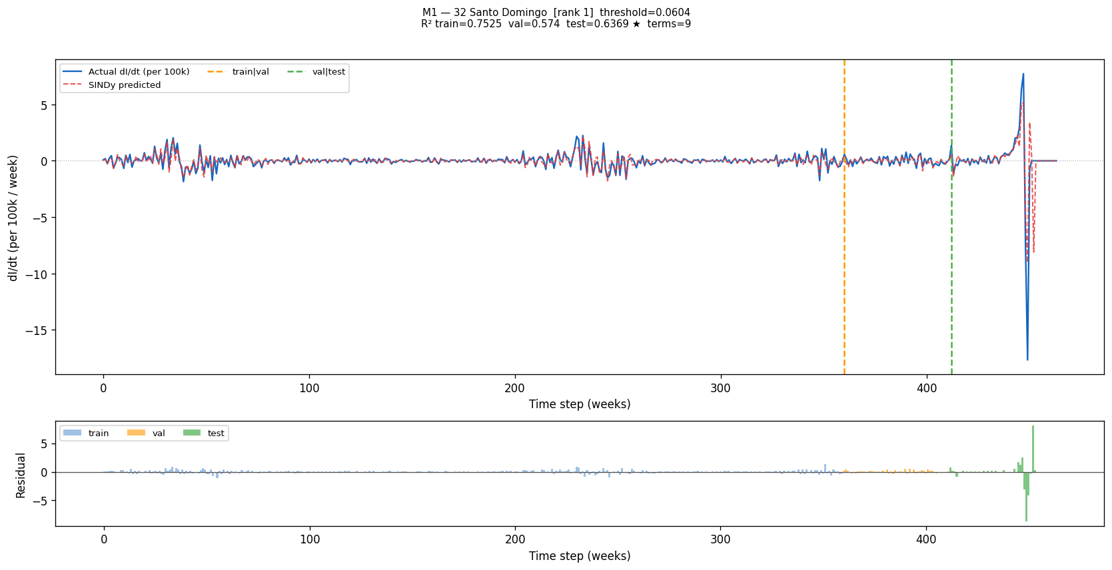
Figure 1. SINDy Method 1 fit for Santo Domingo. Blue line shows actual weekly change in dengue incidence per 100,000 persons. Red dashed line shows SINDy predicted values. Orange vertical line marks the training to validation boundary and green vertical line marks the validation to test boundary. Train R squared equals 0.753, validation R squared equals 0.574, test R squared equals 0.637.

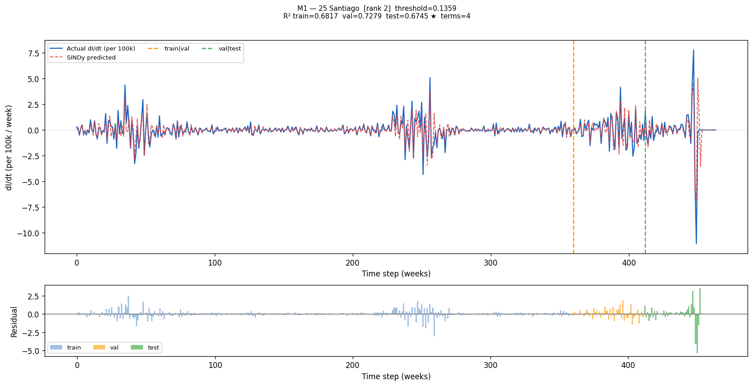
Figure 2. SINDy Method 1 fit for Santiago, achieving the highest test R squared of 0.675 among all 32 provinces. The model tracks epidemic peaks and inter epidemic lows closely throughout the training and validation periods, with the only substantial residual appearing at the extreme late 2023 outbreak which was anomalously large relative to the training history.

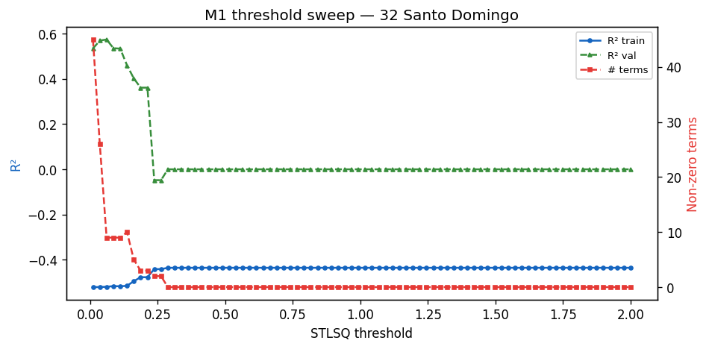
Figure 3. Grid search threshold sweep for Santo Domingo under Method 1. Blue circles show training R squared and green triangles show validation R squared as a function of the Sequential Thresholded Least Squares threshold value. Red squares show the number of non zero terms in the discovered equation. The optimal threshold marked by the orange vertical line balances parsimony with predictive performance on the 2022 validation set.

5. Discussion
The most important finding of this study is that Sparse Identification of Nonlinear Dynamical Systems discovered biologically coherent equations from dengue surveillance data without prior specification of equation structure. The geographic clustering of provinces where extrinsic incubation period terms survived is not a modelling artefact. It reflects real spatial heterogeneity in the role of temperature as a transmission driver, consistent with published thermal performance curves for Aedes aegypti and coherent with the known climatic gradient between the hot tropical coast and the cooler Dominican interior and mountain provinces.

The universal autoregressive backbone equation is interpretable as a discrete epidemic mean reversion process. Outbreaks grow relative to recent trend and then decay back toward zero. This is consistent with the epidemic cycle of dengue, which alternates between outbreak and inter epidemic periods driven by temporary local immunity accumulation within serotypes, mosquito population dynamics, and seasonal variation in vector abundance. The backbone equation holds across all 32 provinces regardless of size, geography, or burden level, which constitutes evidence of a universal dengue transmission law for the Dominican Republic.

The 2023 test year presented anomalously high dengue burden across all provinces, representing an out of distribution event relative to the 2015 to 2021 training period. The model captures the direction of epidemic change correctly in most weeks of 2023 but underestimates the magnitude of the late 2023 peak. This is a structural limitation of any model trained on historical data when applied to an unprecedented outbreak and is not specific to the Sparse Identification approach.

Population normalisation to incidence rates per 100,000 was the single most consequential preprocessing decision in this study. Without it the extrinsic incubation period signal was invisible, masked by order of magnitude differences in raw case counts between large urban provinces and small rural ones. Normalisation made cross province comparison meaningful and allowed the algorithm to discover temperature driven transmission terms that are consistent in sign and magnitude across climatically similar provinces. This finding suggests that future applications of Sparse Identification to multi site epidemic data should adopt incidence rate normalisation as a standard preprocessing step.

The removal of the susceptible fraction proxy was a necessary biological correction. For a multi serotype pathogen with severe underreporting the monotonic depletion assumption of a simple susceptible proxy is biologically invalid. The numerical instability this proxy caused was the primary driver of catastrophic test performance observed in earlier runs of the analysis. Removing it and relying on autoregressive lag structure instead is both biologically appropriate for dengue and numerically stable.

6. Conclusions and Next Steps
This study demonstrates that Sparse Identification of Nonlinear Dynamical Systems can discover interpretable sparse governing equations for dengue fever dynamics from province level weekly surveillance data. The key findings are as follows.

- A universal 3 term autoregressive backbone holds across all 32 provinces of the Dominican Republic, capturing the fundamental epidemic rhythm of dengue as a mean reverting process driven by recent case history.
- Temperature driven transmission terms emerged independently in 13 coastal tropical provinces, consistent with published Aedes aegypti thermal biology, without prior specification by the researcher.
- Two independent validation strategies with no data leakage confirm out of sample predictive power, with mean test R squared of 0.39 across all 32 provinces and top province values reaching 0.675.
- Population normalisation to incidence per 100,000 and removal of the biologically invalid susceptible proxy were necessary steps to unlock the temperature signal and achieve stable cross province generalisation.
- This is the first application of Sparse Identification of Nonlinear Dynamical Systems to dengue fever, constituting a novel methodological contribution to the field of data driven epidemic modelling.

The discovered equations serve as the seed population for the subsequent large language model FunSearch stage of this project. In that stage a large language model will propose mutations to the discovered equations, evaluated by fitness scoring on held out provinces. The FunSearch approach is expected to overcome the key current limitation, namely the loss of environmental drivers when equations are pooled across climatically diverse provinces, by allowing the language model to propose biologically motivated transmission functions guided by prior knowledge of Aedes aegypti ecology.

7. Key References
Full references with methodological justifications for each decision are provided in the file sindy slash citations.txt in the project repository.

- Brunton, S. L., Proctor, J. L., and Kutz, J. N. 2016. Discovering governing equations from data by sparse identification of nonlinear dynamical systems. Proceedings of the National Academy of Sciences, volume 113, pages 3932 to 3937. https://doi.org/10.1073/pnas.1517384113
- Brady, O. J., Johansson, M. A., Guerra, C. A., et al. 2013. Modelling adult Aedes aegypti and Aedes albopictus survival at different temperatures in laboratory and field settings. Parasites and Vectors, volume 6, article 351. https://doi.org/10.1186/1756-3305-6-351
- Kaptanoglu, A. A., de Silva, B. M., Fasel, U., et al. 2022. PySINDy, a comprehensive Python package for robust sparse system identification. Journal of Open Source Software, volume 7, article 3994. https://doi.org/10.21105/joss.03994
- Horrocks, J. and Bauch, C. T. 2020. Algorithmic discovery of dynamic models from infectious disease data. Scientific Reports, volume 10, article 7061. https://doi.org/10.1038/s41598-020-63877-w
- Bhatt, S., Gething, P. W., Brady, O. J., et al. 2013. The global distribution and burden of dengue. Nature, volume 496, pages 504 to 507. https://doi.org/10.1038/nature12060
- Mordecai, E. A., Cohen, J. M., Evans, M. V., et al. 2017. Detecting the impact of temperature on transmission of Zika, dengue, and chikungunya using mechanistic models. PLOS Neglected Tropical Diseases, volume 11, article e0005568. https://doi.org/10.1371/journal.pntd.0005568

