**Practical week 3**

Task1

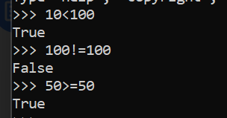

Task 2

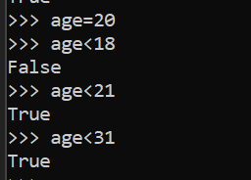

Task3

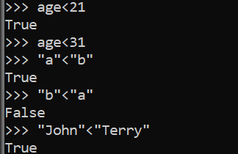

Task 4

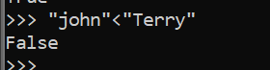

Task 5

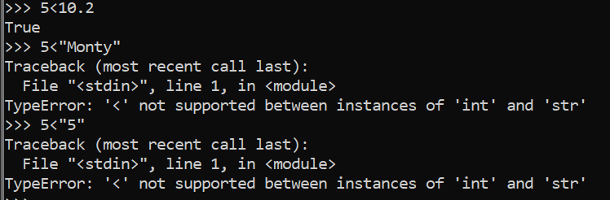

**Task 6**

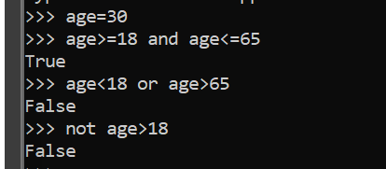

In case of AND both scenarios must be true to be true as in above case both cases are true the output was TRUE.

In case of OR if one of the scenarios is true then the output is evaluated as true. In the given case both cases are false so it was evaluated as False.

Lastly in case of not operator, it opposes the result. in the above case the output was true but using not operator made the output FALSE.

**Task 7**

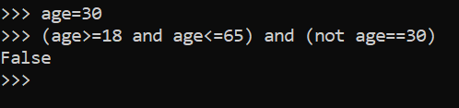

Python evaluates the code in bracket first.

**Task 8**

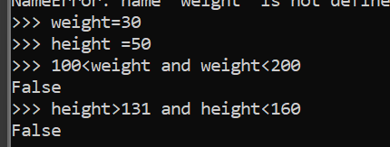

**MEMBERSHIP TESTING**

**Task 9**

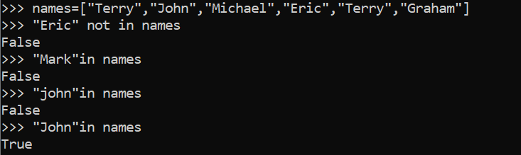

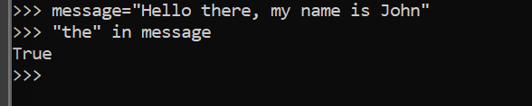

**IF STATEMENT**

**TASK 10**

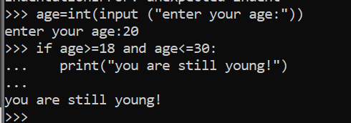

**Task 11**

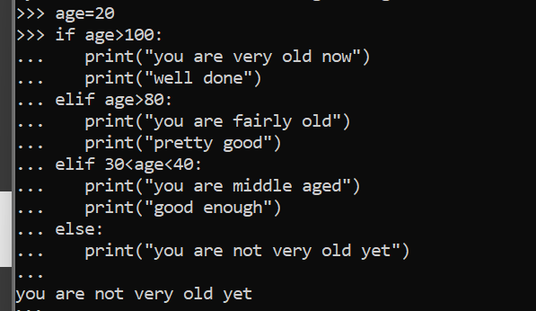

**Task 13**

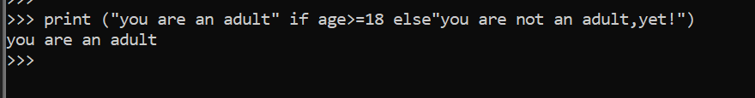

**Task15**

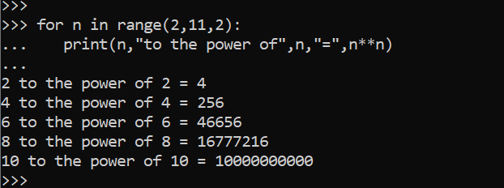

**Task 16**

