PROJECT DESIGN PHASE-II
Data Flow Diagram & User Stories
Team ID | ________________
Project Name | Streamlining IT Procurement – Automating Standard Laptop
Maximum Marks | 4 Marks

Data Flow Diagrams
A DFD shows how laptop procurement information enters, is processed, stored, and leaves the system. The diagrams below are a project-specific adaptation of the template's DFD concept.
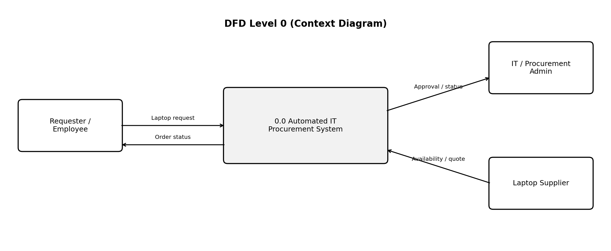
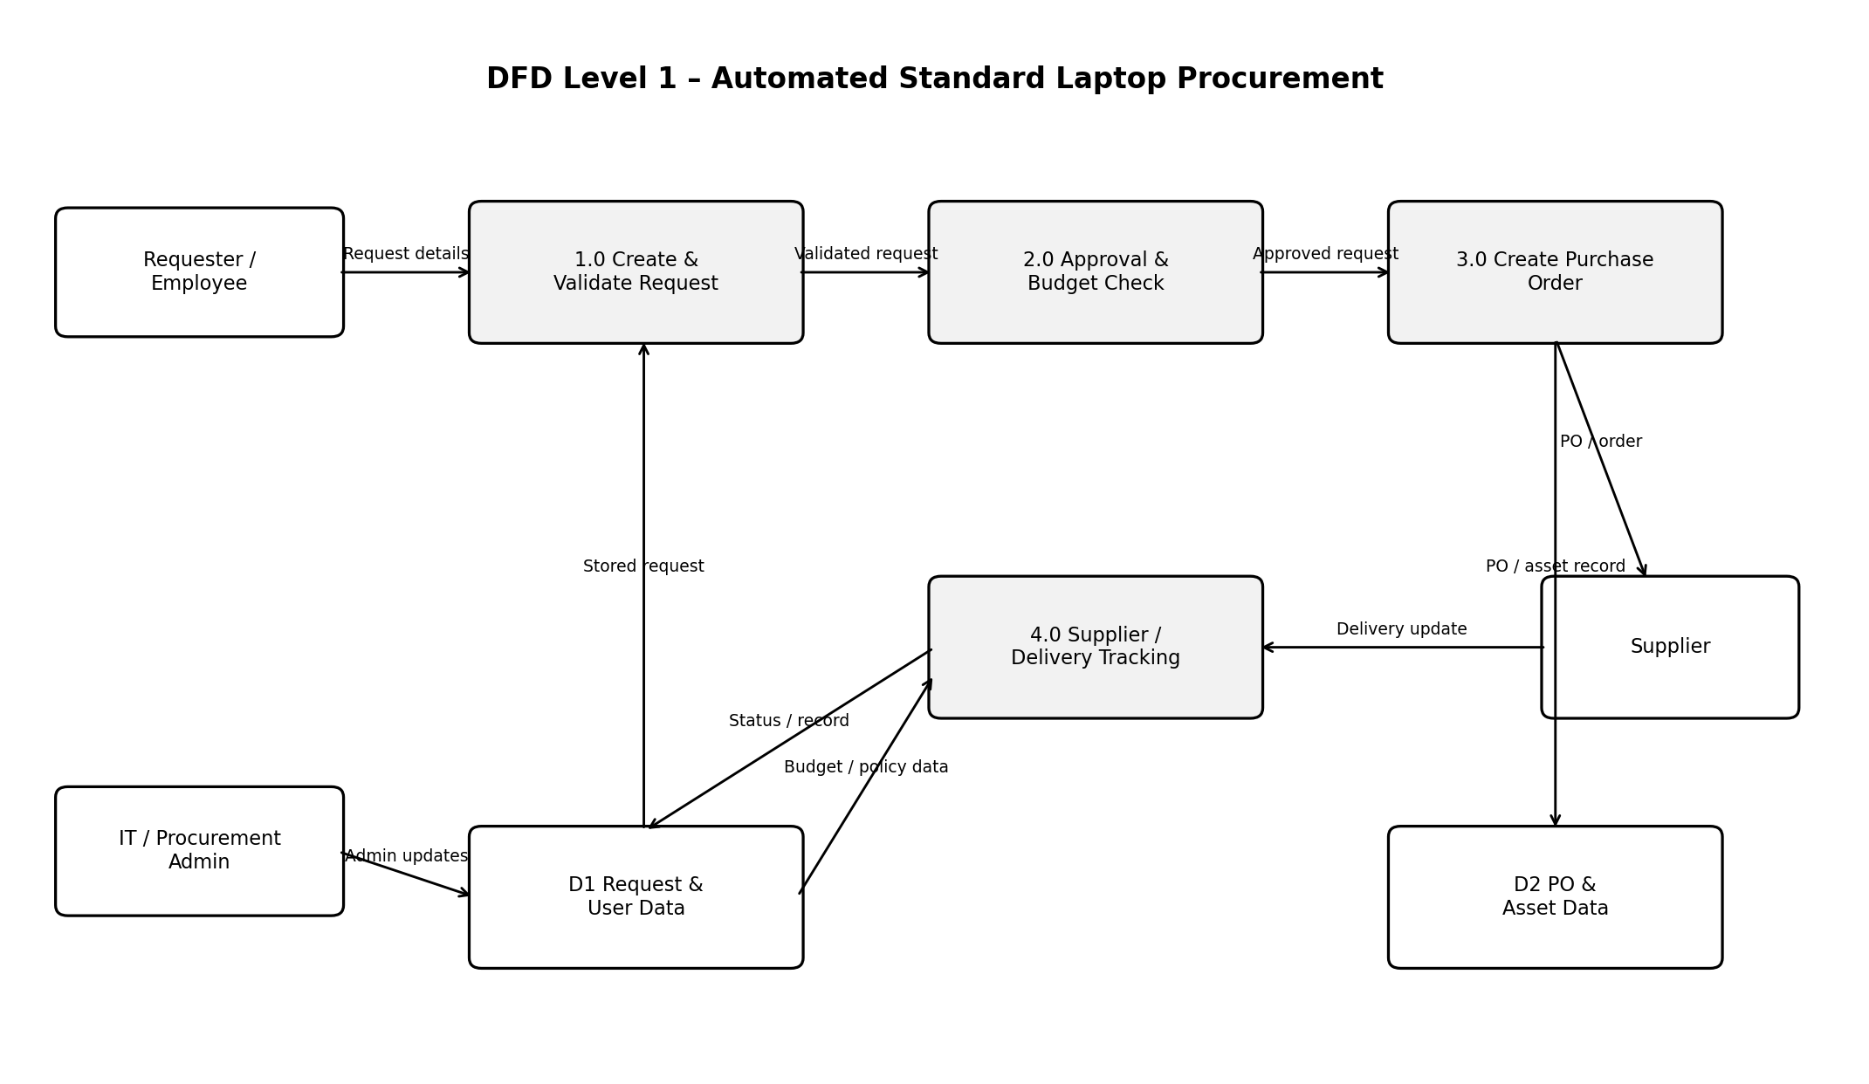
User Stories
The following table follows the uploaded template's fields: User Type, Functional Requirement (Epic), User Story Number, User Story / Task, Acceptance Criteria, Priority, and Release.
User Type | Functional Requirement (Epic) | User Story Number | User Story / Task | Acceptance Criteria | Priority | Release
Employee / Requester | Laptop Request | USN-1 | As an employee, I can submit a standard laptop request with my required details. | Request is saved with a unique request ID and standard laptop option. | High | Sprint-1
Employee / Requester | Laptop Request | USN-2 | As an employee, I can view the status of my laptop request. | Status shows submitted, approved, ordered, shipped, or delivered. | High | Sprint-1
Manager / Approver | Approval | USN-3 | As a manager, I can review and approve or reject a standard laptop request. | Request can be approved/rejected and the decision is recorded. | High | Sprint-1
IT / Procurement Admin | Policy & Validation | USN-4 | As an administrator, I can validate requests against standard laptop policy. | System flags incomplete or non-standard requests before ordering. | High | Sprint-1
IT / Procurement Admin | Purchase Order | USN-5 | As a procurement admin, I can generate a purchase order for an approved request. | PO contains requester, standard laptop details, quantity and supplier information. | High | Sprint-2
IT / Procurement Admin | Supplier & Delivery | USN-6 | As an administrator, I can update and track supplier and delivery status. | Supplier/order status is stored and visible against the request. | Medium | Sprint-2
Employee / Requester | Notifications | USN-7 | As an employee, I can receive notifications when my request status changes. | Notification is triggered after approval, ordering, shipping, and delivery updates. | Medium | Sprint-2
IT / Procurement Admin | Asset Record | USN-8 | As an administrator, I can record the delivered laptop as an IT asset. | Asset record contains device details and is linked to the original request. | Medium | Sprint-2

Source note: The DFD definition and the user-story table headings/format are based on the uploaded template. Project-specific roles, flows, stories, acceptance criteria, priorities, and sprint releases are an adaptation for the stated project because the template itself provides only a generic example.

