Could homozygosity for an unknown genetic factor account for measles mortality on Rotuma?

We consider the extreme case where all of those who died in the 1911 epidemic were homozygous for an allele (or haplotype) that made them susceptible to death from measles. We define this risky allele as “M”. Possible genotypes in the population are MM (at risk of death from measles), Mm and mm (neither of the latter are at risk of death from measles). We calculate the assumed genotype distribution in the population in 1911 (fig 1A). Based on the genotype distribution in the survivors, and predicting the genotypes of people born during the period between the 1911 outbreak and the next measles outbreak in 1927-8, we then estimate the new population distribution of genotypes in the next measles outbreak (fig 1B).
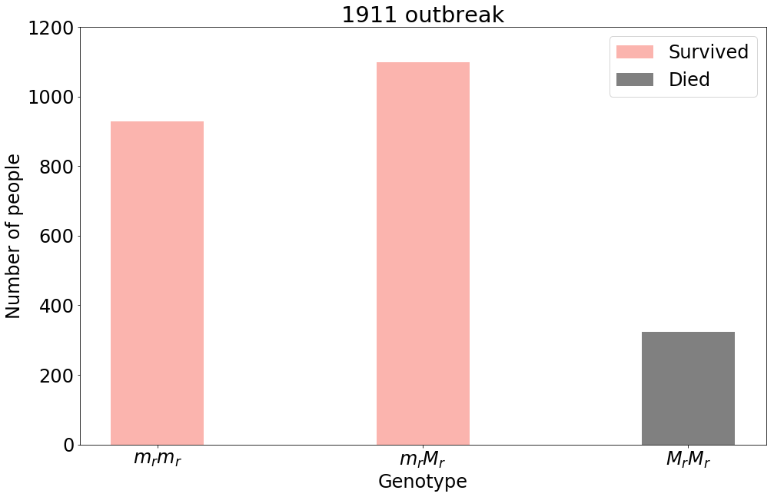
a)

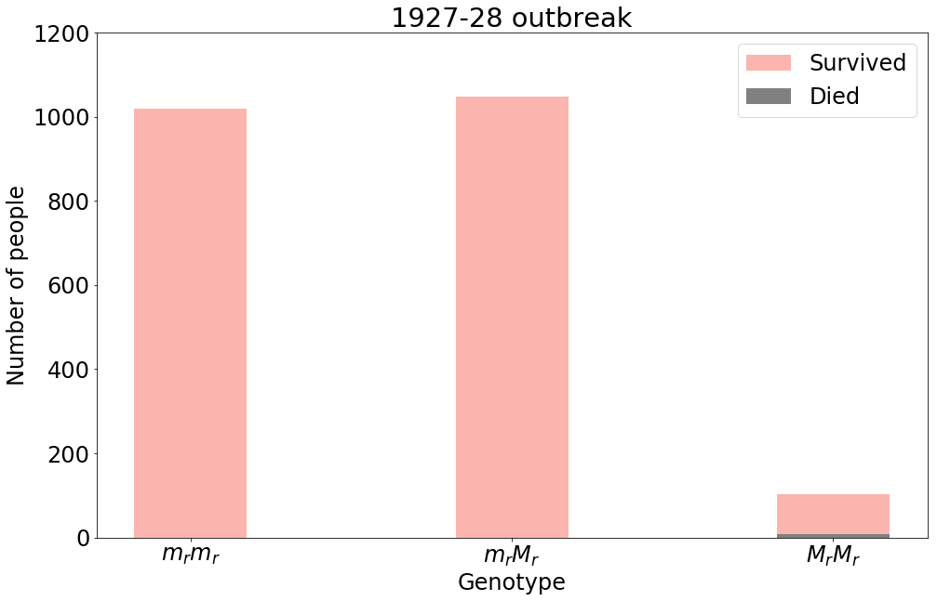
b)

Figure 1 The calculated genotype distribution in the population in a) 1911 and
b) 1927.
Far fewer people died in 1927-8. Even if they were all of the genotype MM, that still represents only a small proportion of the MM population we predict to have been present by 1927 (figure 1B, grey shading in third column). Nevertheless, it is possible that the measles epidemic of 1927-8 infected only a small proportion of the susceptible population. To account for the smaller number of deaths in 1927-8 within the constraints of the genetic scenario proposed in figure 1, and assuming that anyone who had been alive in 1911 and was still alive in 1927 was immune, we must assume that the basic reproductive number (R0) of measles in the 1927-8 outbreak was approximately 2. Whilst this is a very low number for measles, it is not outside the possible R0s of measles that have been calculated for other studies (Guerra et al., 2017).

We also considered the possibility that simultaneous homozygosity at several independently inherited loci might account for the measles deaths in 1911. However, to account for the 13% mortality in the population in 1911 requires high frequencies of these “risky” alleles to be present in the population (e.g. for 0.13 of the population to be simultaneously homozygous for alleles A and B, we need both A and B to be at a frequency of 0.6, or A to be at a frequency of 0.5 and B at 0.7 and so on). Such high frequencies of the risky alleles at these hypothetical loci mean that by 1928 we still predict there to be a high proportion of the population with the simultaneously homozygous genotype, exacerbating the problem we already had in figure 1 that by 1928 there should have been a relatively high proportion of the population genetically susceptible to measles mortality.

Examining the epidemic curve
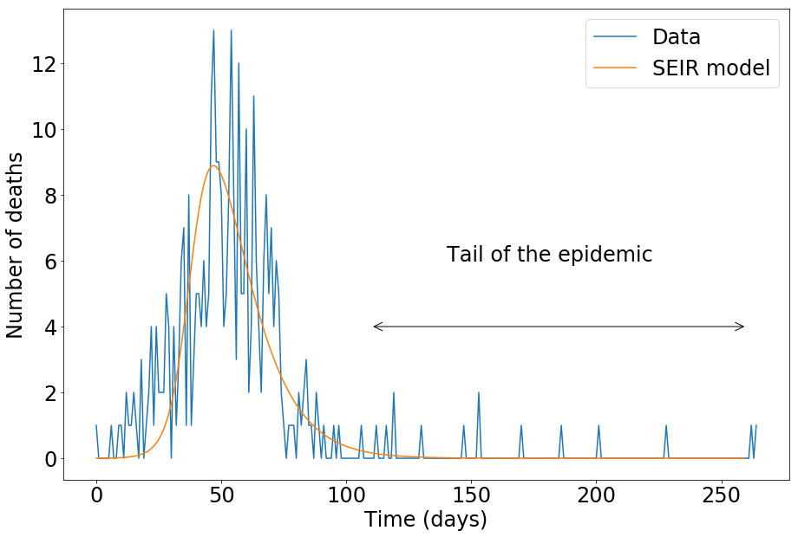

Figure 2 The epidemic curve from the 1911 outbreak and predictions of deaths using an SEIR model.

We create a SEIR (susceptible , exposed, infected, recovered) with deaths due to measles matching the data and plot this for a suitable transmission probability. We see the data has a longer tail than the prediction. Most of those in the tail of the epidemic also have pthisis listed on cause of death.

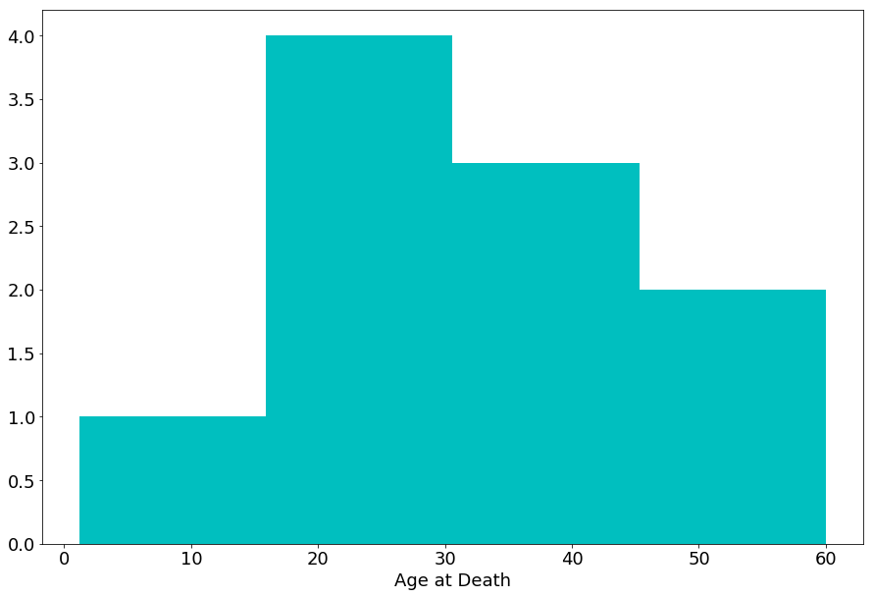

Figure 3 Age distribution of those who died in the tail of the epidemic.

References
Guerra, F., Bolotin, S., Lim, G., Heffernan, J., Deeks, S., Li, Y. and Crowcroft, N. (2017). The basic reproduction number (R 0 ) of measles: a systematic review. The Lancet Infectious Diseases, 17(12), pp.e420-e428.

