CADENCE IN DETAILS:

- OVERALL LAYOUT:

GND rail –Standard Cell ---> VCC rail –Standard Cell --> GND rail

Triangles denote orientation of metal layers.
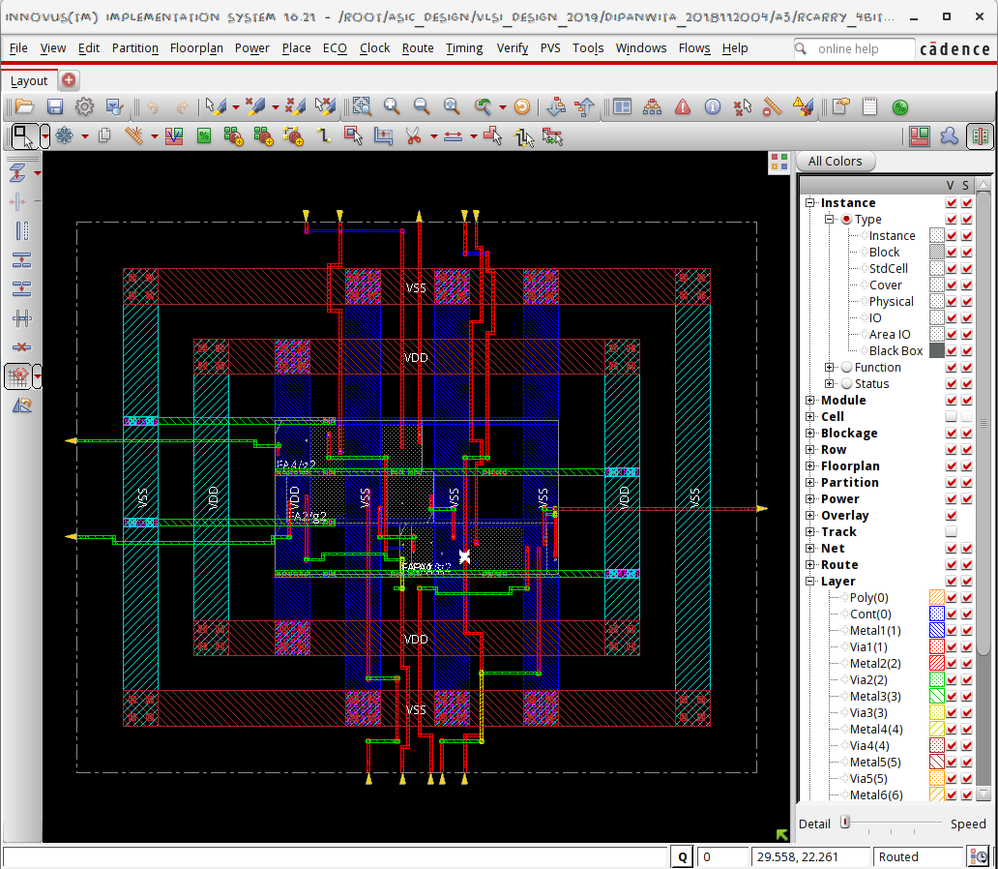

Layer layout:
VDD --> Bump --> Metal layer(a) --> Via (a,b) --> Metal layer(b) --> Standard Cell

Metal Layers:
- There are 9 metal layers.
- Resistivity: Decreases from Metal 1 to Metal 9
- Orientation: Odd layers are horizontal, Even layers are vertical.
- VIA: Connections between successive metal layers
- Pitch: Distance between wires on the same metal layer.
- Track: Total portion of metal layers currently in use.

Standard Cells:
Set of AND, OR, NOT gates provided by the foundry.
- Tap cell: Maintains potential of the bulk/ substrate of the MOSFET.
- FOR Mosfets:
  - This size in nm (45,90,5 etc) is the gate length of the transistor. for clarity, the gate length is also an approximate measure of transistor speed and of how densely you can pack transistors together in a hand-crafted layout.
  - Slow/fast .lib refers to worst and best case scenarios in terms of delays.
Suppose you switch from 16 nm to 7 nm technology, you have to do away with all your existing designs and rebuild the whole design.
What happens as an advantage/ disadvantage?
    - Area of each cell shrinks, so you can accommodate more cells in smaller area. Leads to compactness of design.
    - Delay reduces
      - Gate delay reduces faster than wire delay.
      - Wire delay reduces slower than gate delay.

    - Capacitance (C = (A €) / d ) reduces.
- WHAT IS PG NETWORK: VCC --> GND --> VCC network
- WHAT IS IR DROP: drop in power due to passing through metal layers of varying currents and resistances. So that the power at the bump is higher than the power that reaches the standard cell on the base layer.

WHAT WORK DOES GENUS DO?
- Generates RTL schematic: HOW?
  - From your verilog code, generates a netlist file that has the behavioral model of the code. Generates RTL schematic based on the behavioral synthesis. (RTL : Register Transfer Level) [SOFT IP]
  - Maps your universal standard cells to the target technology(takes 90/ 45 libraries) as per the delay, power, area constraints and tech- maps them to the reqd. Standard cell. [HARD IP].
  - How to decide which target cell to pick?
    - Pick most optimised parameter: Routes so that the most timing critical net gets the lowest delay, or as per design constraints, assigns lowest power or area to certain blocks.(constraints are specified in constraints_top.sdc)
- Gives area,power,timing reports according to behavioral model.

WHAT WORK DOES INNOVUS DO?
- Floorplan:
  - Read from .lef and .def files.
    - LEF : Layout exchange format: Specifies physical obstructions
    - DEF : specifies physical connectivity.
  - Gets info about die area, core area, no of rows, tracks etc.
- Placement:
  - Place macros, rams, I/o pins, standard cells optimally on the die satisfying the area, power constraints specified in the .def files and timing constraints in the .sdc files.
SDC : Synopsis Design Constraints
  - Optimises on the following:
    - Total wirelength
    - No of cut nets
    - Wire congestion
    - Signal delay
- Routing:
  - First route the highest switching signal, I,e clock through CTS (CLOCK TREE SYNTHESIS). NDR (Non-default route) specially for clock nets.
  - Global and default route.

THREE TYPES OF POWER:

Dynamic Power = Switching Power + Short circuit power

Leakage Power

Total Power = Pswitching + Pshort-circuit + Pleakage
Dynamic power is the sum of two factors: switching power plus short-circuit power.
Switching power is dissipated when charging or discharging internal and net capacitances. Short-circuit power is the power dissipated by an instantaneous short-circuit connection between the supply voltage and the ground at the time the gate switches state.
Pswitching = a.f.Ceff.Vdd2
Where a = switching activity, f = switching frequency, Ceff = the effective capacitance and Vdd = the supply voltage.
Pshort-circuit = Isc.Vdd.f
Where Isc = the short-circuit current during switching, Vdd = the supply voltage and f = switching frequency.
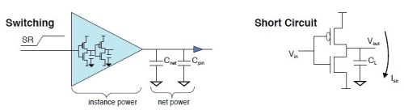
Dynamic power can be lowered by reducing switching activity and clock frequency, which affects performance; and also by reducing capacitance and supply voltage. Dynamic power can also be reduced by cell selection-faster slew cells consume less dynamic power.
Leakage power is a function of the supply voltage Vdd, the switching threshold voltage Vth, and the transistor size.
PLeakage = f (Vdd, Vth, W/L)
Where Vdd = the supply voltage, Vth = the threshold voltage, W = the transistor width and L = the transistor length.
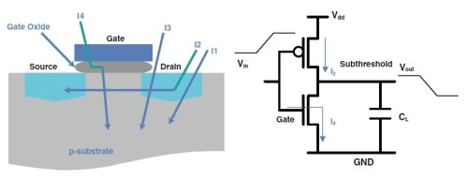
Of the following leakage components, sub-threshold leakage is dominant.
• I1: Diode reverse bias current
• I2: Sub-threshold current
• I3: Gate-induced drain leakage
• I4: Gate oxide leakage
While dynamic power is dissipated only when switching, leakage power due to leakage current is continuous.

