**Ticket Tracker Application**

**Screenshots:**

1. Home Screen with data and action buttons (New Ticket, Edit, Delete, View)

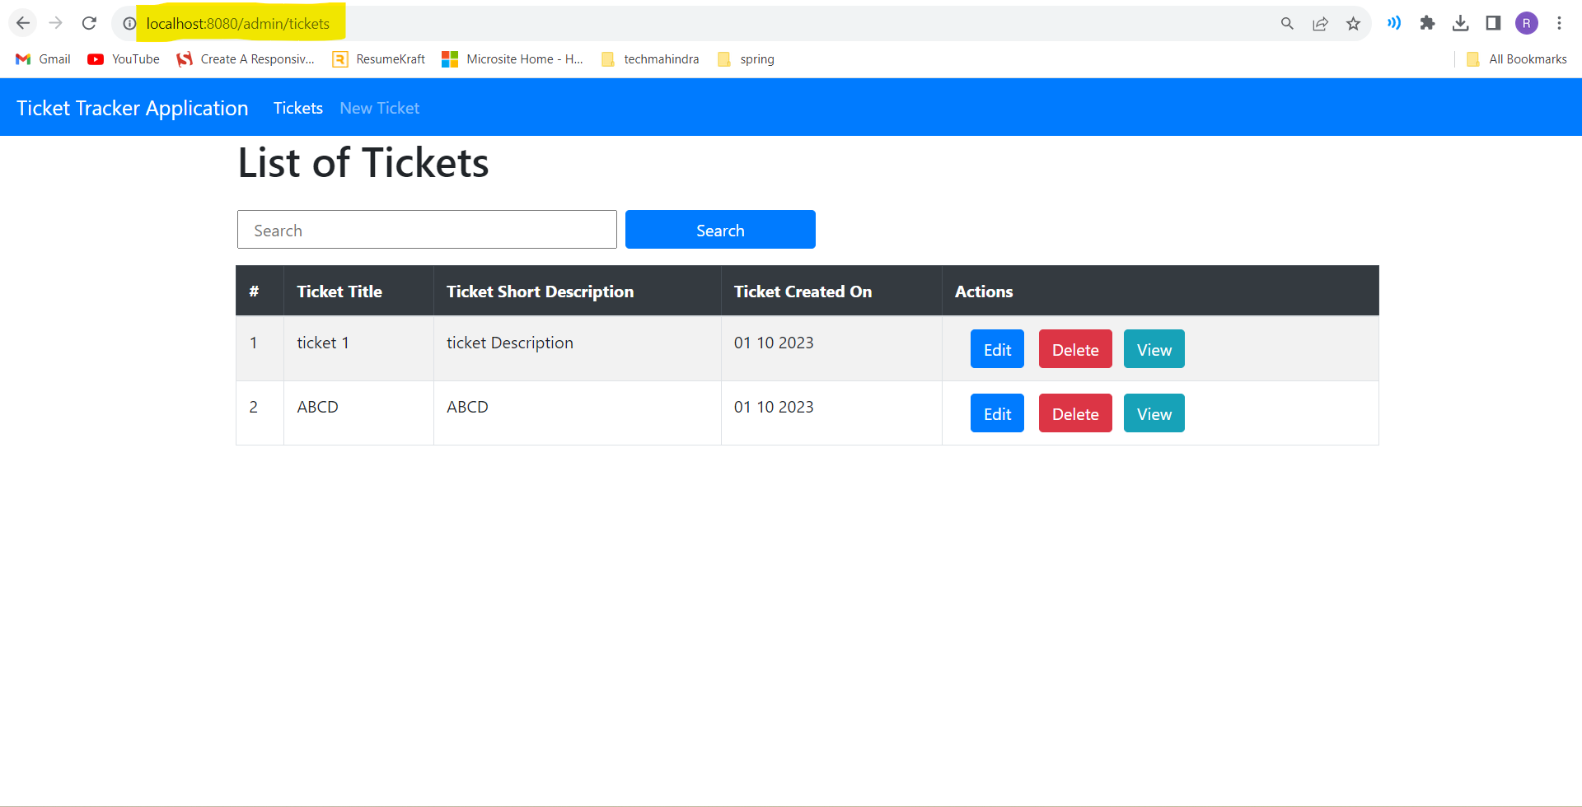

2. Create Ticket page

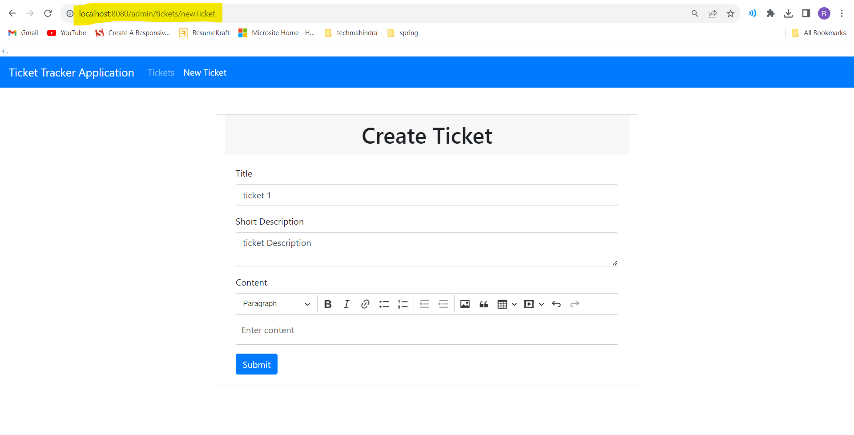

3. Edit Ticket

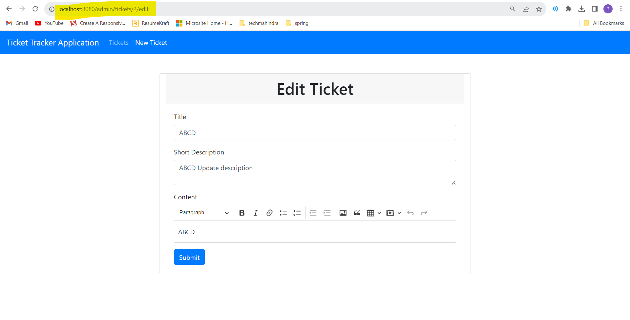

4. View Ticket

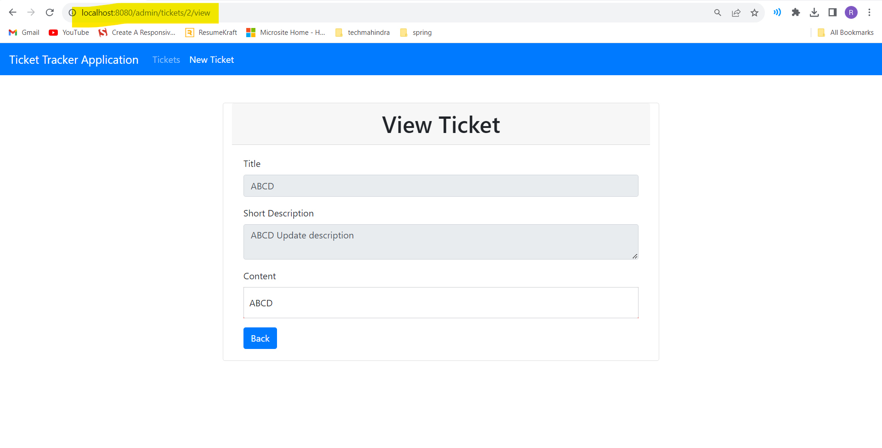

5. Search Ticket

