**Employee Management Rest Api Based Web Application**

1. **Insert role**

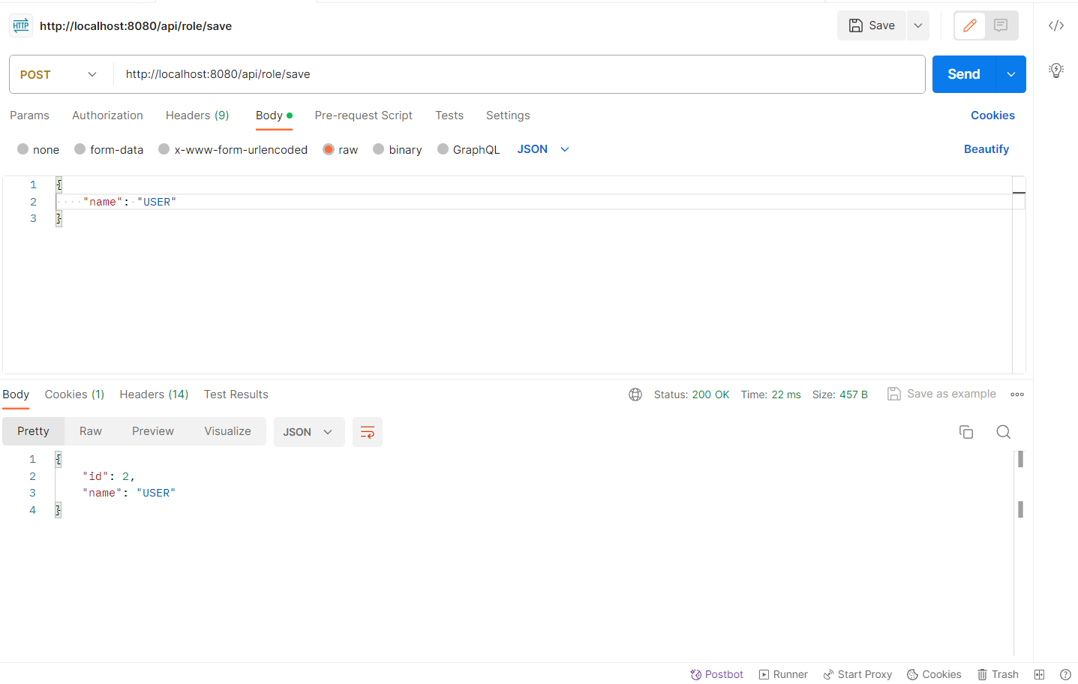

1. **Insert User: User Role**

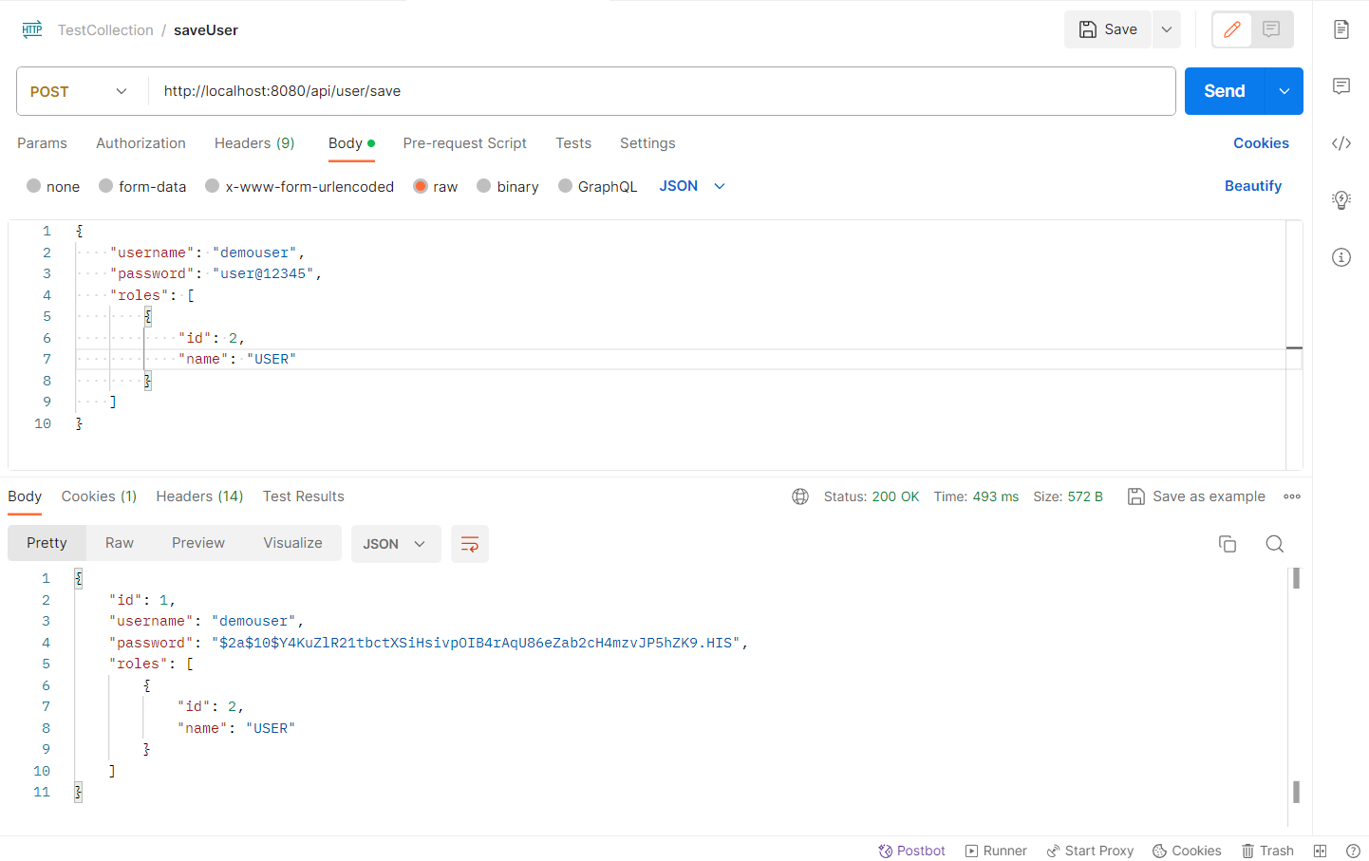

1. **Insert User: Admin Role**

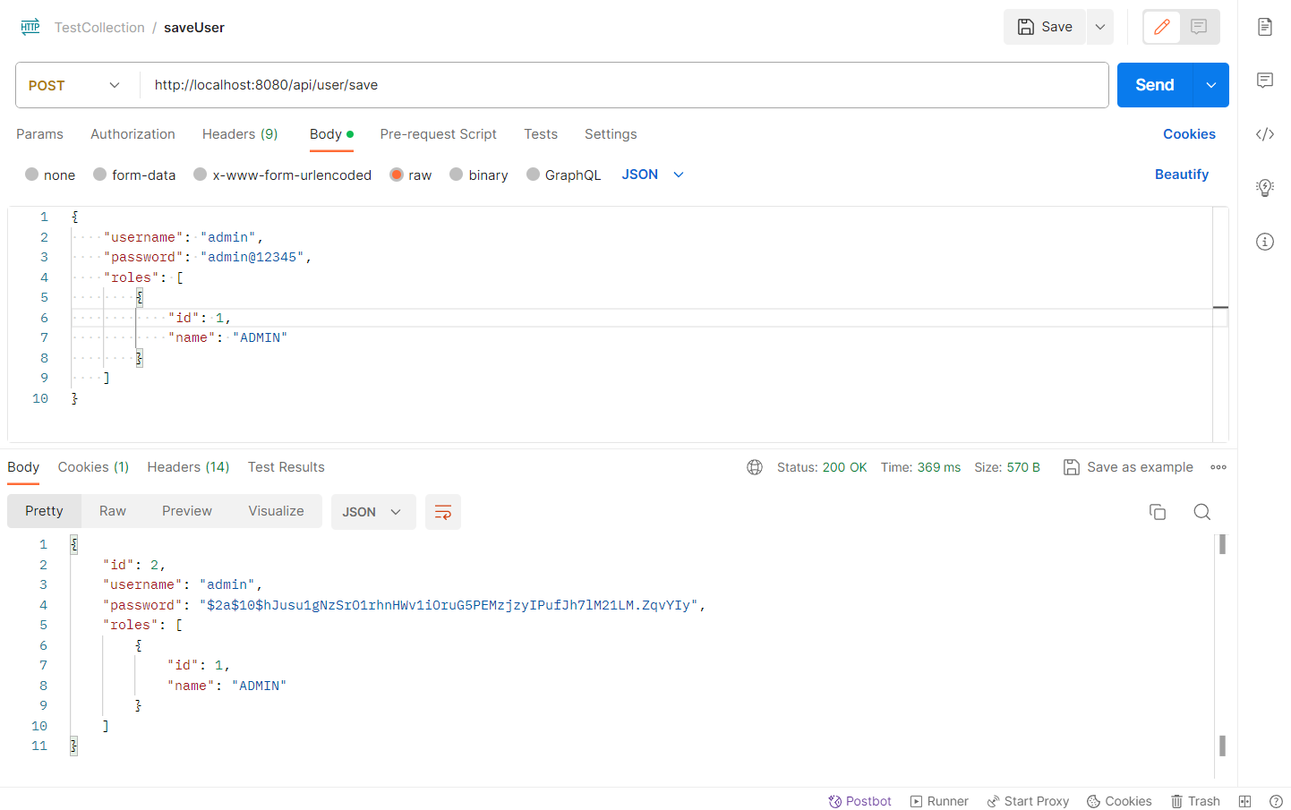

1. **Save Employee**
   1. **401 Unauthorized Error: Authorization is not passed**

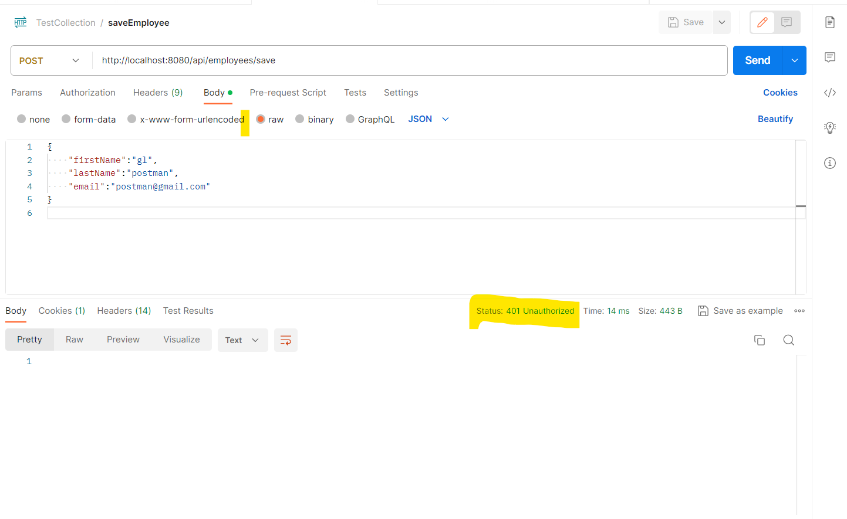

* 1. **403 Forbidden Error: User doesn’t have access to save employee**

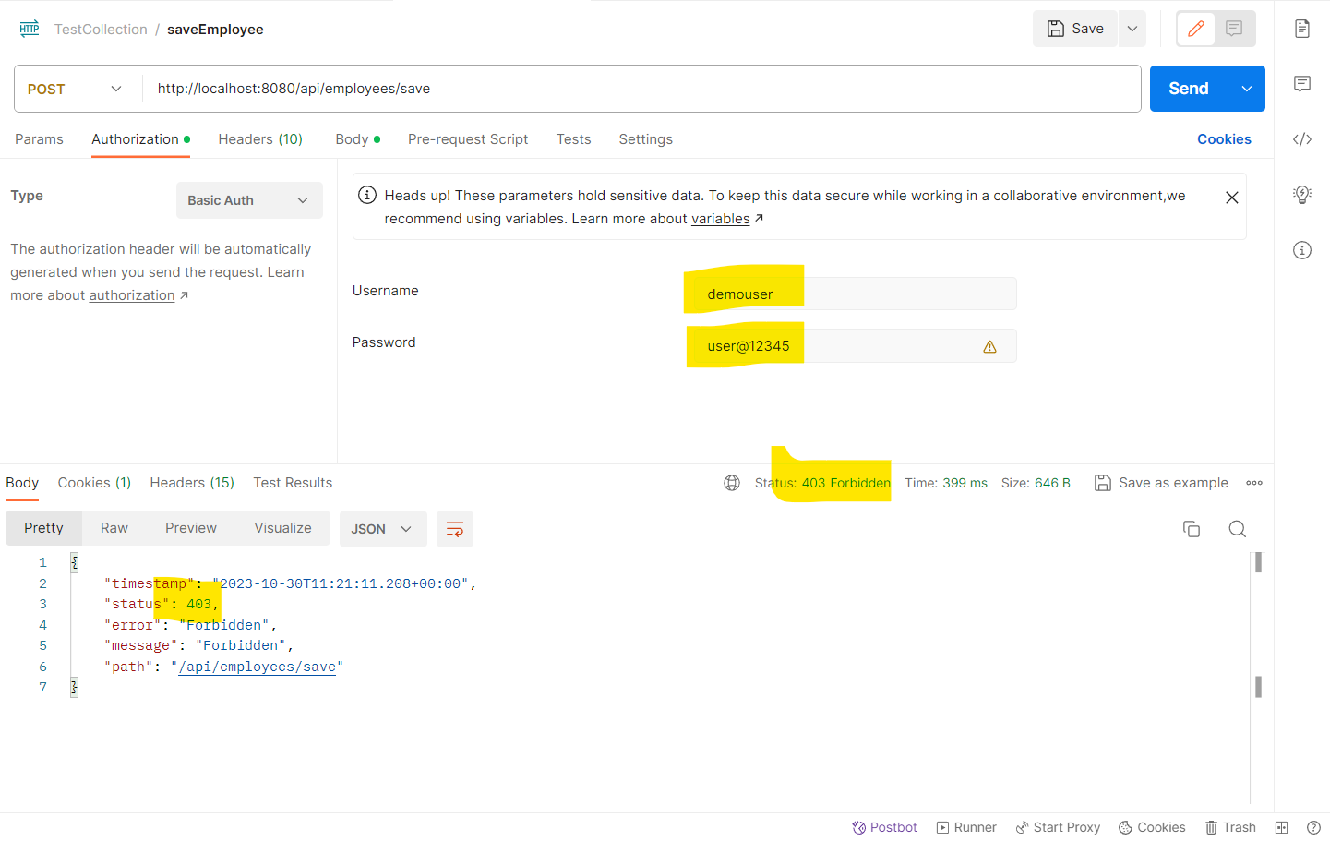

* 1. **Admin User successfully able to save employee**

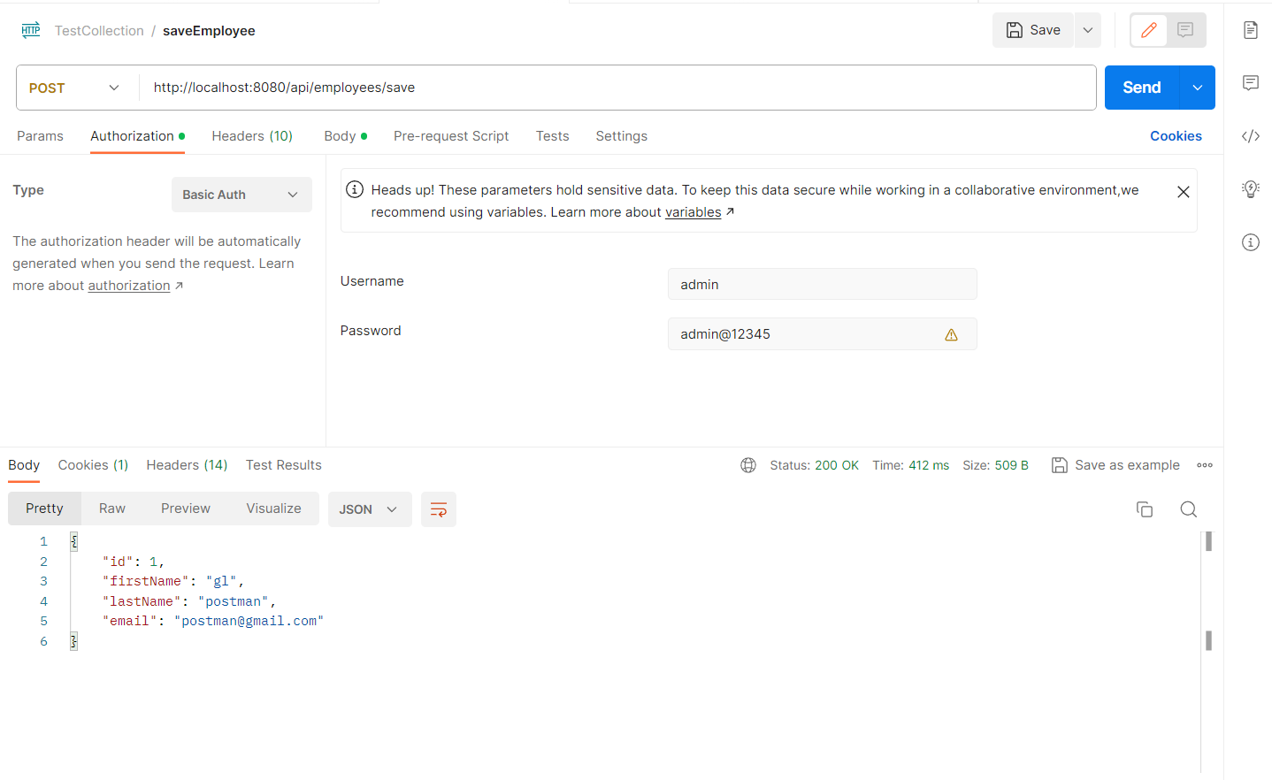

1. **Get All Employees**

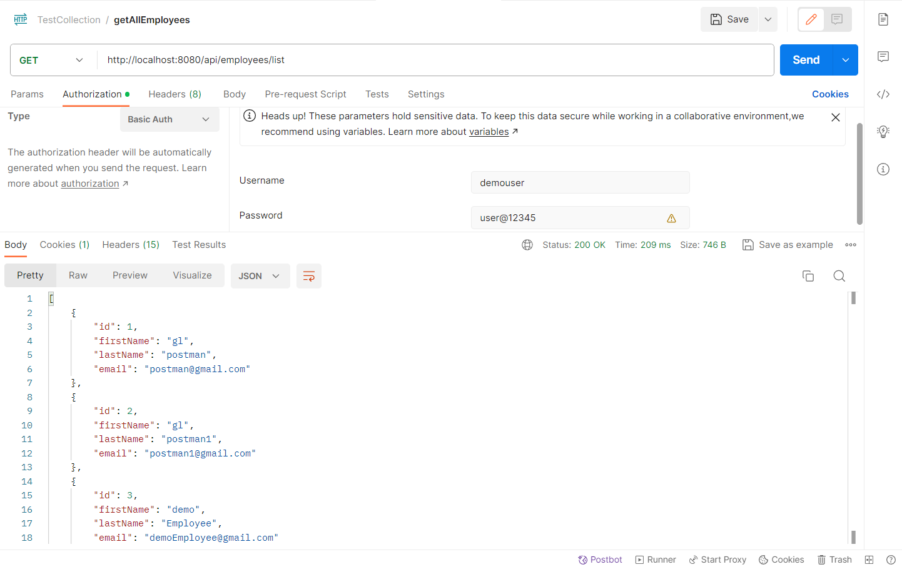

1. **Find an Employee By Id**

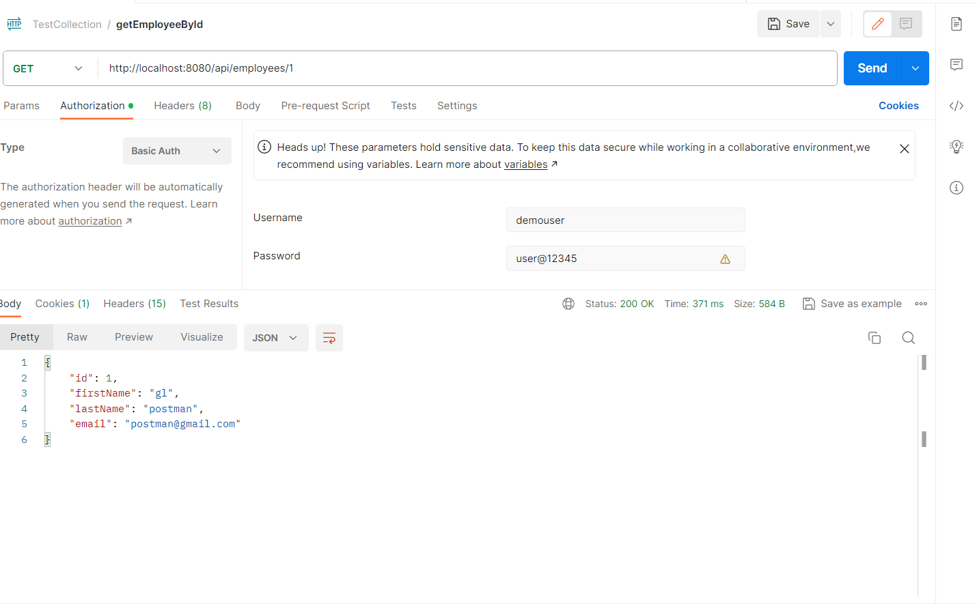

1. **Update on Employee by ID:**

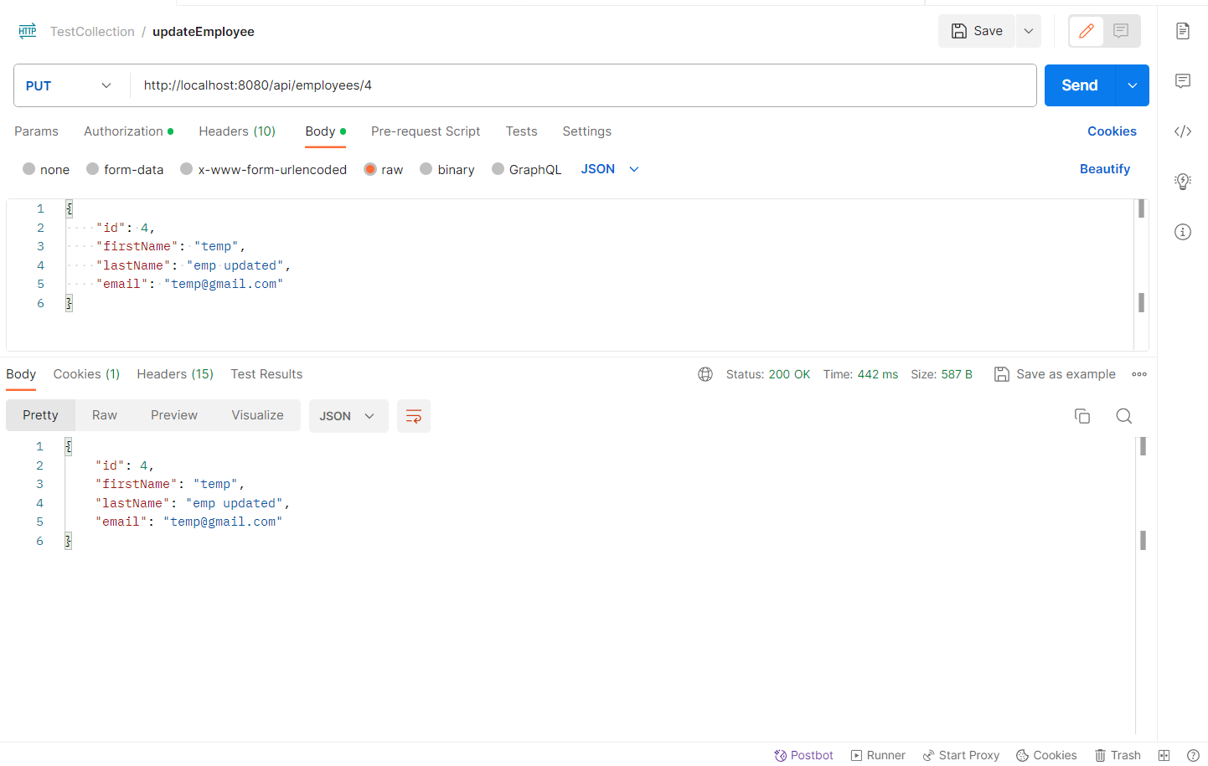

1. **Delete an Employee by Id:**

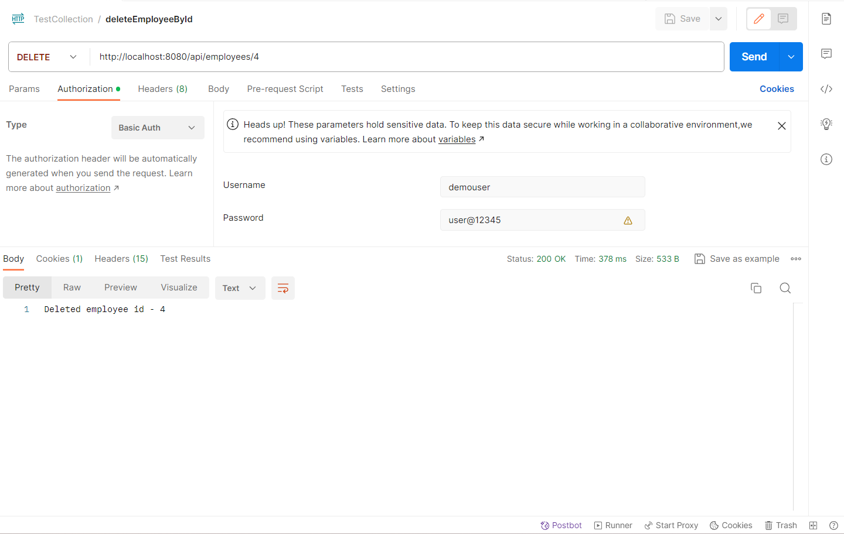

1. **Search Employee by First Name**

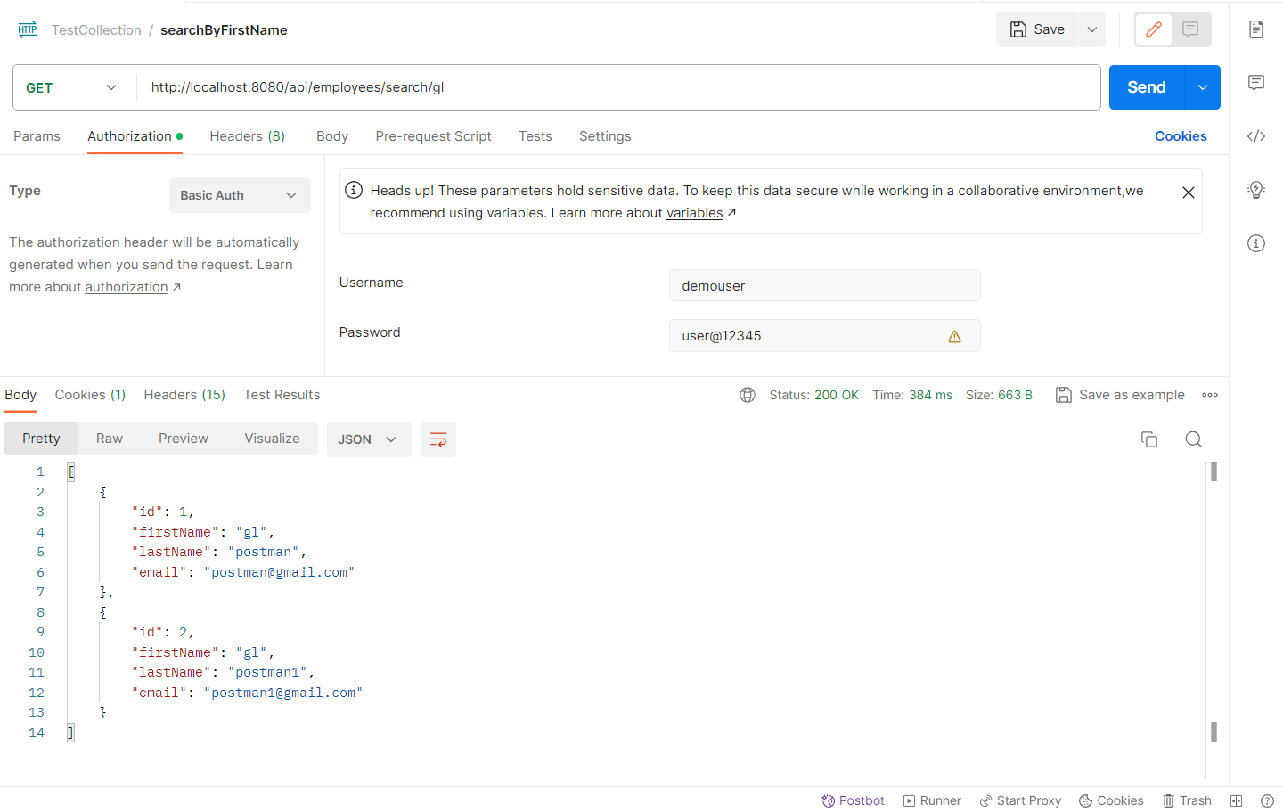

1. **Sort Employee by First Name**

