REST ASSURED
Rest Assured: https://rest-assured.io/
What REST?
REST: Representational State Transfer
- An architectural style for designing web services
- Stateless communication between client and server
- Uses standard methods like: GET, POST, PUT, DELETE, PATCH
Components:
- Resources: URI
- Representational: JSON/XML/HTML
- HTTP Methods: CRUD operations
- Status Code: Server Responses
Client-Server Basics:
HTTP request Structure:
- Method: GET/POST/PUT/DELETE (GET /api/users?page=2 HTTP/1.1) -> Request Line
- URL: Resource Location (Host: https://www.restaurant.com/)
- Headers: Content-type, Auth (Metadata) (Accept: application/json)
- Payload/Body: data send for POST/PUT ( { name: qweee, }
HTTP Responses:
- Status code: 200, 201, 401, 403, 404, 500
- Headers (Server, Content-Type, ..)
- Response Body – actual data in JSON format
Final Discussion:
- REST fundamentals
- HTTP protocol demo with Post, get, put, delete
- JSON/XML Parsing techniques
- Authentication (Credentials, token, OAuth)
- SSL Handling
- Logging mechanism with log4j

API Test Site: https://reqres.in/ (and) https://restful-api.dev/
Step 1: Pre-Requisites
- Java Download (https://www.oracle.com/in/java/technologies/downloads/) – Install, and check cmd: java -version
- Java IDE (Eclipse, IntelliJ, etc) (https://www.eclipse.org/downloads/packages/) - Install - Eclipse IDE for Java Developers -> Windows X86_64 -> Download
- Maven – Install (restassured, testng, harmcrest, jackson, log4j)
- TestNG – Install (Eclipse -> help -> Install New Software
Step 2: Open Eclipse ->Project Folder -> Package Explorer
Step 3: Create Maven Project -> Go to File -> New -> Maven Project -> Next
- File ▸ New ▸ Maven Project → archetype-quickstart
- Group Id: com.simplilearn | Artifact Id: RestAssuredAutomation
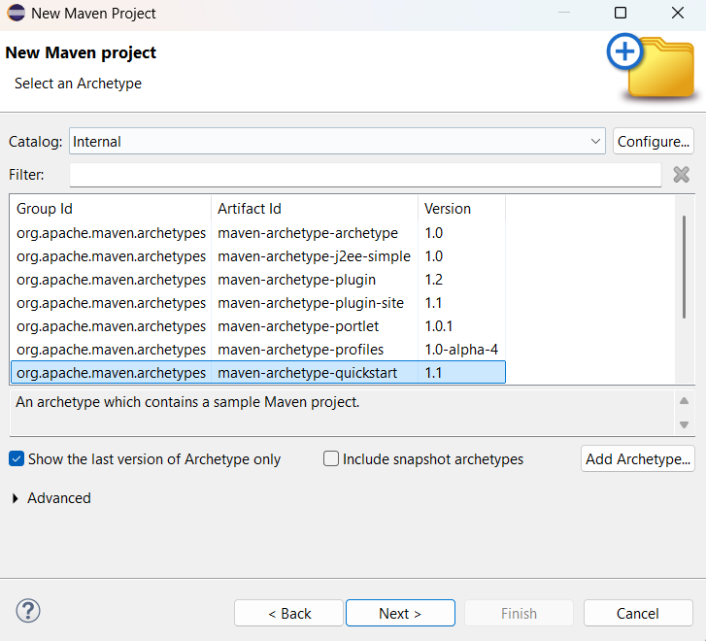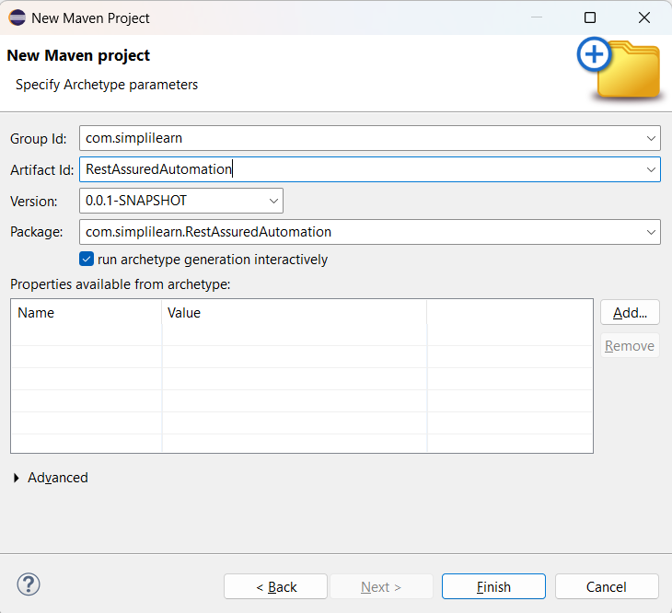
- Group ID: Organization name
- Artifact ID : Project Name as, “RestAssuredAutomation”
Step 4: Add dependency to POM.xml
<!-- https://mvnrepository.com/artifact/io.rest-assured/rest-assured -->
<dependency>
<groupId>io.rest-assured</groupId>
<artifactId>rest-assured</artifactId>
<version>5.5.6</version>
<scope>test</scope>
</dependency>
<!-- https://mvnrepository.com/artifact/org.testng/testng -->
<dependency>
<groupId>org.testng</groupId>
<artifactId>testng</artifactId>
<version>7.11.0</version>
<scope>test</scope>
</dependency>
Step 4: Save the Project and Check libraries added
Step 5: Add TestNG plugin in eclipse
Eclipse -> Help -> Install New Software
(Go to testNG web site, look for testNG for eclipse)
url : https://github.com/testng-team/testng-eclipse/
Take the latest release link: https://testng.org/testng-eclipse-update-site
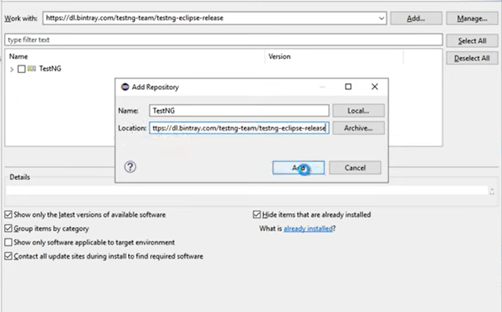
Add and select the check box. Restart the eclipse.

Create First Test:
Step 1: Create a class
Step 2: create a function and annotate with @Test (TestNG)
Step 3: Run a get request
Step 4: Store response and print response data
Step 5: Add assertions
Step 6: Run and verify

REST Assured Framework - Java
Rest API URL: https://restful-api.dev/
- Maven Project Structure
- Pom.xml (Rest Assured + TestNG + harmcrest + Jackson + log4j + reports)
- Base Test SetUp
- All HTTP requests methods (POST, GET, PUT, DELETE) with URI
- TestNG annotations
- Reports – Extended reports
1.Maven Project Structure
RestAssuredAutomationDemo/
|- pom.xml
|- testng.xml
|- src/main/java
|- com.sl.api.framework
|- BaseApiTest.java
|- client
|- ReqResClient.java
|- model
| - CreateUserRequest.java
| - CreateUserResponse.java
|- src/main
|- resources
| - log4j.properties
| |- test/java
| - com.sl.api.tests
|- GetObjectsTest.java
|- CreateObjectTest.java
| | |-resources
| - (optional test data files)

2.pom.xml – add all dependencies discussed
<properties>
<project.build.sourceEncoding>UTF-8</project.build.sourceEncoding>
<maven.compiler.source>21</maven.compiler.source>
<maven.compiler.target>21</maven.compiler.target>

<restassured.version>5.5.6</restassured.version>
<testng.version>7.11.0</testng.version>
<harmcrest.version>3.0</harmcrest.version>
<jackson.version>3.0.3</jackson.version>
<log4j.version>2.25.2</log4j.version>
</properties>

3.Log4J Configuration (src/main/resources/log4j.properties)

