Angular:
Pre: HTML + CSS + JavaScript Basic
What is Angular?
- Angular is a front-end development framework, developed by Google
- Type-scripts, css, html
- Building single-page application with modular or component-based architecture
- MVC (Model, View, Components) and reactive programming pattern
Dependencies requirements:
- Node JS
- NPM (Node Package Manager)
- Angular CLI
- VS Code
1.Setup & Installation (Nodejs, VS Code, Angular CLI)
- Install NodeJS
https://nodejs.org/en/download
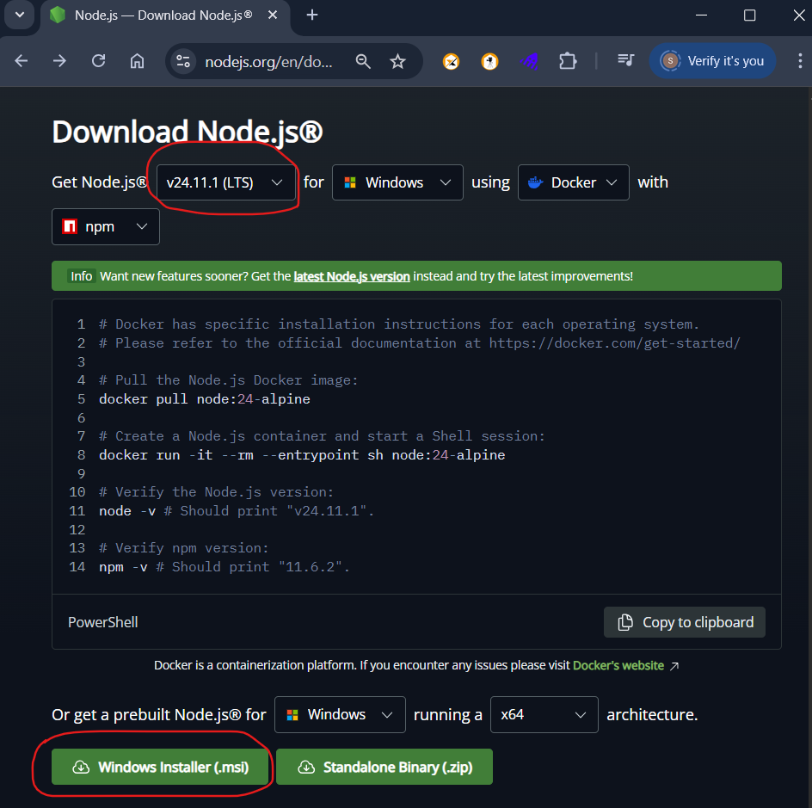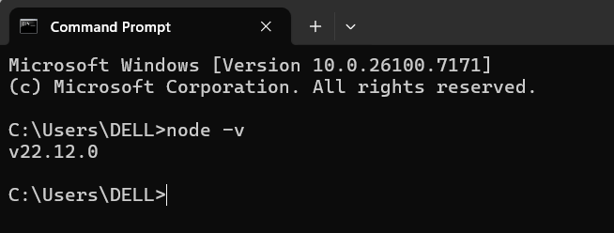
-Angular installation: https://angular.dev/installation
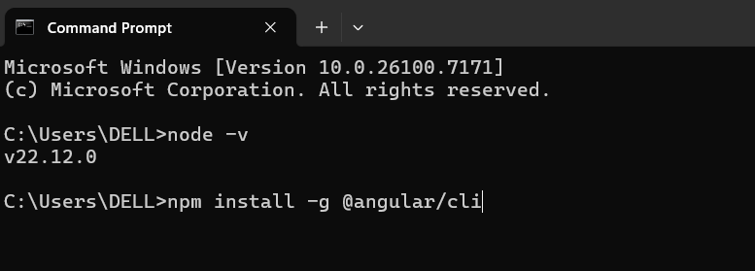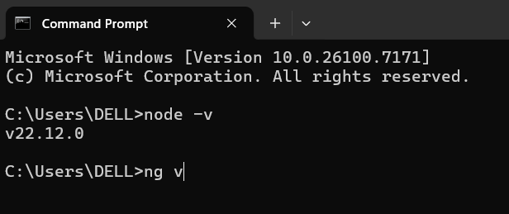

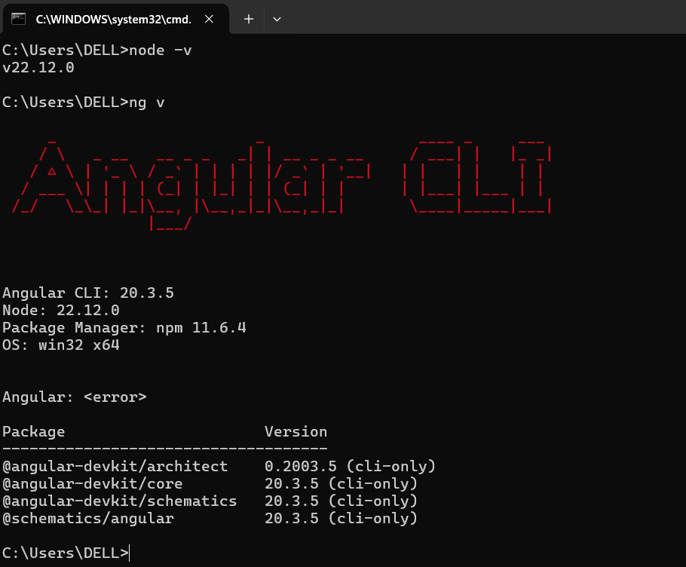
-Create a folder for Angular: AngularProject -> Inside create “angular-app-demo”
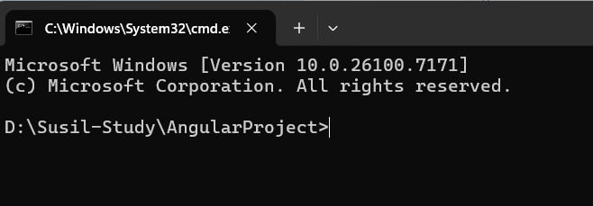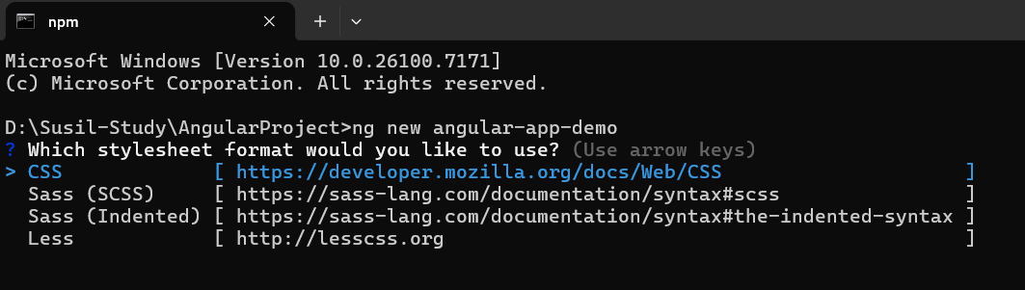
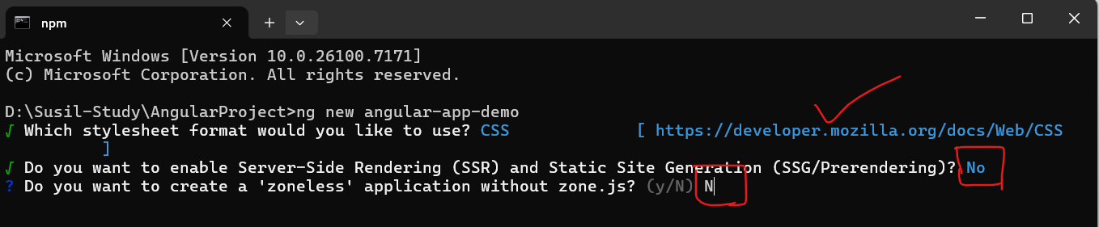
-Created “angular-project-demo”
-Open VS Code and Open the folder angular_project_demo
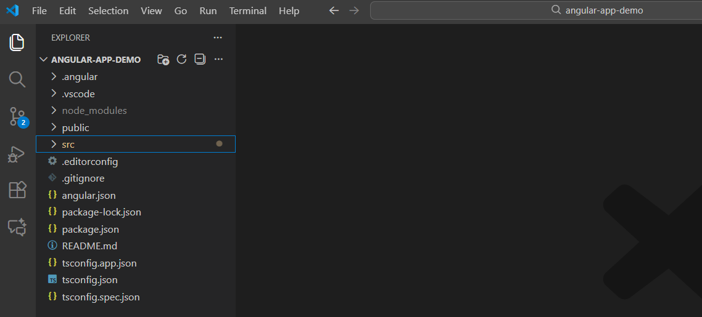
-Project run command: open terminal
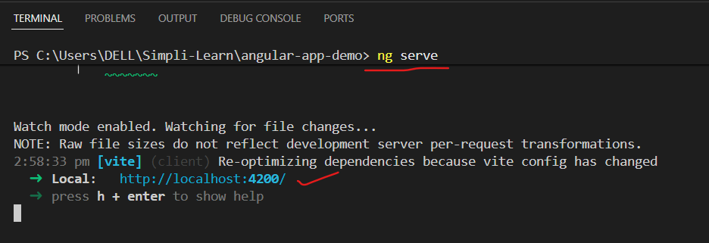
-User url: http://localhost:4200/
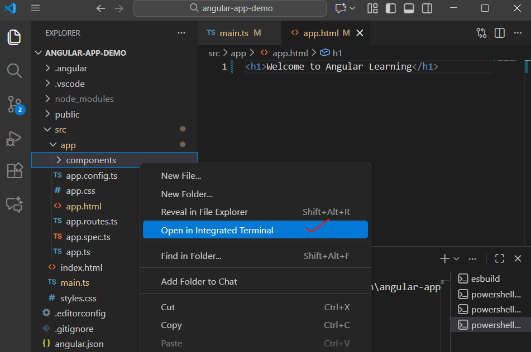
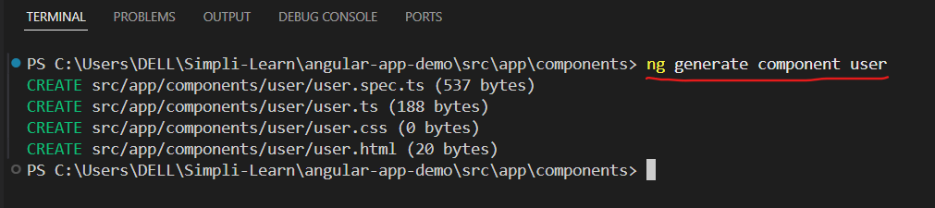

Steps to create Appointment Booking app

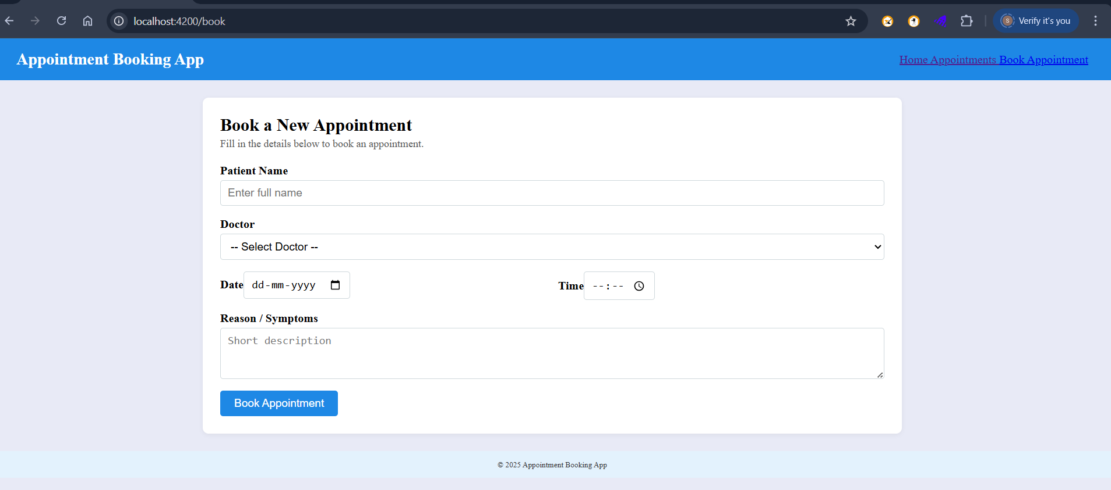
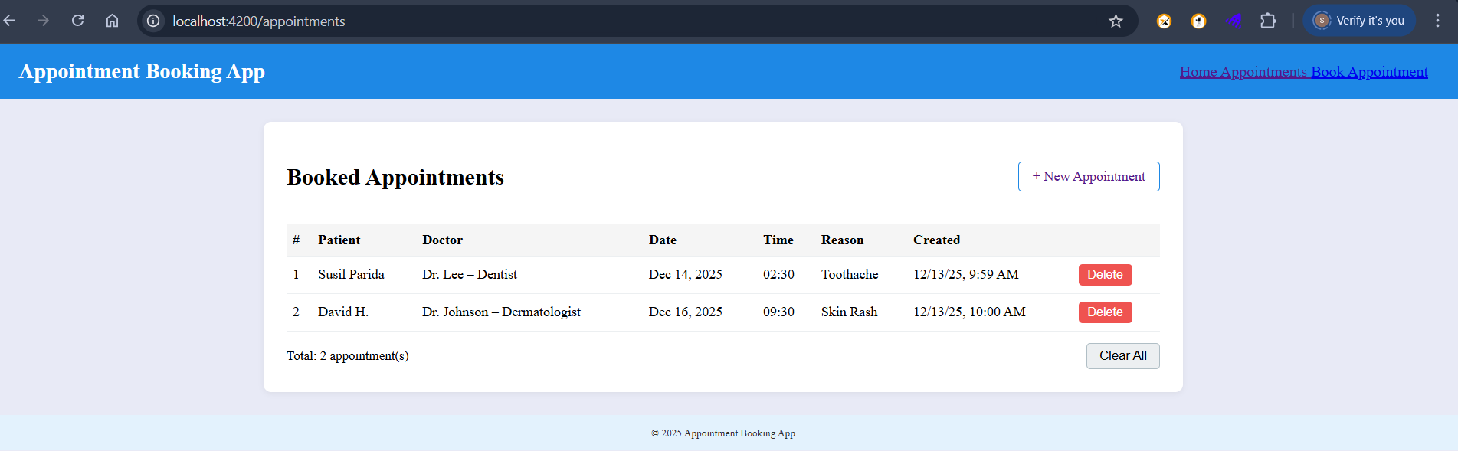

Angular-App-Demo folder structure as below:
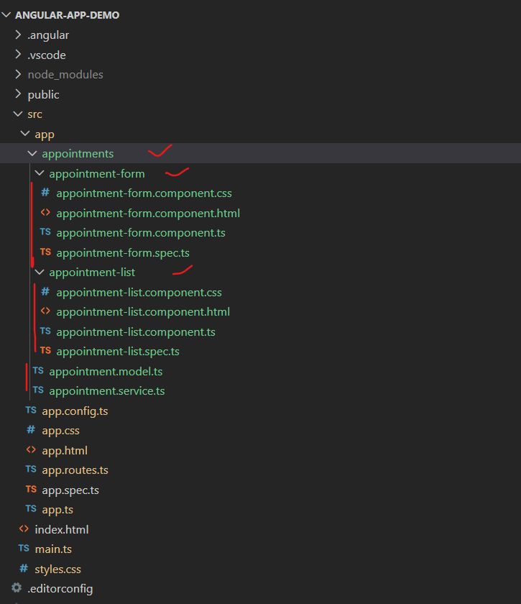

- To create components, use below code:
Use Angular CLI to generate the components (this will create the paths used below):
# From project root: PS D:\Susil-Study\AngularProject\angular-app-demo>
ng g component appointments/appointment-form --standalone --inline-style=false --inline-template=false
ng g component appointments/appointment-list --standalone --inline-style=false --inline-template=false
-Then add a model and service manually.
src/app/appointments/appointment.model.ts
src/app/appointments/appointment.service.ts
-Generate components as shown above, so path match.
-Replace content of the existing files with: https://github.com/susilparida01/angular-app-demo
- Go to src folder.
- Run: PS D:\Susil-Study\AngularProject\angular-app-demo>ng serve
Then open http://localhost:4200
-------------------------------------------------------------------------------------------------------------
• main.ts → app.config.ts → app.routes.ts
• Show standalone root component
• Build appointments/ feature step by step
• Add Reactive Form
• Add list with *ngFor
• Connect using service

