# FUTURE SALES PREDICTION

# PHASE 5 Submission Document Project

TEAM MEMBERS:

P.NANDHINI(LEADER)

K.SUGANYA

G.RUBIKA

M.SUSHMINA

P.SUBASHINI

INTRODUCTION

Creating an introduction for a future sales prediction report or presentation is crucial to capture the audience's attention and set the stage for the insights to come. Here's an example of an introduction:

"Welcome to our future sales prediction report, where we embark on a journey to unlock the potential of data-driven insights. In today's dynamic business landscape, anticipating and understanding future sales trends is not just an advantage but a necessity. As we delve into this report, we will explore the patterns, trends, and market dynamics that will shape our sales strategies in the months and years to come. Our goal is to equip you with the knowledge and foresight needed to make informed decisions, optimize resources, and stay ahead in an ever-evolving marketplace. So, let's begin our exploration of the future of sales and unveil the opportunities and challenges that await us."

ABSTRACTION

Sales Forecasting is the process of predicting future sales. It is the vital part of the financial planning of the business. Most of the companies heavily depend on the future prediction of the sales. Accurate sales empower the organizations to make informed business decisions and it will help to predict the short-term and long-term performances. A precise forecasting can avoid overestimating or underestimating of the future sales,which may leads to great loss to companies. Tthe past and current sales statistics is used to estimate the future performance. But it is difficult to deal with accuracy of sales forecasting by traditional forecasting. For this purpose, various Data Science and Machine Learning techniques have been discovered. In this work, we have taken Black Friday dataset and made a detailed analysis over the dataset. By analyasing the peformance, we have trying to suggest the suitable predictive algorithm to our problem statement.

PROBLEM STATEMENT AND DESIGN THINKING

Most of the business organizations heavily depend on a knowledge base and demand prediction of sales trends. Sales forecasting is the process of estimating future sales. Accurate sales forecasts enable companies to make informed business decisions and predict short-term andlong-term performances. The goal is to improve the accuracy from the existing project. So that the sales and profit could be increased for the companies. Choosing an efficient algorithm from camparing different a lgorithms to improve the prediction further more.

Intelligent Sales Prediction using Machine Learning Techniques.

Forecasting the Retail Sales Industry Using Support Vector Machines.

An Intelligent Model for Predicting the Sales of a Product.

A Deep Learning Approach for the Prediction of Retail Store Sales

DATA PREPROCESSING

This step is an important step in Data Mining Process. Because it improves the quality of the experimental raw data.

Data Sources

Analytical Methods

Key Findings

Sales Projections

Recommendations

Data Sources:

Discuss the data sources used for predictions, including historical sales data, market trends, customer data, and any other relevant sources.

Analytical Methods

Explain the analytical methods and tools used for prediction, such as machine learning algorithms, statistical models, or other techniques.

Key Findings

Present the main findings from your analysis, highlighting significant trends, seasonality, and any patterns that emerged.

Sales Projections

Provide the future sales predictions. This could be in the form of graphs or tables, showing sales forecasts for various timeframes.

Recommendations

Offer actionable recommendations based on the predictions. What strategies should the company implement to capitalize on these insights?

Architecture Diagram

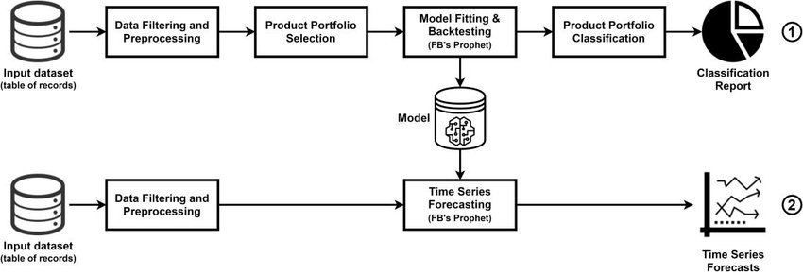

CODINGS

Future Sales Prediction

**import** pandas as pd

**import** csv

**import** numpy as np

**import** matplotlib.pyplot as plt

**import** tensorflow as tf

**from** tensorflow **import** keras

list_row,date,traffic **=** get_data('C:\Users\Windows\Documents\archive\sales_dataset.csv')

Original data set for sales data for 5 years:

*Sales data from Jan 2015 to Dec 2019*

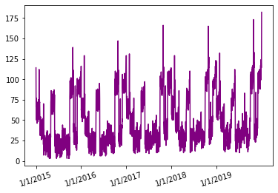

**from** tensorflow.keras.models **import** Model

**from** tensorflow.keras.layers **import** Input, Dense,LSTM,Flatten

**from** tensorflow.keras.layers **import** concatenate

#an Input variable is made from every input array

input_day **=** Input(shape**=**(inp_day.shape[1],),name **=** 'input_day')

input_mon **=** Input(shape**=**(inp_mon.shape[1],),name **=** 'input_mon')

input_year **=** Input(shape**=**(inp_year.shape[1],),name **=**'input_year')

input_week **=**Input(shape**=**(inp_week.shape[1],),name**=**'input_week')

input_hol **=** Input(shape**=**(inp_hol.shape[1],),name **=** 'input_hol')

input_day7 **=** Input(shape**=**(inp7.shape[1],inp7.shape[2]),name **=** 'input_day7')

input_day_prev=Input(shape**=**(inp_prev.shape[1],),name'input_day_prev')

input_day_sess **=** Input(shape**=**(inp_sess.shape[1],),name='input_day_sess‘)

x1 **=** Dense(5, activation**=**'relu')(input_day)

x2 **=** Dense(5, activation**=**'relu')(input_mon)

x3 **=** Dense(5, activation**=**'relu')(input_year)

x4 **=** Dense(5, activation**=**'relu')(input_week)

x5 **=** Dense(5, activation**=**'relu')(input_hol)

x_6 **=** Dense(5, activation**=**'relu')(input_day7)

x__6 **=** LSTM(5,return_sequences**=**True)(x_6)

x6 **=** Flatten()(x__10)

x7 **=** Dense(5, activation**=**'relu')(input_day_prev)

x8 **=** Dense(5, activation**=**'relu')(input_day_sess)

c **=** concatenate([x1,x2,x3,x4,x5,x6,x7,x8)

layer1 **=** Dense(64,activation**=**'relu')(c)

outputs **=** Dense(1, activation**=**'sigmoid')(layer)

model **=** Model(inputs**=**[input_day,input_mon,input_year,

input_week,input_hol,input_day7,input_day_prev,input_day_sess],

outputs**=**outputs)

model.summary()

history=model.fit(x=[inp_day,inp_mon,inp_year,inp_week,inp_hol,inp7,inp_prev,inp_sess],

           y = out,

           batch_size=16,

           steps_per_epoch=50,

           epochs = 15,

           verbose=1,

           shuffle =False

           )

All the inputs were fed into the model and the training was completed.

**def** forecast_testing(date):

    maxj **=** max(traffic)

    out**=**[]

    count**=-**1

    ind**=**0

**for** i **in** list_row:

        count **=**count**+**1

**if** i[0]**==**date:

            int**=** count

    t7**=**[]

    t_prev**=**[]

    t_prev.append(list_row[ind**-**365][1])

**for** j **in** range(0,7):

          t7.append(list_row[ind**-**j**-**365][1])

    result**=**[]

    count**=**0

**for** i **in** list_date[ind**-**364:ind**+**2]:

        d1,d2,d3,week2,h,sess **=** input(i)

        t_7 **=** np.array([t7])

        t_7 **=** t_7.reshape(1,7,1)

        t_prev**=**[]

        t_prev.append(list_row[ind**-**730**+**count][1])

        t_prev **=** np.array([t_prev])

        y_out **=** model.predict([d1,d2,d3,week2,h,t_7,t_prev,sess])

**print**(y_out[0][0]**\***maxj)

        t7.pop(0)

        t7.append(y_out[0][0])

        result.append(y_out[0][0]**\***maxj)

        count**=**count**+**1

**return** result

plt.plot(result,color**=**'red',label**=**'predicted')

plt.plot(test_sales,color**=**'purple',label**=**"actual")

plt.xlabel("Date")

plt.ylabel("Sales")

leg **=** plt.legend()

plt.show()

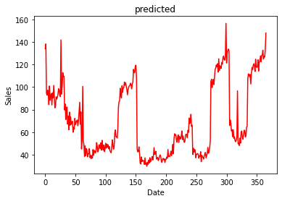

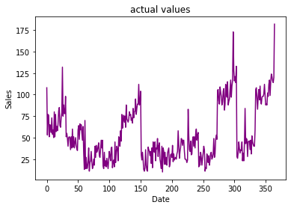

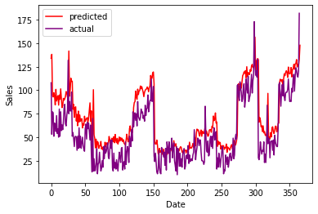

CONCLUSION

In conclusion, accurate future sales prediction is vital for any business to make informed decisions, allocate resources efficiently, and adapt to changing market conditions. To enhance the accuracy of sales predictions, it's essential to consider historical data, market trends, customer behavior, and emerging technologies like artificial intelligence and data analytics. By leveraging these tools and insights, businesses can better navigate the ever-evolving landscape of sales and ensure long-term success. Keep in mind that sales predictions are not set in stone and should be regularly reviewed and adjusted as new data becomes available, allowing companies to stay agile and responsive to the dynamic nature of the market.

Thank you!