NEARBY
LOCAL SERVICES MARKETPLACE
A PROJECT REPORT
Submitted by
Susindran D (310624104342)
in partial fulfilment for the award of the degree
of
BACHELOR OF ENGINEERING
IN
COMPUTER SCIENCE AND ENGINEERING

EASWARI ENGINEERING COLLEGE
(AN AUTONOMOUS INSTITUTION)
AFFILIATED TO ANNA UNIVERSITY, CHENNAI
OCTOBER 2026

EASWARI ENGINEERING COLLEGE
BONAFIDE CERTIFICATE
Certified that this project report “NEARBY: LOCAL SERVICES MARKETPLACE” is the Bonafide work of “Susindran D (310624104342)” who carried out the project work under my supervision.
HEAD OF THE DEPARTMENT  Dr. S. Cloudin  Easwari Engineering College  Ramapuram, Chennai - 600089 |  | SUPERVISOR  Ms. Swapna Duggi  Easwari Engineering College  Ramapuram, Chennai - 600089

EASWARI ENGINEERING COLLEGE

Certificate of Viva-voce Examination
This is to certify that the Viva Voce Examination of the project work entitled “NEARBY: LOCAL SERVICES MARKETPLACE” submitted by Mr. Susindran D (310624104342) in partial fulfilment of the requirements for the award of the degree of Bachelor of Engineering in Computer Science and Engineering was conducted on [VIVA DATE] in the Department of Computer Science and Engineering, Easwari Engineering College, Ramapuram – Chennai.
Internal Examiner
Date :
ACKNOWLEDGEMENT
We express our sincere gratitude to the Principal Dr. P. Deiva Sundari and the Management of our college for providing us with the opportunity to carry out this project work.
We convey our heartfelt thanks to the Head of the Department Dr. S. Cloudin, Department of Computer Science and Engineering, for the continuous encouragement and support.
We are extremely thankful to our Project Guide Ms. Swapna Duggi, Computer Science and Engineering, for valuable guidance, suggestions and motivation throughout the completion of this project.
We would also like to extend our gratitude to all the faculty members of the Department of Computer Science and Engineering for their support.
Finally, we thank our parents and friends for their constant encouragement and help during the course of this project.
TABLE OF CONTENTS
S. No. | Contents | Page No.
1 | Abstract | i
2 | List of Tables | ii
3 | List of Figures | iii
4 | List of Abbreviations | iv
5 | Chapter 1 INTRODUCTION | 1
 | 1.1 Overview | 1
 | 1.2 Problem Definition | 1
 | 1.3 Objective Of The Project | 2
 | 1.4 Scope Of The Project | 2
6 | Chapter 2 EXISTING SYSTEM AND PROPOSED SYSTEM | 4
 | 2.1 Existing System | 4
 | 2.2 Limitations Of The Existing System | 4
 | 2.3 Proposed System | 4
 | 2.4 Advantages Of The Proposed System | 5
7 | Chapter 3 SYSTEM ANALYSIS AND DESIGN | 6
 | 3.1 Hardware And Software Requirements | 6
 | 3.2 System Architecture | 7
 | 3.3 Module Description | 9
 | 3.4 Uml Diagrams And Data Flow Diagram | 12
 | 3.5 Algorithm And Flowchart | 14
8 | Chapter 4 IMPLEMENTATION | 18
 | 4.1 Implementation Details | 18
 | 4.2 Module Implementation | 18
 | 4.3 Tools And Technologies Used | 23
9 | Chapter 5 RESULTS AND TESTING | 25
 | 5.1 Screenshots And Outputs | 25
 | 5.2 Testing And Validation | 28
 | 5.3 Results And Discussion | 30
10 | Chapter 6 CONCLUSION AND FUTURE ENHANCEMENT | 32
 | 6.1 Conclusion | 32
 | 6.2 Future Enhancements | 32
11 | References / Bibliography | 34
12 | Appendices (Source Code) | 35

ABSTRACT
Nearby is a Local Services Marketplace developed to connect customers with service providers through exact six digit Indian pincode matching. Informal service enquiries often separate coverage, price, availability and confirmation across calls and messages. Nearby brings these activities into a centralized web application and links payment status, communication, reviews and disputes to a booking. Its purpose is to provide an organized service journey with clearly defined responsibilities for customers, providers and administrators.
Customers search active services, inspect details and request a scheduled booking. Providers maintain profiles, service areas, listings and date scoped availability, and accept or reject requests. Checkout follows provider acceptance. Administrators manage verification references, marketplace policy, linked payout accounts and disputes. The system uses React, Vite and Tailwind CSS for the interface, Node.js and Express for the API, MongoDB with Mongoose for persistence, and Socket.IO for booking participant messages. JWT and bcrypt support authentication, while password recovery uses an expiring email code and invalidates earlier tokens after a successful reset.
The project contains implementation code for these workflows, but external integration and production readiness require separate verification. The local run on 22 October 2026 recorded 15 passing backend tests and one failing assertion, a successful frontend production build and one frontend lint error. Public interface screenshots were captured from the running application without a connected API. The current development KYC adapter produces a pending reference only; production verification requires a vendor integration. Live payment processing, SMTP delivery and authenticated multi user journeys remain unverified in this report. These evidence limits are retained throughout the results chapter.

LIST OF TABLES
TABLE NO. | TITLE | PAGE NO.
1.1 | Nearby at a glance | 1
1.2 | Objectives and how they are met | 2
2.1 | Comparison of the existing process and Nearby | 4
3.1 | Functional requirements | 6
3.2 | Software requirements | 7
3.3 | Hardware and execution requirements | 7
3.4 | Layers of the system | 8
3.5 | Main project folders | 8
3.6 | Main API route groups | 9
3.7 | Summary of backend modules | 9
3.8 | Summary of frontend screens | 10
3.9 | Background and event driven operations | 10
3.10 | Database models | 11
3.11 | Actors and their responsibilities | 12
4.1 | Libraries frameworks and services | 23
4.2 | Installation and run commands | 24
5.1 | Protected screenshot requirements | 28
5.2 | Test cases and observed outcomes | 29
5.3 | Test coverage by module | 30
5.4 | Objectives and outcomes | 30
6.1 | Roadmap of future work | 32
6.2 | Representative endpoints | 41
LIST OF FIGURES
FIGURE NO. | TITLE | PAGE NO.
3.1 | System architecture of Nearby | 8
3.2 | Use case diagram of Nearby | 12
3.3 | Database model and relationships | 13
3.4 | Booking request sequence diagram | 13
3.5 | Level one data flow diagram | 14
3.6 | Booking lifecycle states | 14
3.7 | Authentication and recovery flow | 15
3.8 | Flowchart of booking hold processing | 16
3.9 | Flowchart of password recovery | 17
5.1 | Landing page | 25
5.2 | Login page | 25
5.3 | Registration role selection | 26
5.4 | Customer registration form | 26
5.5 | Password recovery page | 27
5.6 | Service discovery page | 27
5.7 | Pincode validation output | 28
LIST OF ABBREVIATIONS
ABBREVIATION | EXPANSION
API | Application Programming Interface
bcrypt | Password hashing function based on the Blowfish cipher
CORS | Cross-Origin Resource Sharing
CRUD | Create, Read, Update, Delete
CSS | Cascading Style Sheets
CSV | Comma-Separated Values
DFD | Data Flow Diagram
HPP | HTTP Parameter Pollution
HTTP(S) | Hypertext Transfer Protocol (Secure)
JSON | JavaScript Object Notation
JWT | JSON Web Token
MIME | Multipurpose Internet Mail Extensions
NoSQL | Not only Structured Query Language
ODM | Object Document Mapper
PDF | Portable Document Format
RBAC | Role-Based Access Control
REST | Representational State Transfer
SMTP | Simple Mail Transfer Protocol
SPA | Single-Page Application
UI | User Interface
UML | Unified Modeling Language
URL | Uniform Resource Locator
YAML | YAML Ain’t Markup Language

CHAPTER 1
INTRODUCTION

1.1 OVERVIEW
Nearby is a responsive English language marketplace for customers and service providers in India. It supports a service journey from discovery to a recorded outcome: customers find a listing, select a time, request a booking and pay after provider acceptance. Providers publish the services and pincodes they support. Administrators maintain marketplace settings and review exceptional cases.
The system uses exact pincode matching. It does not calculate distance, locate users on a map or perform geocoding. This boundary is reflected in the discovery interface, provider service areas and booking validation. A customer should therefore understand “local” as a matching configured pincode rather than a guaranteed physical radius.
Table 1.1 Nearby at a glance
Item | Description
Project | Nearby Local Services Marketplace
Users | Customer provider and administrator
Frontend | React Vite React Router and Tailwind CSS
Backend | Node.js Express and Socket.IO
Database | MongoDB with Mongoose
Matching rule | Exact six digit Indian pincode
Currency and time | INR integer paise and Asia/Kolkata

1.2 PROBLEM DEFINITION
Service discovery can involve repeated calls to determine coverage, price and availability. Informal arrangements provide little shared history when a booking changes or a disagreement occurs. Providers also need a consistent place to maintain service information and respond to requests. The project addresses this coordination problem by linking operational records to a booking and assigning responsibility to defined roles.
An enquiry is useful only if the customer and provider share the same understanding of the work, service area and schedule. A directory entry alone does not record whether the provider accepted the requested slot. Likewise, a separate payment receipt does not necessarily identify the scope or completion state of the job. Nearby therefore models the booking as a durable coordination record.
A second problem is inconsistent access to operational information. Customers should view their own bookings, providers should manage their own listings and requests, and administrators need controlled access to policy and dispute queues. These responsibilities must be enforced at the API boundary because a browser route or hidden button alone cannot prevent an unauthorized request.
The project also addresses account recovery and exceptional outcomes. A customer who forgets a password needs a bounded recovery path, while cancelled or disputed work needs explicit handling rather than deletion of its history. The implementation uses reset code expiry, attempt limits and token versions, and retains financial and dispute records. Live correctness of the complete journey still requires an integrated test environment.

1.3 OBJECTIVE OF THE PROJECT
The main objective is to provide a structured marketplace for discovering and booking fixed price services. Supporting objectives are to match service coverage accurately, record provider acceptance before checkout, restrict private data to authorized users, and maintain the booking context for messages, reviews and disputes.
Table 1.2 Objectives and how they are met
Objective | Implementation approach
Organize discovery | Search active verified provider listings by configured pincode
Coordinate scheduling | Publish date scoped windows and validate reservations
Confirm responsibility | Record provider acceptance before checkout
Protect accounts | Hash passwords and validate JWT identity and role
Support recovery | Use a six digit expiring email code and revoke earlier tokens
Retain service context | Link chat reviews payments and disputes to bookings
Support administration | Maintain policy references resolution queues and audit records

1.4 SCOPE OF THE PROJECT
The implemented scope includes registration, login, profile updates, password recovery, provider onboarding, service listing management, pincode based discovery, availability, booking state transitions, payment integration code, customer reviews, participant messaging and administration. Prices use INR, with integer paise as the internal representation. Slot dates and times use Asia/Kolkata.
The scope excludes maps, radius search, geocoding, a native mobile application and an implemented production KYC vendor. External account approval, actual payment settlement and delivery of email cannot be established from application source alone. The report separates these dependencies from capabilities visible in the code.

Organization of the report
Chapter 2 compares informal service coordination with the proposed marketplace. Chapter 3 explains requirements, architecture, roles, data relationships and workflows. Chapter 4 describes implementation and configuration. Chapter 5 presents observed interfaces and verification results with their limitations. Chapter 6 gives the conclusion and a prioritized direction for future work. References and an appendix provide supporting documentation and selected technical material.
The report is based on repository inspection, the recorded local checks and actual public browser captures. It does not claim an independently measured improvement in cost, adoption, response time or service quality. External documentation is used to identify the technologies, while project behaviour is explained from implementation evidence and the explicitly reported verification run.

Service coverage and user responsibilities
The discovery contract accepts category, pincode, search text, page and limit parameters. When a pincode is supplied, the route checks a six digit value and requires both the provider profile and the service listing to include that pincode. It filters out inactive listings and providers without verified status. This is a coverage rule maintained by the provider, not a calculation of the physical distance between two addresses. Unsupported query parameters are rejected rather than silently interpreted as a different search method.
The customer is responsible for selecting a suitable service, providing the service address and requesting an available time. The provider remains responsible for maintaining accurate descriptions, coverage and date scoped windows. Administrators configure marketplace policy and review exceptional cases. The application records these decisions, but it does not establish that a provider attended a real appointment or that a customer received satisfactory work merely because a database status changed.
A listing price is a fixed INR amount represented internally in paise. The booking records the agreed amount and duration so that the service context survives later listing changes. The catalogue, schedule and payment configuration therefore work together: a visible service does not by itself establish checkout readiness, and a created request does not establish provider acceptance. These distinctions define the project scope and guide the validation scenarios in Chapter 5.

CHAPTER 2
EXISTING SYSTEM AND PROPOSED SYSTEM

2.1 EXISTING SYSTEM
For comparison, the existing process is an informal workflow in which customers identify providers through personal contacts or directories, then agree on service details by phone or message. This is a problem model used for design; the project has not measured how frequently any particular organization follows it. Availability, payment confirmation and dispute evidence may remain in separate records.

2.2 LIMITATIONS OF THE EXISTING SYSTEM
Customers may need to repeat the same enquiry with several providers because service coverage and free times are not published consistently. Providers receive requests without a common structure, which makes scheduling harder. Without a shared booking identifier, later communication and payment references can be difficult to reconcile. Reviews and complaints may also lack a clear link to completed work.
A fragmented process provides no uniform validation for pincode coverage, selected time or permitted cancellation. It also depends on the participants retaining the same conversation and receipts. The comparison describes a design problem, not a field survey or a measured claim about all service providers. A centralized application can improve record organization only when its data and operating processes are maintained reliably.

2.3 PROPOSED SYSTEM
Nearby uses a central API to validate operations and persist related records. A customer searches for an active listing offered by a verified provider, views the relevant availability and submits a booking request. The provider decides whether to accept the request. Acceptance establishes a temporary hold; checkout then uses configured payment settings. A paid booking proceeds towards completion, with a review period and dispute handling.
The provider maintains profile information, supported pincodes, listings and time windows. The administrator reviews verification references and manages policy settings, linked payout accounts and disputes. The development verification adapter only produces a pending reference. It does not perform identity verification and is disabled as a live verification option in production.
Table 2.1 Comparison of the existing process and Nearby
Aspect | Informal process | Nearby
Coverage | Individual enquiry | Exact configured pincode
Scheduling | Calls and separate calendars | Date scoped provider windows
Confirmation | Unstructured agreement | Recorded provider decision
Payment record | Separate receipt | Booking linked state
Communication | Personal conversation history | Participant booking conversation
Review | May not identify completed work | Customer completed booking review
Complaint | Scattered records | Dispute and admin resolution queue

2.4 ADVANTAGES OF THE PROPOSED SYSTEM
A shared booking record reduces ambiguity about which service, customer, provider and time a conversation concerns. Exact coverage matching makes the search rule explicit. Integer money values avoid representing paise as floating point fractions. Role and participant checks provide a consistent place to enforce access. Audit records support investigation of administrative and financial changes.

How the proposed system works
A provider creates a profile, declares supported pincodes and publishes a listing with price and duration. Availability windows identify when the provider can accept work.
A customer discovers an eligible service and requests a scheduled booking. The server checks the service area and scheduling inputs before storing the request.
The provider accepts or rejects the request. Accepted work receives a temporary slot hold. Checkout is allowed only when marketplace and payment configuration permit it.
The booking retains the payment and completion context. Eligible participants can communicate, the customer can review completed work, and disputes are reviewed by an administrator.

Feasibility and operating boundaries
The stack is suitable for developing a browser application and a modular API with the tools present in the repository. Operational feasibility depends on reliable MongoDB access, configured email and payment integrations, deployment monitoring and marketplace support processes. Economic feasibility has not been established through a cost study, and no revenue, adoption or performance projections are claimed in this report.

Operational tradeoffs
Centralized coordination requires maintained coverage, availability and support processes. Database connectivity and configured integrations are prerequisites for transactions. The benefit is a consistent shared record; the software does not itself guarantee service quality or replace marketplace support.

CHAPTER 3
SYSTEM ANALYSIS AND DESIGN

3.1 HARDWARE AND SOFTWARE REQUIREMENTS
Requirements are derived from the current marketplace modules. Functional requirements specify observable responsibilities and access boundaries. They are distinguished from the local tests reported in Chapter 5; a documented requirement is not itself a passing test.
Table 3.1 Functional requirements
ID | Area | Requirement
FR1 | Accounts | Register customers and providers and authenticate active accounts
FR2 | Access | Restrict role and ownership protected actions
FR3 | Recovery | Issue bounded email reset codes and invalidate old tokens
FR4 | Providers | Maintain profiles service areas and verification references
FR5 | Listings | Create manage and search eligible services
FR6 | Availability | Publish date windows and detect conflicting reservations
FR7 | Bookings | Record requests decisions checkout and completion
FR8 | Payments | Track checkout webhook refund and transfer state
FR9 | Communication | Restrict messages to booking participants
FR10 | Reviews | Allow a customer review for completed work once
FR11 | Disputes | Record participant complaints and administrative outcomes
FR12 | Administration | Manage policy linked accounts and audit records

Non functional requirements
Security requires server side identity and permission checks. Data integrity requires consistent pincode, time and money representations. Usability requires readable states for waiting, errors and unavailable services. Maintainability is supported by domain modules and shared utilities. Reliability, throughput and recovery time are deployment goals which require separate measurement; no performance benchmark is claimed.
Table 3.2 Software requirements
Component | Selection
Operating environment | Windows development workspace with Node.js and npm
Web framework | React 19 Vite 8 React Router 7
Styles and icons | Tailwind CSS 4 project CSS and Lucide icons
API | Node.js Express 5 CommonJS modules
Persistence | MongoDB and Mongoose 9
Realtime and email | Socket.IO 4 and Nodemailer
Verification | Node test runner ESLint and Vite build
Major version families above come from the project manifests. A documentation site may describe a newer release than the installed package. The report therefore uses the local lockfile and command output for implementation observations and the bibliography for general technology reference.

3.2 SYSTEM ARCHITECTURE
Table 3.3 Hardware and execution requirements
Component | Requirement and evidence limit
Computer | Capable of running Node.js browser and development tools
Memory and CPU | No measured minimum or production capacity is established
Storage | Space for dependencies source build artifacts and logs
Network | Connectivity to the selected MongoDB and integration services
Production host | Capacity to be selected through workload and recovery testing
The application separates presentation, API behaviour and persistence. React renders pages and sends requests through the API client. Express validates input and authorization, invokes domain operations and queries MongoDB through Mongoose. Socket.IO connects authorized booking participants. External services are reached through server side configuration and adapters.
This architecture gives a clear boundary between the browser and private credentials. Database connection details, JWT secrets, Razorpay secrets and SMTP passwords belong on the server. Browser environment values beginning with VITE_ are public configuration. A secure architecture also depends on deployment configuration, monitoring and review of the actual runtime behaviour.
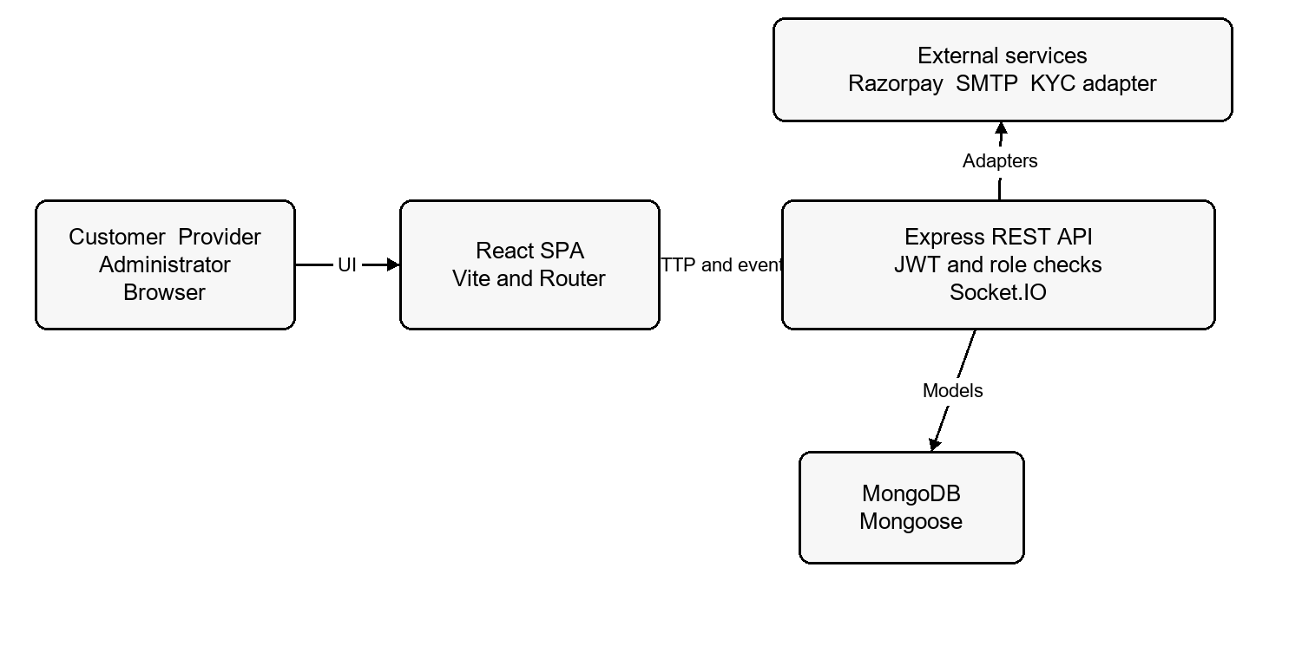
Figure 3.1 System architecture of Nearby
Table 3.4 Layers of the system
Layer | Responsibility
Presentation | Public pages protected dashboards and user feedback
Access middleware | Token account role and ownership checks
Domain routes | Service booking payment and dispute operations
Data models | Mongoose schemas references and indexes
Integration | Razorpay SMTP and the KYC adapter contract
The architecture diagram describes implemented boundaries. It does not imply that the external integrations were enabled or exercised during report preparation. The server waits for database connection before listening, and readiness includes a database ping.
Table 3.5 Main project folders
Folder or file | Purpose
server/src/app.js | Middleware route groups and readiness response
server/src/index.js | Database first startup HTTP realtime and shutdown
server/src/modules | Domain routes services and models
server/src/middleware | Authentication and role checks
server/src/utils | Lifecycle validation and HTTP helpers
server/tests | Focused automated verification
website/src/pages | Public pages authentication and dashboards
website/src/services | Browser API client and session context
Table 3.6 Main API route groups
Group | Responsibility
auth and users | Account access recovery and profile
providers and services | Provider information and marketplace listings
availability and bookings | Time windows reservations and booking decisions
payments | Checkout events verification and refunds
messages reviews disputes | Booking communication feedback and complaints
admin and settings | Operations policy linked accounts and audit

3.3 MODULE DESCRIPTION
Table 3.7 Summary of backend modules
Module | Responsibility
Accounts | Validate registration login password recovery and profiles
Provider profiles | Maintain pincodes and vendor verification references
Services | Store fixed price listings and enforce provider ownership
Availability | Represent windows and date level reservations
Bookings | Coordinate requests acceptance holds and completion
Payments | Manage orders signatures event records refunds and transfers
Messaging | Check participants and persist booking conversation
Reviews and disputes | Store customer feedback and participant exceptions
Administration | Review providers disputes policy accounts and audit data
A modular directory is an implementation organization rather than proof of isolation under all failure conditions. Routes still share a database and utility layer. Cross module actions, such as a refund affecting payout eligibility, need integration tests that span their records and error paths.
Table 3.8 Summary of frontend screens
Screen | Purpose
Landing page | Introduce the product and provide term and pincode search
Service search | Filter categories and display eligible listings
Service details | Present selected service and booking entry
Login and recovery | Authenticate or start a bounded reset flow
Registration | Choose account role and enter required account details
Customer dashboard | Access own bookings and related operations
Provider dashboard | Manage supply profiles listings availability and requests
Administrator dashboard | Access controlled marketplace operations
The same React application hosts these experiences. Protected routing improves navigation, while API checks remain responsible for security. A user with the wrong role is redirected to the appropriate dashboard. The screenshots in Chapter 5 cover actual public states. The report does not replace missing protected session evidence with illustrative screens.
Table 3.9 Background and event driven operations
Trigger | Operation
Lifecycle worker interval | Expire eligible checkout holds and update reservations
Lifecycle worker interval | Complete mature eligible jobs after the review period
Lifecycle worker interval | Reconcile pending refund records
Payment webhook | Verify signature and process an external event
Socket message | Authorize participant persist text and emit message
Reset confirmation | Consume reset state increment token version and close old sockets
The lifecycle worker uses a running guard to avoid overlapping ticks within its process and skips work when the database is disconnected. It uses conditional updates to limit stale state changes. These details do not establish multi instance safety; process coordination, retries and monitoring require a deployment review and integration checks.

Access and private data
The user model excludes password and reset digest fields by default. Provider verification and payout references have restricted exposure. Middleware reloads the active account and checks the token version and role against stored values. This helps reject tokens after reset or account changes, but the complete security posture also depends on secret handling, transport and browser session storage.
Table 3.10 Database models
Model | Stored information
User | Identity role password hash token version and reset state
ProviderProfile | Provider user service areas and verification references
Service | Provider title category fixed price duration and active state
Availability | Provider date scoped windows
AvailabilityDay | Date level reservations and hold state
Booking | Customer provider service schedule price and lifecycle
Payment and WebhookEvent | External references events refund and transfer tracking
Message and Review | Booking linked conversation and customer feedback
Dispute and AuditLog | Exceptions resolutions and operational audit
MarketplaceSettings | Public readiness and configured business policy
References are ObjectId values rather than SQL foreign key constraints. Route operations must therefore validate relevant ownership and state. Booking snapshots retain selected commercial details so that later listing edits do not silently change the original request. Index declarations support intended lookups; actual query performance has not been measured in this report.

3.4 UML DIAGRAMS AND DATA FLOW DIAGRAM
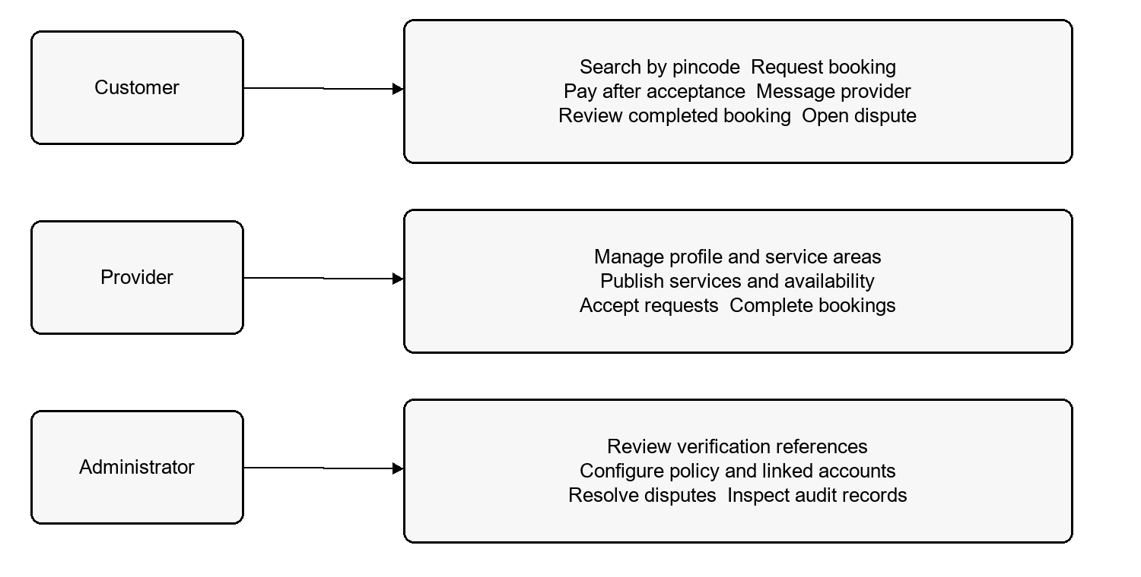
Figure 3.2 Use case diagram of Nearby
Table 3.11 Actors and their responsibilities
Actor | Responsibility
Customer | Discover request pay message review and raise eligible dispute
Provider | Manage profiles coverage listings availability and requests
Administrator | Review verification references policy linked accounts and disputes
Lifecycle worker | Perform eligible time based booking and refund processing
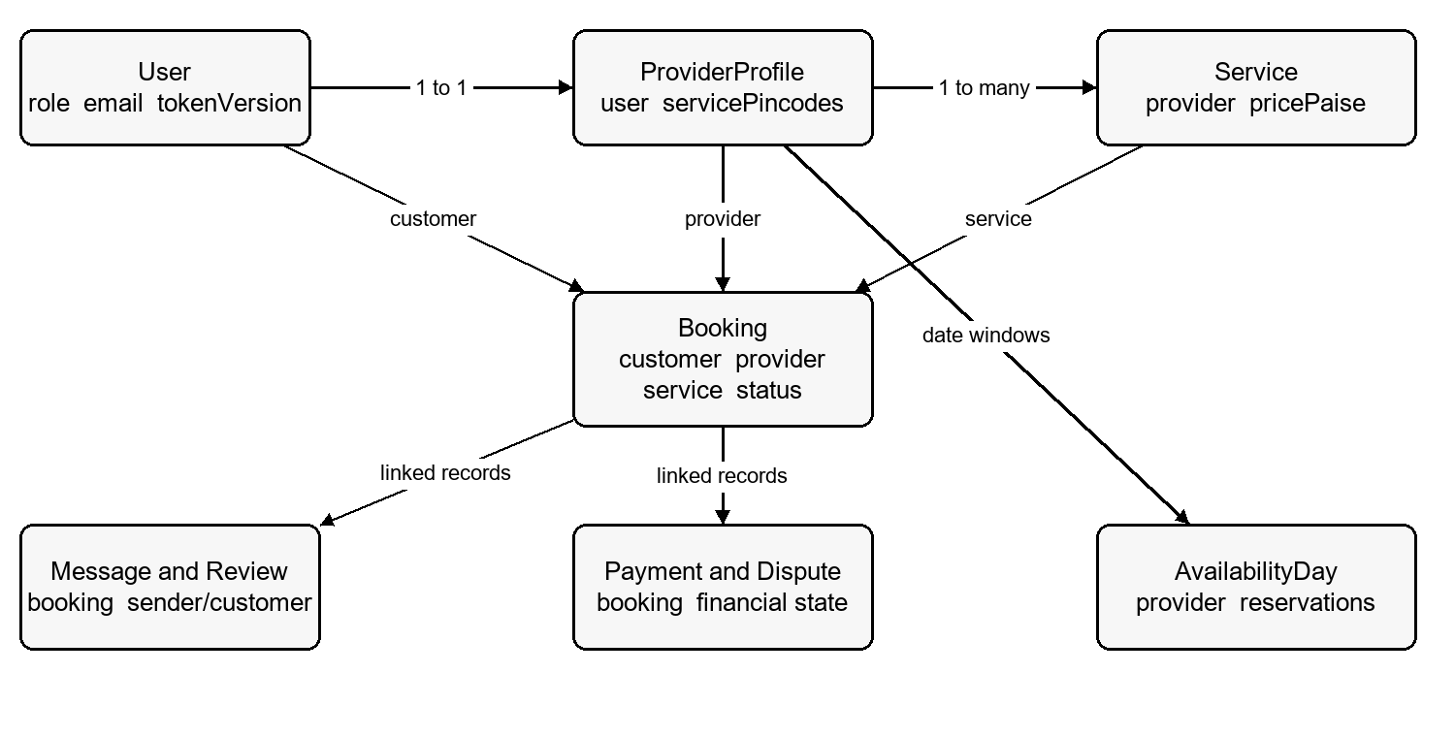
Figure 3.3 Database model and relationships
The diagram shows the principal references around the booking. The provider profile belongs to a user and owns service listings. A booking references its customer, provider and service. Messages, payments, reviews and disputes retain the booking identifier. Availability reservations relate the provider and date to held or confirmed work.
Supporting details are intentionally summarized so the diagram remains readable. It is a document database relationship view and not a complete relational schema. The field level model definitions and route validation are the source of truth for implementation.
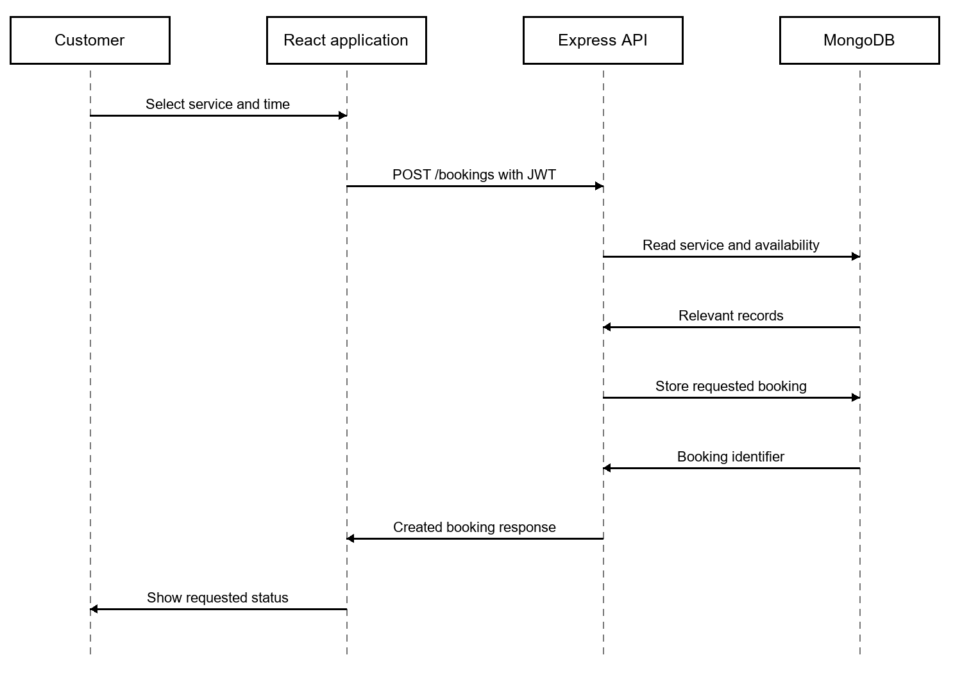
Figure 3.4 Booking request sequence diagram
The sequence describes a request being stored after validation; acceptance and payment are later operations. Each return arrow represents an application response rather than proof of a successful live test.
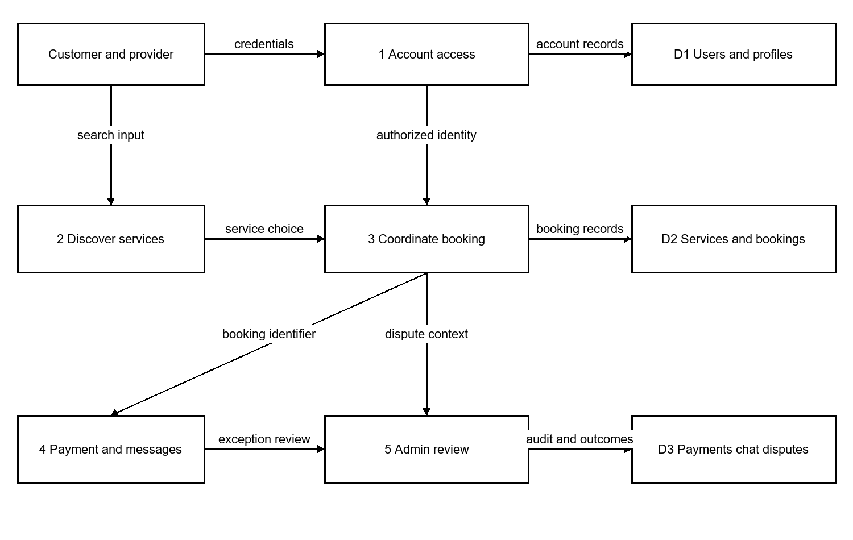
Figure 3.5 Level one data flow diagram

3.5 ALGORITHM AND FLOWCHART

Booking lifecycle and exception outcomes
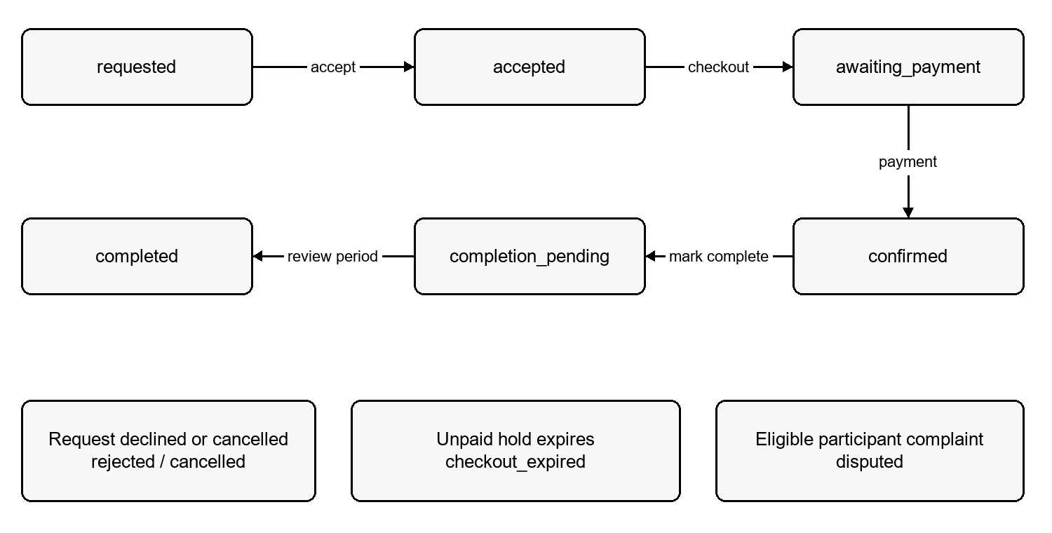
Figure 3.6 Booking lifecycle states
A booking starts as requested. Provider acceptance creates a temporary hold, while rejection closes the request. Checkout begins after acceptance. Successful payment moves the booking to confirmed. A completion action introduces completion_pending and a review deadline before eligible completion. A dispute interrupts normal payout processing. Cancellation and checkout expiry are additional terminal or exception outcomes.
This figure summarizes major paths; individual routes enforce their own state and participant checks. It is not an assertion that every displayed state can transition directly to every exception state. Unpaid holds are released after expiry. Refund state is tracked with the payment record, and provider transfers remain held when refund reconciliation or an open dispute requires it.

Sign in and role based authorization algorithm
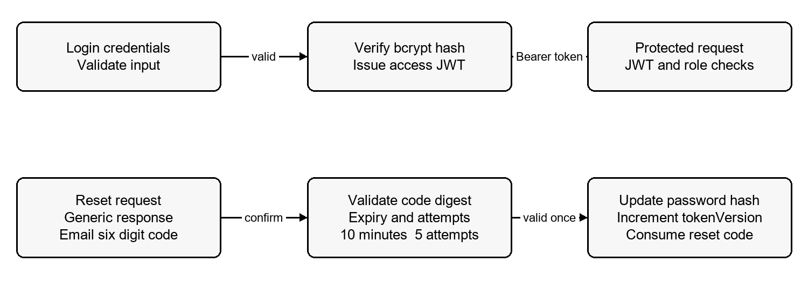
Figure 3.7 Authentication and recovery flow
Login validates credentials against a bcrypt hash and issues a signed JWT. Protected API requests verify the token and relevant role. Token versions provide a way to invalidate earlier access tokens after password recovery. A reset request returns the same account safe message whether or not an active account exists.
The reset code is six decimal digits generated with cryptographic randomness. The application stores a keyed digest with an expiry ten minutes in the future and a maximum of five failed attempts. A valid confirmation hashes the new password, consumes the reset fields and increments tokenVersion. Existing messaging sessions are also disconnected where possible. Actual receipt of email depends on SMTP configuration.

Account state and role changes
Authentication is checked against current account data rather than only the role embedded in an old token. Middleware verifies that the user still exists, is active and has the claimed role, then compares token versions. Password recovery increments the version so that earlier access tokens fail subsequent checks. Domain operations add their own ownership or participant restrictions. A valid customer token therefore does not grant access to another customer’s booking, and a valid provider token does not grant editing rights over another provider’s listing.

Availability hold and checkout algorithm
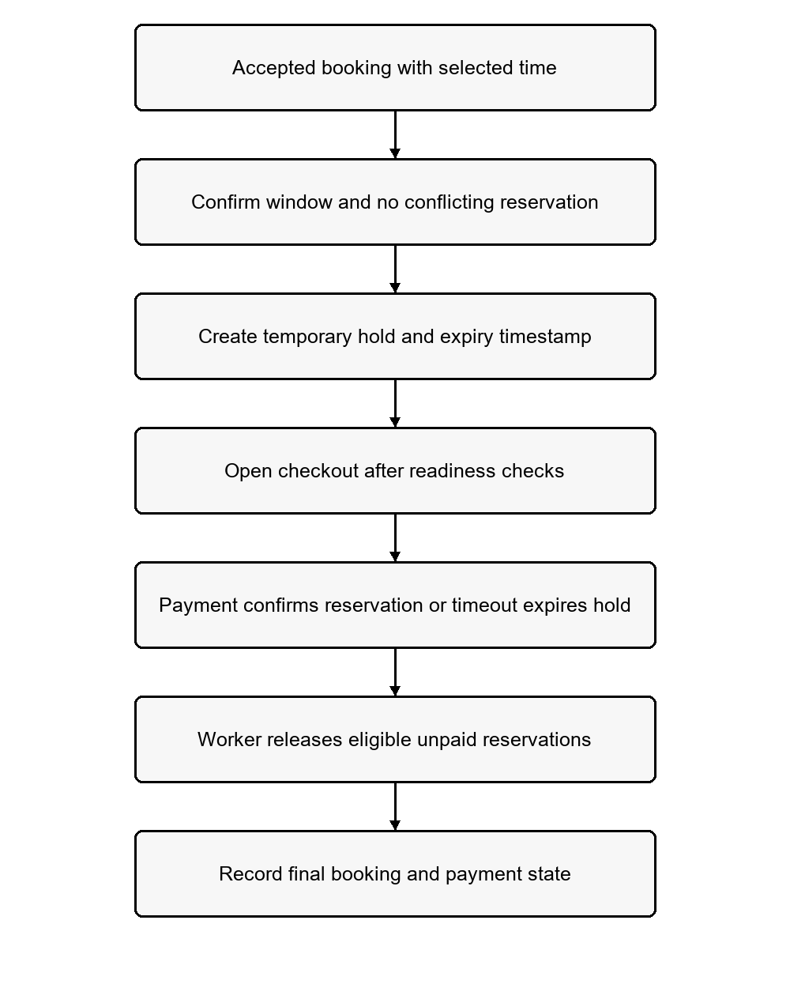
Figure 3.8 Flowchart of booking hold processing
Window validation and reservation checks must occur before checkout proceeds. A hold is temporary, while a confirmed payment retains the reservation. The worker expires only eligible unpaid holds. Failed external operations and reconciliation need separate test scenarios rather than an assumed successful transition.

Password reset and session invalidation algorithm
A request accepts the email address and returns an account safe response. For an active account and usable secret, the server generates a six digit code, stores a keyed digest and records an expiry ten minutes ahead. The code is sent through SMTP; a failed or unavailable delivery clears the matching stored reset state.
Confirmation reads the private reset fields. Expired codes and codes beyond the attempt limit cannot change the password. An incorrect code increments the counter conditionally, and reaching five attempts clears the code. A valid code proceeds to a password hash and a conditional update that consumes the digest, changes the password and increments tokenVersion.
The conditional update binds the operation to the same active code and its remaining time and attempt budget. A later request cannot simply reuse a consumed code. Authentication compares the token version against the current user, so earlier JWTs fail after successful recovery. Existing booking message sockets are disconnected where possible.

Money and time consistency
Listing prices are accepted in rupees and converted to integer pricePaise values. Bookings retain the agreed price and duration rather than relying solely on a later editable listing. Provider dates and slot times are interpreted in Asia/Kolkata. The model supports explicit financial and scheduling rules without introducing geolocation based matching.

Password recovery flowchart
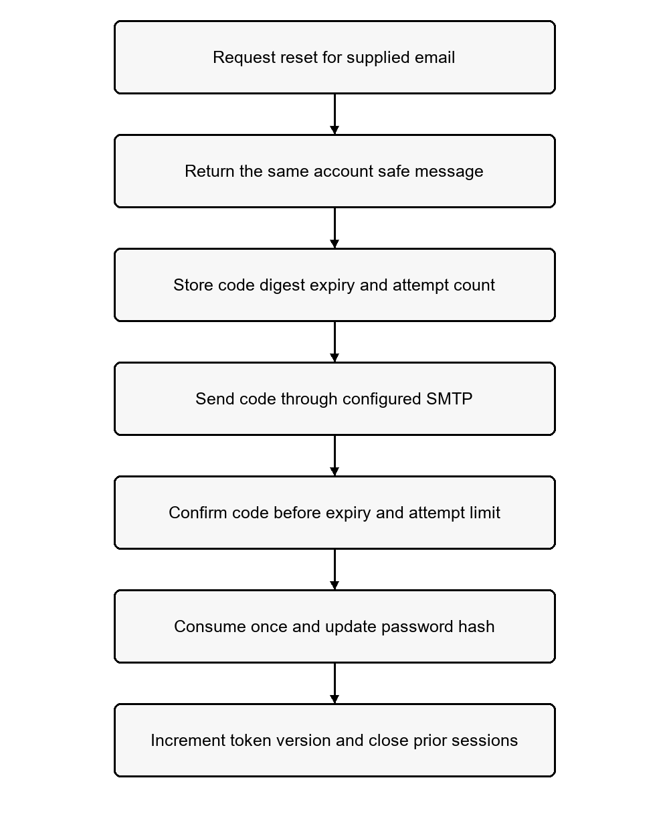
Figure 3.9 Flowchart of password recovery
This is the intended implementation path. The focused automated reset tests passed, but receipt of an actual email and completion in a browser were not verified. The flowchart must therefore be read with the evidence boundary in Chapter 5.

Failure behaviour
When verification, payment configuration or email delivery is unavailable, the associated workflow must be reported as unavailable or incomplete. It must not be treated as successful because the interface rendered. Account recovery, booking holds and refunds each retain their own state and failure conditions, which require separate tests before live operation.

CHAPTER 4
IMPLEMENTATION

4.1 IMPLEMENTATION DETAILS
The server entry point loads configuration, connects to MongoDB, creates the HTTP and Socket.IO services and starts lifecycle processing. The default API port is 4000. The frontend runs through Vite on port 5173 and reads a browser safe API base URL. The configured local web origin should use localhost consistently with the CORS allowlist.
Environment examples document required settings without exposing real values. MONGO_URI supplies database access and JWT_SECRET signs authentication tokens. CLIENT_ORIGINS defines permitted browser origins. Razorpay and SMTP settings stay on the server. The VITE_API_URL variable is public configuration and must not contain private credentials.

Database connection and startup
Code snippet 4.1 Database connection configuration
const mongoose = require("mongoose");
const dns = require("node:dns");
const net = require("node:net");

function configureDnsResolvers() {
const configured = process.env.MONGODB_DNS_SERVERS;
if (!configured) return;

const servers = configured.split(",").map((server) => server.trim());
if (!servers.length || servers.some((server) => !net.isIP(server))) {
throw new Error("MONGODB_DNS_SERVERS must contain comma-separated IP addresses.");
}

dns.setServers(servers);
}

async function connectdb(dbUrl) {
if (!dbUrl) {
throw new Error("MONGO_URI is required to start the API.");
}

configureDnsResolvers();
await mongoose.connect(dbUrl, {

4.2 MODULE IMPLEMENTATION

Authentication and account creation
Registration validates name, email, phone, country code, password and role. Phone input contains seven to fifteen digits and the country code uses a leading plus sign. Passwords must contain at least eight characters and fit the bcrypt compatible limit of 72 UTF 8 bytes. Public registration accepts customer and provider roles. Password hashes are created with bcrypt and returned account data excludes the password hash.
The observed backend test failure is explained by validation order: its attempted administrator registration omits the now required phone value, so the endpoint returns HTTP 400 before reaching the forbidden role check that the test expects to return HTTP 403. The request is rejected, but this test does not currently isolate the intended role restriction. No application or test code was changed while preparing this report.
Code snippet 4.2 Account creation and password hashing
try {
const normalizedEmail = normalizeEmail(email);
const existing = await User.exists({ email: normalizedEmail });
if (existing) return sendError(res, 409, "EMAIL_IN_USE", "An account already exists for this email address.");

const passwordHash = await bcrypt.hash(password, 12);
const user = new User({ name: name.trim(), email: normalizedEmail, phone, countryCode, passwordHash, role, isActive: true });
const token = createAccessToken(user);
await user.save();

return sendSuccess(res, {
token,
user: { id: String(user._id), name: user.name, email: user.email, phone: user.phone, countryCode: user.countryCode, role: user.role },
}, 201);
} catch (error) {

Role based authorization middleware
requireAuth parses a Bearer token, requires a configured secret and verifies HS256 claims. It then checks that the referenced active user still has the claimed role and token version. requireRole applies the route role restriction after identity has been established. Ownership and participant checks are additional domain rules, not replacements for token validation.
Code snippets 4.3 and 4.4 Account validation and role restriction
|| !["customer", "provider", "admin"].includes(claims.role)) {
return sendError(res, 401, "INVALID_TOKEN", "The access token is invalid or expired.");
}

try {
const user = await User.findById(claims.sub).select("name email phone countryCode role isActive tokenVersion").lean();
const tokenVersion = Number.isSafeInteger(user?.tokenVersion) ? user.tokenVersion : 0;
if (!user || !user.isActive || user.role !== claims.role) {
return sendError(res, 401, "ACCOUNT_UNAVAILABLE", "This account is unavailable.");
}
if ((claims.ver ?? 0) !== tokenVersion) {
return sendError(res, 401, "INVALID_TOKEN", "The access token is invalid or expired.");
}

req.user = { id: String(user._id), role: user.role, email: user.email };
return next();
} catch (error) {
console.error("Authentication lookup failed:", error.message);
return sendError(res, 500, "AUTH_LOOKUP_FAILED", "Unable to validate the account.");
}
// Intervening source lines omitted
function requireRole(roleOrRoles) {
const roles = Array.isArray(roleOrRoles) ? roleOrRoles : [roleOrRoles];
return (req, res, next) => {
if (!req.user) return sendError(res, 401, "UNAUTHENTICATED", "Sign in to continue.");
if (!roles.includes(req.user.role)) return sendError(res, 403, "FORBIDDEN", "You do not have access to this action.");
return next();
};
}

module.exports = { requireAuth, requireRole };

Provider profiles and service management
Provider profiles hold service coverage and verification references. Listings expose a category, service details, fixed price and duration. Public discovery limits results to active listings from verified providers and applies exact pincode matching. Provider only listing operations enforce ownership. Availability publishes date scoped time windows and checks conflicts against reservations and bookings.
The KYC adapter has an explicit disabled mode. In development it can return a pending reference without receiving documents. In production the current adapter reports verification unavailable. Selecting a vendor and implementing its production integration is required before treating the marketplace as a verified provider onboarding service.
Code snippet 4.5 KYC adapter selection
if (!configuredProvider || configuredProvider === "development_stub" || configuredProvider === "mock") {
return developmentAdapter;
}
return disabledAdapter;
}

module.exports = { disabledAdapter, developmentAdapter, getKycAdapter };

Availability and reservation handling
Availability stores provider windows with explicit dates and time ranges. The helper converts local values using the India offset and checks that a booking fits in one local calendar day. Date level reservations represent held and confirmed work. Overlap checks compare interval starts and ends, while expired held reservations do not permanently block the provider.
Code snippet 4.6 Reservation overlap predicate
const now = new Date();
const noOtherOverlap = {
provider: providerId,
dateKey: local.dateKey,
reservations: {
$not: {
$elemMatch: {
booking: { $ne: bookingId },
startsAt: { $lt: endsAt },
endsAt: { $gt: startsAt },
$or: [
{ state: { $in: ["confirmed", "completed"] } },
{ state: "held", expiresAt: { $gt: now } },
],
},
},
},
};

const existing = await AvailabilityDay.findOne({
provider: providerId,
dateKey: local.dateKey,
"reservations.booking": bookingId,
}).lean();
const ownReservation = existing?.reservations?.find((item) => String(item.booking) === String(bookingId));
The update condition prevents another active overlapping reservation in the same provider day record. Concurrent requests, expiry races and retry handling still need live database tests before drawing conclusions about production scheduling reliability.

Booking requests and state transitions
Booking creation validates the service, service area, selected time and availability. Provider acceptance, rejection, checkout, completion and cancellation are separate operations. The booking stores its price snapshot and lifecycle timestamps. Checkout readiness depends on marketplace policy, payment configuration and a provider linked account rather than a frontend button alone.
Payment integration code handles Razorpay orders, signature checks, webhook event deduplication, refund tracking and held Route transfers. For a partial cancellation refund, commission applies to the amount retained; the provider receives the remaining cancellation fee. A full refund leaves no provider transfer. External processing and settlement were not exercised during this report run.
Code snippet 4.7 Booking status and lifecycle timestamps
},
pricePaise: { type: Number, required: true, min: 1 },
durationMinutes: { type: Number, required: true, min: 1 },
slotHoldExpiresAt: { type: Date, default: null, index: true },
completionMarkedAt: { type: Date, default: null },
completionMarkedBy: { type: mongoose.Schema.Types.ObjectId, ref: "User", default: null },
reviewDeadlineAt: { type: Date, default: null, index: true },
completedAt: { type: Date, default: null },
cancelledAt: { type: Date, default: null },
cancellationReason: { type: String, trim: true, maxlength: 1000, default: "" },
},
{ timestamps: true }
);

bookingSchema.index({ customer: 1, createdAt: -1 });
bookingSchema.index({ provider: 1, scheduledAt: 1, status: 1 });
bookingSchema.virtual("review", {
ref: "Review",

Payment processing and financial reconciliation
The payment routes accept webhook bytes before ordinary JSON parsing so that signature verification can use the original payload. Webhook event records help handle duplicates, while payment records track order creation, refunds and held transfers. Configuration determines whether checkout is ready; no sandbox payment was performed while preparing this report.
Code snippet 4.8 Webhook entry point
router.post(
"/webhook",
asyncHandler(async (req, res) => {
const rawBody = Buffer.isBuffer(req.body) ? req.body : req.rawBody;
ensure(Buffer.isBuffer(rawBody), 400, "Webhook requires the raw request body", "RAW_WEBHOOK_BODY_REQUIRED");
const secret = process.env.RAZORPAY_WEBHOOK_SECRET;
ensure(secret, 503, "Razorpay webhook secret is not configured", "PAYMENTS_NOT_CONFIGURED");
const received = req.get("x-razorpay-signature");
ensure(typeof received === "string" && /^[a-f\d]{64}$/i.test(received), 401, "Webhook signature is missing or invalid", "INVALID_WEBHOOK_SIGNATURE");
const expected = crypto.createHmac("sha256", secret).update(rawBody).digest("hex");
const expectedBuffer = Buffer.from(expected, "hex");
const receivedBuffer = Buffer.from(received, "hex");
ensure(expectedBuffer.length === receivedBuffer.length && crypto.timingSafeEqual(expectedBuffer, receivedBuffer), 401, "Webhook signature is invalid", "INVALID_WEBHOOK_SIGNATURE");

let payload;
try {
payload = JSON.parse(rawBody.toString("utf8"));
} catch (_error) {
throw new LifecycleError(400, "Webhook body is not valid JSON", "INVALID_WEBHOOK_BODY");
}
const eventName = payload?.event;
ensure(typeof eventName === "string", 400, "Webhook event is missing", "INVALID_WEBHOOK_BODY");
const eventId = req.get("x-razorpay-event-id") || crypto.createHash("sha256").update(rawBody).digest("hex");
const result = await processWebhookEvent(eventId, eventName, payload);
res.status(200).json({ success: true, data: { received: true, duplicate: result.duplicate } });
Partial cancellation calculations apply commission to the retained balance. The focused arithmetic tests pass for the recorded scenarios. They do not establish that the external gateway accepted a refund or that a provider received a transfer. Those outcomes require separately captured sandbox evidence.

Booking messages reviews and disputes
Messaging opens after provider acceptance for the supported booking states. REST and Socket.IO operations verify booking participation. Message text is trimmed and limited to 4000 characters. Realtime connection authentication uses auth.token; booking:join selects the room, message:send submits a message and message:new delivers new records.
Review creation is customer only and requires the customer’s completed booking, a rating from one to five and a unique booking review. Disputes are participant requests reviewed through administrative operations. An open dispute pauses payout. Administrative and financial actions record audit information to support later review; this does not substitute for an operational support process.
Code snippet 4.9 Participant message validation
async function createMessage(bookingId, senderId, rawText) {
ensure(isObjectId(bookingId), 400, "Invalid booking ID", "INVALID_BOOKING_ID");
const text = typeof rawText === "string" ? rawText.trim() : "";
ensure(text.length > 0 && text.length <= 4000, 400, "Message must be between 1 and 4000 characters", "INVALID_MESSAGE");
const booking = await Booking.findById(bookingId);
ensure(booking, 404, "Booking not found", "BOOKING_NOT_FOUND");
ensure(MESSAGE_STATUSES.includes(booking.status), 409, "Messaging opens after a provider accepts the booking", "MESSAGING_NOT_AVAILABLE");
ensure(await canParticipate(booking, { id: senderId }), 403, "Only booking participants can access this conversation", "FORBIDDEN");
const message = await Message.create({ booking: booking._id, sender: senderId, text });
const populated = await Message.findById(message._id).populate("sender", "name role").lean();
return { booking, message: populated };
}

async function notifyRecipient(booking, senderId, text) {
let recipientId = booking.customer;
if (String(booking.customer) === String(senderId)) {

4.3 TOOLS AND TECHNOLOGIES USED
Table 4.1 Libraries frameworks and services
Technology | Use
React and React Router | Components route selection and protected views
Vite and Tailwind CSS | Development bundle tooling and responsive styling
Express and Mongoose | Domain endpoints schemas and persistence
JWT bcryptjs and Zod | Token validation password hashes and request checks
Socket.IO and Nodemailer | Booking events and configured SMTP delivery
Razorpay Checkout and Route | Checkout linked accounts and held transfers

Frontend data access
React Router defines public landing, search, service detail, login, registration and password recovery pages. Protected routes provide customer, provider and administrator dashboards. Session context supplies the current user and readiness state. ProtectedPage redirects unauthenticated users to login and sends a user with a mismatched role to the appropriate dashboard.
The visual system uses a white canvas, yellow navigation and highlighted surfaces, blue actions and dark text. Search accepts a service term and a six digit pincode. Forms and API components expose loading and error states. The public screenshots in Chapter 5 show the running interface; protected workflows were inspected in source but were not exercised with authenticated accounts in this report run.
Table 4.2 Installation and run commands
Command and folder | Purpose
npm install in server | Install API dependencies
npm run dev in server | Run the database connected development API
npm test in server | Run existing focused backend tests
npm install in website | Install browser application dependencies
npm run dev in website | Start Vite development server
npm run lint in website | Check frontend code using ESLint
npm run build in website | Generate the production browser bundle

Deployment and integration configuration
The repository describes deploying the web application with website as the Vercel root and the server as a Node service on Render. These are deployment instructions, not verified active deployments. Production requires HTTPS, secrets management, database network access, email delivery, payment approval, operational monitoring and tested backup recovery. Local build success establishes a generated web bundle only.
Keep localhost consistent with allowed origins during local testing. Set the public web API base URL to the deployed /api/v1 URL only after configuring the backend origin and HTTPS. Deploying a frontend alone does not establish database readiness, payment approval, SMTP delivery or successful administration of disputes.

API errors and integration readiness
The browser API client reads its token from session storage and attaches it as a Bearer header. It distinguishes a failed network request from an HTTP response and attempts to parse JSON before returning data. Network failures produce a message asking the user to check API availability. The current client mainly expects a structured error object, while some lifecycle routes return an error string with a separate code. Broader integration testing should check whether useful failure messages reach the interface in both cases.
Marketplace settings store commission, checkout timeout, completion review and cancellation policy values, together with the Route enabled flag. Several values begin unset, and Route is disabled by default. These fields are operational configuration, not evidence that a particular commission or refund percentage has been approved. An operator must configure the intended policy and verify the external payment account before enabling checkout. The report therefore separates configured readiness from the existence of payment handling code.

CHAPTER 5
RESULTS AND TESTING

5.1 SCREENSHOTS AND OUTPUTS
These are actual public browser captures from the running local application. They show visible states rather than successful authenticated transactions. The database connected API was unavailable during capture; no account or payment was created for the report.

Figure 5.1 Landing page
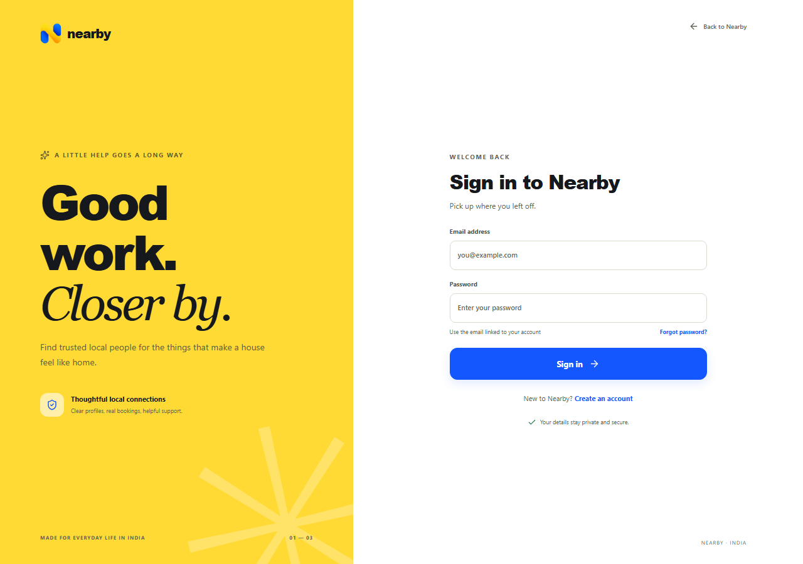
Figure 5.2 Login page
The login page links to registration and recovery. This capture contains no credentials or session token; successful authentication still requires an active account and a connected API.

Registration role selection and account form
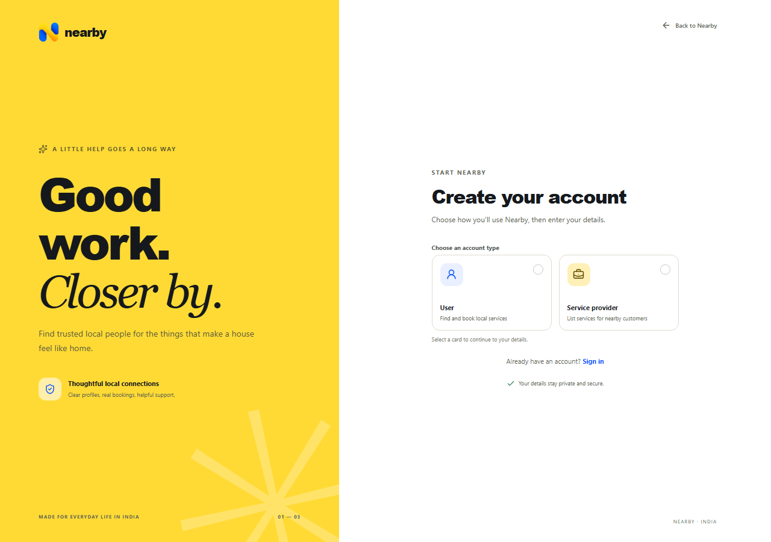
Figure 5.3 Registration role selection
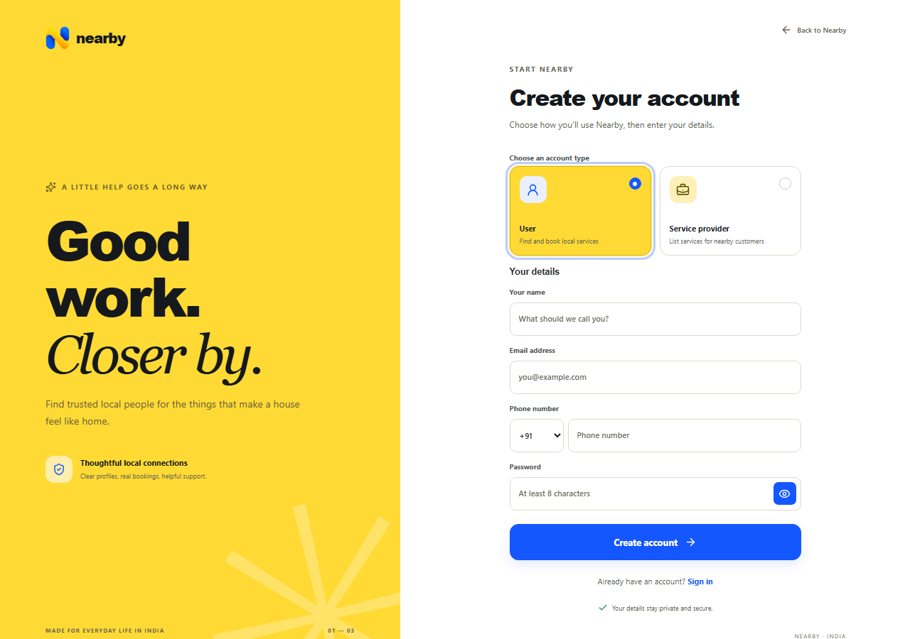
Figure 5.4 Customer registration form
Choosing the customer role reveals account entry fields. The screenshot records this UI interaction only and does not demonstrate persistence or a successful registration response.
Role selection reveals the account form. The server validates submitted identity and contact values and restricts public registration to customer and provider accounts.

Recovery and service discovery interfaces
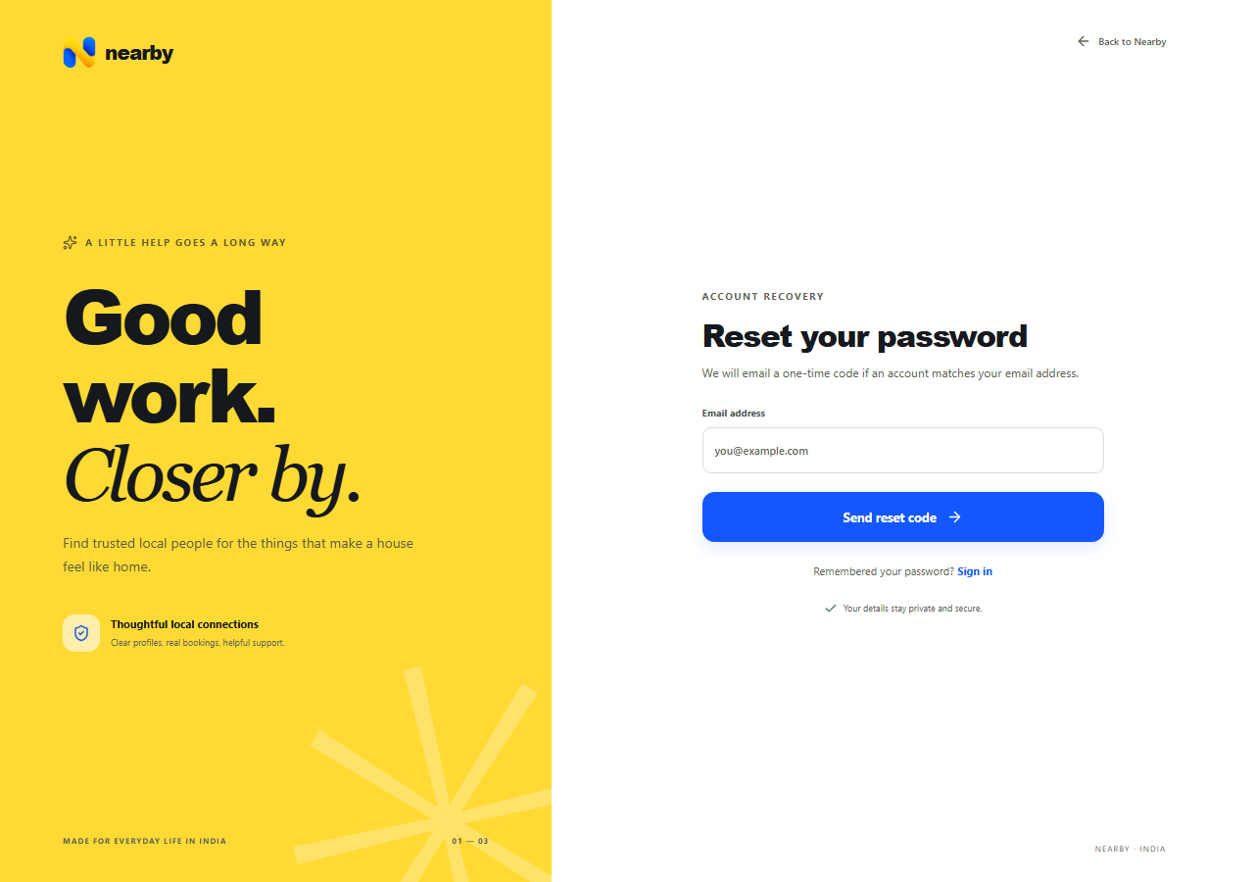
Figure 5.5 Password recovery page
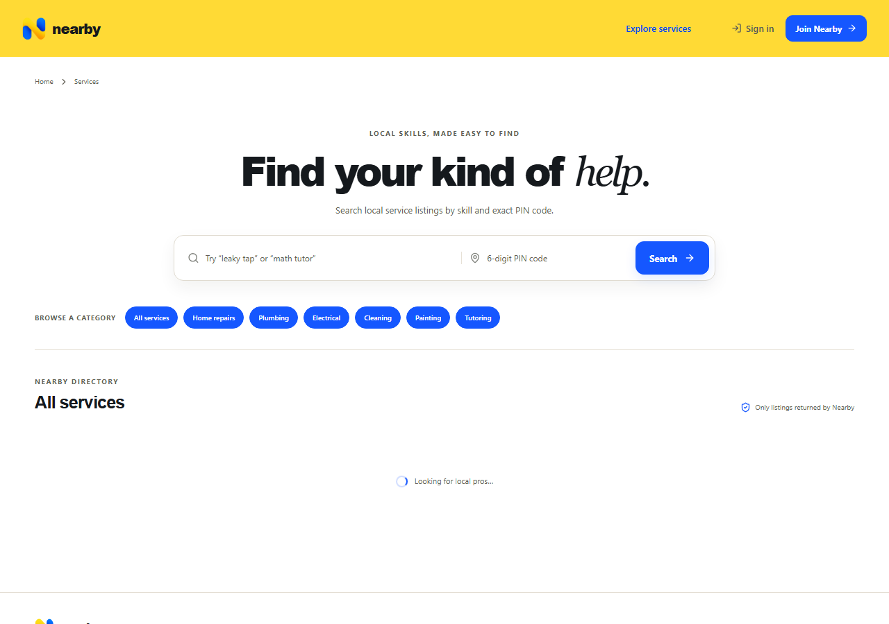
Figure 5.6 Service discovery page
The discovery capture includes the waiting state while the API is unavailable. Actual listing and booking results require a connected backend and suitable records.
Recovery depends on email delivery, while search depends on eligible service records. A rendered page does not establish that either backend workflow completed.

Pincode validation and protected output requirements

Figure 5.7 Pincode validation output
Submitting a three digit pincode displays the interface validation message. This confirms visible rejection of that input. It does not establish every search validation case or successful database discovery.
Table 5.1 Protected screenshot requirements
Screen | Required evidence
Customer and provider dashboards | Authenticated accounts and owned booking records
Administrator operations | Trusted admin account and appropriate records
Checkout and payout | Accepted booking and configured Razorpay sandbox
Booking chat and disputes | Two authorized participants and eligible booking state

5.2 TESTING AND VALIDATION
The existing backend suite was run with npm test on revision bc1ff9c on 22 October 2026. It reported 16 tests: 15 passed and one failed. The following table records the actual cases rather than converting proposed scenarios into claimed results. No coverage percentage or load benchmark was measured.
Table 5.2 Test cases and observed outcomes
ID | Existing test focus | Observed result
TC1 | Model references and private selected fields | Passed
TC2 | Unique six digit pincode validation | Passed
TC3 | Rupees converted to integer paise | Passed
TC4 | Demo categories and India calendar dates | Passed
TC5 | Development KYC stays pending without documents | Passed
TC6 | Authentication and role middleware responses | Passed
TC7 | Admin registration and coordinate discovery | Failed at first assertion
TC8 | Retained cancellation commission split | Passed
TC9 | Full refund leaves no provider amount | Passed
TC10 | Account safe reset and stored code digest | Passed
TC11 | Expired reset code cannot update password | Passed
TC12 | Five incorrect code attempts exhaust budget | Passed
TC13 | One time reset hashing and token revocation | Passed
TC14 | Password character and UTF 8 limits | Passed
TC15 | Token version compatibility and reset change | Passed
TC16 | Reset API rejects non six digit code | Passed

Interpretation of the failed assertion
The registration fixture omits the required phone field. The route validates phone before checking the public role allowlist, so the request receives HTTP 400 instead of the HTTP 403 expected by the test. This is a rejected request, but the fixture does not isolate the role restriction. Its later coordinate discovery assertion is not executed in this run because the first assertion fails.

Frontend checks
npm run lint reported one error and zero warnings: react-hooks/set-state-in-effect at Dashboard.jsx line 568, where setLoading(true) occurs synchronously inside an effect. npm run build passed, transforming 1961 modules and producing the browser bundle. A successful build does not override a failed lint check.

Additional scenarios requiring execution
An integrated environment should verify successful customer and provider registration, login, unauthorized cross account access, concurrent slot requests, checkout expiry, webhook signature failures, duplicated payment events, refund reconciliation, participant socket isolation and administrator dispute decisions. Email delivery and reset completion should be checked through an actual configured test mailbox. These scenarios are recommendations and are not recorded as passed tests.
Table 5.3 Test coverage by module
Module | Evidence present | Remaining verification
Accounts and recovery | Middleware and focused reset tests | Full browser login reset and SMTP delivery
Service discovery | Pincode and price unit checks | Database filtering and live listing results
Bookings and availability | Source inspection | Concurrent reservation hold and completion tests
Payments | Cancellation arithmetic tests | Sandbox orders webhooks refunds and transfers
Messages and disputes | Participant checks inspected in source | Two session isolation and admin outcomes
Frontend | 7 public state captures and build | Mobile keyboard and protected route interaction
The matrix reports the type of evidence available, not a count of production features. A mocked API assertion cannot verify a real email, a database concurrency condition or an external gateway decision. Likewise, an interface image establishes visible rendering but not the correctness of every operation behind it.

Reproducibility
The source revision, commands and observed failure details are retained in this report so a later run can distinguish a changed implementation from a changed test fixture. The report generation did not edit application code. Future verification should use an isolated test database and preserve the same evidence separation when updating these results.

5.3 RESULTS AND DISCUSSION
Table 5.4 Objectives and outcomes
Objective | Current evidence | Limit
Structured discovery | Listings and pincode logic implemented | Live search not exercised
Controlled access | Middleware tests and route inspection | Cross user browser tests pending
Account recovery | Focused reset tests pass | SMTP and browser journey pending
Booking coordination | State models and routes implemented | Database concurrency tests pending
Financial handling | Arithmetic tests pass | External settlement not verified
User interface | Public captures and build pass | Lint issue and protected evidence remain
The project demonstrates a modular application with a coherent booking domain and visible public interfaces. The current evidence supports development progress while identifying a stale test fixture and one lint issue. It does not establish production readiness, complete end to end correctness, external service approval, measured response times or marketplace adoption.

Validation follow up
Update the registration test fixture so it reaches the role restriction, then exercise its coordinate search check. Resolve the dashboard lint finding and rerun the focused checks. Use an isolated development database for customer, provider and administrator journeys. Follow with Razorpay sandbox events, refunds, failed delivery behaviour, participant room isolation, concurrent booking requests and lifecycle recovery after restart. Record outcomes before making deployment claims.

Acceptance criteria for integrated testing
A complete customer journey should produce an owned booking for the selected service, pincode and time, then show the provider decision before checkout becomes available. A second account should be unable to read or change that booking unless it is the linked provider participant or has an explicitly authorized administrative operation. A successful test needs observable API and database results as well as the expected browser state.
Sandbox verification should capture event identifiers, payment state and booking transitions. Duplicate events should not create duplicate effects. Pending refunds must remain distinguishable from completed refunds, and payout must respect disputes. These are future acceptance criteria, not additional passing results.

CHAPTER 6
CONCLUSION AND FUTURE ENHANCEMENT

6.1 CONCLUSION
Nearby brings service discovery, provider availability, booking decisions and related communication into a centralized web application. The project uses explicit customer, provider and administrator roles and exact pincode coverage. Its data model links the service journey to booking records, allowing payment state, reviews and disputes to be understood in context.
The implementation applies full stack development concepts through React components, an Express API, MongoDB models, JWT access control and Socket.IO messaging. Password recovery adds expiring email codes and invalidation of earlier tokens. Integer money representation and recorded lifecycle states provide a foundation for more predictable marketplace operations.
Verification identified useful implemented behaviour together with clear limits. Fifteen backend tests passed, one backend assertion failed, lint reported one dashboard error and the web production build succeeded. Public pages were captured from the running app. Production KYC, external payment execution, email delivery and authenticated multi user workflows remain outside the verified results. These distinctions should be retained when presenting the project for academic review.

6.2 FUTURE ENHANCEMENTS
Future work should first close the existing verification gaps and configure the external integrations. New product capabilities should follow measured needs. The current evidence supports a development foundation and does not establish a live marketplace ready to receive payments.
Table 6.1 Roadmap of future work
Priority | Enhancement | Expected evidence
Immediate | Repair stale registration fixture and lint finding | Passing focused checks and reachable intended assertions
Immediate | Capture authenticated role journeys | Customer provider and admin browser results
Before launch | Select and implement production KYC vendor | Sandbox adapter integration with documented outcomes
Before launch | Exercise external payment lifecycle | Orders signed events refunds and held transfer evidence
Before launch | Configure SMTP and operations | Delivery retries monitoring backup and restore checks
Next phase | Improve accessibility and mobile usability | Keyboard screen reader and viewport results
Optional | Evaluate distance based discovery | Separate decision and design beyond exact pincode
Optional | Develop analytics or native clients | Measured requirements and scoped validation
The marketplace requires external vendor configuration and operational support before live use. Current evidence includes no load benchmark, production deployment health check, disaster recovery exercise or usability study. Service coverage relies on configured pincodes, and no distance aware discovery is implemented. Protected workflow screenshots and browser evidence remain to be completed with a configured test environment.
Maps and distance matching would change the current pincode boundary and require their own product and data decisions. A native client should reuse stable, verified API contracts. Analytics should start from reliable operational records rather than projections of user growth or provider earnings.

Prioritized validation sequence
The first stage is to establish a reliable isolated development environment. Restore a clean test fixture for the required registration fields, resolve the dashboard lint finding and verify database readiness. Then exercise customer, provider and administrator accounts separately, retaining the relevant request and response evidence. A green build is useful at this stage because it proves bundle generation, but it should be reported alongside the test and lint outcomes.
The next stage is to validate operations across module boundaries. Scheduling tests should include two requests for an overlapping provider window, an unpaid hold that expires and a paid booking that reaches completion review. Communication tests should involve two authorized sessions and an unrelated third account. Verification tests should demonstrate that a development or disabled KYC reference cannot be approved as a live vendor result.
Only after those checks should an operator move to external sandbox processing and deployment recovery exercises. Record successful and failed webhook handling, email delivery and refund reconciliation. Review logging and backup recovery with the deployed configuration. Additional product features can then be prioritized using observed gaps and user feedback rather than assumed adoption or performance improvements.

REFERENCES AND BIBLIOGRAPHY
[1] React documentation. https://react.dev/
[2] Vite guide. https://vite.dev/guide/
[3] Node.js API documentation. https://nodejs.org/docs/latest/api/
[4] Express documentation. https://expressjs.com/
[5] MongoDB documentation. https://www.mongodb.com/docs/
[6] Mongoose documentation. https://mongoosejs.com/docs/
[7] Tailwind CSS with Vite. https://tailwindcss.com/docs/installation/using-vite
[8] React Router routing. https://reactrouter.com/start/declarative/routing
[9] Socket.IO 4 documentation. https://socket.io/docs/v4/
[10] RFC 7519 JSON Web Token. https://www.rfc-editor.org/rfc/rfc7519
[11] bcrypt.js project documentation. https://github.com/dcodeIO/bcrypt.js
[12] Zod documentation. https://zod.dev/
[13] Nodemailer documentation. https://nodemailer.com/
[14] Helmet documentation. https://helmet.js.org/
[15] Express Rate Limit overview. https://express-rate-limit.mintlify.app/overview
[16] Razorpay documentation. https://razorpay.com/docs/
[17] Vercel documentation. https://vercel.com/docs
[18] Render Node Express deployment guide. https://render.com/docs/deploy-node-express-app
Official URLs checked 22 October 2026. Project evidence: local Nearby source and tests at revision bc1ff9c. Technology documentation does not establish application runtime behaviour.

Project evidence sources
The implementation descriptions draw on the local README, server domain modules, middleware, Mongoose models and frontend route and service files. The automated results come from the existing server tests, frontend lint command and Vite production build run on 22 October 2026. The screenshots were captured from the local browser application; they establish visible public interface states and do not represent authenticated bookings or live payments.
The official references above explain the selected tools and protocols. They should not be cited as proof that Nearby meets a security, availability or performance target. For reproducibility, later report revisions should identify the checked source revision, executed commands, configured test environment and external sandbox outcomes. Private environment values, access tokens, passwords and vendor documents should remain outside the report and its source excerpts.

APPENDICES
Source Code

1 Project structure
Nearby separates the server and browser application. The following selected tree identifies the main implementation areas. Environment files and the local demo access file contain private configuration and are excluded from the report.
Selected repository structure
server/
package.json
src/
app.js HTTP middleware and route groups
index.js Database HTTP Socket.IO and lifecycle startup
config/db.js MongoDB connection
middleware/auth.js Identity token version and roles
modules/
auth/ Registration login and password recovery
users/ User model and account profile
providers/ Provider profiles and KYC adapter
services/ Listings search and integer price helpers
availability/ Windows and provider day reservations
bookings/ Request acceptance checkout completion
payments/ Payment events refunds and transfers
messaging/ Booking REST and Socket.IO messages
reviews/ Customer completed booking reviews
disputes/ Participant complaints and resolution
admin/ Audit and marketplace operations
settings/ Marketplace policy and readiness
utils/ Lifecycle validation and response helpers
tests/ Existing focused Node tests
scripts/ Admin provisioning and guarded demo seed
website/
package.json
src/
App.jsx Public and protected routes
pages/ Landing search detail auth and dashboards
components/ Shared application layout and states
services/ Browser API and session context
assets/ Project image assets
index.css Brand and layout foundations
App.css Component and page styles

2 Package installation
# Terminal 1 from the project root
cd server
npm install
Copy-Item .env.example .env
# Configure private MongoDB and JWT values locally
npm run dev

# Terminal 2 from the project root
cd website
npm install
Copy-Item .env.example .env
# VITE_API_URL=http://localhost:4000/api/v1
npm run dev
The API readiness URL is http://localhost:4000/health and the web development URL is http://localhost:5173. Readiness depends on a connected database and successful ping. The guarded demo seed requires a fresh disposable database; it was not run for this report.

3 MongoDB connection
server/src/config/db.js lines 1 to 28
const mongoose = require("mongoose");
const dns = require("node:dns");
const net = require("node:net");

function configureDnsResolvers() {
const configured = process.env.MONGODB_DNS_SERVERS;
if (!configured) return;

const servers = configured.split(",").map((server) => server.trim());
if (!servers.length || servers.some((server) => !net.isIP(server))) {
throw new Error("MONGODB_DNS_SERVERS must contain comma-separated IP addresses.");
}

dns.setServers(servers);
}

async function connectdb(dbUrl) {
if (!dbUrl) {
throw new Error("MONGO_URI is required to start the API.");
}

configureDnsResolvers();
await mongoose.connect(dbUrl, {
serverSelectionTimeoutMS: 10000,
connectTimeoutMS: 10000,
});

return mongoose.connection;

4 Express server and realtime engine
server/src/index.js lines 1 to 23
require("dotenv").config();

const http = require("node:http");
const mongoose = require("mongoose");
const { Server } = require("socket.io");
const connectdb = require("./config/db");
const { app, allowedOrigins } = require("./app");
const { attachMessageSocket } = require("./modules/messaging/socket");
const { startLifecycleWorker } = require("./utils/lifecycle");

const port = Number(process.env.PORT || 4000);

async function startServer() {
if (!Number.isInteger(port) || port < 1 || port > 65535) {
throw new Error("PORT must be an integer between 1 and 65535.");
}

// MONGO_URI is canonical; keep the old key as a local migration fallback.
await connectdb(process.env.MONGO_URI || process.env.MONGODB_URI);

const server = http.createServer(app);
const io = new Server(server, {
cors: {
The remaining startup logic coordinates listening, background lifecycle work and shutdown. The mounted application routes and Socket.IO share the server environment. A frontend development start does not prove that this database dependent process is ready.

5 Environment configuration
Illustrative variable names only
PORT=4000
MONGO_URI=<configure privately>
JWT_SECRET=<configure a strong private secret>
CLIENT_ORIGINS=http://localhost:5173
# SMTP and Razorpay secrets belong only on the server.
# Browser configuration contains VITE_API_URL only.

6 User model
server/src/modules/users/user.model.js lines 10 to 23
passwordResetCodeHash: { type: String, select: false, default: undefined },
passwordResetExpiresAt: { type: Date, select: false, default: undefined },
passwordResetAttempts: { type: Number, select: false, default: 0, min: 0, max: 5 },
role: { type: String, enum: ["customer", "provider", "admin"], required: true, default: "customer" },
isActive: { type: Boolean, default: true, required: true },
}, { timestamps: true, versionKey: false });

userSchema.index({ email: 1 }, { unique: true });

module.exports = mongoose.models.User || mongoose.model("User", userSchema);

7 Authentication controller and password recovery
server/src/modules/auth/password-reset.js lines 6 to 25
const PASSWORD_RESET_TTL_MS = 10 * 60 * 1000;
const PASSWORD_RESET_MAX_ATTEMPTS = 5;
const PASSWORD_RESET_REQUEST_MESSAGE = "If an account exists for this email, a reset code will be sent.";
const PASSWORD_RESET_FIELDS = {
passwordResetCodeHash: 1,
passwordResetExpiresAt: 1,
passwordResetAttempts: 1,
};

function hasPasswordResetSecret(secret = process.env.JWT_SECRET) {
return typeof secret === "string" && secret.length >= 32;
}

function hashPasswordResetCode(code, secret = process.env.JWT_SECRET) {
if (!hasPasswordResetSecret(secret)) return null;
return crypto.createHmac("sha256", secret).update(String(code)).digest("hex");
}

function createPasswordResetCode() {
return crypto.randomInt(0, 1_000_000).toString().padStart(6, "0");
Reset state is stored with a digest rather than a plaintext code. Confirmation consumes the active reset and increments the token version. These excerpts must be read with the full module; they are not an alternative implementation.

8 Role authorization middleware
server/src/middleware/auth.js selected lines 38 to 60
}
if ((claims.ver ?? 0) !== tokenVersion) {
return sendError(res, 401, "INVALID_TOKEN", "The access token is invalid or expired.");
}

req.user = { id: String(user._id), role: user.role, email: user.email };
return next();
} catch (error) {
console.error("Authentication lookup failed:", error.message);
return sendError(res, 500, "AUTH_LOOKUP_FAILED", "Unable to validate the account.");
}
// Intervening source lines omitted
function requireRole(roleOrRoles) {
const roles = Array.isArray(roleOrRoles) ? roleOrRoles : [roleOrRoles];
return (req, res, next) => {
if (!req.user) return sendError(res, 401, "UNAUTHENTICATED", "Sign in to continue.");
if (!roles.includes(req.user.role)) return sendError(res, 403, "FORBIDDEN", "You do not have access to this action.");
return next();
};
}

module.exports = { requireAuth, requireRole };

9 Service discovery and listing rules
Public search is based on exact pincode coverage. Service ownership and provider role protect modifications. Prices are represented as integer paise and a listing includes a duration used in booking validation. No map or radius fallback is implemented.
server/src/modules/services/pricing.js lines 1 to 13
function priceToPaise(price) {
if (typeof price === "number") {
if (!Number.isFinite(price) || price <= 0) return null;
price = String(price);
}
if (typeof price !== "string") return null;

const match = /^(0|[1-9]\d*)(?:\.(\d{1,2}))?$/.exec(price.trim());
if (!match) return null;

const rupees = BigInt(match[1]);
const paiseDigits = (match[2] || "").padEnd(2, "0");
const paise = rupees * 100n + BigInt(paiseDigits || "0");

10 Availability and scheduling
server/src/modules/availability/service.js selected lines 8 to 65
return new Date(`${date}T${time}:00${INDIA_OFFSET}`);
}

function isDateKey(value) {
if (typeof value !== "string" || !/^\d{4}-\d{2}-\d{2}$/.test(value)) return false;
const parsed = new Date(`${value}T00:00:00.000Z`);
return Number.isFinite(parsed.getTime()) && parsed.toISOString().slice(0, 10) === value;
}

async function getProviderWindow(providerId, startsAt, endsAt) {
// Intervening source lines omitted
const now = new Date();
const noOtherOverlap = {
provider: providerId,
dateKey: local.dateKey,
reservations: {
$not: {
$elemMatch: {
booking: { $ne: bookingId },
startsAt: { $lt: endsAt },
endsAt: { $gt: startsAt },
$or: [
{ state: { $in: ["confirmed", "completed"] } },
{ state: "held", expiresAt: { $gt: now } },
],
},
},
},

11 Booking lifecycle records
server/src/modules/bookings/booking.model.js lines 14 to 27
enum: ["requested", "accepted", "checkout_expired", "awaiting_payment", "confirmed", "completion_pending", "completed", "rejected", "cancelled", "disputed"],
default: "requested",
index: true,
},
pricePaise: { type: Number, required: true, min: 1 },
durationMinutes: { type: Number, required: true, min: 1 },
slotHoldExpiresAt: { type: Date, default: null, index: true },
completionMarkedAt: { type: Date, default: null },
completionMarkedBy: { type: mongoose.Schema.Types.ObjectId, ref: "User", default: null },
reviewDeadlineAt: { type: Date, default: null, index: true },
completedAt: { type: Date, default: null },
cancelledAt: { type: Date, default: null },
cancellationReason: { type: String, trim: true, maxlength: 1000, default: "" },
},

12 Payment and refund operations
Payment processing combines booking state, external identifiers, signed events and refund reconciliation. The following worker excerpt shows the scheduled coordination points. It does not establish that an external refund or transfer completed.
server/src/utils/lifecycle.js lines 112 to 128
async function startLifecycleWorker() {
let running = false;
const tick = async () => {
if (running || mongoose.connection.readyState !== 1) return;
running = true;
try {
await expireCheckoutHolds();
await completeMatureJobs();
await require("../modules/payments/service").reconcilePendingRefunds();
} catch (error) {
console.error("Booking lifecycle worker failed:", error.message);
} finally {
running = false;
}
};
const timer = setInterval(() => { void tick(); }, 30_000);
timer.unref?.();

13 Booking communication
server/src/modules/messaging/routes.js lines 19 to 28
async function createMessage(bookingId, senderId, rawText) {
ensure(isObjectId(bookingId), 400, "Invalid booking ID", "INVALID_BOOKING_ID");
const text = typeof rawText === "string" ? rawText.trim() : "";
ensure(text.length > 0 && text.length <= 4000, 400, "Message must be between 1 and 4000 characters", "INVALID_MESSAGE");
const booking = await Booking.findById(bookingId);
ensure(booking, 404, "Booking not found", "BOOKING_NOT_FOUND");
ensure(MESSAGE_STATUSES.includes(booking.status), 409, "Messaging opens after a provider accepts the booking", "MESSAGING_NOT_AVAILABLE");
ensure(await canParticipate(booking, { id: senderId }), 403, "Only booking participants can access this conversation", "FORBIDDEN");
const message = await Message.create({ booking: booking._id, sender: senderId, text });
const populated = await Message.findById(message._id).populate("sender", "name role").lean();

14 Reviews and dispute handling
A customer review requires a completed owned booking. Disputes remain tied to the customer and provider context, and administrative resolution affects payout eligibility. These operations need a connected database and authorized records for end to end verification.
server/src/modules/reviews/routes.js lines 9 to 18
router.post(
"/",
requireAuth,
requireRole("customer"),
asyncHandler(async (req, res) => {
const { bookingId, rating, comment = "" } = req.body || {};
ensure(isObjectId(bookingId), 400, "bookingId must be a valid booking ID", "INVALID_BOOKING_ID");
ensure(Number.isInteger(rating) && rating >= 1 && rating <= 5, 400, "rating must be an integer from 1 to 5", "INVALID_RATING");
ensure(typeof comment === "string" && comment.length <= 2000, 400, "comment cannot exceed 2000 characters", "INVALID_COMMENT");
const booking = await Booking.findOne({ _id: bookingId, customer: req.user.id });

15 Frontend routing and session access
website/src/App.jsx lines 17 to 24
}

function ProtectedPage({ children, role }) {
const { user, ready } = useSession()
const location = useLocation()
if (!ready) return <LoadingState full label="Getting Nearby ready…" />
if (!user) return <Navigate to="/login" replace state={{ from: `${location.pathname}${location.search}` }} />
if (role && getRole(user) !== role) return <Navigate to={homeForRole(user)} replace />

16 REST API endpoints
Table 6.2 Representative endpoints
Method and route | Purpose
POST /api/v1/auth/login | Authenticate account
POST /api/v1/auth/register | Create public customer or provider account
POST /api/v1/auth/password-reset/request | Request reset code
POST /api/v1/auth/password-reset/confirm | Consume reset and update password
GET /api/v1/services | Search service listings
PUT /api/v1/availability/me | Publish provider windows
POST /api/v1/bookings | Request booking
POST /api/v1/bookings/:bookingId/accept | Accept the identified booking
POST /api/v1/payments/webhook | Receive signed payment event
GET /api/v1/messages/:bookingId | Read participant conversation
POST /api/v1/disputes | Raise an eligible complaint
GET /health | Database readiness check

17 Testing and verification
Run npm test in server, then npm run lint and npm run build in website. The recorded run returned 15 passing tests and one failure, one lint error and a successful build. The failure and coverage boundaries are explained in Chapter 5. Live payment, KYC, SMTP and authenticated multi user tests were not completed and must not be reported as passed.

