### Haggis population density in the Scottish Highlands

#### S. Johnston, University of Edinburgh

The haggis is a common pest species in the Scottish Highlands (Figure 1). Haggis population densities were recorded annually from 1971 to 2000. We found that the haggis population size increased over this period by 11.6743 individuals year-1 (P = 2.615 &times; 10<sup>-15</sup>, Figure 2).

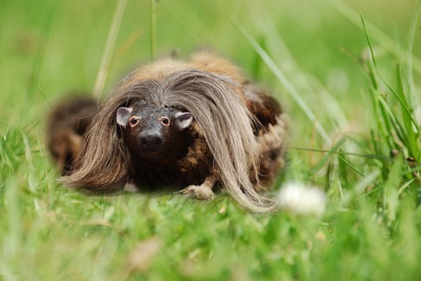

Figure 1. A wild haggis (Photo: StaraBlazkova, Wikimedia Commons)

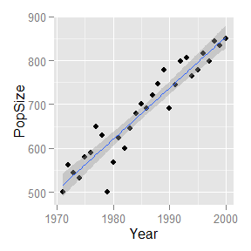

Figure 2: Linear regression of haggis population size and year.