Surge

|  |  |
| --- | --- |
| **Project Information** | |
| Project Name | Surge |
| Area | Racing Video Game |
| Document Location | GITHUB REPO |
| Spec Status | Initial Draft |
| Document Security | Public (All GitHub) ( ) Private (Only Special Topics group) (r) |

|  |  |
| --- | --- |
| **Contact Information** | |
| PM Author | Adi Suskic |
| Dev Author | Ryan Tiotuico |
| Design | Arthur Van Der Hurst |
| Test Contact | 6th Period AP Computer Science |

|  |  |  |  |
| --- | --- | --- | --- |
| Revision Summary | | | |
| Author | Date | Version | Comments |
| Adi Suskic | 12-Sep-22 | 1.0 | Initial Draft |
| Adi Suskic | 9-Nov-22 | 1.1 | Revised Doc |

# Game Description

This purpose of this project is to create a fun new racing game, SURGE, which is accessible to all. The user will control a car, navigate through a course and try to achieve the best time possible. At the top of their screen the user will be able to see a timer showing how long it has been since the start of the race. There will be powerups available to help the user better their time. While navigating through course, there will be objects and obstacles trying to interfere with the user and a timer at the top of the display to show the user’s current time. There will be a leaderboard to show the top three times achieved by the user.



# 2 Car Class

* The user will be able to control the car with the arrow keys. The LEFT arrow key will turn the car to the left, the RIGHT arrow key will turn the car to the right, the Up-arrow key will move the car forward, and the DOWN arrow key will move the car back.
* The user will be able to select which color they would like to use for the car.
* The car will follow gravity and collider mechanics

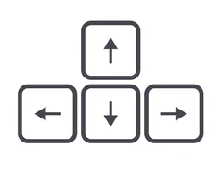

# 3 Scene

* The user will use the 3rd person perspective to drive the car
* Using the Unity RoadSystem package to have a template to make tracks
* The terrain embedded in Unity could not import correctly so we are using the Procedural terrain System package
* Using Stylized textures to add detail to terrain
* Will have different environments for each track made -Desert, Fire, Ice
* All terrains contain colliders that will act as triggers when the car falls off the track on to the terrain

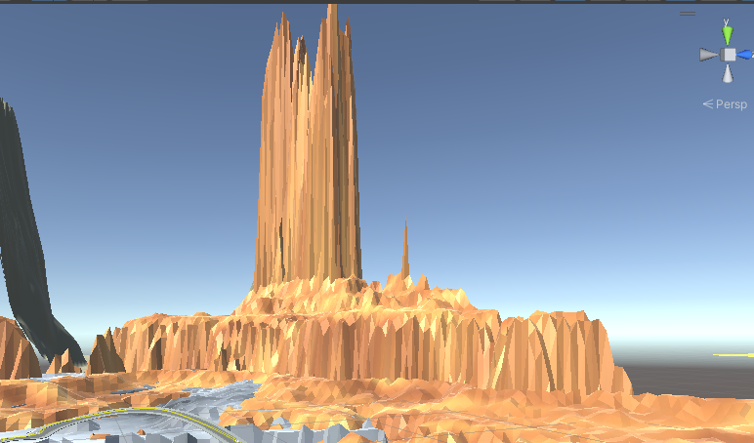

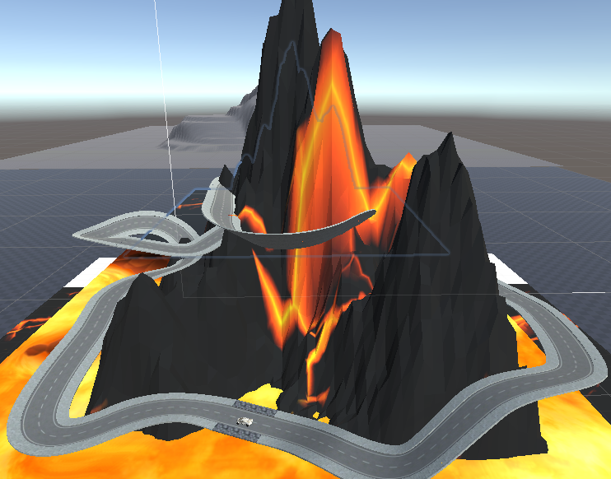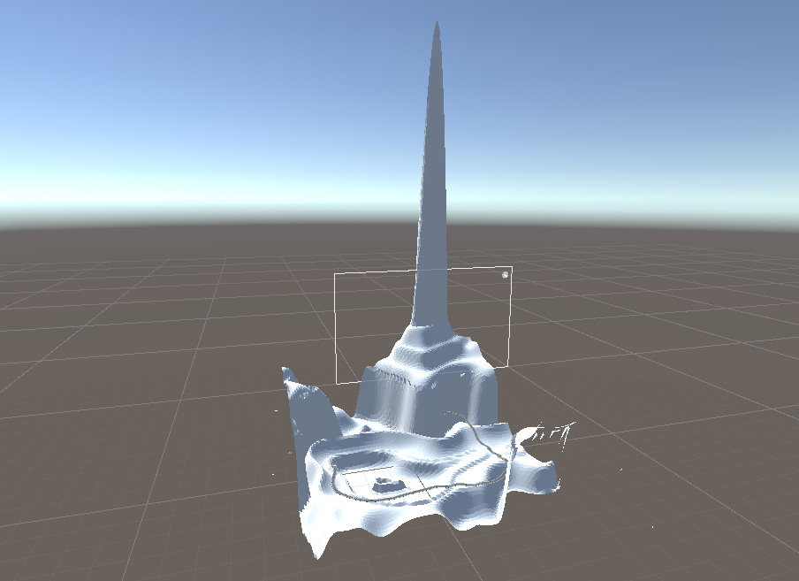

# 4 Powerup Class

* Throughout the course there will be a “boost” powerup available.

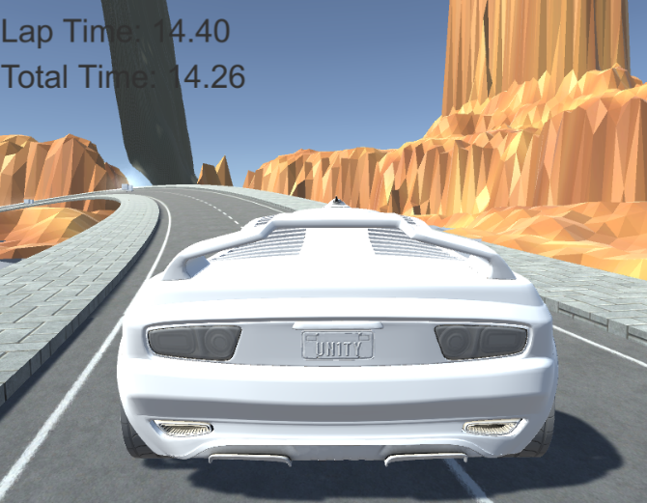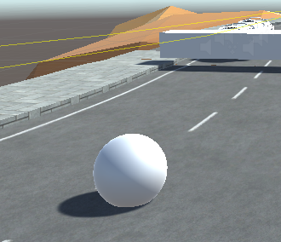

* Can increase or decrease the size of a car
* Still trying to revert the car when I want the powerup to “run out”
* Hope to make a powerup that can increase speed but having trouble with importing
* The Powerup will disappear once the user passes through the object.

# 5 Timer

* Timer program has been made
* Tracks total time spent on track, lap time, and the best lap time you have had
* Uses text UI from the Unity canvas to display time
* Lap time resets after every lap and total time stops after laps done is equal to the number of laps for that track

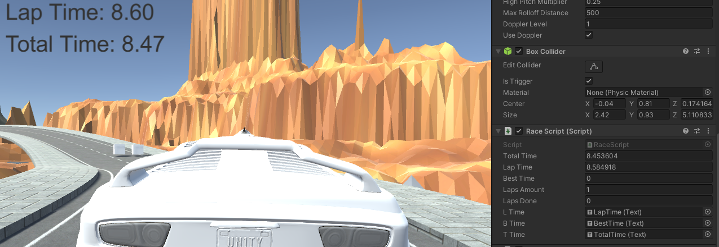

# 6 Game Control Class

* When the user’s car passes through a rigid body with the tag “Respawn”, the “Reset to Checkpoint” script will realize this and save the position of that rigid body. Then, if the car passes through a rigid body with the tag “Death”, the car will be teleported and frozen in place for a matter of time above the last saved position.

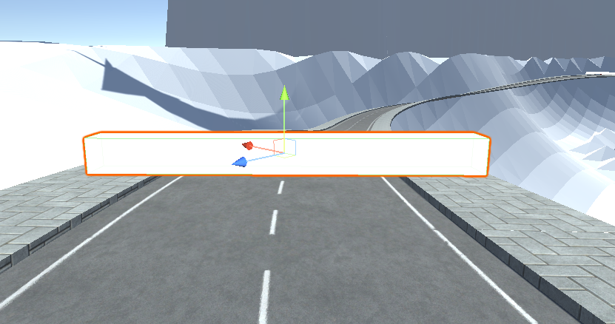

# 7 Menu UI

* The user will start in a main menu where they can select the map they wish to play and change settings
* While the user is playing a map, they will also be able to press Esc and access a pause menu that will allow the user to change their car design and settings from within the game

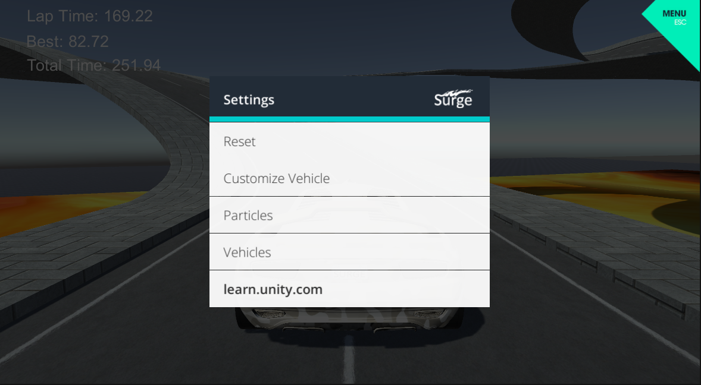

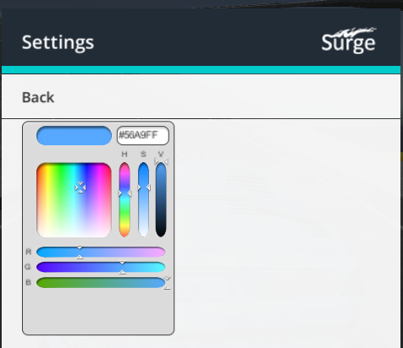

# 8 AI Opponent

* Have two AI cars made so far
* Use code from Standard Asset package
* Empty 3D objects act as way points, so they know where to go on the course

