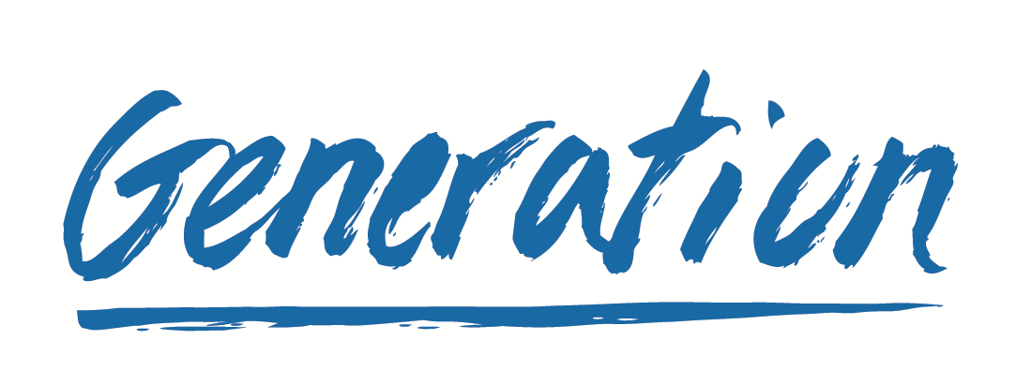

**ABOUT THIS PROJECT**

The Web Page Development Project is a two-week virtual, web development project for graduates of Generation's Junior Web Development program. This project allows teams of web development learners to create web page for a business based on a provided report.

**PROJECT TIMELINE**

This project will run from **March 1st, 2021 to March 12th, 2021**.

Web development learners will commit to 15 hours of effort each per week. Clients will contribute 1 hour per week for feedback and communication with their team.

**THE CLIENT**

Your web page will be developed for the client below:

**Name:** Paul Collins

**Title:** Owner

**Organization:** Elevate HR

**Company website:** None

**Organization’s mission statement/vision statement:** <MissionAndVision>

**PROJECT DETAILS**

The final web page will include the following elements:

* Fully Responsive
* Sections
* Images/Graphics
* Navbar
* Navs & Tabs
* Footer
* Scrolling
* Branded colours
* Carrousel
* Forms
* Cards

The web page will be created based on a public report provided by the client:

**Public Report:** https://drive.google.com/open?id=1iK_jla7TN7L9ilcw8jqBlFhV5MZ6LuZ3

**Pages to focus on:** 2

The web page will be created based on the following layout as chosen by the client:

Layout 4 - https://bit.ly/2NHNXtI

The web page will be created using the following branding guidelines as provided by the client:

<https://drive.google.com/open?id=15alhGW9VB_XMX5djaG5mkHz-m26ypI4Q>

<https://drive.google.com/drive/folders/1n_dhXOPt3yPE9-iuw3BFoCc_TK6AcB5V>

Here is some additional information relevant to the project as provided by the client:

We are a brand new business that has an existing pipeline of clients. The website is something that has been put on the back burner with branding and imagery very much limited at this stage but something that I would like to work on.

As a background to my business idea, I currently work on by-word-of-mouth marketing to boutique hotels, lodges, and corporate clients and would therefore love the website design to have as little reference to me being the key role player in the operation.

In my image folder, I have included stock images, as well as a handful of images from engagements that I feel could be good to represent 'operations in action' - I am very relaxed and will take your team's lead on what to include and what not to include in this website. I trust their design and expertise in this matter as I am largely clueless about what will portray the company in the best light.