EXAMPLE-1

Write a javascript program to print

JavaScript Output

* Writing into an HTML element, using innerHTML.
* Writing into the HTML output using document.write().
* Writing into an alert box, using window.alert().
* Writing into the browser console, using console.log().

Sou

<!DOCTYPE html>

<html>

<body>

<h2>PSCMRCET</h2>

<p>CSE DEPARTMENT.</p>

<p id="demo"></p>

<script>

document.getElementById("demo").innerHTML = 5 + 6;

</script>

</body>

</html>

Output:

* 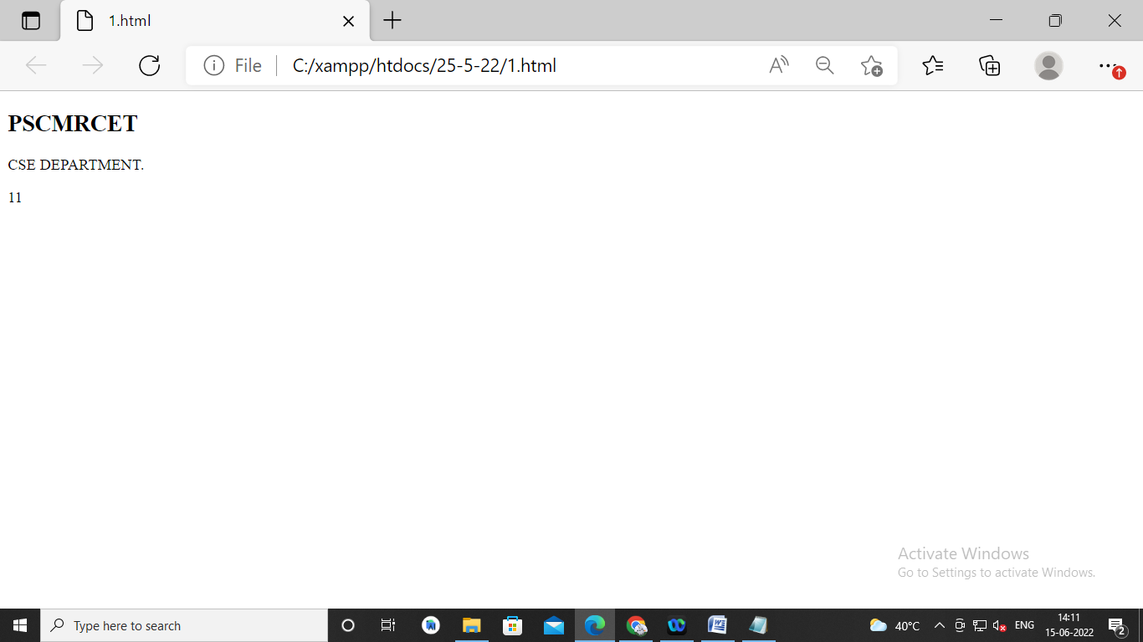

EXAMPLE-2

2.WRITE A