Happy Planet Index (HPI) R Graphics Assignment: 2020 Dataset
I have selected the year 2020 in the Happy Planet Index dataset, providing country-level observations for that year. 2020 was a significant year due to the COVID-19 pandemic, which had widespread social, economic, and environmental impacts worldwide.
After filtering, the dataset includes 155 countries or territories. The Happy Planet Index (HPI) is available for 115 observations, whereas life expectancy data are available for all 155 observations.
The following section presents the R code and corresponding figures generated from the dataset.
- Standard plots
par(mfrow = c(2, 2))
hist(hpi2020$HPI, main = "HPI")
boxplot(hpi2020$`Life Expectancy`,
main = "Life Expectancy")
plot(hpi2020$`Life Expectancy`, hpi2020$HPI,
main = "Life Expectancy vs HPI")
plot(hpi2020$`Ecological Footprint`, hpi2020$HPI,
main = "Ecological Footprint vs HPI")
par(mfrow = c(1, 1))

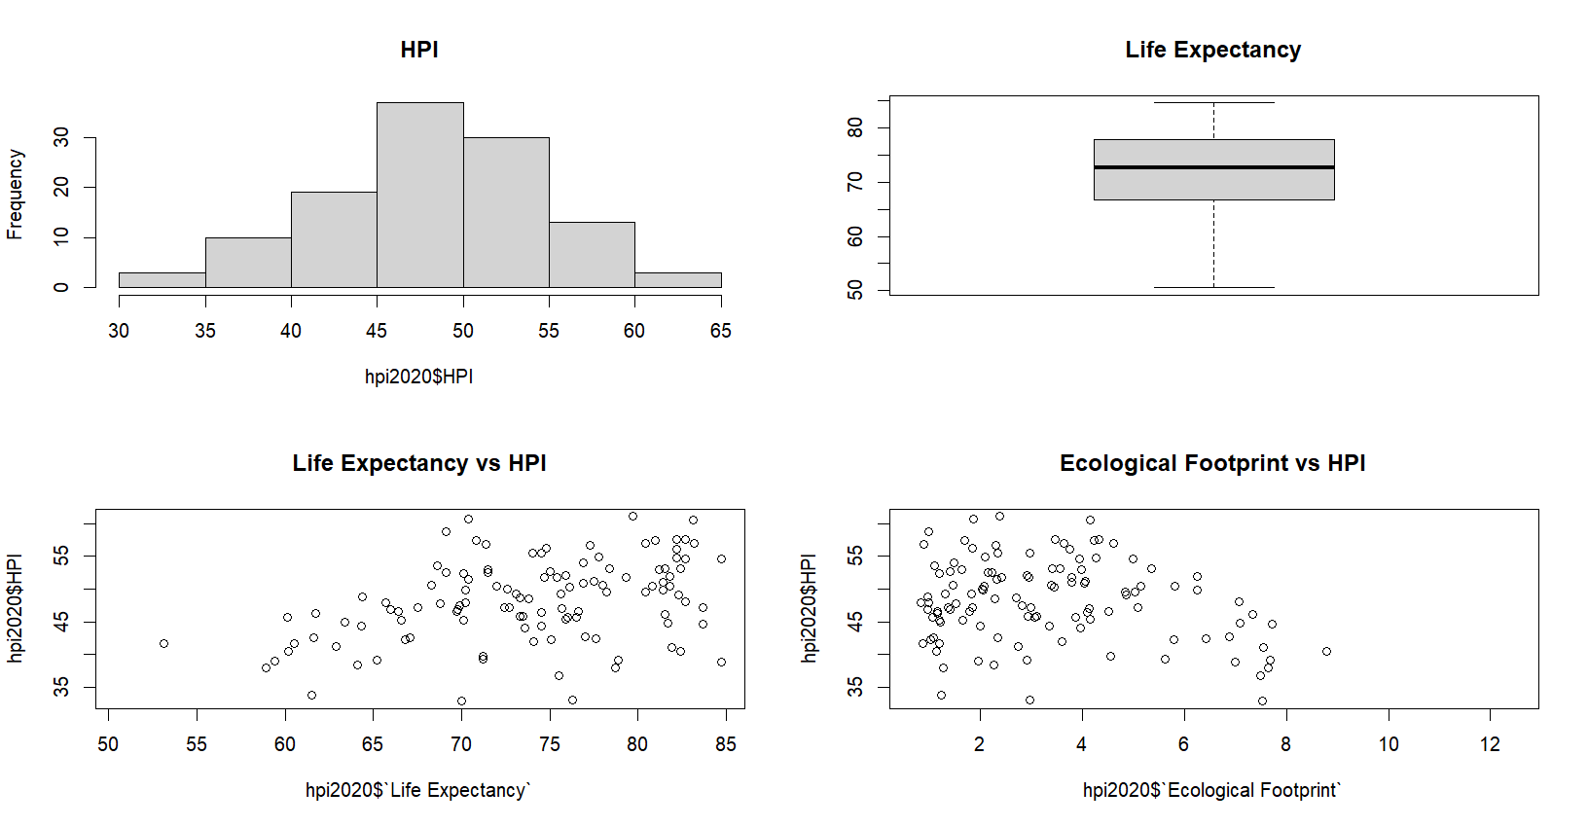
The four standard plots provide an initial overview of the 2020 Happy Planet Index dataset.
The histogram shows how HPI values are distributed across the countries with available HPI data.
The life-expectancy boxplot summarizes its median, spread, and any unusually low or high observations.
The two scatterplots explore how HPI varies with life expectancy and ecological footprint.
Together, these visuals help identify overall patterns, variation, and possible outliers in the data.

- Boxplot - box()
par(mfrow = c(1, 1))
plot(hpi2020$`Life Expectancy`, hpi2020$HPI,
axes = FALSE, xlab = "Life Expectancy", ylab = "HPI", main = "Box plot")
axis(1); axis(2)
box(col = "skyblue", lwd = 3)
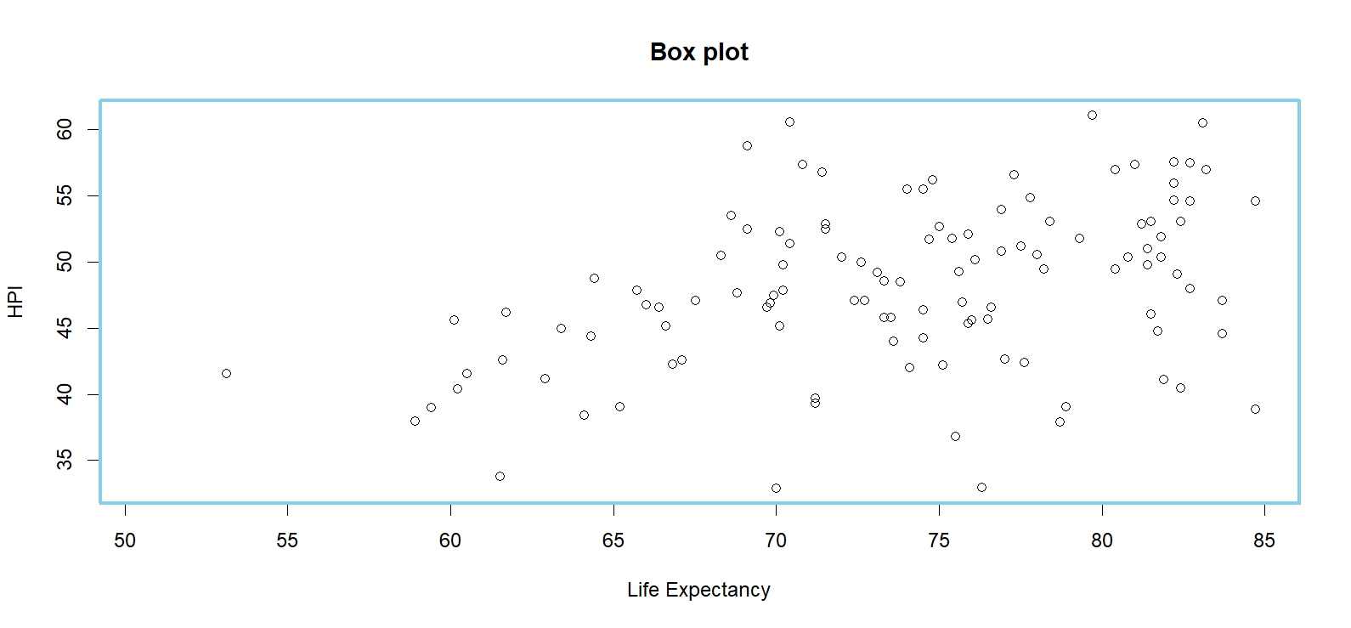
This graph displays the relationship between life expectancy and HPI for the countries in the dataset.
Each point represents one country or territory with available information.
The customized blue box makes the plotting region more visually distinct from the rest of the graph.
The x-axis represents life expectancy, while the y-axis represents the Happy Planet Index.
This format is useful for observing whether countries with longer life expectancy tend to have different HPI scores.

- Box Plot by manually controlling axis:
plot(hpi2020$`Life Expectancy`, hpi2020$HPI,
axes = FALSE,
xlab = "Life Expectancy",
ylab = "HPI",
main = "Box plot")

axis(1, at = seq(50, 90, 10))
axis(2)

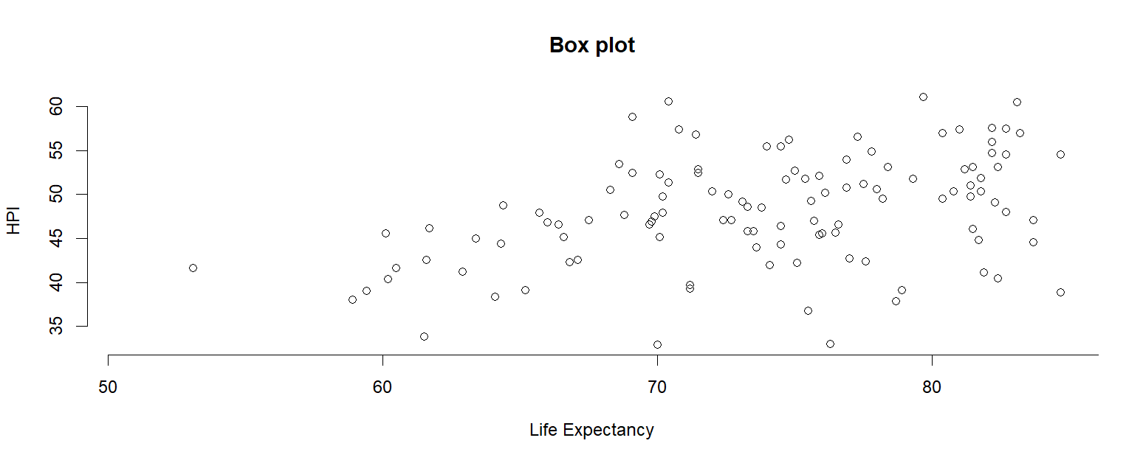
This scatterplot also compares life expectancy with HPI, but its axes are created manually.
The life-expectancy axis is marked at regular 10-year intervals from 50 to 90 years.
Using selected axis breaks makes the horizontal scale easier to read and interpret.
Each plotted point represents an individual country in the 2020 dataset.
The figure demonstrates how axis customization can improve the presentation of a graph.
- Histogram - hist()
hist(hpi2020$HPI,
breaks = 12,
main = "Distribution of HPI, 2020",
xlab = "Happy Planet Index")

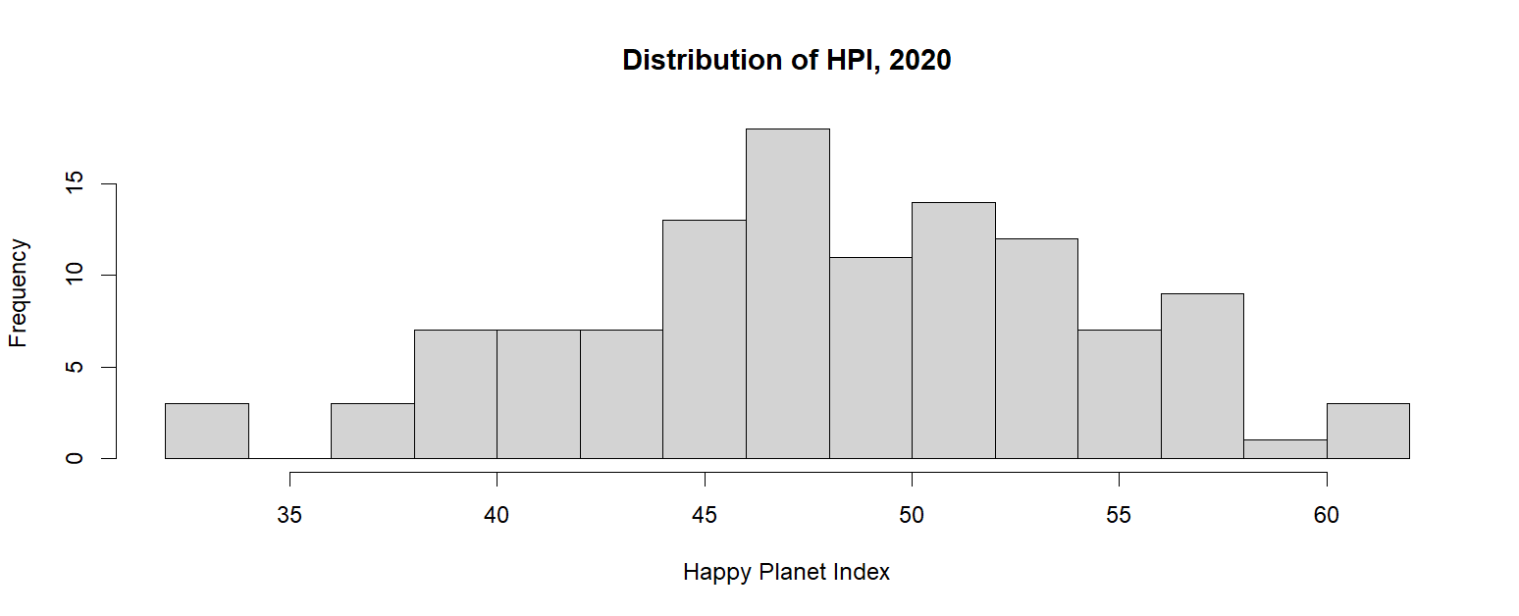
The histogram shows the distribution of Happy Planet Index scores in 2020.
The data are grouped into 12 intervals, making it easier to see where most scores occur.
Taller bars represent ranges of HPI values shared by more countries.
The graph can reveal whether scores are concentrated around certain values or spread widely across the sample.
It is useful for identifying the overall shape, center, and variability of HPI values.

- Box-and-Whisker Plot
Creates boxplots that summarize the center, spread, and potential outliers of numeric data.
boxplot(HPI ~ Continent,
data = hpi2020,
main = "HPI by Continent, 2020",
xlab = "Continent",
ylab = "HPI",
las = 2)
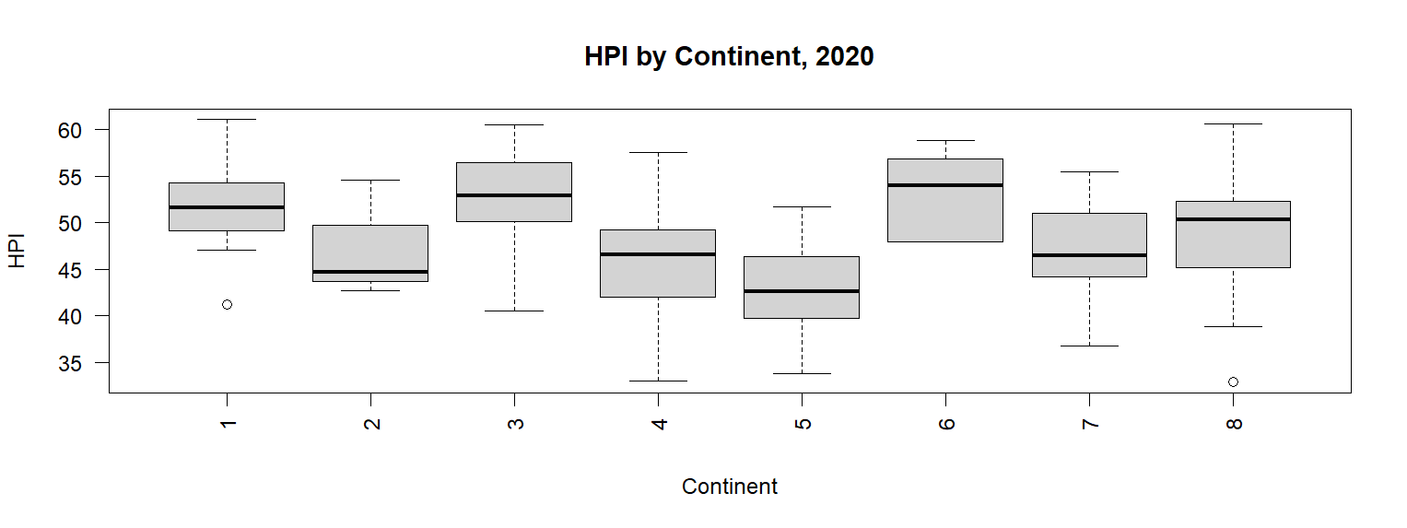
This box-and-whisker plot compares HPI distributions across continents.
Each box summarizes the median and middle 50% of HPI scores for countries in that continent.
The whiskers show the broader range of typical values, while separate points may indicate outliers.
Differences in box position suggest differences in typical HPI levels among continents.
Differences in box height and whisker length show how much HPI varies within each continent.

Pie Chart - pie()
tab <- table(hpi2020$Continent)
pie(tab,
main = "Countries by Continent, 2020",
col = c("lightblue", "lightgreen", "pink", "orange", "purple", "yellow"))


The pie chart shows how the 155 countries or territories are distributed across continents.
Each slice represents one continent, and its size corresponds to the number of observations in that group.
Larger slices indicate continents represented by more countries in the dataset.
This chart describes the composition of the sample rather than comparing HPI scores.
It is useful for understanding whether some regions have more observations than others.

Perspective plot - persp()
Creates a three-dimensional perspective surface from gridded x, y, and z values.
life.bin <- cut(hpi2020$`Life Expectancy`, 8)
ef.bin <- cut(hpi2020$`Ecological Footprint`, 8)
z <- tapply(hpi2020$HPI,
list(ef.bin, life.bin),
mean,
na.rm = TRUE)
z <- apply(z, 2, function(x)
ifelse(is.na(x), mean(x, na.rm = TRUE), x))
x <- seq(min(hpi2020$`Life Expectancy`, na.rm = TRUE),
max(hpi2020$`Life Expectancy`, na.rm = TRUE),
length.out = ncol(z))
y <- seq(min(hpi2020$`Ecological Footprint`, na.rm = TRUE),
max(hpi2020$`Ecological Footprint`, na.rm = TRUE),
length.out = nrow(z))
persp(x, y, z,
xlab = "Life Expectancy",
ylab = "Ecological Footprint",
zlab = "Mean HPI",
main = "Happy Planet Index Surface",
theta = 40,
phi = 25,
expand = 0.6,
col = "lightblue",
border = "gray40",
shade = 0.5)

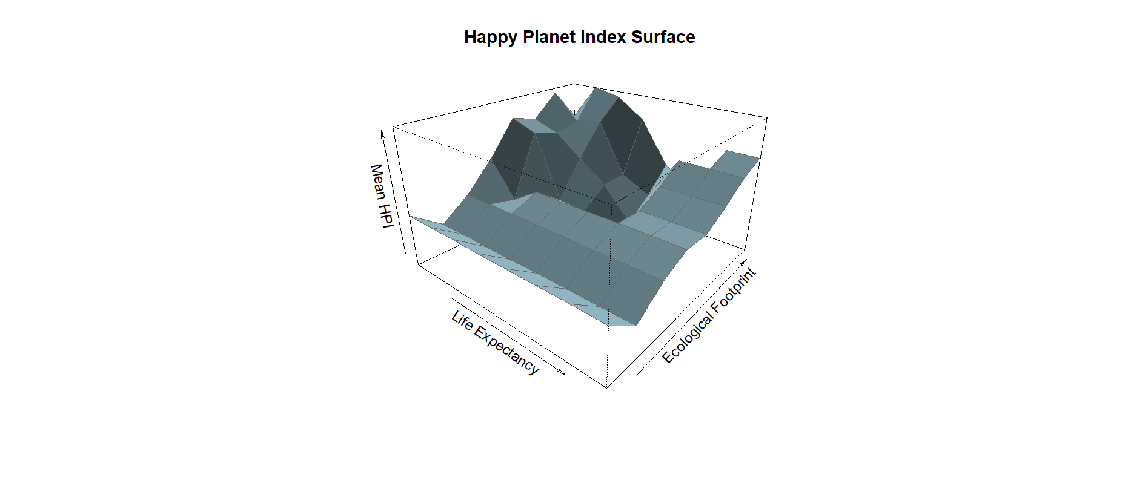
The perspective plot presents a three-dimensional view of mean HPI.
It combines grouped life-expectancy values, ecological-footprint values, and average HPI scores.
The horizontal axes represent life expectancy and ecological footprint, while the vertical dimension represents mean HPI.
The surface helps visualize how HPI changes when both explanatory variables are considered together.
Because the values are grouped into bins, the graph shows broad patterns rather than individual countries.

- Adds individual points to an existing plot - points()

plot(hpi2020$`Life Expectancy`, hpi2020$HPI,
type = "n",
xlab = "Life Expectancy",
ylab = "HPI")
points(hpi2020$`Life Expectancy`, hpi2020$HPI,
pch = 19)

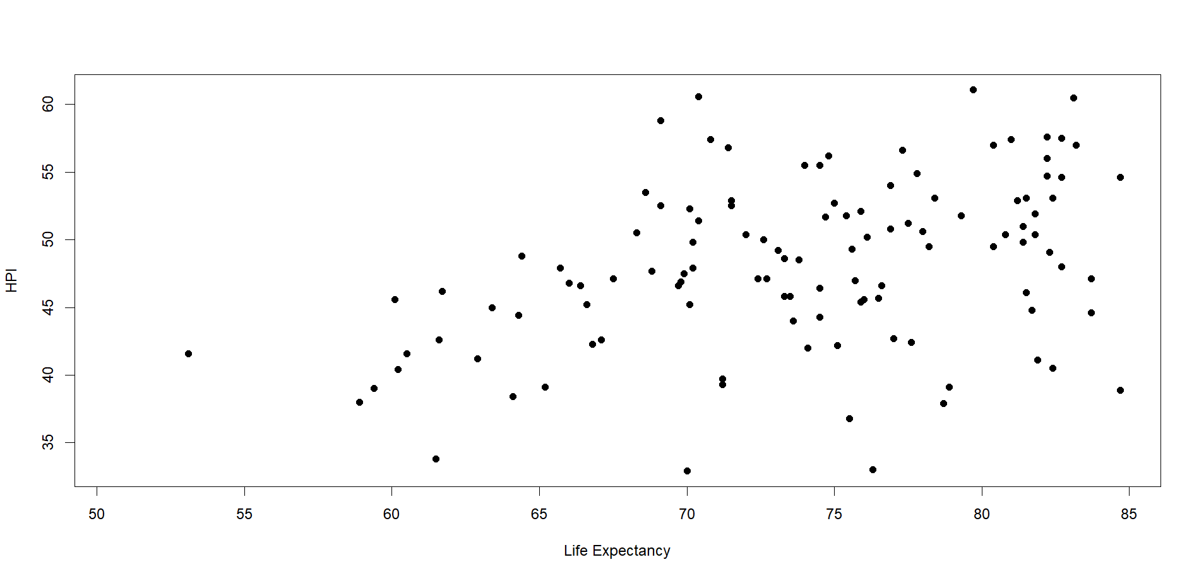

This graph uses individual points to show the relationship between life expectancy and HPI.
Every dot represents a country or territory in the 2020 sample.
The point display makes it possible to see clusters, gaps, and unusually high or low observations.
Unlike a line graph, it does not imply that the countries are connected in any sequence.
It is an appropriate format for examining the relationship between two numerical variables.
- Adds connected line segments to an existing plot – lines()
o <- order(hpi2020$`Life Expectancy`)

plot(hpi2020$`Life Expectancy`,
hpi2020$HPI,
type = "n",
xlab = "Life Expectancy",
ylab = "HPI",
main = "Life Expectancy vs HPI")

lines(hpi2020$`Life Expectancy`[o],
hpi2020$HPI[o])
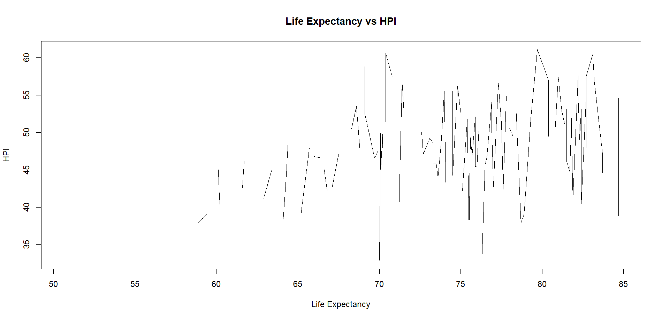
This graph connects HPI observations after the countries are ordered by life expectancy.
The line makes it easier to follow how HPI changes across increasing levels of life expectancy.
However, the connected segments do not represent a time series or a direct path between countries.
Instead, they provide a visual summary of variation in HPI along the ordered life-expectancy scale.
The figure should therefore be interpreted as a descriptive pattern rather than a causal relationship.
- Add Text to existing plot – text()

plot(hpi2020$`Life Expectancy`, hpi2020$HPI,
xlab = "Life Expectancy",
ylab = "HPI")

i <- order(hpi2020$HPI, decreasing = TRUE)[1:5]

text(hpi2020$`Life Expectancy`[i],
hpi2020$HPI[i],
labels = hpi2020$Country[i],
pos = 4,
cex = 0.7)

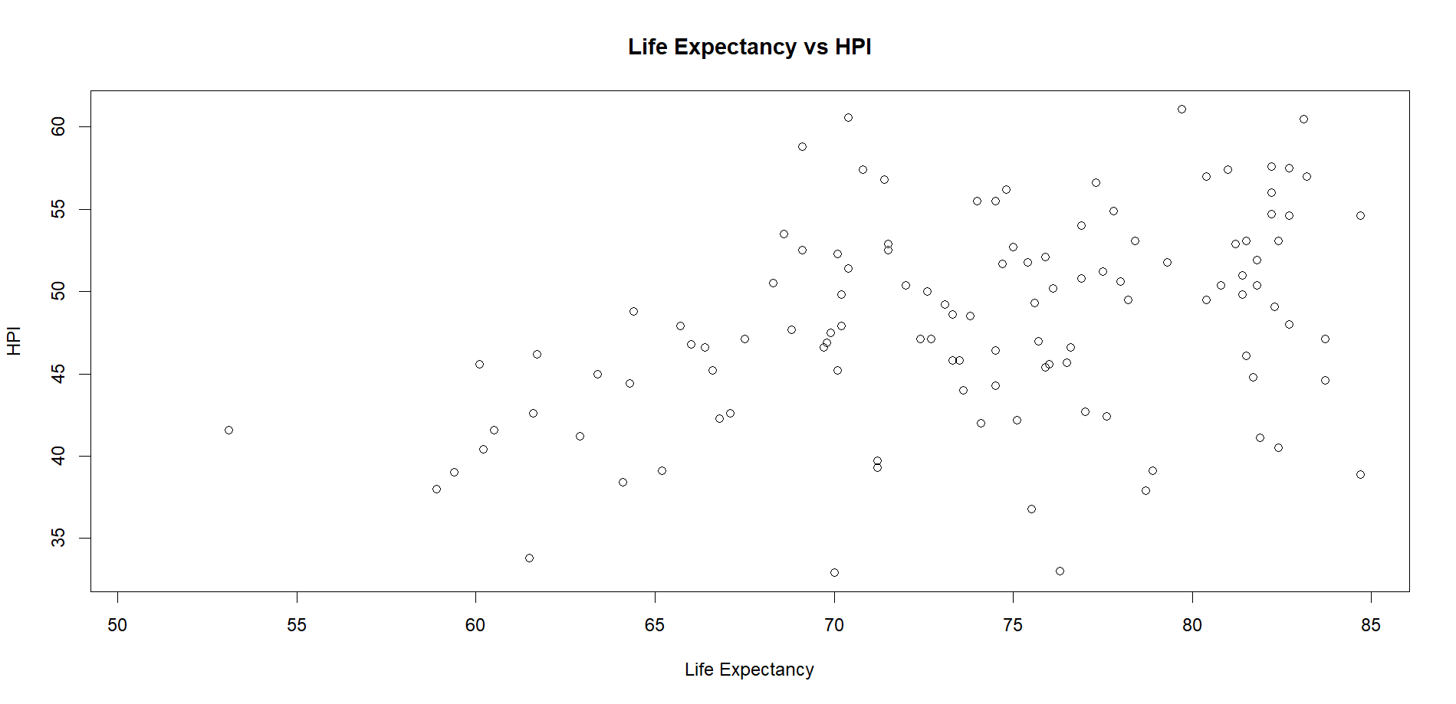

- Adds text to one of the plot margins – mtext()
plot(hpi2020$`Life Expectancy`,
hpi2020$HPI,
xlab = "Life Expectancy",
ylab = "HPI",
main = "Life Expectancy vs HPI")
mtext("2020 Happy Planet Index dataset",
side = 3,
line = 3)

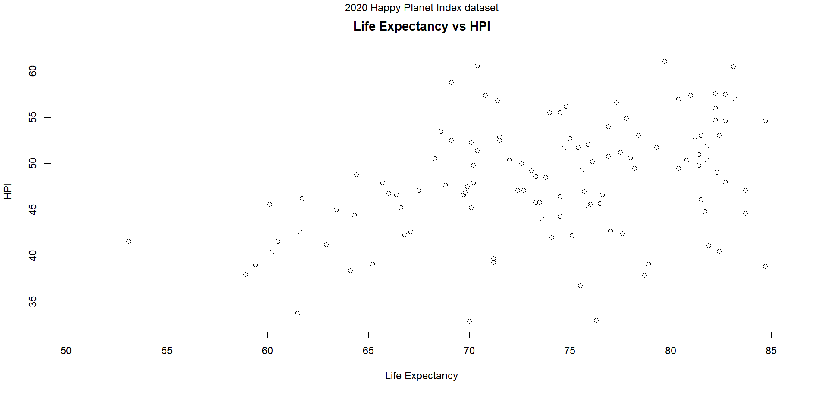
- Adds a legend to identify plotted groups or symbols – legend()
hpi2020$Group <- ifelse(
hpi2020$Continent == "Americas",
"Americas",
"Other continents"
)
plot(hpi2020$`Life Expectancy`,
hpi2020$HPI,
col = ifelse(hpi2020$Group == "Americas", "red", "darkgreen"),
pch = 19,
xlab = "Life Expectancy",
ylab = "HPI",
main = "Life Expectancy vs HPI")
legend("bottomright",
legend = c("Americas", "Other continents"),
pch = 19,
col = c(1, 2))
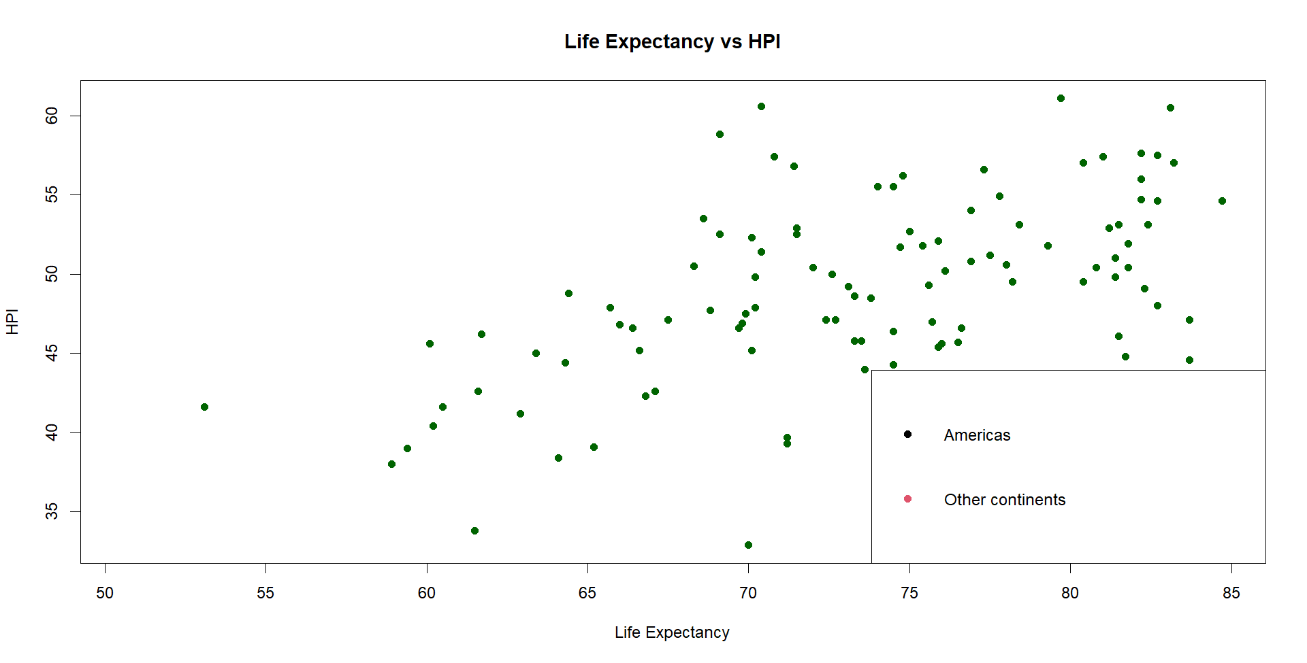
This graph compares life expectancy and HPI while separating the Americas from other continents by color.
Red points represent countries in the Americas, while dark green points represent countries in other regions.
The legend explains the meaning of the colors so the groups can be identified correctly.
This grouping makes it easier to visually compare the position and spread of the Americas with the rest of the dataset.
The plot remains a descriptive comparison and does not, by itself, establish a causal difference between groups.

