**Power BI Assignment 4**

# **1. Make a simple dashboard and show columns, bar charts, line charts, and area charts.**

**Line Chart:**

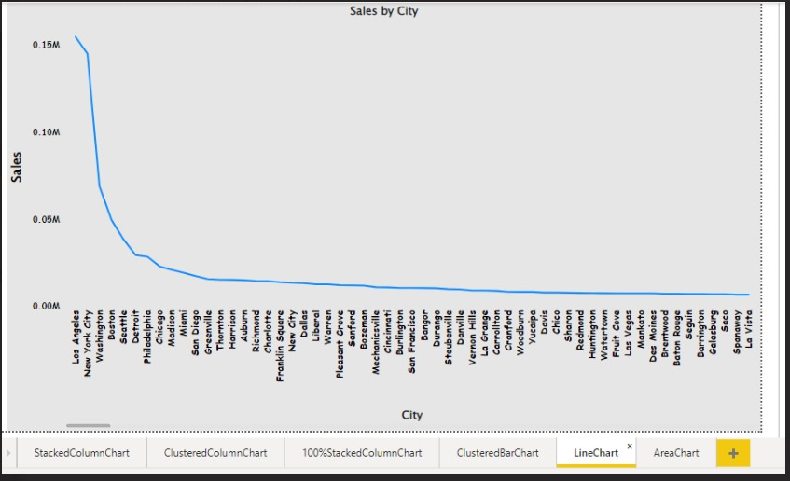

**100% Stacked Column Chart:**

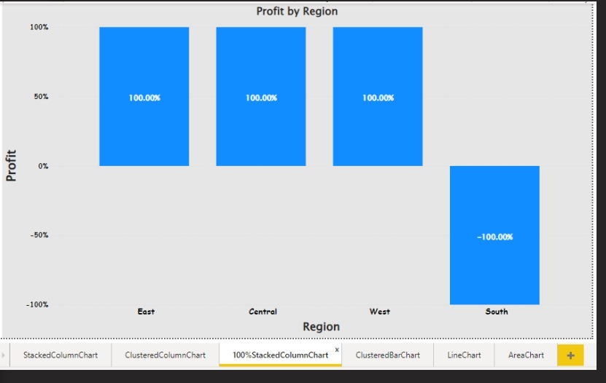

**Clustered Bar Chart:**

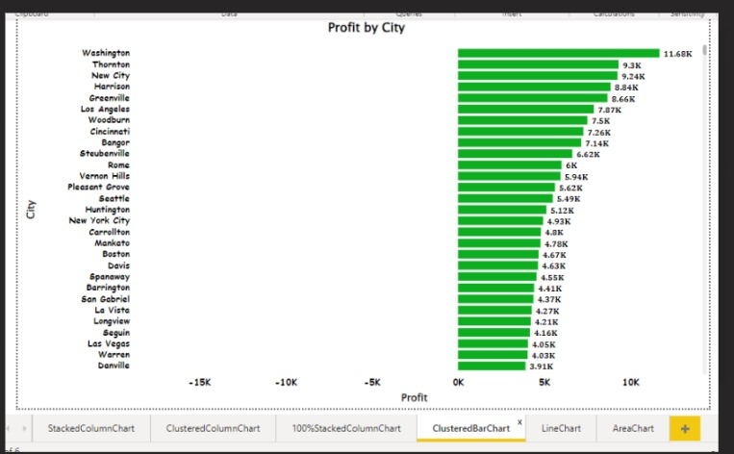

Clustered Column Chart:

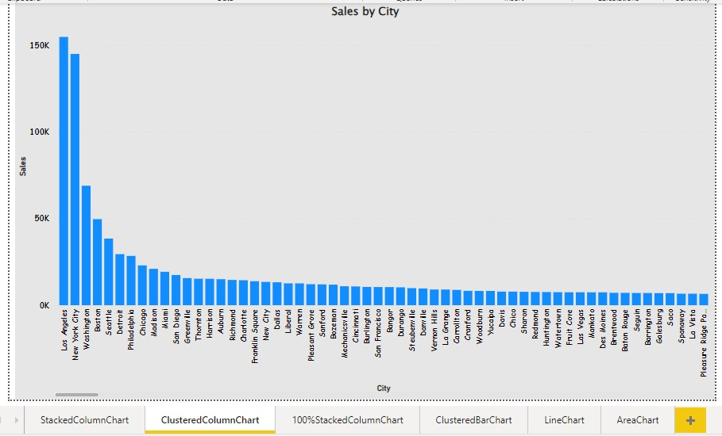

Stacked column Chart:

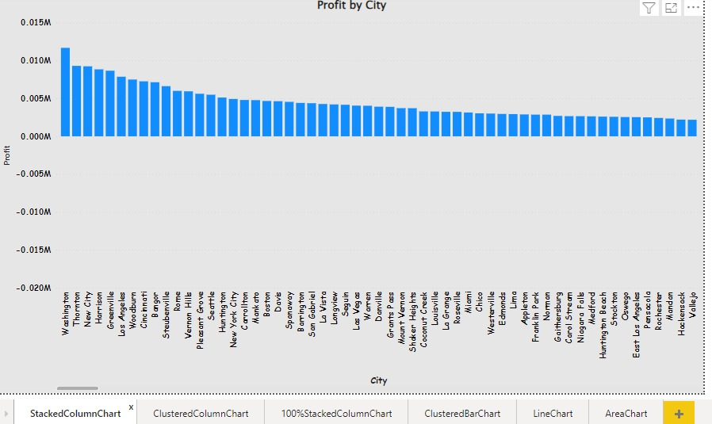

Area Chart:

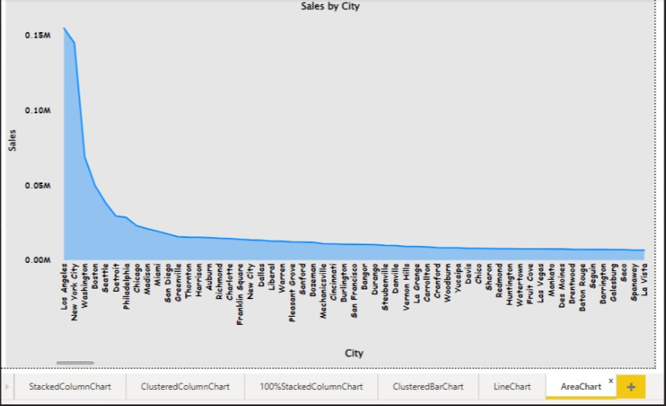

# **Make a simple dashboard and show combination chart, Scatter chart, Shape chart, and Treemap chart.**

Scatter Chart:

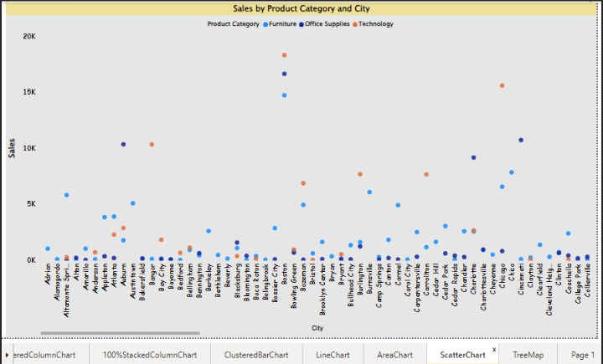

Shape Chart:

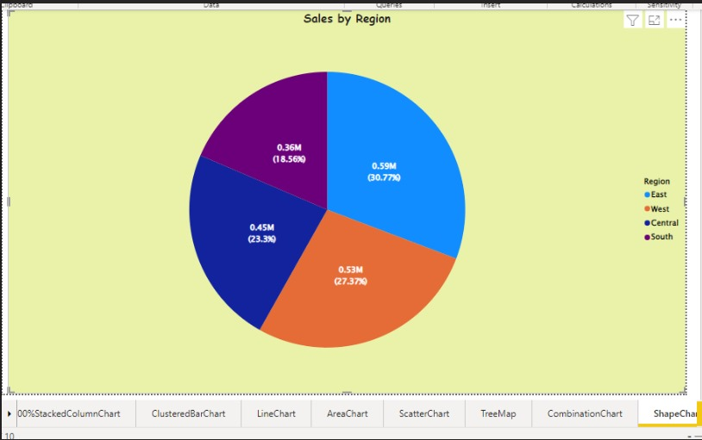

Combination Chart:

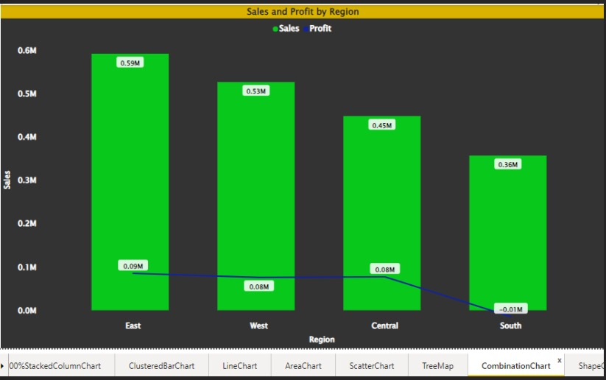

Tree Map:

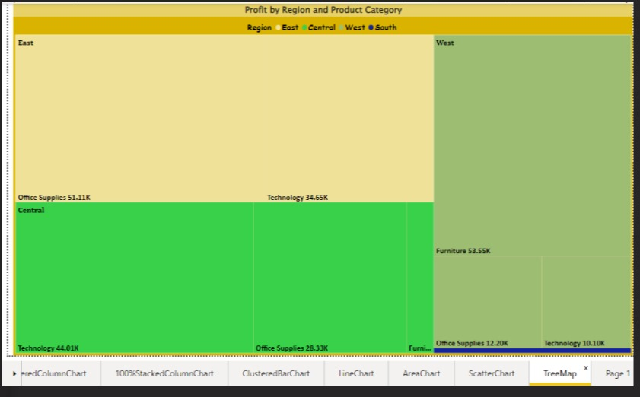

# Make a dashboard and show 2 maps visualization i.e., basic map and filler maps.

Basic Map and Filled Map:

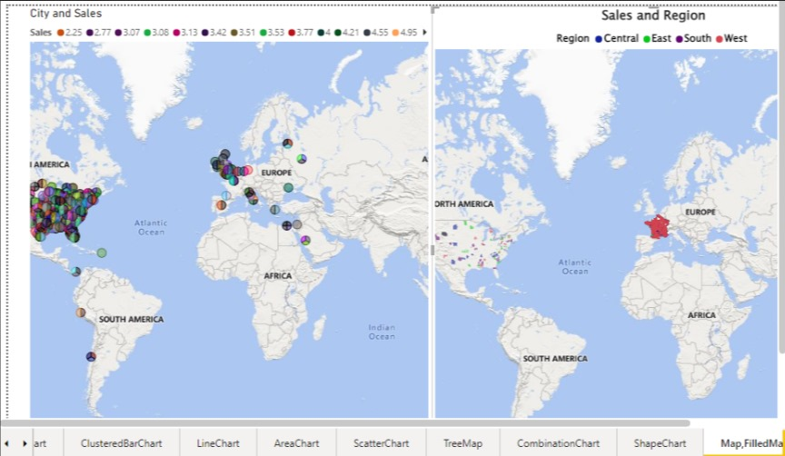

# Create a report which has:

Bar chart

Card visualizations

Combo chart visualizations

Matrix visualizations

Column chart visualizations

guide: Sales data can be used

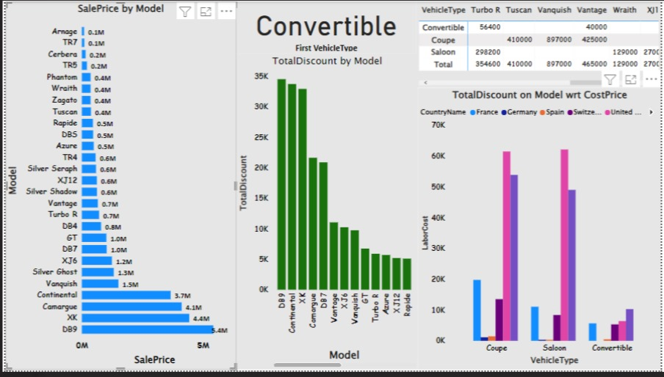

# Make a report to analyze product sales using treemap visualization.

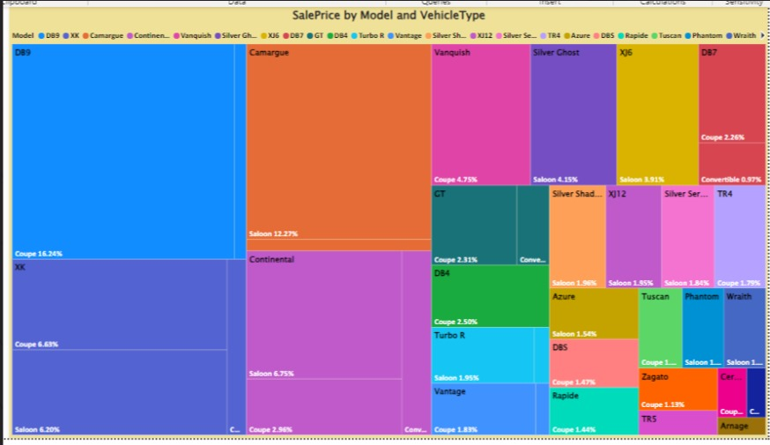

# Make a dashboard on sales data (Minimum 4 tiles).

