# Q1) Write a Program for Randomized Selection Algorithm

from random import randrange def partition(x, pivot_index = 0):

i = 0

if pivot_index !=0: x[0],x[pivot_index] = x[pivot_index],x[0] for j in range(len(x)-1):

if x[j+1] < x[0]:

x[j+1],x[i+1] = x[i+1],x[j+1] i += 1

x[0],x[i] = x[i],x[0] return x,i

def RSelect(x,k): if len(x) == 1:

return x[0] else:

xpart = partition(x,randrange(len(x))) x = xpart[0] # partitioned array

j = xpart[1] # pivot index if j == k:

return x[j] elif j > k:

return RSelect(x[:j],k) else:

k = k - j - 1

return RSelect(x[(j+1):], k)

x = [8,4,2,6,1]

for i in range(len(x)): print (RSelect(x,i))

* **Output**

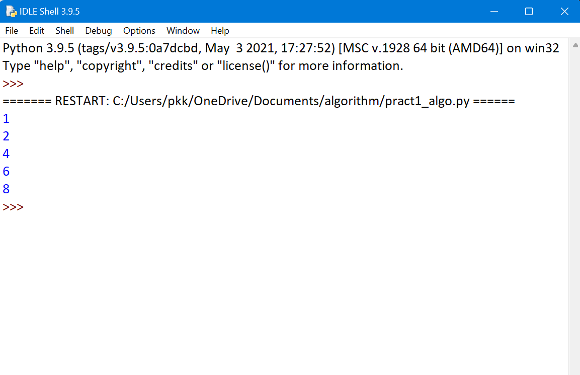

**Q.2) Write a Program for Heap Sort Algorithm** Python program for implementation of heap Sort # To heapify subtree rooted at index i.

# n is size of heap def heapify(arr, n, i):

largest = i # Initialize largest as root l = 2 * i + 1 # left = 2*i + 1

r = 2 * i + 2 # right = 2*i + 2

# See if left child of root exists and is # greater than root

if l < n and arr[i] < arr[l]: largest = l

# See if right child of root exists and is # greater than root

if r < n and arr[largest] < arr[r]: largest = r

# Change root, if needed if largest != i:

arr[i],arr[largest] = arr[largest],arr[i] # swap

# Heapify the root. heapify(arr, n, largest)

# The main function to sort an array of given size def heapSort(arr):

n = len(arr)

# Build a maxheap.

for i in range(n, -1, -1): heapify(arr, n, i)

# One by one extract elements for i in range(n-1, 0, -1):

arr[i], arr[0] = arr[0], arr[i] # swap heapify(arr, i, 0)

# Driver code to test above arr = [2,8,16,11,9,5,0]

heapSort(arr) n = len(arr)

print ("Sorted array is")

for i in range(n):

print ("%d" %arr[i]),

# Output

1. **Write a Program to perform Radix Sort Algorithm**

Python program for implementation of Radix Sort # Python program for implementation of Radix Sort

# A function to do counting sort of arr[] according to # the digit represented by exp.

def countingSort(arr, exp1):

n = len(arr)

# The output array elements that will have sorted arr

output = [0] * (n)

# initialize count array as 0 count = [0] * (10)

# Store count of occurrences in count[] for i in range(0, n):

index = (arr[i]/exp1) count[int((index)%10)] += 1

# Change count[i] so that count[i] now contains actual # position of this digit in output array

for i in range(1,10): count[i] += count[i-1]

# Build the output array i = n-1

while i>=0:

index = (arr[i]/exp1)

output[ count[ int((index)%10) ] - 1] = arr[i] count[int((index)%10)] -= 1

i -= 1

# Copying the output array to arr[],

# so that arr now contains sorted numbers i = 0

for i in range(0,len(arr)): arr[i] = output[i]

# Method to do Radix Sort def radixSort(arr):

# Find the maximum number to know number of digits max1 = max(arr)

# Do counting sort for every digit. Note that instead # of passing digit number, exp is passed. exp is 10^i # where i is current digit number

exp = 1

while max1/exp > 0:

countingSort(arr,exp) exp *= 10

# Driver code to test above

arr = [ 170, 45, 75, 90, 802, 24, 2, 66]

radixSort(arr)

for i in range(len(arr)): print(arr[i],end=" ")

# This code is contributed by Mohit Kumra

# This code is updated by Sudeep Saxena(saxenasudeepcse@gmail.com) on July 9, 2020

# Output

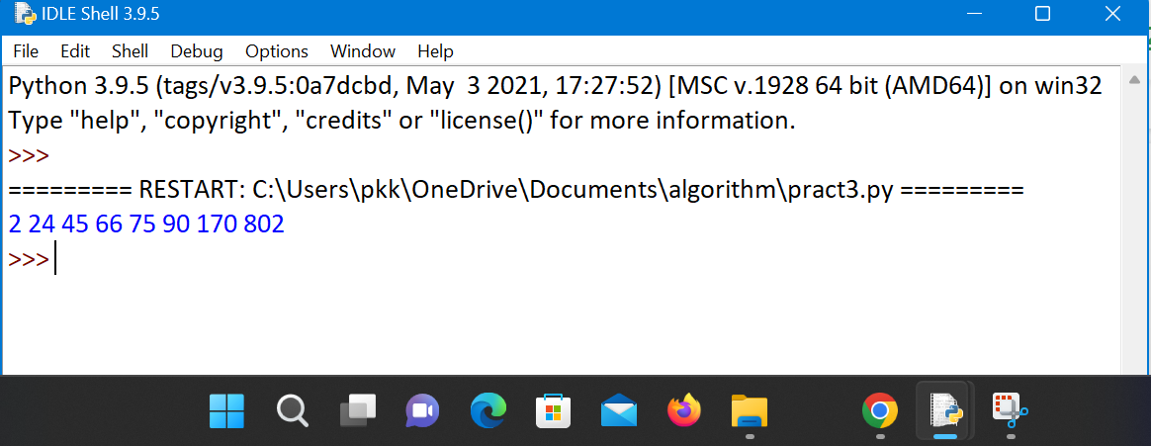

1. **Write a Program to Perform Bucket Sort Algorithm**

# Python3 program to sort an array # using bucket sort

def insertionSort(b):

for i in range(1, len(b)): up = b[i]

j = i - 1

while j >=0 and b[j] > up: b[j + 1] = b[j]

j -= 1

b[j + 1] = up return b

def bucketSort(x): arr = []

slot_num = 10 # 10 means 10 slots, each

# slot's size is 0.1 for i in range(slot_num):

arr.append([])

# Put array elements in different buckets for j in x:

index_b = int(slot_num * j) arr[index_b].append(j)

# Sort individual buckets

for i in range(slot_num):

arr[i] = insertionSort(arr[i]) # concatenate the result

k = 0

for i in range(slot_num):

for j in range(len(arr[i])): x[k] = arr[i][j]

k += 1

return x # Driver Code

x = [0.453, 0.573, 0.8656, 0.9064, 0.5678, 0.2568]

print("Sorted Array is") print(bucketSort(x))

# Output

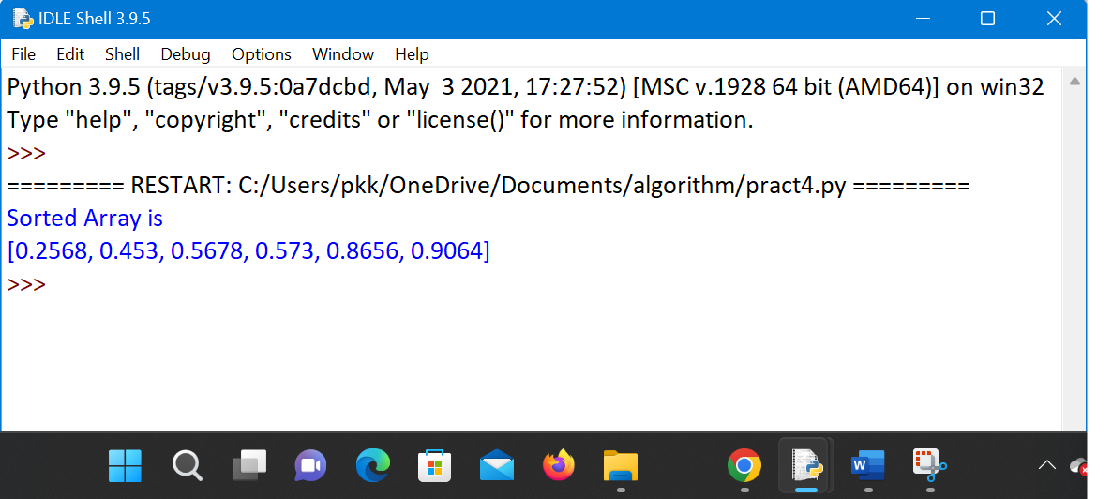

1. **Write a Program to Perform Folyd-Warshall algorithm # Python Program for Floyd Warshall Algorithm**

# Number of vertices in the graph V = 4

# Define infinity as the large enough value. This value will be

# used for vertices not connected to each other INF = 99999

# Solves all pair shortest path via Floyd Warshall Algorithm

def floydWarshall(graph):

dist = map(lambda i : map(lambda j : j , i) , graph) for k in range(V):

# pick all vertices as source one by one

for i in range(V):

# Pick all vertices as destination for the # above picked source

for j in range(V):

# If vertex k is on the shortest path from

# i to j, then update the value of dist[i][j]

dist[i][j] = min(dist[i][j] ,dist[i][k]+ dist[k][j]) printSolution(dist)

# A utility function to print the solution

def printSolution(dist):

print "Following matrix shows the shortest distances\

between every pair of vertices" for i in range(V):

for j in range(V): if(dist[i][j] == INF):

print "%7s" %("INF"), else:

print "%7d\t" %(dist[i][j]), if j == V-1:

print "" graph = [[0,5,INF,10],

[INF,0,3,INF],

[INF, INF, 0, 1],

[INF, INF, INF, 0]]

# Print the solution floydWarshall(graph);

# Output

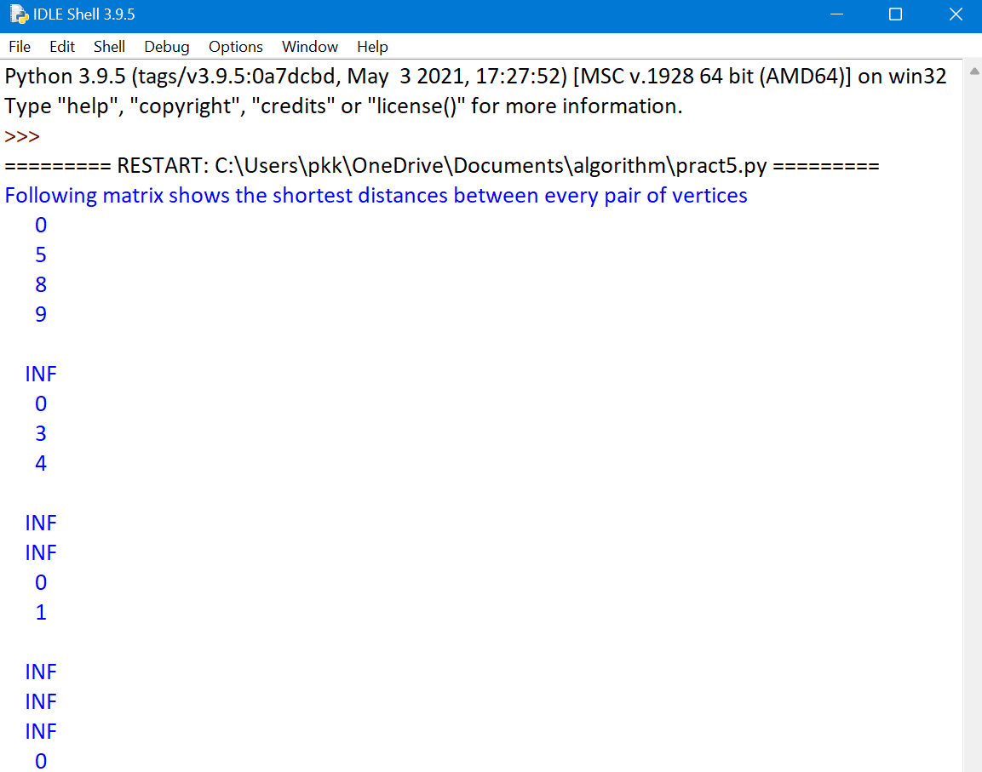

1. **Write a Program for Counting Sort Algorithm in python Python program for counting sort**

# The main function that sort the given string arr[] in # alphabetical order

def countSort(arr):

# The output character array that will have sorted arr output = [0 for i in range(256)]

# Create a count array to store count of inidividul

# characters and initialize count array as 0 count = [0 for i in range(256)]

# For storing the resulting answer since the

# string is immutable

ans = ["" for _ in arr]

# Store count of each character for i in arr:

count[ord(i)] += 1

# Change count[i] so that count[i] now contains actual # position of this character in output array

for i in range(256): count[i] += count[i-1]

# Build the output character array

for i in range(len(arr)):

output[count[ord(arr[i])]-1] = arr[i] count[ord(arr[i])] -= 1

# Copy the output array to arr, so that arr now # contains sorted characters

for i in range(len(arr)): ans[i] = output[i]

return ans

# Driver program to test above function arr = "Sandfoundary"

ans = countSort(arr)

print "Sorted character array is %s" %("".join(ans))

## Output

1. **Write a program for Set Covering Problem**

def set_cover(universe, subsets):

"""Find a family of subsets that covers the universal set"""

elements = set(e for s in subsets for e in s) # Check the subsets cover the universe

if elements != universe: return None

covered = set() cover = []

# Greedily add the subsets with the most uncovered points

while covered != elements:

subset = max(subsets, key=lambda s: len(s - covered)) cover.append(subset)

covered |= subset

return cover

def main():

universe = set(range(11, 21))

**subsets = [set([11,12, 13, 18, 19,20]),**

## set([11, 12, 13, 14, 15]),

**set([14,15, 17]),**

## set([15, 16, 17]),

**set([16, 17, 18, 19,20])]**

cover = set_cover(universe, subsets) print(cover)

if name == ' main ':

main()

**Output**

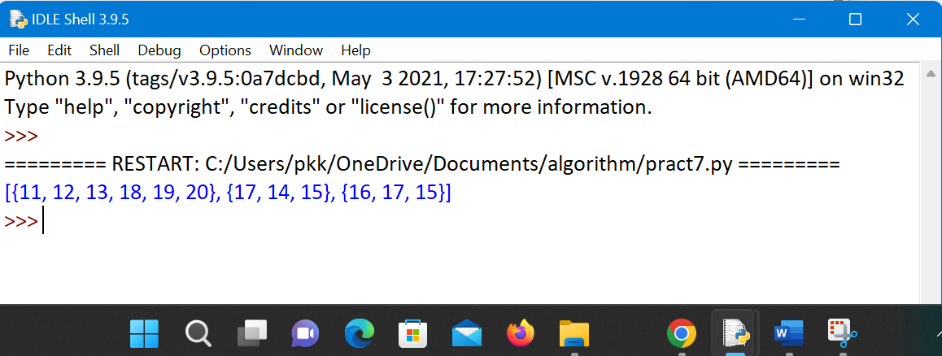

## Write a Program for found a subset with given sum

# A recursive solution for subset sum # problem

# Returns true if there is a subset

# of set[] with sun equal to given sum def isSubsetSum(set,n, sum) :

# Base Cases

if (sum == 0) : return True

if (n == 0 and sum != 0) : return False

# If last element is greater than # sum, then ignore it

if (set[n - 1] > sum) :

return isSubsetSum(set, n - 1, sum); # else, check if sum can be obtained

# by any of the following

# (a) including the last element # (b) excluding the last element

return isSubsetSum(set, n-1, sum) or isSubsetSum(set, n-1, sum-set[n-1]) # Driver program to test above function

set = [3, 34, 4, 12, 5, 2]

sum = 9

n = len(set)

if (isSubsetSum(set, n, sum) == True) : print("Found a subset with given sum")

else :

print("No subset with given sum")

## Output

