1. **Pwd**

The pwd command (print working directory) writes the full pathname of the current working directory to the standard output.



1. **Vi**

To use vi on a file, type in *vi filename*. If the file named *filename* exists, then the first page (or screen) of the file will be displayed; if the file does not exist, then an empty file and screen are created into which you may enter text.

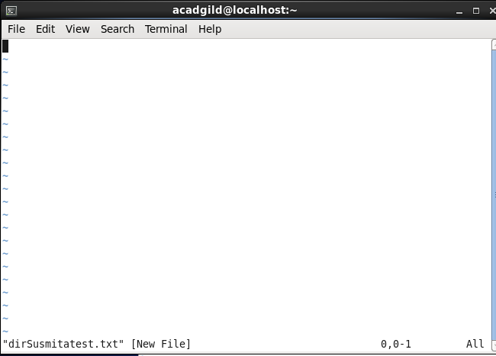

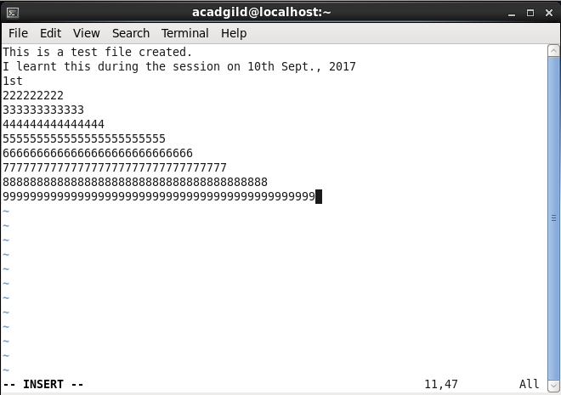

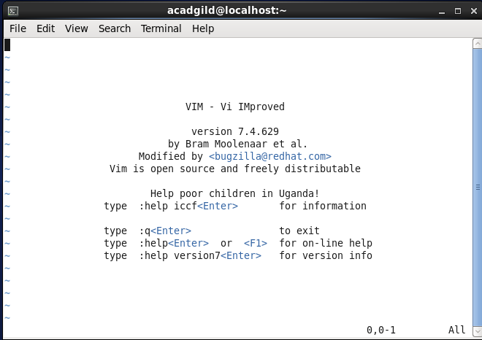

1. **Touch**

The touch command updates the access and [modification](https://www.computerhope.com/jargon/m/modify.htm) times of each FILE to the current system time. If you specify a FILE that does not already exist, touch creates an empty file with that name (unless the -c or -h options are specified).

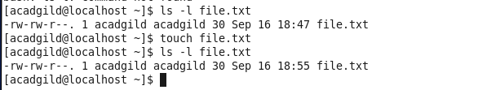

1. **mkdir**

The mkdir command in UNIX allows users to create directories or folders as they are referred to in some operating systems. The mkdir command can create multiple directories at once and also set permissions when creating the directory.

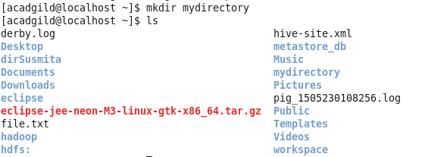

1. **rm**

rm (Unix) rm (short for remove) is a basic UNIX command used to remove objects such as files, directories, device nodes, symbolic links, and so on from the filesystem.



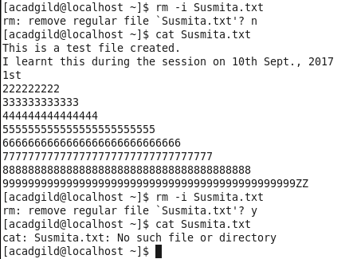

1. **ls**

ls is a Linux shell command that lists directory contents of files and directories.

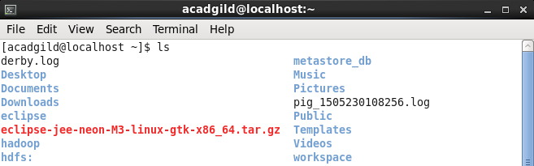

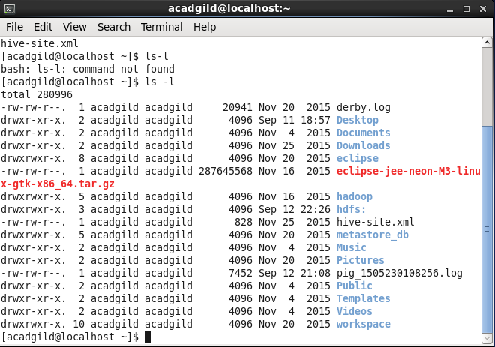

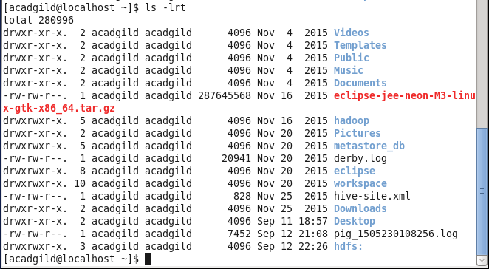

1. **echo**

In computing, echo is a command in DOS, OS/2, Microsoft Windows, Singularity,Unix and Unix-like operating systems that outputs the strings it is being passed as arguments. It is a command typically used in shell scripts and batch files to output status text to the screen or a file.

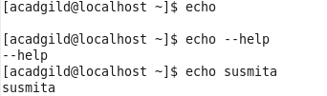

1. **cat**

The cat (short for “concatenate“) command is one of the most frequently used command in Linux/Unix like operating systems. cat command allows us to create single or multiple files, view contain of file, concatenate files and redirect output in terminal or files.

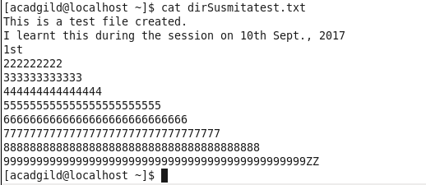

1. **who**

The who command prints information about all users who are currently logged in.

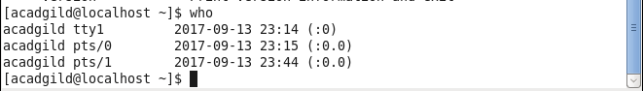

1. **cd**

The cd command, also known as chdir (change directory), is a command-line OS shell commandused to change the current working directory in operating systems such as Unix, DOS, OS/2, AmigaOS.



1. **date**

**date**print or set the system date and time





1. **cal**

The **cal command** is a **command** line utility for displaying a calendar in the terminal. It can be used to print a single month, many months or an entire year. It supports starting the week on a Monday or a Sunday, showing Julian dates and showing calendars for arbitrary dates passed as arguments.

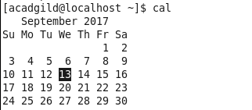

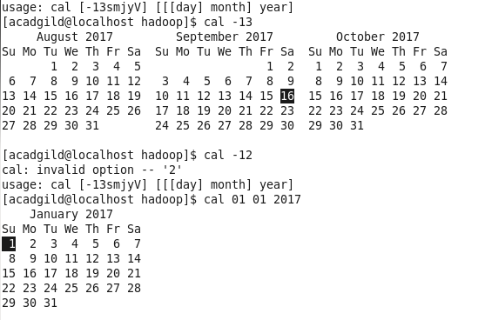

1. mv

*mv*command is used to move files and directories.

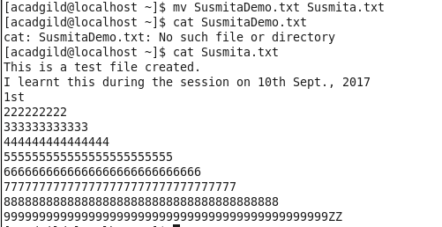

1. **cp**

cp is a Linux shell command to copy files and directories.

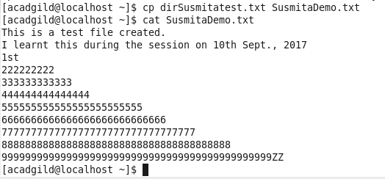

1. **which**

Linux which Command. Which command is very small and simple command to locate executables in the system. It allows user to pass several command names as arguments to get their paths in the system. “which” commands searches the path of executable in system paths set in $PATH environment variable.

