Does Quantization Break World Modeling? A Sub-Skill Analysis of Compressed Multimodal LLMs on CPU-Only Hardware
Author Name(s) — to be completed
Department / Institution — to be completed

Abstract—Quantization is the standard technique for compressing large multimodal models onto cheap, low-power hardware, yet its effect on physical “world modeling” — a model's ability to understand and predict how the physical world behaves — is unstudied. This matters because quantized multimodal models are increasingly deployed exactly where physical reasoning is needed most (robotics, mobile assistants, embedded devices) and exactly where compute is most limited. We decompose world modeling into five independently-measurable sub-skills — physical state prediction, object permanence, causal reasoning, spatial relation reasoning, and temporal consistency — and evaluate a small (2B-parameter) multimodal LLM (Qwen2-VL-2B-Instruct) across four quantization levels (FP16, INT8, INT4, INT3) via llama.cpp/GGUF, using 100 CLEVRER-derived multiple-choice items (20 per sub-skill). We run the entire study, including model conversion and inference, on CPU-only consumer laptop hardware to mirror real deployment constraints. We find that degradation is not uniform: causal reasoning and spatial relation reasoning both hold steady through INT8 and then drop sharply between INT4 and INT3, while temporal consistency remains comparatively robust across the full precision range. Given a small per-cell item count (n=20), we report these as suggestive trends from a pilot study rather than statistically confirmed effects, and discuss concrete deployment implications.
Index Terms—quantization, multimodal LLM, world modeling, physical reasoning, GGUF, edge deployment
I. INTRODUCTION
Post-training quantization — reducing model weights from 16-bit floating point down to 8-, 4-, or even 3-bit representations — is the default way small models are made to fit on consumer and embedded hardware. Prior work has studied how quantization affects general reasoning ability (math, logic, code), and separately, research on “world models” has studied physical/causal reasoning in full-precision vision-language models. No prior work crosses these two lines: does compressing a multimodal model damage its ability to reason about the physical world specifically, and if so, does it damage every kind of physical reasoning equally?
This question is not academic. A quantized vision-language model deployed on a robot arm, a mobile assistant, or an embedded inspection camera is asked to reason about exactly the kind of physical scenarios this paper tests — and it runs on exactly the kind of resource-constrained hardware where INT4 or even INT3 quantization is standard, not optional. If quantization degrades physical reasoning non-uniformly, a deployment decision like “quantize to INT4 to fit on-device” could silently break a specific capability (e.g., causal reasoning) while leaving others (e.g., temporal ordering) intact — a failure mode invisible to aggregate benchmark scores.
We also take the low-resource framing seriously in our methodology, not just our research question: every step of this study, including GGUF conversion and the full inference sweep, was run on a CPU-only consumer laptop (AMD Ryzen 5 5500U, 5.86 GB RAM), the same class of hardware this research is meant to inform decisions about.
Contributions:
1) A five-sub-skill decomposition of physical world modeling, each independently measurable via multiple-choice items with real ground truth.
2) A controlled quantization sweep (FP16/INT8/INT4/INT3) isolating LM-side quantization level as the single variable, vision tower held fixed at FP16.
3) An empirical finding that degradation is sub-skill-dependent, with a sharp INT4→INT3 transition specifically in causal and spatial relational reasoning.
4) A fully reproducible, CPU-only pipeline (build → convert → quantize → evaluate), released with the dataset and attribution log.
II. RELATED WORK
Quantization and general reasoning. GPTQ, AWQ, and GGUF k-quant methods are widely used to compress LLMs for edge deployment. Prior evaluations of quantized models on general benchmarks (MMLU, GSM8K, HumanEval) generally find graceful degradation down to INT4, with more pronounced drops below that. These studies do not evaluate multimodal models or physical/world-modeling tasks specifically.
World modeling and physical reasoning benchmarks. PhysBench, PIQA, and CLEVRER each probe different aspects of physical understanding: PhysBench evaluates multimodal physical world understanding across a range of tasks; PIQA evaluates text-based physical commonsense reasoning; CLEVRER evaluates descriptive, predictive, counterfactual, and explanatory reasoning over synthetic collision videos. All of this prior work evaluates full-precision models only.
The gap. No existing study measures how post-training quantization affects physical/world-modeling reasoning specifically, let alone whether different sub-skills within “world modeling” degrade at different rates. This paper is, to our knowledge, the first to combine a controlled quantization sweep with a sub-skill-decomposed physical reasoning evaluation.
III. METHOD
A. Backbone Model
We use Qwen2-VL-2B-Instruct, a 2-billion-parameter vision-language model, chosen specifically for CPU feasibility and for having an actively maintained llama.cpp GGUF conversion path — including a separate vision-projector (mmproj) export — which is not true of all small VLMs (e.g., Moondream2 was considered and rejected for this reason; its quantization path is bespoke rather than GGUF-based).
B. Quantization Levels
We convert the model to GGUF and quantize the language-model weights to four levels using llama.cpp's llama-quantize (Table I).
TABLE I
Quantization Levels Evaluated
Precision | Method | Bits/wt | Size
FP16 (baseline) | — | 16.00 | 3.1 GB
INT8 | Q8_0 | 8.50 | 1.6 GB
INT4 | Q4_K_M | 5.08 | 986 MB
INT3 | Q3_K_M | 4.24 | 824 MB
The vision tower (mmproj) is held at FP16 across every run. This isolates language-model quantization level as the single controlled variable and reflects standard practice, since GGUF vision-projector quantization is experimental and unsupported in most current tooling.
C. Sub-skill Taxonomy
We decompose “world modeling” into five sub-skills rather than reporting one blended score, since a blended score cannot distinguish “the model got worse at everything” from “the model lost one specific capability”: (1) physical state prediction — predict what happens next in a scene; (2) object permanence — reasoning about an object's continued physical role even when hypothetically removed; (3) causal reasoning — identifying what is/isn't responsible for a physical event; (4) spatial relation reasoning — identifying relationships between objects in space, operationalized via collision/contact relations; (5) temporal consistency — reasoning about event order and state over time.
D. Dataset Construction
We originally planned to sample from PhysBench, PIQA, and CLEVRER. In practice, after checking real access: PhysBench was dropped because its images are distributed only as a 3.7 GB archive, impractical to pull for ~100 items on this hardware/connection, and a pre-formatted mirror intended to avoid this turned out to have empty metadata fields. PIQA was dropped because it is text-only, which would exercise a different (non-visual) capability than the rest of the study and break the multimodal consistency of the evaluation. CLEVRER alone was sufficient to cover all five sub-skills once its four native question types (predictive, explanatory, counterfactual, descriptive) were mapped appropriately, with descriptive short-answer questions converted to proper multiple-choice format using CLEVRER's fixed closed vocabulary (8 colors, 3 shapes, 2 materials, yes/no, counts 0–4) to construct principled same-category distractors.
We source 20 items per sub-skill (100 total), each a single representative video frame (extracted at 85% through the clip) paired with a real question and ground-truth answer from the CLEVRER annotation set. This is smaller than our original 30–40/sub-skill target, a deliberate scope reduction given solo, single-machine execution under a fixed time budget. Full source attribution is in the accompanying ATTRIBUTION_LOG.md.
E. Evaluation Protocol
Each item is presented as an image plus a multiple-choice question, run through llama-mtmd-cli at each precision level with greedy decoding (temperature 0). Model output is parsed for a single answer letter; we distinguish three outcomes per item — correct, incorrect, and unparsed (malformed output) — since at low precision a model can fail by producing a wrong answer or by failing to produce a well-formed answer at all. In this study, unparsed output never occurred (0/400 across the full sweep), meaning all degradation observed is genuine reasoning degradation, not output-format collapse.
F. Hardware
All conversion, quantization, and inference — 400 total inference calls (100 items × 4 precisions) — ran on a CPU-only consumer laptop (AMD Ryzen 5 5500U, 6 cores/12 threads, 5.86 GB total RAM, no discrete GPU). This is a deliberate methodological choice, not a limitation to work around: it mirrors the actual deployment class this research is meant to inform.
IV. RESULTS
TABLE II
Accuracy by Sub-skill and Precision (n=20/cell)
Sub-skill | FP16 | INT8 | INT4 | INT3
Causal reasoning | 65% | 65% | 60% | 50%
Object permanence | 50% | 50% | 45% | 65%
Physical state prediction | 40% | 45% | 45% | 50%
Spatial relation | 70% | 70% | 75% | 55%
Temporal consistency | 80% | 80% | 80% | 75%
(See Fig. 1 and the accompanying results/relative_accuracy_retained.csv for accuracy retained relative to FP16.)
Finding 1 — degradation is not uniform. This is the central result: sub-skills diverge in how they respond to compression, rather than all declining together.
Finding 2 — causal reasoning and spatial relation reasoning both show a sharp INT4→INT3 transition. Both hold flat (or even tick up) through INT8 and INT4, then drop sharply at INT3: spatial relation falls from 75% to 55% (a 20-point single-step drop), and causal reasoning continues a decline from 60% to 50%. Two independently-sourced sub-skills showing the same cliff location is the most directionally consistent pattern in the data.
Finding 3 — temporal consistency is the most robust sub-skill, essentially flat from FP16 through INT4 (80% throughout) with only a small dip at INT3 (75%).
Finding 4 — object permanence and physical state prediction are noisy and non-monotonic. Object permanence actually rises at INT3 (45%→65%), which we attribute to sampling noise rather than a genuine improvement under compression. Physical state prediction hovers near chance level (40–50%) across all four precisions, suggesting this specific task is simply hard for a 2B-parameter model regardless of quantization.
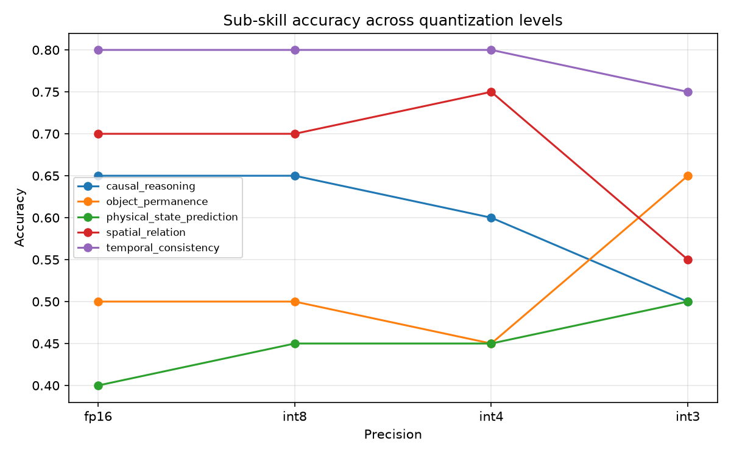
Fig. 1. Sub-skill accuracy across quantization levels (FP16 → INT3). Causal reasoning and spatial relation both show a sharp decline specifically between INT4 and INT3; temporal consistency remains comparatively flat.
Statistical caveat. With n=20 items per sub-skill per precision level, the standard error of an observed proportion near p=0.5 is approximately 11 percentage points, giving a 95% confidence interval of roughly ±22 points. Most individual step-to-step differences reported above are not statistically significant in isolation. We report Findings 1–3 as a suggestive, directionally consistent pattern from a small-sample pilot study, not as a statistically confirmed effect — an honest constraint of this evaluation's scale that should guide interpretation of every number above.
V. DISCUSSION
The practical implication, held to the confidence level the data actually supports: if a deployment depends specifically on causal or spatial relational reasoning, this study's data points toward avoiding quantization below INT4, since both sub-skills that showed a clear cliff did so specifically at the INT4→INT3 transition, not gradually. Applications relying primarily on temporal ordering reasoning may tolerate more aggressive quantization with comparatively less risk, based on the robustness observed here. We frame this as a hypothesis for follow-up work with a larger item count, not a settled guideline.
The divergence itself — not simply “accuracy went down” — is the paper's actual contribution. It suggests that different physical-reasoning sub-skills may depend on the model's weights in structurally different ways: sub-skills requiring multi-step relational inference (what caused this, what relates to what) appear more fragile under aggressive compression than sub-skills requiring more direct temporal pattern-matching (what came first).
VI. LIMITATIONS
• Small per-cell sample size (n=20). As discussed above, this limits statistical confidence in any single reported difference; findings should be read as directional/suggestive.
• Single backbone model. Results may not generalize to other architectures or parameter scales; this is a case study, not a general claim about quantization.
• Static-frame proxy for video. CLEVRER is video-native; our backbone is image-based, so temporal-consistency items use a single representative frame rather than full motion, which may understate the model's (or quantization's effect on) genuinely temporal reasoning.
• Object-permanence operationalization. We proxy object permanence via counterfactual-removal questions rather than direct visual occlusion/tracking, since CLEVRER does not include a dedicated occlusion-tracking split.
• Single-domain dataset. All items derive from CLEVRER's synthetic collision-scene domain; findings may not transfer to naturalistic imagery.
• Vision tower not quantized. Only the language model is quantized; results characterize LM-side compression specifically, not full end-to-end multimodal quantization.
VII. CONCLUSION
We present the first study, to our knowledge, of how post-training quantization affects physical world-modeling ability in a small multimodal LLM, decomposed into five independently-measured sub-skills, run entirely on representative low-resource CPU hardware. We find that degradation is not uniform across sub-skills: causal and spatial relational reasoning show a sharp decline specifically between INT4 and INT3, while temporal consistency remains comparatively robust. Given the small scale of this pilot (n=20/sub-skill), we present these as a directionally consistent, hypothesis-generating pattern rather than a statistically confirmed result, and we release the full pipeline, dataset, and attribution log to support a larger-scale follow-up.
. REPRODUCIBILITY
• Model: Qwen/Qwen2-VL-2B-Instruct (Hugging Face).
• Quantization tool: llama.cpp (mtmd multimodal support), quantize types Q8_0/Q4_K_M/Q3_K_M.
• Dataset build, evaluation harness, scoring, and analysis scripts, full item-level results, attribution log, and full development log are released alongside this paper.

