Does Quantization Break World Modeling? A Sub-Skill Analysis of Compressed Multimodal LLMs on CPU-Only Hardware
Author Name(s) — to be completed
Department / Institution — to be completed
email@institution.edu — to be completed
Abstract
Quantization is the standard technique for compressing large multimodal models onto cheap, low-power hardware, yet its effect on physical “world modeling” — a model's ability to understand and predict how the physical world behaves — is unstudied. This matters because quantized multimodal models are increasingly deployed exactly where physical reasoning is needed most (robotics, mobile assistants, embedded devices) and exactly where compute is most limited. We decompose world modeling into five independently-measurable sub-skills — physical state prediction, object permanence, causal reasoning, spatial relation reasoning, and temporal consistency — and evaluate a small (2B-parameter) multimodal LLM (Qwen2-VL-2B-Instruct) across four quantization levels (FP16, INT8, INT4, INT3) via llama.cpp/GGUF, using 100 CLEVRER-derived multiple-choice items (20 per sub-skill). We run the entire study, including model conversion and inference, on CPU-only consumer laptop hardware to mirror real deployment constraints. We find that degradation is not uniform: causal reasoning and spatial relation reasoning both hold steady through INT8 and then drop sharply between INT4 and INT3, while temporal consistency remains comparatively robust. Given a small per-cell item count (n=20), we report these as suggestive trends from a pilot study rather than statistically confirmed effects, and discuss concrete deployment implications.
Keywords: quantization, multimodal LLM, world modeling, physical reasoning, GGUF, edge deployment
1. Introduction
Post-training quantization — reducing model weights from 16-bit floating point down to 8-, 4-, or even 3-bit representations — is the default way small models are made to fit on consumer and embedded hardware. Prior work has studied how quantization affects general reasoning ability (math, logic, code), and separately, research on “world models” has studied physical/causal reasoning in full-precision vision-language models. No prior work crosses these two lines: does compressing a multimodal model damage its ability to reason about the physical world specifically, and if so, does it damage every kind of physical reasoning equally?
This question is not academic. A quantized vision-language model deployed on a robot arm, a mobile assistant, or an embedded inspection camera is asked to reason about exactly the kind of physical scenarios this paper tests — and it runs on exactly the kind of resource-constrained hardware where INT4 or even INT3 quantization is standard, not optional. If quantization degrades physical reasoning non-uniformly, a deployment decision like “quantize to INT4 to fit on-device” could silently break a specific capability while leaving others intact — a failure mode invisible to aggregate benchmark scores.
We also take the low-resource framing seriously in our methodology, not just our research question: every step of this study, including GGUF conversion and the full inference sweep, was run on a CPU-only consumer laptop (AMD Ryzen 5 5500U, 5.86 GB RAM), the same class of hardware this research is meant to inform decisions about. Section 2 documents this constraint-driven process in detail, since navigating it is itself part of the paper's contribution.
Contributions:
• A five-sub-skill decomposition of physical world modeling, each independently measurable via multiple-choice items with real ground truth.
• A controlled quantization sweep (FP16/INT8/INT4/INT3) isolating LM-side quantization level as the single variable, vision tower held fixed at FP16.
• A fully reproducible, CPU-only pipeline (build → convert → quantize → evaluate), developed under genuine hardware constraints (Section 2).
• An empirical finding that degradation is sub-skill-dependent, with a sharp INT4→INT3 transition specifically in causal and spatial relational reasoning (Section 3).
2. Problem Exploration and Design
This section covers both the exploration process that shaped every major decision in this study and the resulting design — presented together because, in practice, almost none of the final design was decided up front. It was arrived at by trying the straightforward approach, hitting a real constraint, and adapting. We document that process explicitly rather than presenting only the final, cleaned-up pipeline, because the constraints themselves — hardware, data access, tooling maturity — are as much a part of what this study demonstrates as the quantization results are.
2.1 Backbone Model: Exploration and Design
Exploration. Two small (1.5–3B parameter) open multimodal LLMs were considered: Moondream2 and Qwen2-VL-2B-Instruct, both candidates specifically because they can plausibly run on CPU-only hardware. The deciding factor was not raw capability but quantization tooling maturity: Moondream2 uses a bespoke inference/quantization runtime rather than the GGUF format, which would not have produced a clean, comparable precision ladder. Qwen2-VL-2B-Instruct, by contrast, has an actively maintained conversion path in llama.cpp's multimodal (mtmd) support, including a separate vision-projector (mmproj) export.
Design decision. Qwen2-VL-2B-Instruct was selected specifically for this reason — tooling fit for the CPU/GGUF pipeline, not benchmark performance — since a controlled, comparable precision ladder was the precondition for the entire study being possible at all. This was validated with a feasibility spike (Section 2.3) before further work was committed to it.
2.2 Dataset Sourcing: Exploration and Design
Exploration. The original plan was to sample items from three established benchmarks — PhysBench, PIQA, and CLEVRER — each covering different aspects of physical reasoning. Checking real access to each changed the plan substantially:
• PhysBench (USC-PSI-Lab/PhysBench, Apache-2.0): the official images are distributed only as a single 3.7 GB archive, with a matching 3.7 GB video archive — impractical to download for the ~100 items actually needed. A compact, pre-formatted mirror (lmms-lab-eval/PhysBench) appeared to solve this, but inspection of its parquet schema revealed every metadata field was an empty string — the mirror was unusable for building real items.
• PIQA (ybisk/piqa): available only as a legacy loading script, and — more fundamentally — text-only. Using it would exercise a different, non-visual capability than the rest of the study, breaking the multimodal consistency the evaluation depends on.
• CLEVRER (zechen-nlp/clevrer): small (<5 MB), well-structured parquet files split by native question type (predictive, explanatory, counterfactual, descriptive), each with real ground-truth answers. Videos are not embedded, but a targeted search for the official video host found that individual clips — not just the full multi-GB archive — are directly downloadable (~1.5 MB each) once the correct folder-sharding URL pattern was identified empirically.
Closer inspection of CLEVRER's descriptive split showed its answers are short strings drawn from a small, fixed vocabulary (8 colors, 3 shapes, 2 materials, yes/no, and counts 0–4) rather than free text — which made a principled multiple-choice conversion possible: for a given correct answer, distractors are sampled from the same category, rather than being handwritten or arbitrary.
Design decision. The dataset was sourced entirely from CLEVRER rather than the original three-benchmark plan, once mapped onto all five sub-skills: predictive→physical_state_prediction, explanatory→causal_reasoning, counterfactual→object_permanence (proxying permanence via whether the model tracks an object's continued causal role when hypothetically removed), and descriptive, filtered by keyword into two disjoint pools: collision/contact-relation questions for spatial_relation, and ordering questions for temporal_consistency. This design was itself revised once empirically: an initial keyword filter for spatial_relation assumed CLEVR-style left/right/behind phrasing, which does not occur in CLEVRER's actual question text — it was redefined around collision-relation phrasing instead, with mutual exclusion against the temporal keyword set.
The target item count was also reduced during design, from an initial 30–40 per sub-skill to 20 per sub-skill (100 total), a deliberate, explicitly-logged scope reduction given solo execution on a single machine under a fixed time budget, not a silent cut (see Section 3.3 for how this affects statistical interpretation).
2.3 Hardware Constraints: Exploration and Design
Exploration. The target machine was profiled before committing to any pipeline design: 5.86 GB total RAM, with as little as 0.31–0.41 GB free at points during the session, and the primary drive (C:) had only ~2.5 GB free against a 6+ GB requirement for model weights alone. No build tools were present at the start. Each of these was discovered by direct inspection rather than assumed, and each shaped a specific design choice below.
Design decisions, each tied to a specific constraint:
• Toolchain placement. A portable MinGW toolchain (w64devkit) and CMake were installed to the secondary drive (E:) rather than C:, avoiding any dependency on the nearly-full system drive. An isolated Python virtual environment was built on E: from an existing interpreter rather than installing a redundant copy.
• Build parallelism. The RAM ceiling meant a full-parallel C++ compile of llama.cpp risked hanging or crashing the machine. The build was run with -j 2 rather than full core count, after closing memory-heavy background applications (RAM went from ~0.35 GB to ~0.81 GB free).
• Scratch/cache redirection. Two tools defaulted their temporary storage to the nearly-full C: drive without being asked — Python's tempfile and huggingface_hub's model cache — both causing real failures (a disk-write error mid-conversion, in the first case) before being redirected to E:.
• FP16 feasibility, tested rather than assumed. Whether the FP16 baseline (4.4 GB of weights) would even load on a 5.86 GB machine was a genuine open question — resolved with a direct feasibility spike before further pipeline work was built on the assumption it would work. It did, removing the need for a cloud-GPU fallback.
• Resumability, added after a real failure. A multi-hour evaluation sweep was interrupted mid-run by a session/process teardown. The evaluation harness was redesigned after this to skip already-completed items on rerun instead of overwriting from scratch — a design change made necessary by the reality of running a long job on this class of hardware/session environment.
2.4 Quantization Pipeline and Sub-skill Taxonomy: Design
The language model is quantized to four levels via llama-quantize (Table 1). The vision tower (mmproj) is deliberately held at FP16 across every run — this isolates language-model quantization level as the single controlled variable, and matches standard practice, since GGUF vision-projector quantization is experimental and unsupported in most current tooling.
Table 1: Quantization Levels Evaluated
Precision | Method | Bits/wt | Size
FP16 (baseline) | — | 16.00 | 3.1 GB
INT8 | Q8_0 | 8.50 | 1.6 GB
INT4 | Q4_K_M | 5.08 | 986 MB
INT3 | Q3_K_M | 4.24 | 824 MB
The five sub-skills were chosen to decompose “world modeling” into independently-measurable parts precisely so that a single blended accuracy score could not hide which specific capability, if any, degrades first. This design choice is what makes the result in Section 3 legible: without the decomposition, “accuracy went down” would be the only available finding.
2.5 Evaluation Protocol: Design
Each item is presented as a single image plus a multiple-choice question, run through llama-mtmd-cli at each precision level with greedy decoding (temperature 0, for determinism and reproducibility). Model output is parsed for a single answer letter, and three outcomes are distinguished per item — correct, incorrect, and unparsed (malformed output) — as a deliberate design choice, since at low precision a model can fail by giving a wrong answer or by failing to produce a well-formed answer at all. In this study, unparsed output never occurred (0 of 400 calls), meaning all degradation observed is genuine reasoning degradation, not output-format collapse.
3. Evaluation
3.1 Experimental Setup
All conversion, quantization, and inference — 400 total inference calls (100 items × 4 precisions) — ran on the CPU-only hardware described in Section 2.3. This is a deliberate methodological choice: it mirrors the actual deployment class this research is meant to inform, and every result below was produced under exactly the resource constraints a real low-power deployment would face.
3.2 Results
Table 2: Accuracy by Sub-skill and Precision (n=20/cell)
Sub-skill | FP16 | INT8 | INT4 | INT3
Causal reasoning | 65% | 65% | 60% | 50%
Object permanence | 50% | 50% | 45% | 65%
Physical state prediction | 40% | 45% | 45% | 50%
Spatial relation | 70% | 70% | 75% | 55%
Temporal consistency | 80% | 80% | 80% | 75%
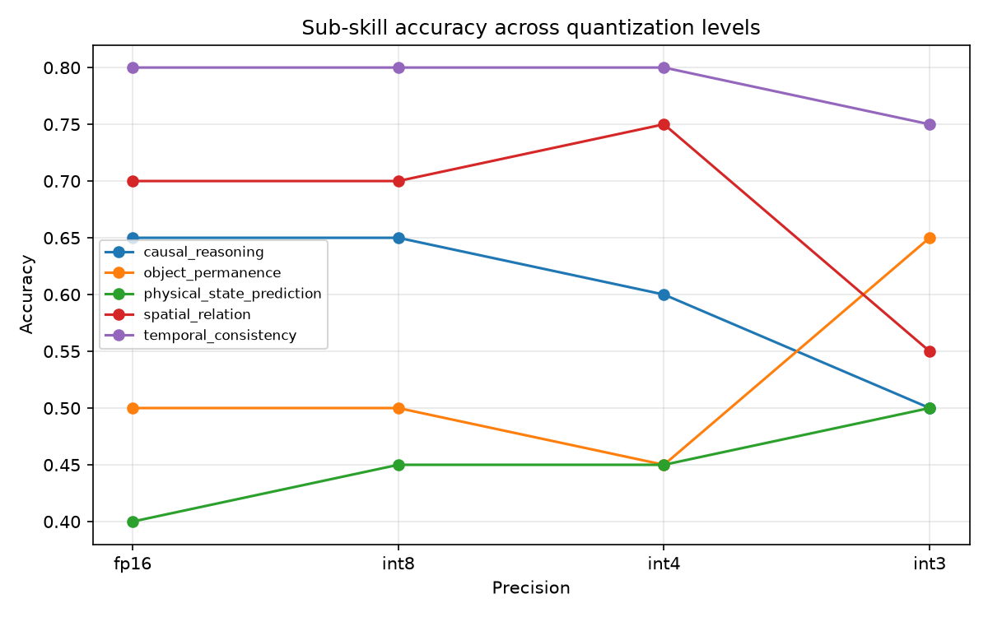
Figure 1: Sub-skill accuracy across quantization levels (FP16 → INT3). Causal reasoning and spatial relation both show a sharp decline specifically between INT4 and INT3; temporal consistency remains comparatively flat.
Finding 1 — degradation is not uniform. This is the central result: sub-skills diverge in how they respond to compression, rather than all declining together.
Finding 2 — causal reasoning and spatial relation reasoning both show a sharp INT4→INT3 transition. Both hold flat (or even tick up) through INT8 and INT4, then drop sharply at INT3: spatial relation falls from 75% to 55%, and causal reasoning continues a decline from 60% to 50%. Two independently-sourced sub-skills showing the same cliff location is the most directionally consistent pattern in the data.
Finding 3 — temporal consistency is the most robust sub-skill, essentially flat from FP16 through INT4 (80% throughout) with only a small dip at INT3 (75%).
Finding 4 — object permanence and physical state prediction are noisy and non-monotonic. Object permanence rises at INT3 (45%→65%), attributed to sampling noise. Physical state prediction hovers near chance level (40–50%) across all four precisions, suggesting this task is simply hard for a 2B-parameter model regardless of quantization.
A single concrete example makes Finding 2 tangible: for the item asking “What is the material of the object to collide with the green cylinder?” (choices: metal / rubber; correct answer: metal), the model answers correctly at FP16, INT8, and INT4, then answers “rubber” specifically at INT3 — reproduced live, deterministically, in the accompanying demo notebook.
3.3 Statistical Discussion
With n=20 items per sub-skill per precision level, the standard error of an observed proportion near p=0.5 is approximately 11 percentage points, giving a 95% confidence interval of roughly ±22 points. Most individual step-to-step differences reported above are not statistically significant in isolation. Findings 1–3 are reported as a suggestive, directionally consistent pattern from a small-sample pilot study, not as a statistically confirmed effect — an honest constraint of this evaluation's scale that should guide interpretation of every number above, and a direct target for a larger-scale follow-up.
3.4 Discussion and Deployment Implications
Held to the confidence level the data actually supports: if a deployment depends specifically on causal or spatial relational reasoning, this study's data points toward avoiding quantization below INT4, since both sub-skills that showed a clear cliff did so specifically at the INT4→INT3 transition, not gradually. Applications relying primarily on temporal ordering reasoning may tolerate more aggressive quantization with comparatively less risk. This is framed as a hypothesis for follow-up work with a larger item count, not a settled guideline.
The divergence itself — not simply “accuracy went down” — is the paper's actual contribution. It suggests that different physical-reasoning sub-skills may depend on the model's weights in structurally different ways: sub-skills requiring multi-step relational inference appear more fragile under aggressive compression than sub-skills requiring more direct temporal pattern-matching.
4. Related Work
Quantization and general reasoning. GPTQ (Frantar et al., 2023), AWQ (Lin et al., 2024), and GGUF k-quant methods are widely used to compress LLMs for edge deployment. Prior evaluations of quantized models on general benchmarks (MMLU, GSM8K, HumanEval) generally find graceful degradation down to INT4, with more pronounced drops below that. These studies do not evaluate multimodal models or physical/world-modeling tasks specifically.
World modeling and physical reasoning benchmarks. PhysBench (Chow et al., 2024/2025), PIQA (Bisk et al., 2020), and CLEVRER (Yi et al., 2020) each probe different aspects of physical understanding. All of this prior work evaluates full-precision models only.
The gap. No existing study measures how post-training quantization affects physical/world-modeling reasoning specifically, let alone whether different sub-skills within “world modeling” degrade at different rates.
(Citations above are given in good faith from memory of the cited works' authors, titles, and approximate years — verify exact venue/page details before final submission.)
5. Limitations
• Small per-cell sample size (n=20). Limits statistical confidence in any single reported difference; findings should be read as directional/suggestive.
• Single backbone model. Results may not generalize to other architectures or parameter scales; this is a case study, not a general claim about quantization.
• Static-frame proxy for video. CLEVRER is video-native; the backbone is image-based, so temporal-consistency items use a single representative frame rather than full motion.
• Object-permanence operationalization. Proxied via counterfactual-removal questions rather than direct visual occlusion/tracking.
• Single-domain dataset. All items derive from CLEVRER's synthetic collision-scene domain; findings may not transfer to naturalistic imagery.
• Vision tower not quantized. Only the language model is quantized; results characterize LM-side compression specifically.
6. Conclusion
This paper presents, to our knowledge, the first study of how post-training quantization affects physical world-modeling ability in a small multimodal LLM, decomposed into five independently-measured sub-skills, developed and evaluated entirely on representative low-resource CPU hardware — with the exploration and design process shaped directly by that hardware's real constraints, not abstracted away. We find that degradation is not uniform across sub-skills: causal and spatial relational reasoning show a sharp decline specifically between INT4 and INT3, while temporal consistency remains comparatively robust. Given the small scale of this pilot (n=20/sub-skill), these are presented as a directionally consistent, hypothesis-generating pattern rather than a statistically confirmed result. The full pipeline, dataset, attribution log, and a live, executed demo notebook are released to support a larger-scale follow-up.
. Appendix: Reproducibility
• Model: Qwen/Qwen2-VL-2B-Instruct (Hugging Face).
• Quantization tool: llama.cpp (mtmd multimodal support), quantize types Q8_0/Q4_K_M/Q3_K_M.
• Dataset build, evaluation harness, scoring, and analysis scripts, full item-level results, attribution log, and full development log are released alongside this paper.
• Live demo: notebooks/demo_quantization_degradation.ipynb, executed end-to-end, not just generated.

