Name – Susmita Mondal

Roll no- 54

1. Write a Java Program to print your Name entered through the command line as an argument.

class Name{

    public static void main(String args[])

{

    System.out.println("Name-susmita,roll no-54,Program Name- print my Name entered through the command line as an argument");

    for(int i=0;i<args.length;i++)

    {

        System.out.println("arr is " + args[i]);

    }

}

}

Output –

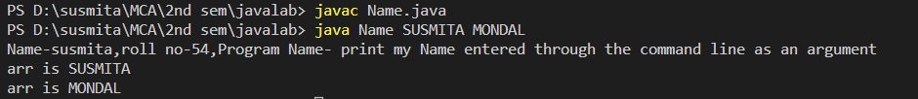

2.Write a Java program to convert Temperature from Fahrenheit to Celsius and vice versa.

import java.util.Scanner;

public class Calculator {

    public static void main(String args[])

    {

        Scanner scan=new Scanner(System.in);

        System.out.println("Name-SUSMITA MONDAL,Roll no-54,Program Name- Write a Java program to convert Temperature from Fahrenheit to Celsius and vice versa.");

        System.out.println("enter the number 1 for Fahrenheit to Celsius and 2 for Celsius to Fahrenheit");

        int result = scan.nextInt();

        //System.out.print(result);

        if (result==1)

        {

            System.out.println("you are selecting Fahrenheit to Celsius conversion ");

            System.out.println("Enter the fahrenheit value ");

            double f=scan.nextDouble();

            double c=((f-32) * 5)/9;

            System.out.println("The converted celsius value is  " + c);

        }

        else if(result==2)

        {

            System.out.println("you are selecting  Celsius to Fahrenheit  conversion");

            System.out.println("Enter the Celsius value ");

            double c=scan.nextDouble();

            double f=(((c * 9)/5) + 32);

            System.out.println("The converted Fahrenheit value is  " + f);

        }

        else

    {

        System.out.println("not a valid number");

    }    }

}

Output - 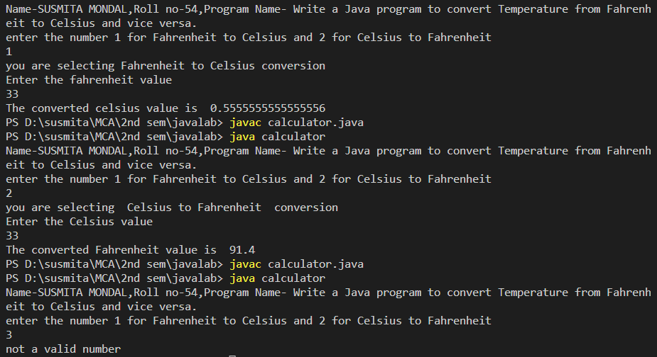

1. Write a Java program to add two numbers.

import java.util.Scanner;

public class Sum {

    public static void main(String args[]){

        Scanner scan=new Scanner(System.in);

        System.out.println("Name-SUSMITA MONDAL,Roll no-54,Program Name- Write a Java program to add two numbers");

        System.out.println("Enter first number ");

        int f_num = scan.nextInt();

        System.out.println("Enter second number ");

        int s_num = scan.nextInt();

        int result= s_num + s_num;

        System.out.println("The sum of two number is " +result);

    }

}

Output-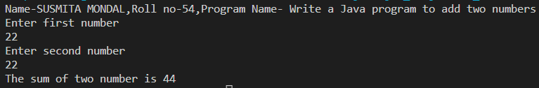

1. Write a java Program to find the area and Perimeter of a rectangle.
2. import java.util.Scanner;
3. public class Area {
4. public static void main(String args[])
5. {
6. Scanner scan= new Scanner(System.in);
7. System.out.println("Name-SUSMITA MONDAL,Roll no-54,Program Name- Write a java Program to find the area and Perimeter of a rectangle");
8. System.out.println("Enter the number 1 for Calculate the area of a rectangle and 2 for  Perimeter");
9. int result= scan.nextInt();
10. if(result == 1)
11. {
12. System.out.println("calculate the area of rectangle ");
13. System.out.println("enter the length of a rectangle");
14. double l=scan.nextDouble();
15. System.out.println("enter the wigth of a rectangle ");
16. double w=scan.nextDouble();
17. double area=(l*w);
18. System.out.println("the area of a rectangle is " + area);
19. }
20. else if(result==2)
21. {
22. System.out.println("calculate the Perimeter of rectangle ");
23. System.out.println("enter the length of a rectangle");
24. double l=scan.nextDouble();
25. System.out.println("enter the wigth of a rectangle ");
26. double w=scan.nextDouble();
27. double Perimeter=(2*l +2*w);
28. System.out.println("the Perimeter of a rectangle is " + Perimeter);
29. }
30. else{
31. System.out.println("invalid number");
32. }
33. }
35. }

Output-

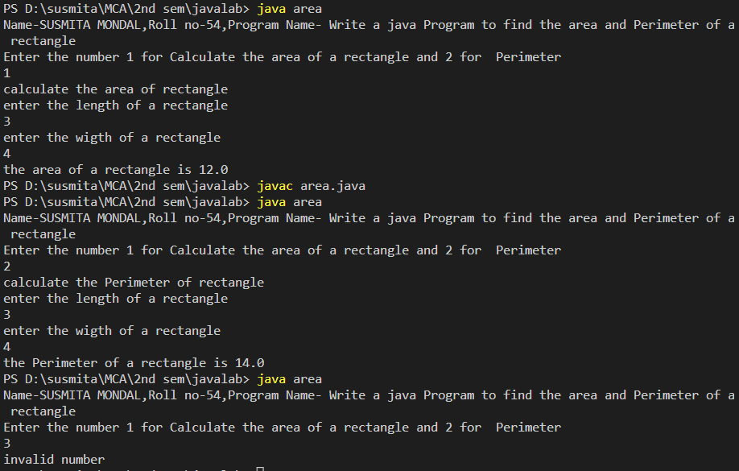

5.Write a program in Java to find the maximum of three numbers.

import java.util.Scanner;

public class Max {

    public static void main(String args[]){

        Scanner scan=new Scanner(System.in);

        System.out.println("Name-SUSMITA MONDAL,Roll no-54,Program Name- Write a program in Java to find the maximum of three numbers");

        System.out.println("Enter the number 1st number");

        int f_num= scan.nextInt();

        System.out.println("Enter the second number");

        int s_num=scan.nextInt();

        System.out.println("Enter the third number");

        int t_num=scan.nextInt();

        if(f_num >= s_num && f_num >= t_num)

        {

            System.out.println("the max number is first number : " + f_num);

        }

        else if(s_num>=f_num && s_num>=t_num){

            System.out.println("the max number is second number : " + s_num);

        }

        else{

            System.out.println("the max number is third number : " + t_num);

        }

    }

}

Output-

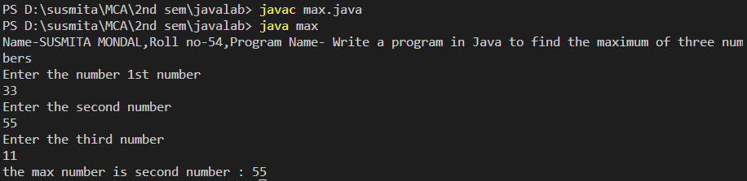

6. Write a Java Program to check whether a given year is a leap year.

import java.util.Scanner;

public class Leap_year {

public static void main(String args[]){

    System.out.println("Name-SUSMITA MONDAL,Roll no-54,Program Name- Write a Java Program to check whether a given year is a leap year.");

    Scanner scan=new Scanner(System.in);

    System.out.println("Enter the year");

    int year = scan.nextInt();

    if(((year % 4 == 0) && (year % 100 != 0)) ||

    (year % 400 == 0)){

    System.out.println("year is leap year");

    }

    else {

        System.out.println("year is not leap year");

}

}

}

Output-

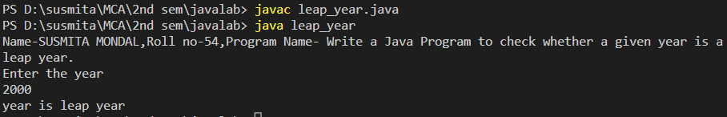

7. Create four different classes with three of them containing the function main.

Save the file with a different name than that of the class name and run each of the classes with the main function.

8.Write a java program to reverse a number entered as a command line argument.

import java.util.Scanner;

public class Reverse{

    public static void main(String args[]){

        Scanner scan=new Scanner(System.in);

        System.out.println("Name-susmita,roll no-54,Program Name- Write a java program to reverse a number entered as a command line argument");

        System.out.println("Enter a number");

        int number=scan.nextInt();

        int reverse = 0;

        while(number>0)

        {

           int remainder = number % 10;

           reverse = (reverse * 10) + remainder;

           number = number/10;

           //System.out.println("The reverse number is " + reverse);

        }

        System.out.println("The reverse number is " + reverse);

    }

}

Output -

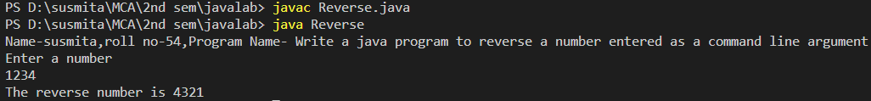

**9.** Write a java Program to count the number of digits entered through the command line argument.

import java.util.Scanner;

public class Count {

    public static void main(String args[])

    {

        System.out.println("Name-susmita,roll no-54,Program Name- Write a java Program to count the number of digits entered through the command line argument");

        Scanner scan=new Scanner(System.in);

System.out.println("Enter the number ");

        int number=scan.nextInt();

        int count =0;

        for(;number>0;number=number/10)

        {

            count = count + 1;

        }

        //while(number>0)

        // {

        //    number = number/10;

        //    count = count +1;

        //}

        System.out.println("The number of digit is " + count);

    }

}

Output-

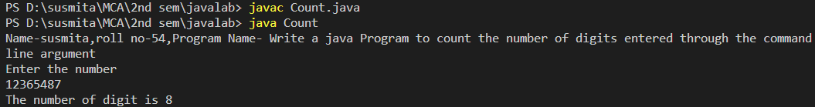

**10.** Write a java program to find all the multiples of 3 within a given range where the starting and ending value are entered through command line argument.

import java.util.Scanner;

public class Multiply {

    public static void main(String args[])

    {

        Scanner scan=new Scanner(System.in);

        System.out.println("Name-susmita,roll no-54,Program Name- Write a java program to find all the multiples of 3 within a given range where the starting and ending value are entered through command line argument ");

        System.out.println("Enter the starting number ");

        int s_number=scan.nextInt();

        System.out.println("Enter the ending number ");

        int e_number=scan.nextInt();

        for(int i=s_number;i<=e_number;i++)

        {

            int result=(3*s_number);

            s_number=s_number+1;

            System.out.println(i +" multiples by 3 = " + result);

        }

    }

}

**Output-**

