- Create a folder and initialize it , add environmental variables and activate them
- Install all dependency and libraries and check in project.toml file
- Connect to Git before starting the code to keep backup at start
- Document :structure of data (manually (import os),load text files data, load directory ,load pdf files(pypdf &pymupdf)

Versions :
- tqdm : 4.70.0
- langchain>=1.3.14 → Core abstractions (chains, prompts, etc.)
- langchain-community>=0.4.2 → Document loaders, vector stores, third-party integrations
- langchain-core>=1.5.1 → Base interfaces

Langchain Data structure has two components : page content (string), metadata(dictionary )
Loaders : PDF Loader, csv loader, web base loader, Directory loader
output will be inform of document structure (page content or metadata)
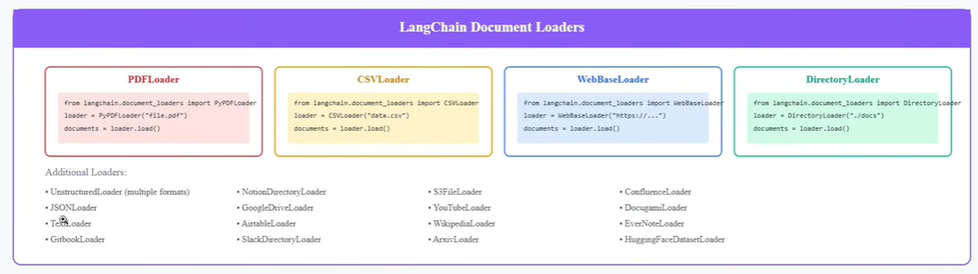
langchain | langchain_core | langchain_community
 | documents | Document_loaders

Document Loaders : TextLoader, DirectoryLoader,
- langchain>=1.3.14 → Core abstractions (chains, prompts, etc.)
- langchain-community>=0.4.2 → Document loaders, vector stores, third-party integrations
- langchain-core>=1.5.1 → Base interfaces

Create a empty folder in E drive : to avoid any data leakage or for smooth access
open that path in cmd , by simple give cmd + enter on file explorer of that path
Open this folder in vs code from cmd as below :
C:\Users\hp\HANDS-ON>code .
>uv init – for initializing your project with necessary dependencies & files(.py, READ.ME)
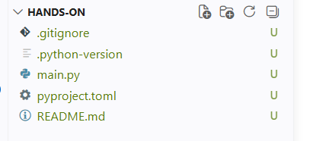
>uv venv- set virtual environment and activate them : .venv\Scripts\activate 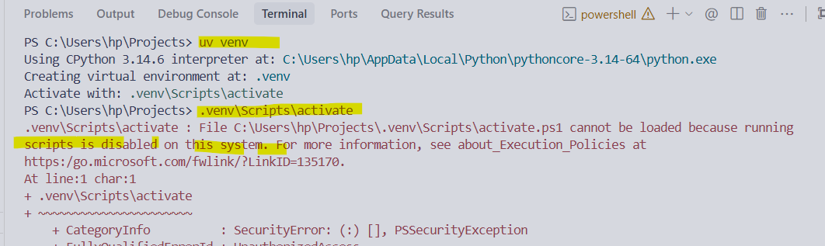
Errored while activating venv through above directory due policy issue, Run below command to avoid this error
Set-ExecutionPolicy -ExecutionPolicy RemoteSigned -Scope CurrentUser
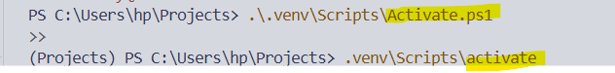
Task | Frequency
Set-ExecutionPolicy -ExecutionPolicy RemoteSigned -Scope CurrentUser | Once ever (already done ✅)
.\.venv\Scripts\Activate.ps1 | Every time you open a new terminal
TIP
To avoid manually activating every time, you can configure your code editor to auto-activate. For example in VS Code, set the Python interpreter to the .venv one:
- Press Ctrl+Shift+P
- Type "Python: Select Interpreter"
- Choose the one pointing to .venv\Scripts\python.exe
VS Code will then auto-activate the venv in its integrated terminal.

Create a Requirements.txt file for langchain, langchain-core, langchain-community and install libraries using this method, also save file
>uv add -r requirements.txt
TIP
Use Tab key for auto-completion — type uv add -r req then press Tab and PowerShell will auto-complete the filename correctly, avoiding typos.
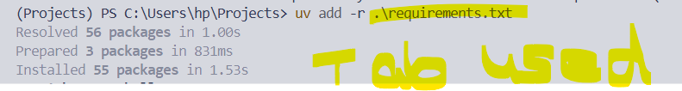
It adds dependencies in form of scripts added in virtual environment and validate packages in pyproject.toml
Observation: uv.lock.txt file created: for version compatibility that helps to work in any machine , uv.lock make sure that developer and system install the exact version
Pyproject.toml ----add dependencies
Venv-----install packages + sub dependencies
- uv lock is run: This explicitly resolves the dependencies and writes/updates the lock file without modifying your. venv.
- Key insight: pyproject.toml is your "wish list" (minimum versions), while uv.lock is the "receipt" (exact versions actually installed). Both must be committed to Git so your teammates get the identical environment.
- uv.lock file created automatically and managed by uv commands
Command | What it does to uv.lock
uv init | Creates an empty project (no lock file yet)
uv add <package> | Creates or updates uv.lock with the new package
uv remove <package> | Updates uv.lock, removing that package
uv sync | Creates uv.lock if missing, then installs from it
uv lock | Explicitly regenerates uv.lock without installing

Add pypdf, pymupdf using above cmd : specifically, to read documents
Also add kernel: uv add ipykernel (you see select kernel option when you open file with.ipynb)
Create data, notebook(docment.ipynb) folders and connect to kernel, by clicking on select kernel
Always select current environmental kernel from venv/scripts/python.exe
For Jupiter in web browser we need to register the kernel after installing
Document Structure :
From langchain_core.documents import Document
Document : Class for storing a piece of text and associated metadata.
Use case :
doc= Document (
page_content =”This is my First RAG Project “,
metadata={
“Name”: “Susmitha”,
“Age”:27,
“lifestyle”:”rich”
“Organization”:”Accenture”
}
)
Benefit of using Metadata : helps to apply filter after chunking and embedding in Vector store
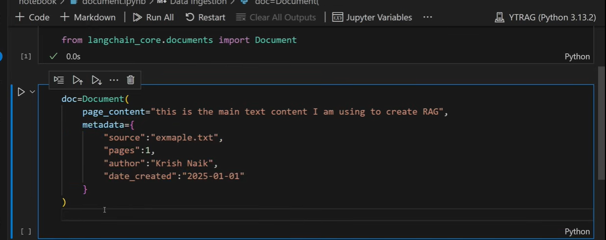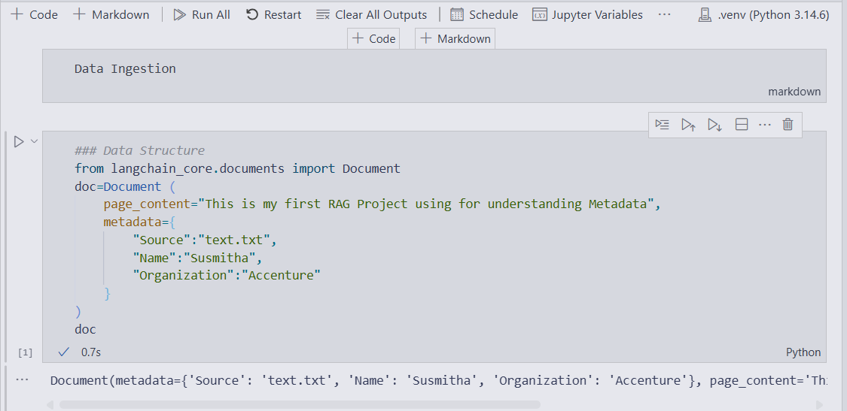
Create a new file: data.txt
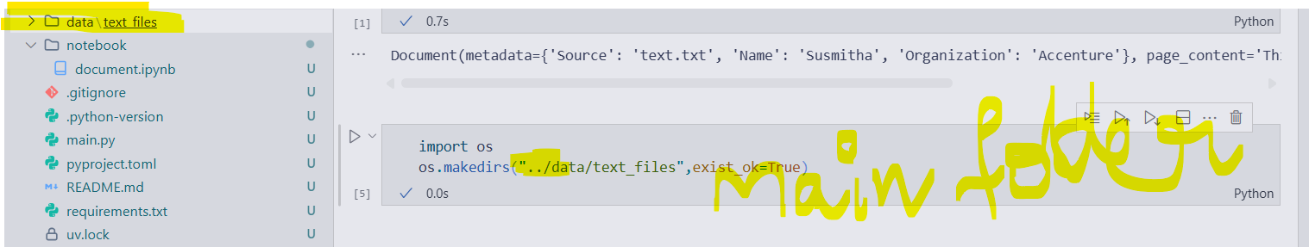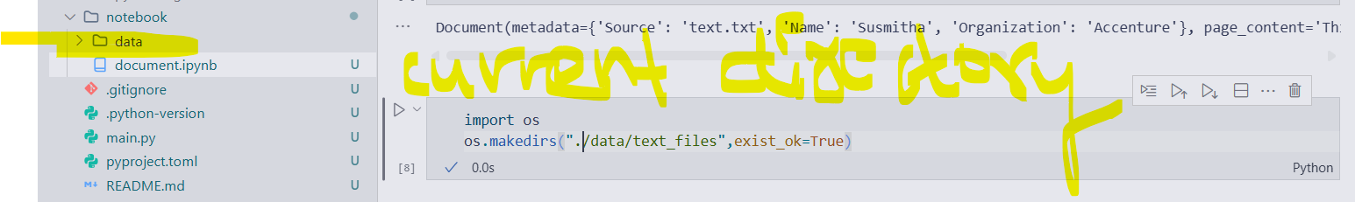
Exist_ok=True , to avoid file already exists error
Creates file if there is no file name as given directory and ignores if file already exist
import os Imports Python's built-in os (Operating System) module, which allows Python to interact with your computer's file system (creating folders, deleting files, renaming paths, etc.)
difference between
1. “..\data\text_files” error because ‘\’ takes as string in python
2. “./data/text_files” creates a file in current directory
3.”../data/text_files”go to open folder up & creates file there or in main or parent folder
- ./ → current folder (same level as notebook)
- ../ → one folder UP (parent folder)
- ../../ → two folders UP

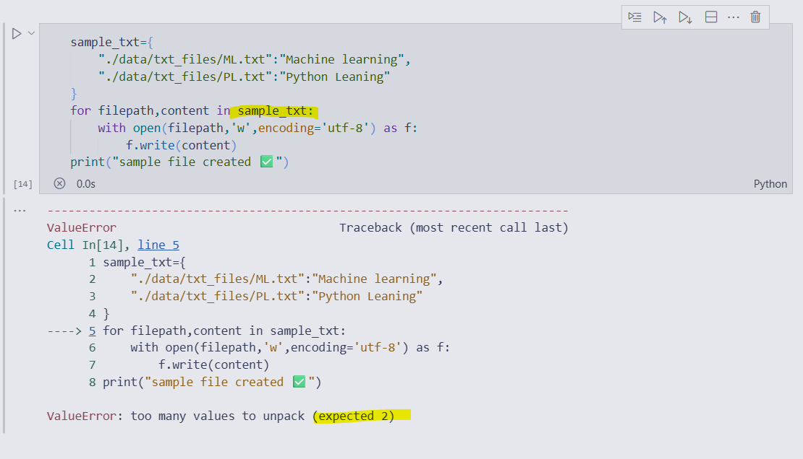
So add items:
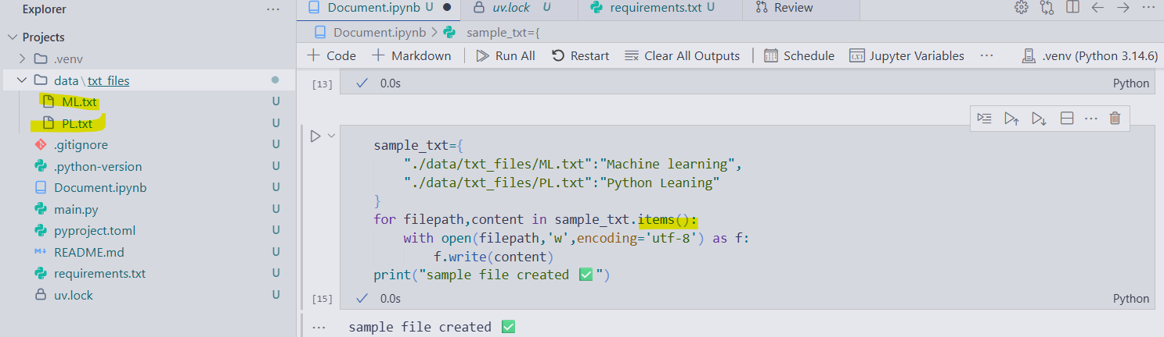
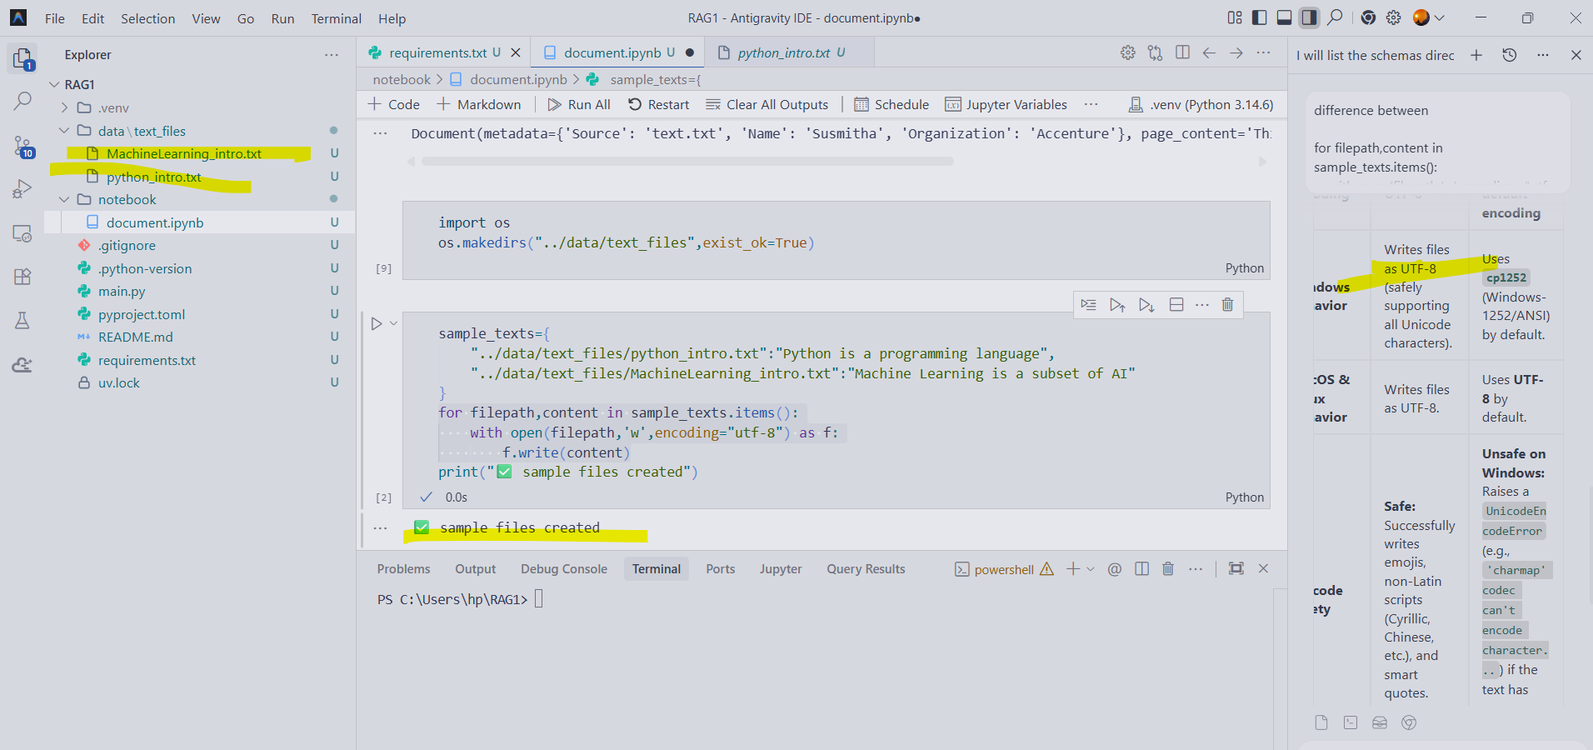
Windows+: for emoji’s
Sql: with and as are the sql queries helping to open and write content into the files
‘w’- write mode
We are not using load() function for
Loading data : Document Loader
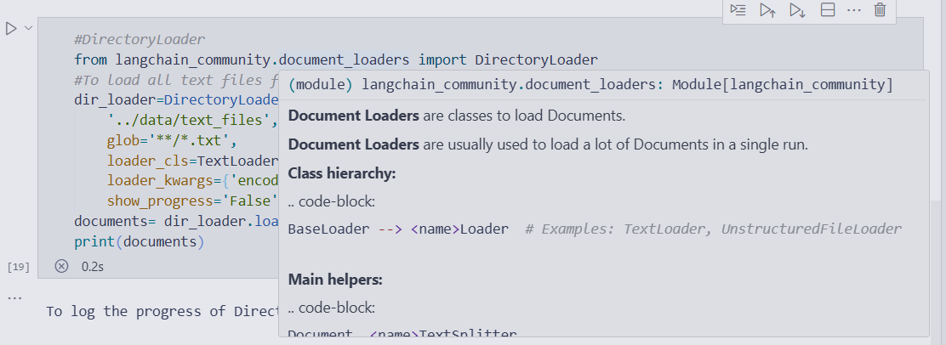
1. Load & read text file data 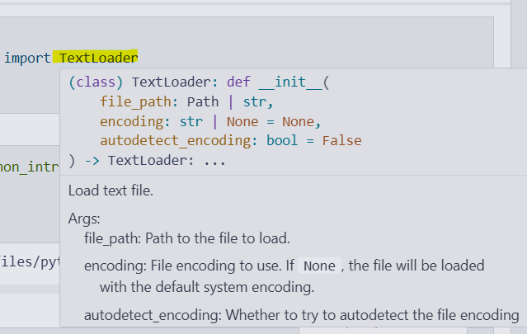

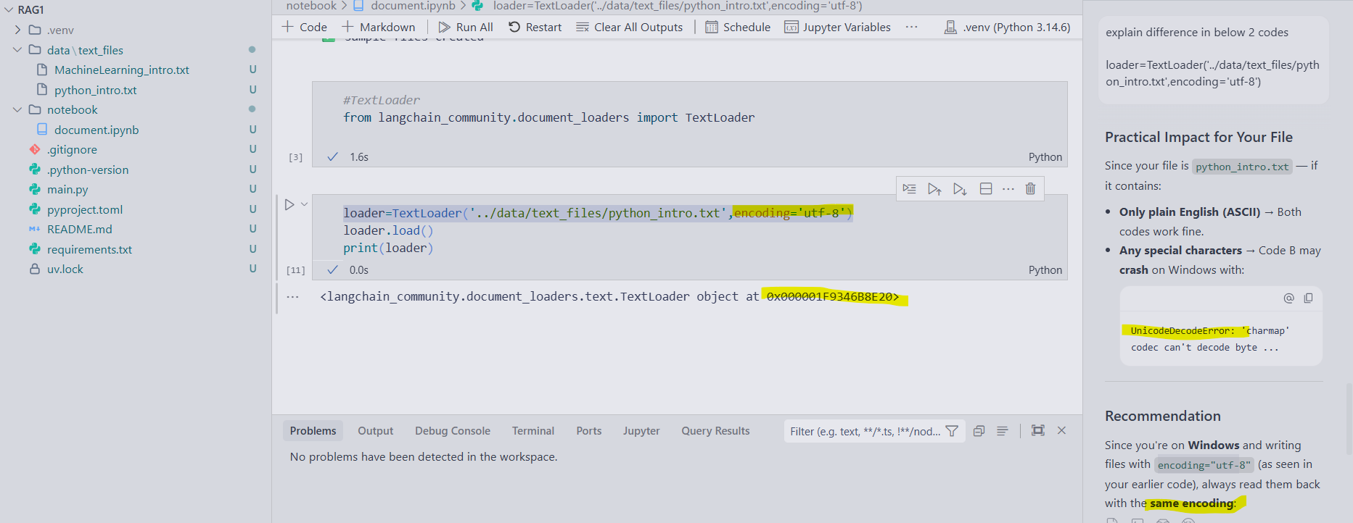
Always load data from main directory 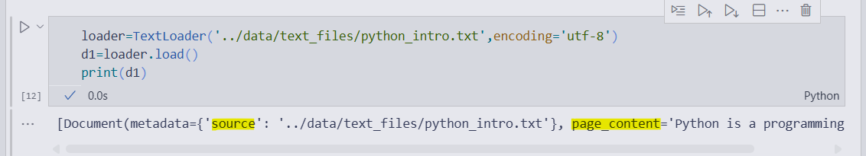
Here in output , you can see metadata as source and filepath
2. load and read from directory 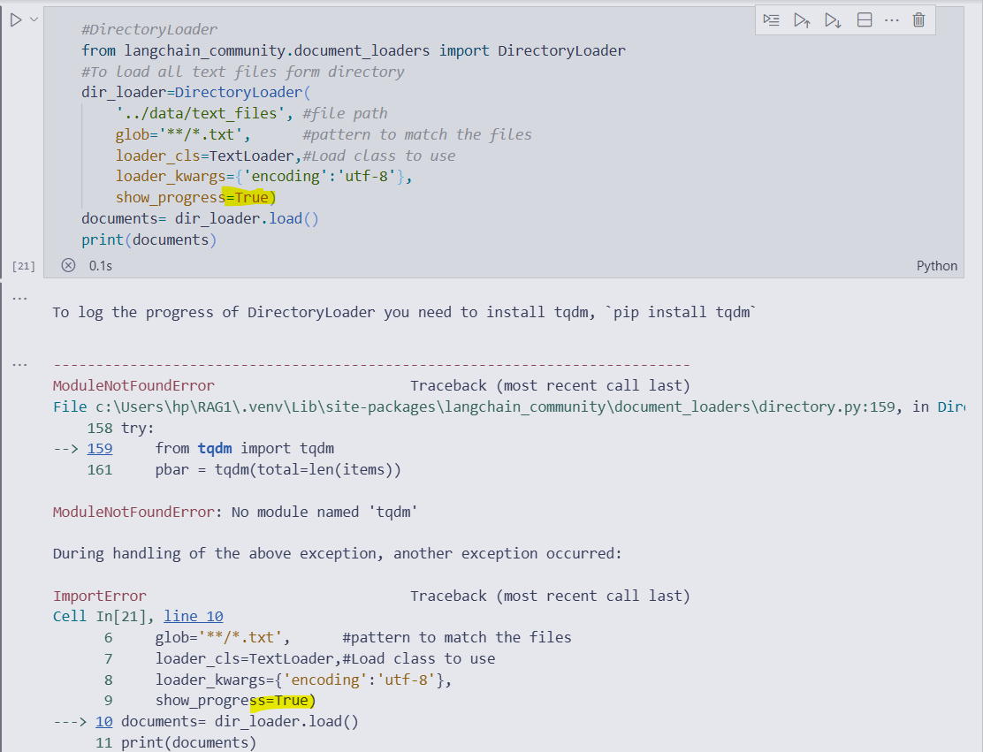
show_progress= True \\install tqdm to show Progress bar
show_progress=False \\ tp avoid error or installing tqdm
uv add tqdm
(verify at project.toml for version, tqdm.exe in venv, package/version added at uv.lock)

Physically make changes
Declaring the dependencies Package files downloaded & installed
Locks the exact resolved version
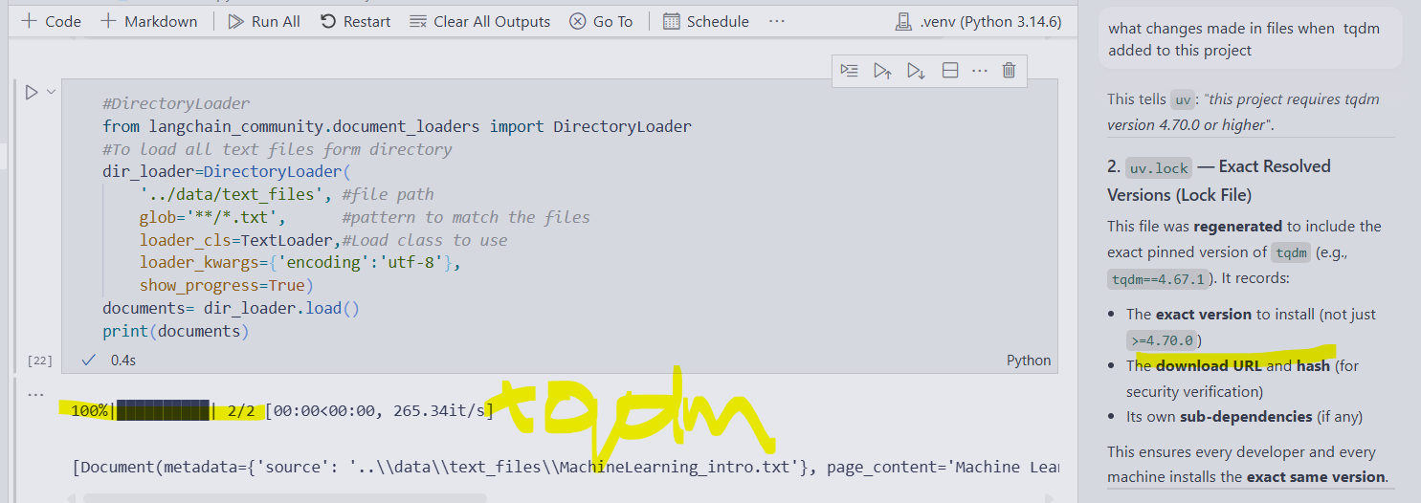
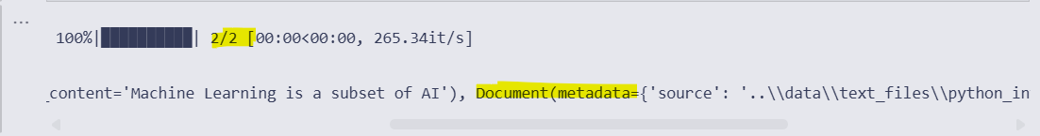it loading how many number of files with .txt in that directory
3.Reading files from PDF format: import PyPDFLoader and PyMuPDFLoader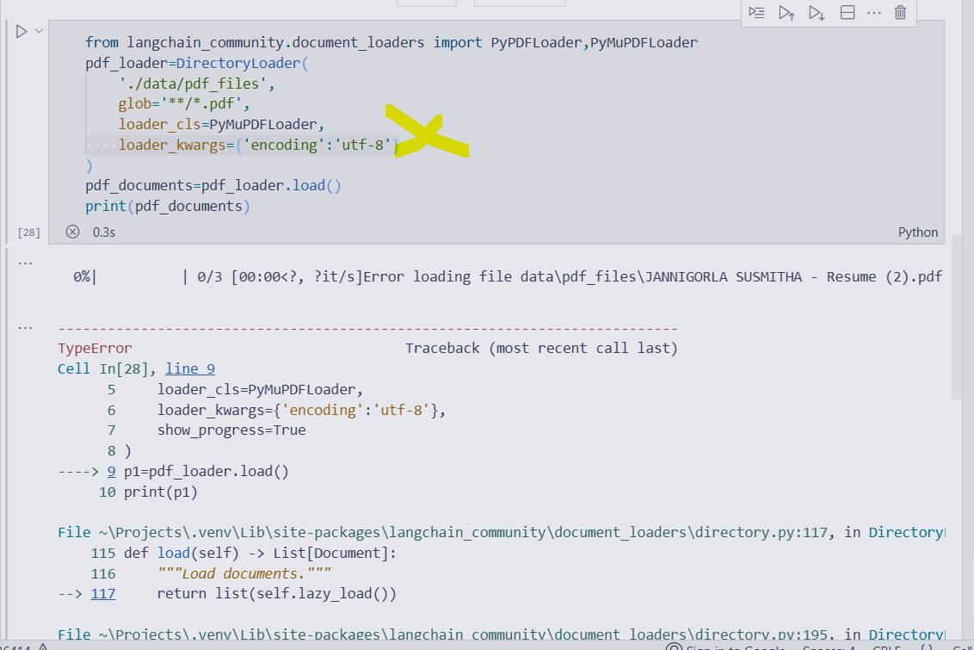
No need of encoding of loading pdf files
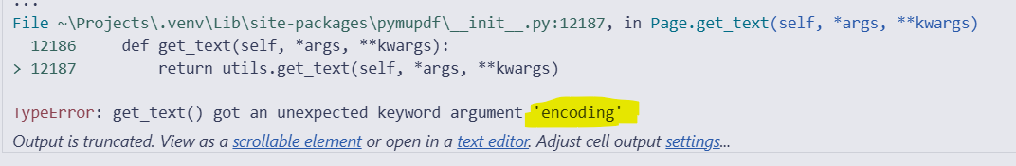
Output: 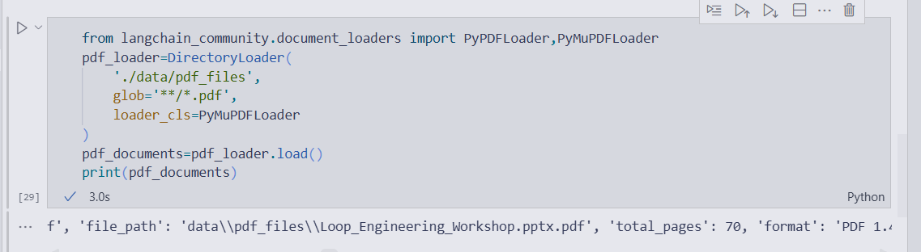
Type entries is Document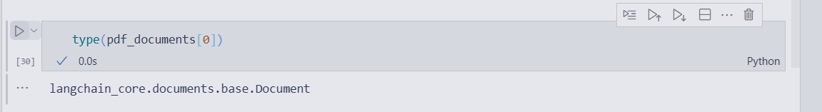
Type of files is List
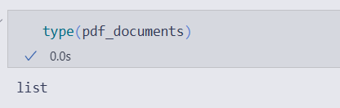
4.Excel(csv)
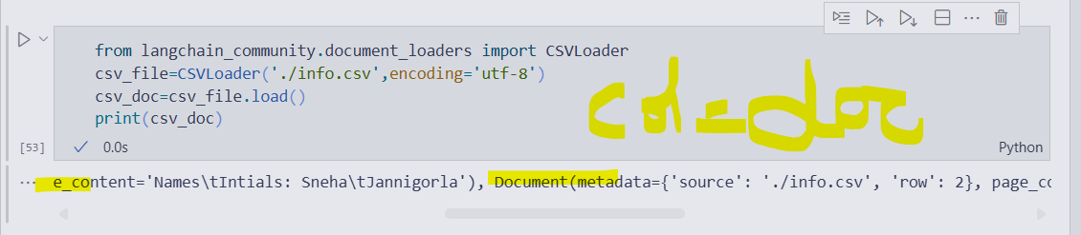
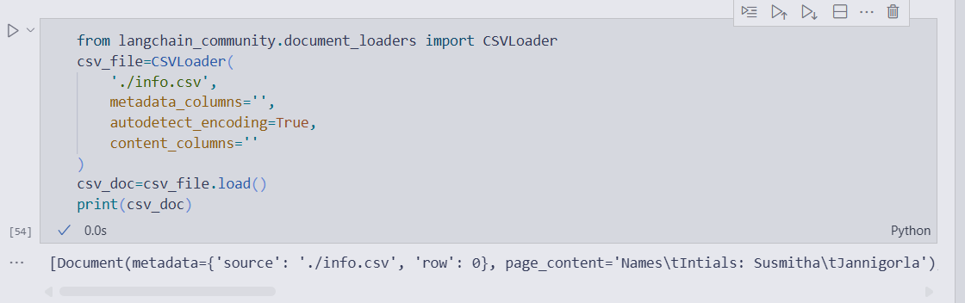
5.DB

