UNIT-1
EXPERIMENT 1
AIM: To find the roots of a quadratic equation using C++.
ax2+bx+c=0
using the quadratic formula.
DESCRIPTION:
A quadratic equation is a second-degree polynomial equation in a single variable x, with the standard form:
ax2+bx+c=0ax^2 + bx + c = 0ax2+bx+c=0
where:
- a, b, and c are real coefficients, and
- a ≠ 0.
To find the roots (or solutions) of the quadratic equation, we use the quadratic formula:
x=−b±b2−4ac2ax = \frac{-b \pm \sqrt{b^2 - 4ac}}{2a}x=2a−b±b2−4ac​​
The term inside the square root, D=b2−4acD = b^2 - 4acD=b2−4ac, is called the discriminant.
- If D > 0: Two real and distinct roots
- If D = 0: Two real and equal roots
- If D < 0: Two complex roots
The program calculates D, checks its value, and finds roots accordingly.
PROGRAM:
// Find the roots of a quadratic equation (ax2 + bx + c)
// This code handles real and distinct, real and equal, and complex roots.
#include <iostream>
#include <cmath> // for sqrt() function
using namespace std;
int main()
{
float a, b, c;
cout << "Enter coefficients a, b and c: ";
cin >> a >> b >> c;
float discriminant = b*b - 4*a*c;
float root1, root2;

if (a == 0) {
cout << "This is not a quadratic equation (a cannot be 0)." << endl;
}
else if (discriminant > 0) {
// Real and distinct roots
root1 = (-b + sqrt(discriminant)) / (2*a);
root2 = (-b - sqrt(discriminant)) / (2*a);
cout << "Roots are real and distinct." << endl;
cout << "Root 1 = " << root1 << endl;
cout << "Root 2 = " << root2 << endl;
}
else if (discriminant == 0) {
// Real and equal roots
root1 = root2 = -b / (2*a);
cout << "Roots are real and equal." << endl;
cout << "Root = " << root1 << endl;
}
else {
// Complex roots
float realPart = -b / (2*a);
float imagPart = sqrt(-discriminant) / (2*a);
cout << "Roots are complex and imaginary." << endl;
cout << "Root 1 = " << realPart << " + " << imagPart << "i" << endl;
cout << "Root 2 = " << realPart << " - " << imagPart << "i" << endl;
}
return 0;
}
OUTPUT:
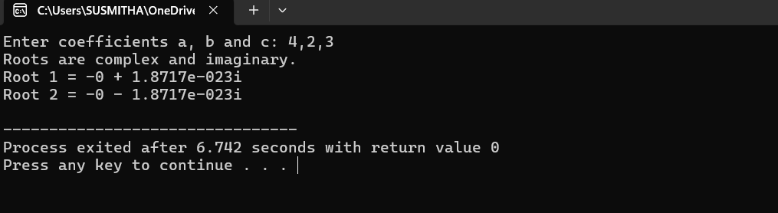
RESULT:
The program successfully calculates and displays the roots of the quadratic equation.
• When the discriminant is positive, it gives two distinct real roots.
• When the discriminant is zero, it returns equal real roots.
• When the discriminant is negative, it computes and displays the complex roots in the form p±qi
EXPERIMENT 2
AIM: Find factorial of a given number using recursion
DESCRIPTION:
Factorial of a non-negative integer n, denoted as n!, is the product of all positive integers less than or equal to n.
n!=n×(n−1)×(n−2)×…×1n! = n \times (n-1) \times (n-2) \times \ldots \times 1n!=n×(n−1)×(n−2)×…×1
For example:
- 5! = 5 × 4 × 3 × 2 × 1 = 120
- 0! = 1 (by definition)
This program uses recursion, a technique where a function calls itself, to calculate the factorial of a number.
Explanation Steps:
- Define a recursive function called factorial(int n).
- Inside the function:
  - If n == 0 or n == 1, return 1 (base case).
  - Else, return n * factorial(n - 1) (recursive case).
- In the main() function:
  - Accept a number from the user.
  - Pass it to the recursive function.
  - Display the result.
PROGRAM:
//Find factorial of a given number using recursion
#include <iostream>
using namespace std;
// Recursive function to calculate factorial
long factorial(int n)
{
if (n == 0 || n==1)
return 1;
else
return n * factorial(n - 1);
}
int main()
{
int number;
cout << "Enter a positive integer: ";
cin >> number;
if (number < 0)
{
cout << "Factorial is not defined for negative numbers." << endl;
}
else
{
long result = factorial(number);
cout << "Factorial of " << number << " = " << result << endl;
}
return 0;
}
OUTPUT:
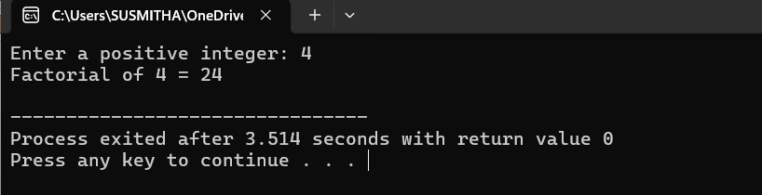
RESULT:
The program successfully calculates the factorial of a given number using recursion. It handles special cases such as zero and negative numbers appropriately. The recursive approach demonstrates the use of function calls within a function to solve problems elegantly.
EXPERIMENT 3
AIM: Implement scope resolution and namespaces.
DESCRIPTION:
In C++, scope resolution (::) and namespaces help to manage and organize identifiers (like variables or functions) and avoid naming conflicts.
- The :: operator is used to:
  - Access global variables/functions when a local variable/function has the same name.
  - Access elements defined inside namespaces or classes.
- Namespaces are used to group logically related identifiers (functions, variables, etc.) and avoid name collisions.
Explanation of Steps:
- Declare a global variable int value = 10;
- Inside main(), declare a local variable with the same name int value = 20;
- Use the scope resolution operator ::value to access the global variable.
- Create two namespaces: NamespaceA and NamespaceB — each having a function named display().
- Call both functions using namespace resolution (NamespaceA::display() and NamespaceB::display()).
PROGRAM:
// Implement Scope Resolution Operation and namespace
#include <iostream>
using namespace std; // using standard namespace
int x = 100; // Global variable
namespace MyNamespace
{
int value = 50;
void show()
{
cout << "Inside MyNamespace, value = " << value << endl;
}
}
int main()
{
int x = 10; // Local variable
cout << "Local x = " << x << endl;
cout << "Global x = " << ::x << endl; // Using scope resolution to access global x
// Accessing namespace variable and function
cout << "Namespace value = " << MyNamespace::value << endl;
MyNamespace::show();
return 0;
}
OUTPUT:
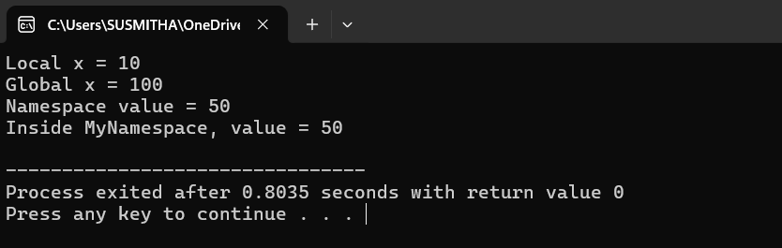
RESULT:
The program successfully demonstrates the usage of the scope resolution operator to distinguish between global and local variables, and the use of namespaces to avoid naming conflicts. It also shows that the scope resolution operator can be used to access namespace members explicitly, improving code organization and readability.
EXPERIMENT 4
AIM: Illustrate the use of default arguments and access specifiers
Description:
In C++, default arguments allow a function to assign default values to parameters, so the caller can choose to omit those arguments.
Access specifiers (private, public, and protected) control the visibility and accessibility of class members.
This program demonstrates both concepts using a simple class Rectangle.
Concepts Used
Default Arguments
A function can assign default values to its parameters like:
int add(int a, int b = 5); // b has a default value of 5
Access Specifiers
- private: Accessible only within the class.
- public: Accessible from outside the class.
- protected: Accessible in derived classes.
PROGRAM:
// Illustrate the use of default arguments and access specifiers
#include <iostream>
using namespace std;
class Student
{
private: // it is the default access specifier
int sno; // Private: accessible only inside the class
protected:
string sgrade; // Protected: accessible in derived classes
public:
string sname; // Public: accessible from outside
// Constructor
Student(int sn, string sna, string sg)
{
sno = sn;
sname = sna;
sgrade = sg;
}
// Function with default arguments
void disp(string sgrade = "Pass")
{
cout << " Name: " << sname << endl;
cout << "Roll Number: " << sno << endl;
cout << "Grade: " << sgrade << endl;
}
};
int main()
{
Student s1(100, "Rajesh", "A+"); // Creating object
cout << "Name of the Student ="<< s1.sname << endl; // accessing public variable
s1.disp();
s1.disp("Distinction");
s1.disp();
return 0;
}
OUTPUT:
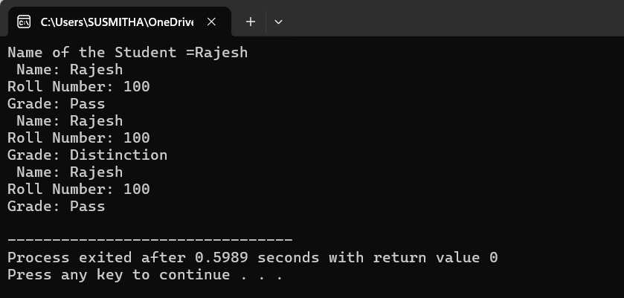
RESULT:
The program successfully demonstrates:
• How default arguments simplify function calls by allowing omission of some parameters.
• The role of access specifiers in encapsulation and data protection.
The output verifies that public members are accessible directly, private members are hidden from outside the class, and protected members are only accessible through inheritance.

