UNIT-5
EXPERIMENT 1
AIM: To implement exception handling in C++ using try, catch, and throw for handling runtime errors.
DESCRIPTION:
Exception handling in C++ is a mechanism to handle runtime errors, ensuring the program continues to execute smoothly without crashing. It allows separating the error-handling code from the normal logic of the program.
The keywords used are:
- try – Contains the block of code that might generate an exception.
- throw – Used to signal (or raise) an exception when an error occurs.
- catch – Handles the exception thrown by the throw statement.
When an error occurs in the try block, the throw keyword passes control to the corresponding catch block that can handle that particular type of exception. This helps maintain robust and error-tolerant programs.
PROGRAM:
#include <iostream>
#include <stdexcept> // Needed for runtime_error
using namespace std;
int main() {
int numerator, denominator;
cout << "Enter numerator: ";
cin >> numerator;
cout << "Enter denominator: ";
cin >> denominator;
try {
if (denominator == 0) {
throw runtime_error("Division by zero is not allowed!");
}
double result = static_cast<double>(numerator) / denominator;
cout << "Result = " << result << endl;
}
catch (const runtime_error &e) {
cout << "Exception caught: " << e.what() << endl;
}
cout << "Program continues after exception handling..." << endl;

return 0;
}
OUTPUT:
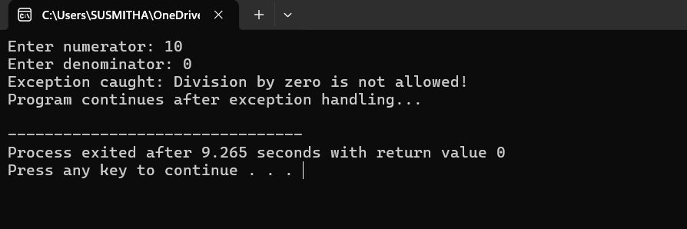
RESULT:
The program successfully demonstrates exception handling in C++ using try, catch, and throw statements.
It efficiently handles runtime errors such as division by zero without terminating the program abruptly and displays an appropriate error message, ensuring smooth program execution.

EXPERIMENT 2
AIM: To write a C++ program that demonstrates the use of multiple catch statements for handling different types of exceptions.
DESCRIPTION:
In C++, exception handling allows a program to respond to unexpected runtime errors using the keywords try, throw, and catch.
Sometimes, a program may generate different types of exceptions, such as division by zero, invalid input, or negative numbers.
To handle these efficiently, multiple catch blocks are used after a single try block. Each catch block can handle a different data type or kind of exception.
When an exception is thrown, control is transferred to the first matching catch block that can handle that particular type.
This approach helps in building robust and error-tolerant programs by providing specific error-handling mechanisms for various exception types.
PROGRAM:
#include <iostream>
using namespace std;
int main() {
try {
int choice;
cout << "Enter 1 for int exception, 2 for float exception, 3 for string exception: ";
cin >> choice;
if (choice == 1)
throw 10; // Integer exception
else if (choice == 2)
throw 3.14f; // Float exception
else if (choice == 3)
throw "Hello"; // String exception
else
throw 'X'; // Character exception
}
catch (int e) {

cout << "Caught an integer exception: " << e << endl;
}
catch (float e) {
cout << "Caught a float exception: " << e << endl;
}
catch (const char* e) {
cout << "Caught a string exception: " << e << endl;
}
catch (...) {
cout << "Caught an unknown exception!" << endl;
}
cout << "Program continues after exception handling." << endl;
return 0;
}
OUTPUT:
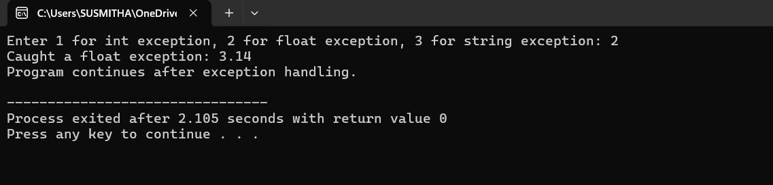
RESULT:
The program successfully demonstrates the use of multiple catch statements in C++ for handling different types of exceptions.
It shows that each catch block can handle a specific type of exception (int, char, or float), allowing the program to respond appropriately to various runtime errors and continue executing normally after handling them.

EXPERIMENT 3
AIM: Program to implement List, Vector and perform basic operations using the STL (Standard Template Library) in C++.
DESCRIPTION:
The Standard Template Library (STL) in C++ provides a set of powerful, reusable, and efficient template classes for handling common data structures and algorithms.
Two commonly used container classes in STL are vector and list.
- A vector is a dynamic array that allows random access and automatic resizing when elements are added or removed.
- A list is a doubly linked list that allows efficient insertion and deletion of elements at any position.
Using STL containers like vector and list, programmers can perform basic operations such as insertion, deletion, traversal, and display easily without manually managing memory or pointers.
This program demonstrates how to:
- Create and initialize vectors and lists
- Insert and delete elements
- Traverse and display contents
- Use STL functions like push_back(), pop_back(), begin(), end(), and erase()
PROGRAM:
#include <iostream>
#include <vector>
#include <list>
using namespace std;
int main() {
// Vector operations
vector<int> v;
v.push_back(10);
v.push_back(20);
v.push_back(30);
cout << "Vector elements: ";
for (int i = 0; i < v.size(); i++)
cout << v[i] << " ";
cout << "\nSize: " << v.size() << ", Capacity: " << v.capacity() << endl;
v.pop_back();
cout << "After pop_back, Vector elements: ";
for (auto it = v.begin(); it != v.end(); ++it)
cout << *it << " ";
cout << endl;
// List operations
list<int> l;
l.push_back(100);
l.push_front(50);
l.push_back(150);
cout << "\nList elements: ";
for (auto it = l.begin(); it != l.end(); ++it)
cout << *it << " ";
l.remove(100); // Remove element
cout << "\nAfter removing 100, List elements: ";
for (int x : l)
cout << x << " ";
cout << endl;
return 0;
}
OUTPUT:
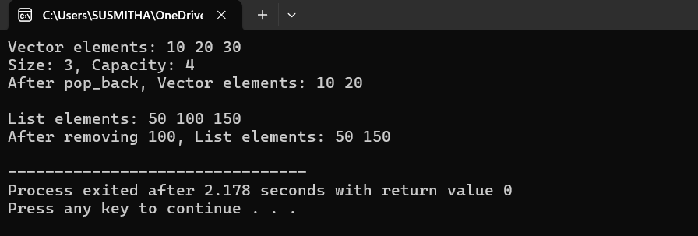
RESULT: The program successfully shows basic operations on Vector and List.
- Vector elements after operations: 10, 20
- List elements after operations: 100, 150, 200
EXPERIMENT 4
AIM: To write a C++ program to implement a Deque (Double-Ended Queue) and perform various operations such as insertion and deletion from both ends.
DESCRIPTION:
A Deque (Double-Ended Queue) is a data structure that allows insertion and deletion of elements from both ends — the front and the rear.
Unlike a normal queue, where insertion happens only at the rear and deletion at the front, a deque provides greater flexibility and efficiency for managing data.
In C++, the Standard Template Library (STL) provides the deque container class, which supports dynamic memory allocation and built-in functions for various operations.
Common operations include:
- push_back() – Insert element at the rear
- push_front() – Insert element at the front
- pop_back() – Remove element from the rear
- pop_front() – Remove element from the front
- front() / back() – Access the first and last elements
This program demonstrates how to create a deque, insert and delete elements from both ends, and display its contents, showing the versatility of STL containers in C++.
PROGRAM:
#include <iostream>
#include <deque>
using namespace std;
int main() {
deque<int> dq;
// Insert elements
dq.push_back(10); // Insert at rear
dq.push_back(20);
dq.push_front(5); // Insert at front
cout << "Deque elements: ";
for (int x : dq) {
cout << x << " ";
}
cout << endl;
// Access elements
cout << "Front element: " << dq.front() << endl;
cout << "Back element: " << dq.back() << endl;
// Deletion
dq.pop_front(); // Remove front element
dq.pop_back(); // Remove rear element
cout << "Deque after deletion: ";
for (int x : dq) {
cout << x << " ";
}
cout << endl;
// Insert more elements
dq.push_front(100);
dq.push_back(200);
cout << "Deque final state: ";
for (int x : dq) {
cout << x << " ";
}
cout << endl;
return 0;
}
OUTPUT:
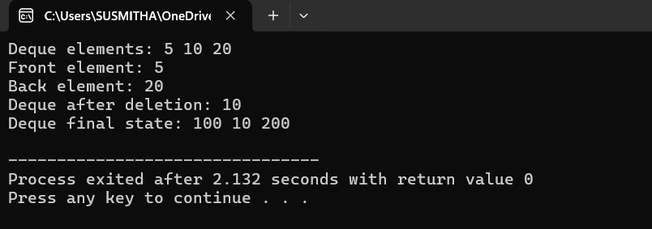
RESULT:
The program shows a Deque where elements can be added or removed from both front and back. After operations, the Deque displays the updated elements correctly.

EXPERIMENT 5
AIM: To write a C++ program that demonstrates the implementation of a map container and performs various operations such as insertion, traversal, search, deletion, and size check.
DESCRIPTION:
The program demonstrates the use of a map container in C++ STL. A map stores key-value pairs with unique keys in sorted order. The program performs various operations including:
- Insertion: Adding key-value pairs to the map.
- Traversal: Displaying all key-value pairs using an iterator or range-based loop.
- Search: Checking if a specific key exists in the map.
- Deletion: Removing a key-value pair using the key.
- Size Check: Finding the number of elements in the map.
This shows how the map efficiently manages and accesses data using keys.
PROGRAM:
#include <iostream>
#include <map>
#include <string>
using namespace std;
int main() {
// Declare a map with key as int and value as string
map<int, string> student;
// Insertion
student[1] = "Alice";
student[2] = "Bob";
student.insert({3, "Charlie"});
student.insert({4, "David"});
cout << "Map Elements (Key -> Value):" << endl;
for (auto it = student.begin(); it != student.end(); ++it) {
cout << it->first << " -> " << it->second << endl;
}
// Searching an element
int key = 3;
auto it = student.find(key);
if (it != student.end()) {
cout << "\nFound: " << it->first << " -> " << it->second << endl;
} else {
cout << "\nKey " << key << " not found." << endl;
}
// Deleting an element
student.erase(2);
cout << "\nAfter deleting key 2:" << endl;
for (auto &pair : student) {
cout << pair.first << " -> " << pair.second << endl;
}
// Size of the map
cout << "\nSize of the map: " << student.size() << endl;
return 0;
}
OUTPUT:
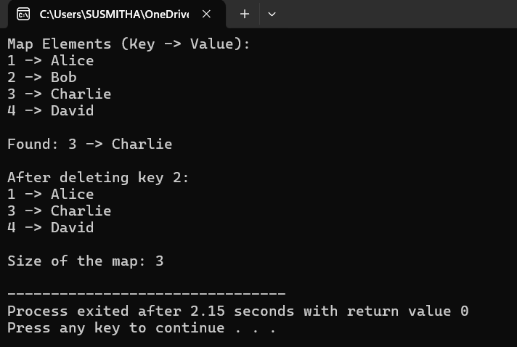
RESULT: The program shows a map where key-value pairs are added, displayed, searched, and deleted. The map correctly updates and shows the number of elements after each operation.

