MINI PROJECT REPORT

Project Title:ChatGPT Django Integration

Team Members:
G.Susmitha -23AK1A04E5
J.Sharanya -23AK1A04D1
K.Sravani -23AK1A04D9

Department:ECE
College: Annamacharya institute of technology and science in tirupati
Academic Year:2025-2025

ACKNOWLEDGEMENT
I would like to express my sincere gratitude to our CRT trainers and faculty members of the Electronics and Communication Engineering (ECE) Department for their valuable guidance, support, and encouragement in completing this mini project successfully.
I also thank our Head of the Department, ECE, for providing the necessary facilities and a good learning environment.
I am grateful to our college for giving us the opportunity to work on this project and improve our technical and practical skills.
Finally, I sincerely thank my team members for their cooperation, hard work, and continuous support in completing this mini project as a group.

ABSTRACT
This CRT mini project is developed to enhance practical knowledge and technical skills of students. It helps in understanding real-world applications by implementing theoretical concepts learned in the classroom.
The project is designed using Python Django framework, HTML, and is developed using Visual Studio Code as the code editor.
It focuses on improving problem-solving ability, teamwork, and programming skills. The system provides an efficient and user-friendly solution to the given problem.
Overall, this project helps in skill development and preparation for future placements.

INTRODUCTION
This CRT mini project is developed to apply theoretical knowledge into practical implementation. It helps students understand how real-world web applications are designed and developed using modern technologies.
The project is built using the Python Django framework for backend development and HTML for frontend design. Visual Studio Code is used as the development environment for writing and managing the code.
This system mainly focuses on improving technical skills, problem-solving ability, and teamwork among students. It also provides hands-on experience in developing a complete web-based application.
The project demonstrates how user input is processed, handled by the backend, and displayed as output through a web interface. It helps in understanding the basic structure and workflow of web development projects.
Overall, this project is useful for enhancing programming knowledge and preparing students for placements and real-time software development tasks.

OBJECTIVES
- To develop a web-based application using Python Django framework
- To design a simple and user-friendly interface using HTML
- To understand the basic workflow of web development projects
- To improve programming and problem-solving skills
- To gain practical knowledge of backend and frontend development
- To enhance teamwork and collaboration skills
- To prepare for real-time software development and placements.

TEAM MEMBERS
S.No | Name | Roll Number | Role
1. | G.Susmitha | 23AK1A04E5 | Frontend/ Design (HTML)
2. | J.Sharanya | 23AK1A04D1 | Backend(Django/ Python)
3. | K.Sravani | 23AK1A04D9 | Documentation/ Report

TECHNOLOGY USED
- Python Programming Language
- Django Framework for Backend Development
- HTML for Frontend Design
- Visual Studio Code as Code Editor
- SQLite Database (if used in the project)
- Windows Operating System.

DESCRIPTION
The project is a web-based application developed using the Python Django framework. It is designed to provide an efficient solution to the given problem in a simple and user-friendly manner.
The system consists of two main parts: frontend and backend. The frontend is designed using HTML, which is used to create web pages for user interaction. The backend is developed using Django, which handles the logic, processing, and communication between the user and the database.
When the user enters data through the web page, the request is sent to the Django server. The server processes the request, performs the required operations, and sends the response back to the user in the form of output displayed on the webpage.
This project follows a basic client-server architecture, where the user acts as the client and interacts through a browser, while Django acts as the server handling all processing tasks.
Overall, the system is simple, efficient, and helps in understanding real-time web application development using Python and Django.

IMPLEMENTATION
The project is implemented using the Python Django framework, which follows the Model-View-Template (MVT) architecture. The development is done using Visual Studio Code as the code editor.
The implementation process starts by creating a Django project and required applications. The necessary configurations are made in the settings file, including templates and static files setup.
HTML is used to design the frontend pages, which allows users to interact with the system through a web interface. Django handles the backend logic, processes user requests, and manages the flow of data between the frontend and backend.
When a user accesses the application, the request is routed through Django URLs. The corresponding views process the request and return the appropriate response using templates. If a database is used, Django ORM is used to store and retrieve data efficiently.
The system is tested by running the local server and checking all functionalities such as input handling, output display, and page navigation.
Overall, the implementation ensures a smooth and functional web application that demonstrates the integration of frontend and backend technologies.

OUTPUT

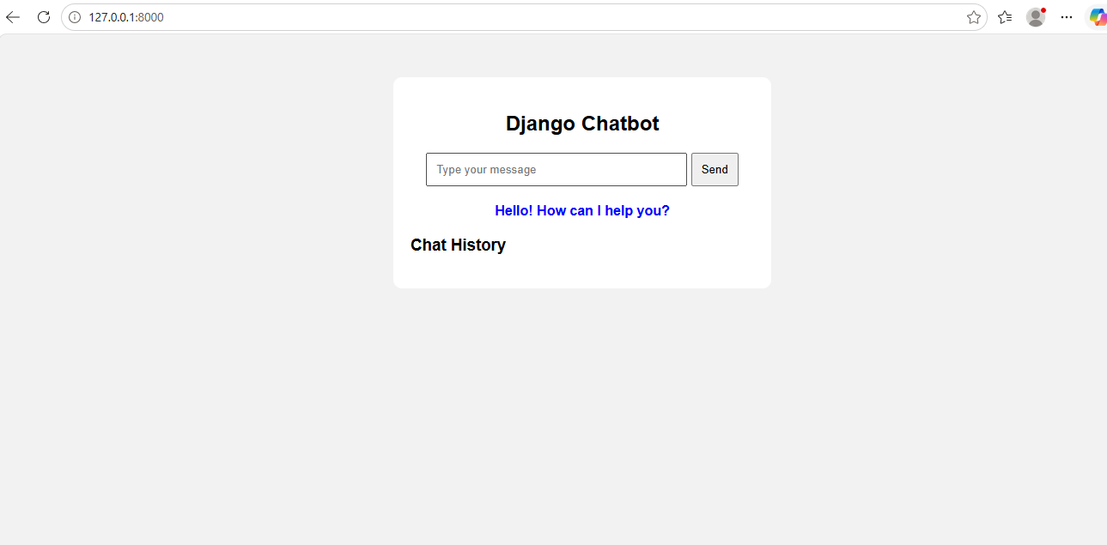

RESULTS
The project was successfully developed and tested using Python Django framework. It performs all the required functions as expected.
The system takes user input through the web interface, processes the data using backend logic, and displays the correct output on the screen.
The application is user-friendly, efficient, and works without errors. It helps in understanding the basic concepts of web development using Django, HTML, and Python.
Overall, the project gives correct results and meets all the objectives of the mini project.

CONCLUSION
The CRT mini project was successfully completed using Python Django framework, HTML, and Visual Studio Code.
This project helped us to understand the real-time process of web application development, including frontend and backend integration.
It improved our technical skills, problem-solving ability, and teamwork experience.
The system works efficiently and provides correct output based on user input.
Overall, this project was a valuable learning experience and will be helpful for future placements and software development careers.

REFERENCES
https://www.python.org/doc/⁠�
https://docs.djangoproject.com/⁠�
https://www.w3schools.com/html/⁠�
https://developer.mozilla.org/⁠�
https://www.geeksforgeeks.org/django-tutorial/⁠�
YouTube – Django Web Development Tutorials

