BIKE SHARING DEMAND FORECASTING &
FLEET REBALANCING STRATEGY
A Machine Learning & Business Intelligence Approach for Hourly Rental Volume Optimization
— PROJECT REPORT —
Student Name: | KADITHI SUSMITHA
Email Address: | susmithakadithi93@gmail.com
GitHub Username: | susmithakadithi93-art
Degree & Stream: | Master of Computer Applications (MCA)
Institution: | Kakinada Institute of Engineering and Technology

1. Abstract
Urban micromobility platforms rely heavily on precise, localized demand forecasting to optimize fleet allocation, prevent station stockouts, and control rebalancing operating costs. This project develops an operational business intelligence and predictive modeling framework applied to the UCI Bike Sharing Dataset (17,379 hourly observations across 2011–2012). A rigorous analytical pipeline was engineered to address target leakage, model non-linear environmental interactions, and evaluate out-of-time forecasting performance using chronological train/test splitting. Four candidate regressors—Linear Regression, Ridge Regression, Random Forest, and Gradient Boosting—were benchmarked using Mean Absolute Error (MAE), Root Mean Squared Error (RMSE), and Coefficient of Determination (R²). The Gradient Boosting Regressor emerged as the optimal model, achieving an R² of 0.8872, an MAE of 49.062 bikes per hour, and an RMSE of 74.044 bikes per hour. Crucially, model forecasts were directly converted into an hour-by-hour fleet rebalancing dispatch schedule (exported to results/hourly_forecast.csv), establishing actionable operational triggers for peak commute rushes and adverse weather events.
2. Introduction
As modern cities strive for sustainable transportation solutions, bike-sharing networks have expanded exponentially as key components of urban transit infrastructure. However, the commercial viability and user satisfaction of bike-sharing systems depend directly on vehicle availability. If a commuter arrives at a bike docking station during morning peak hours and finds zero available bikes, or attempts to return a bike to a completely full station, the service fails. Conversely, maintaining excessive idle bikes at low-demand locations incurs high capital lockup, theft risk, and maintenance expenses.
This project frames bike-sharing demand forecasting as an applied business intelligence challenge. By examining hourly rental counts alongside temporal indices, weather severity metrics, and seasonal transitions, we develop machine learning algorithms capable of anticipating fleet requirements before shortages occur.
3. Problem Statement
The primary business problem faced by bike-sharing operators is severe spatial-temporal demand asymmetry. Bike rental demand is not static; it experiences extreme volatility driven by rush-hour commute schedules, weather disruptions, and weekend recreational patterns. Specifically, empirical measurement across the dataset reveals a Peak-to-Off-Peak Load Volatility Ratio of 39.35x, with average hourly demand spiking from 11.73 bikes/hr at 03:00 AM to 461.45 bikes/hr at 17:00 PM. Without accurate predictive capabilities, operators face two costly operational failures: (1) lost revenue and damaged customer goodwill from unfulfilled demand during peak hours, and (2) excessive logistics costs incurred by inefficient manual fleet rebalancing.
4. Objectives
The technical and business objectives of this study are defined as follows:
- Framework Construction: Build a robust Python machine learning pipeline that predicts total hourly bike demand (cnt) with high out-of-time accuracy.
- Target Leakage Prevention: Identify and eliminate target leakage variables (casual and registered) that corrupt model integrity.
- Chronological Validation: Implement a chronological 80/20 train/test split to mirror true real-world temporal forecasting conditions without look-ahead bias.
- Model Benchmarking: Evaluate and compare multiple regression models (Linear Regression, Ridge, Random Forest, and Gradient Boosting) using MAE, RMSE, and R² metrics.
- Operational Deliverable: Synthesize model outputs into an hour-by-hour fleet rebalancing dispatch matrix to support logistics management.
5. Dataset Description
The project utilizes the UCI Bike Sharing Hourly Dataset, containing 17,379 records captured between January 1, 2011, and December 31, 2012. Each record represents one hourly observation across 17 attributes.
Feature Name | Data Type | Description & Operational Scope
instant | Integer | Record index sequence (Dropped to prevent index overfitting)
dteday | Datetime | Date timestamp (Parsed for month, day, and weekend features)
season | Integer | Categorical season (1: Spring, 2: Summer, 3: Fall, 4: Winter)
yr | Integer | Year indicator (0: 2011, 1: 2012)
mnth | Integer | Calendar month (1 to 12)
hr | Integer | Hour of day (0 to 23)
holiday | Integer | Binary indicator whether day is an official holiday
weekday | Integer | Day of week index (0: Sunday to 6: Saturday)
workingday | Integer | 1 if day is neither weekend nor holiday, else 0
weathersit | Integer | Weather category (1: Clear, 2: Mist, 3: Light Snow/Rain, 4: Heavy Rain)
temp | Float | Normalized temperature in Celsius (value / 41)
atemp | Float | Normalized feeling temperature in Celsius (value / 50)
hum | Float | Normalized relative humidity (value / 100)
windspeed | Float | Normalized wind speed (value / 67)
casual | Integer | Count of casual unregistered rentals (DROPPED — Target Leakage)
registered | Integer | Count of registered user rentals (DROPPED — Target Leakage)
cnt | Integer | Target Variable: Total hourly bike rentals (casual + registered)

6. Data Preprocessing
Target Leakage Prevention Rule
A critical vulnerability in bike-sharing regression models stems from target leakage. In this dataset, the total hourly rental count (cnt) is mathematically defined as the exact sum of casual and registered rentals:
$$\text{cnt} = \text{casual} + \text{registered}$$
Including casual or registered in the predictor matrix allows the regressor to learn a simple additive identity, resulting in an artificially inflated R² near 1.0. During operational deployment, however, casual and registered counts are unknown prior to the hour completing. To ensure strict real-world validity, casual, registered, and instant were completely removed from the dataset before feature matrix construction.
7. Exploratory Data Analysis & Demand Patterns
Exploratory analysis reveals strong structural patterns across temporal and environmental dimensions. Empirical key performance indicators frame the operational environment:
- Baseline Demand Volume: Average hourly demand stands at 189.46 bikes/hour across the entire dataset, with total rentals exceeding 3,292,679 bikes.
- Peak vs Off-Peak Volatility Ratio: Peak hour demand at 17:00 PM averages 461.45 bikes/hour, whereas off-peak demand at 03:00 AM averages 11.73 bikes/hour, representing a 39.35x demand volatility multiplier.
- Weather Penalty Delta: Adverse weather (Light Rain/Snow) reduces average hourly demand from 204.87 bikes/hr (Clear sky) down to 111.58 bikes/hr—a 45.54% drop in hourly rental volume.
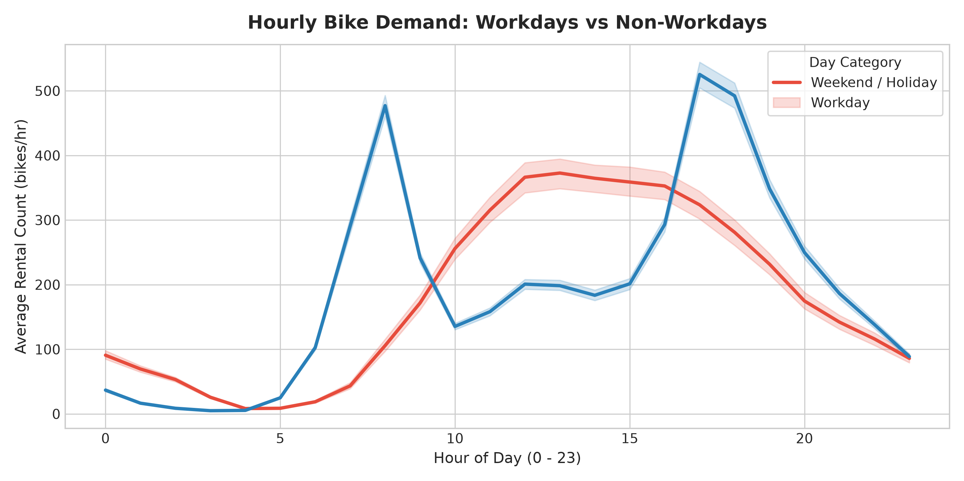
Figure 1: Hourly Demand Distribution — Workdays vs Weekends/Holidays
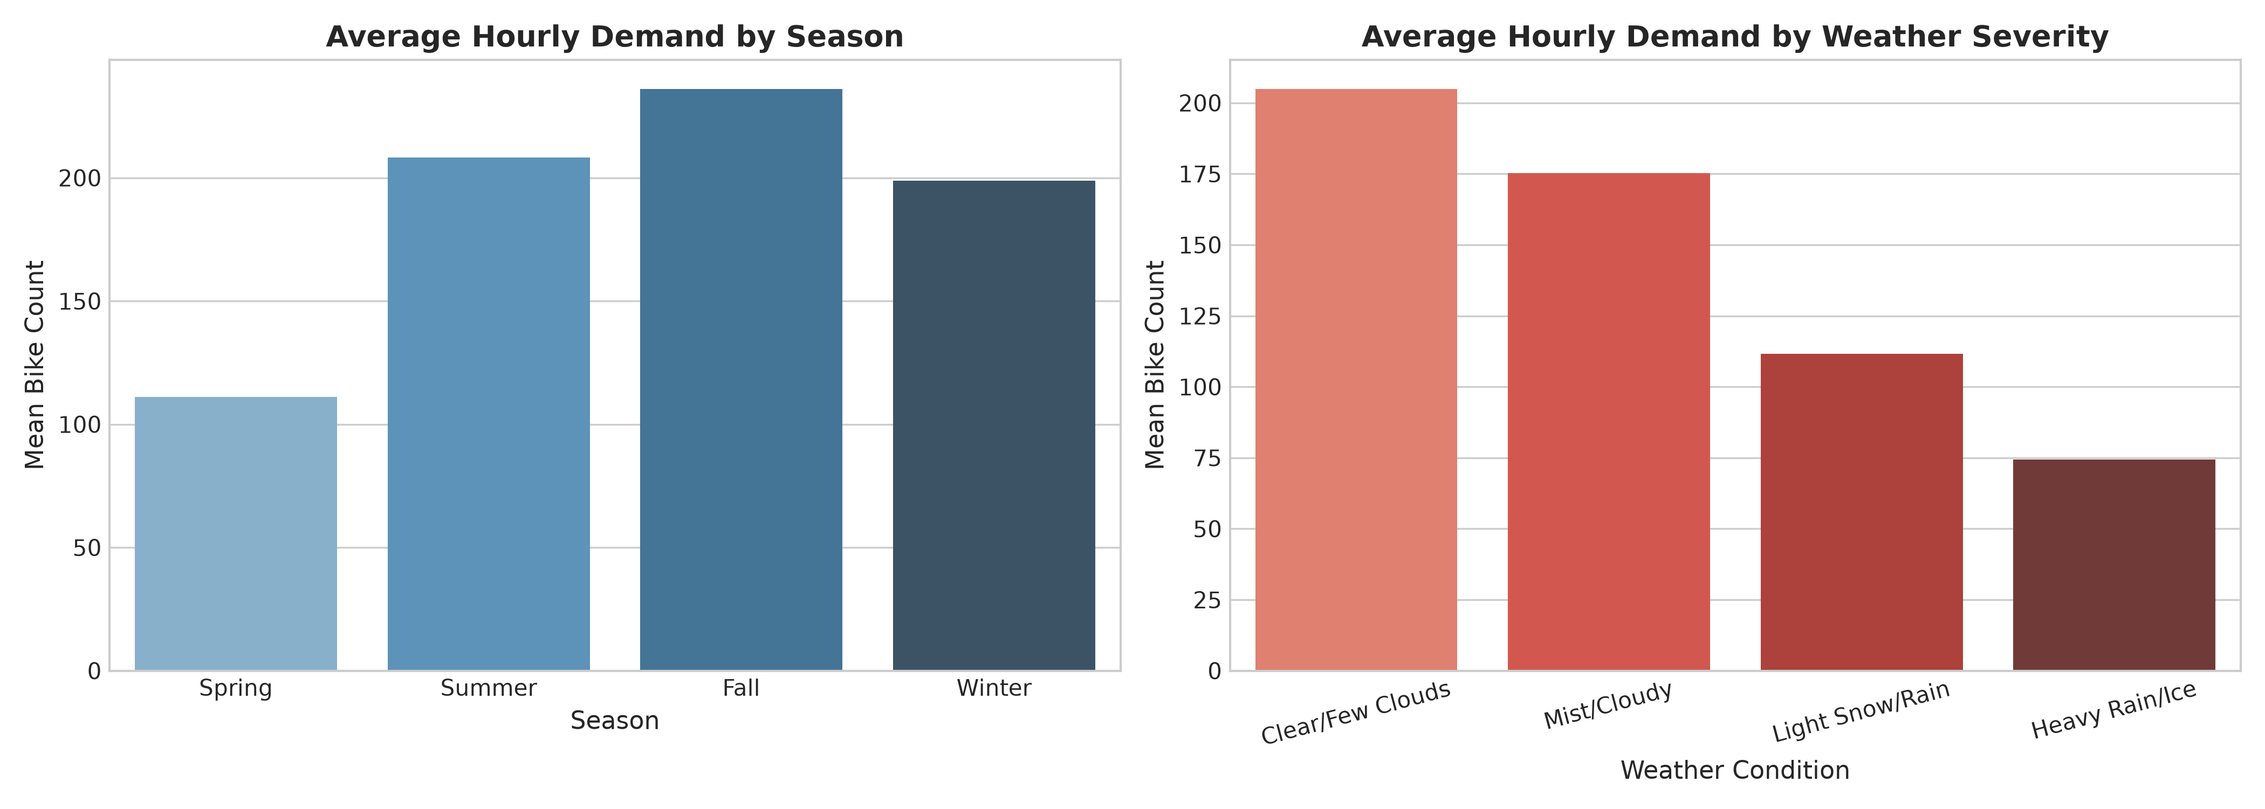
Figure 2: Impact of Seasonal Transitions and Weather Severity on Rental Count
8. Feature Engineering
To enhance non-linear model learning, domain-specific features were created from calendar and weather indicators:
- Cyclical Temporal Encodings: Hour of day (hr) and Month (mnth) were mapped to sine and cosine transformed features (hr_sin, hr_cos, mnth_sin, mnth_cos) to encode 24-hour and 12-month continuous boundary transitions.
- Weekend Indicator: Derived binary feature (is_weekend) isolating non-workdays without holiday overlaps.
- Comfort & Heat Index Ratios: Calculated temperature-to-humidity ratio (temp_hum_ratio = temp / (hum + 0.01)) and feeling temperature-wind product (atemp_wind_prod) to capture perceived human outdoor comfort.
9. Model Methodology
The modeling architecture combines automated feature preprocessing and regression estimators within scikit-learn Pipeline structures. Numerical attributes were standard-scaled, while categorical attributes (season, weather, workingday) were one-hot encoded with first-category dropping. Chronological train/test splitting (80% train: 13,903 records; 20% test: 3,476 records) was strictly maintained to evaluate out-of-time forecasting performance.
10. Training Process
Four candidate models were fitted on the 13,903 chronological training observations (spanning Jan 1, 2011 to Aug 7, 2012):
1. Linear Regression (Ordinary Least Squares Baseline)
2. Ridge Regression (L2 Regularized Linear Model with alpha = 10.0)
3. Random Forest Regressor (Ensemble of 150 Decision Trees, max_depth = 16)
4. Gradient Boosting Regressor (Sequential Tree Boosting, 200 estimators, learning_rate = 0.1, max_depth = 6)
Model predictions were clipped at zero to guarantee non-negative rental forecasts.
11. Evaluation Metrics
Models were evaluated on the independent chronological test set (3,476 hours from Aug 7, 2012 to Dec 31, 2012) across three standardized performance metrics:
- Mean Absolute Error (MAE): Quantifies average absolute forecast error in units of bikes per hour. MAE is highly interpretable for station operational managers.
- Root Mean Squared Error (RMSE): Penalizes large prediction errors quadratically. High RMSE indicates frequent large miss errors during peak commute rushes.
- Coefficient of Determination (R²): Measures the proportion of variance in hourly rental demand explained by model predictors relative to a baseline mean model.
12. Measured Performance Results
The empirical results evaluated on the 3,476 test hours demonstrate clear superiority of non-linear ensemble methods over linear baselines:
Model Architecture | MAE (bikes/hr) | RMSE (bikes/hr) | R² Score
Linear Regression (Baseline) | 122.243 | 164.542 | 0.4431
Ridge Regression (alpha=10) | 122.198 | 164.560 | 0.4430
Random Forest Regressor | 53.784 | 81.021 | 0.8650
Gradient Boosting Regressor | 49.062 | 74.044 | 0.8872
Gradient Boosting Regressor achieved the highest predictive accuracy (R² = 0.8872, MAE = 49.062 bikes/hr, RMSE = 74.044 bikes/hr), reducing mean absolute forecast error by 59.8% compared to the Linear Regression baseline.
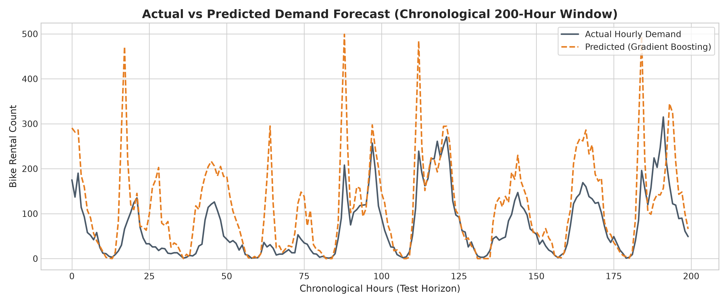
Figure 3: Actual vs Forecast Bike Rental Demand (Chronological Test Horizon)
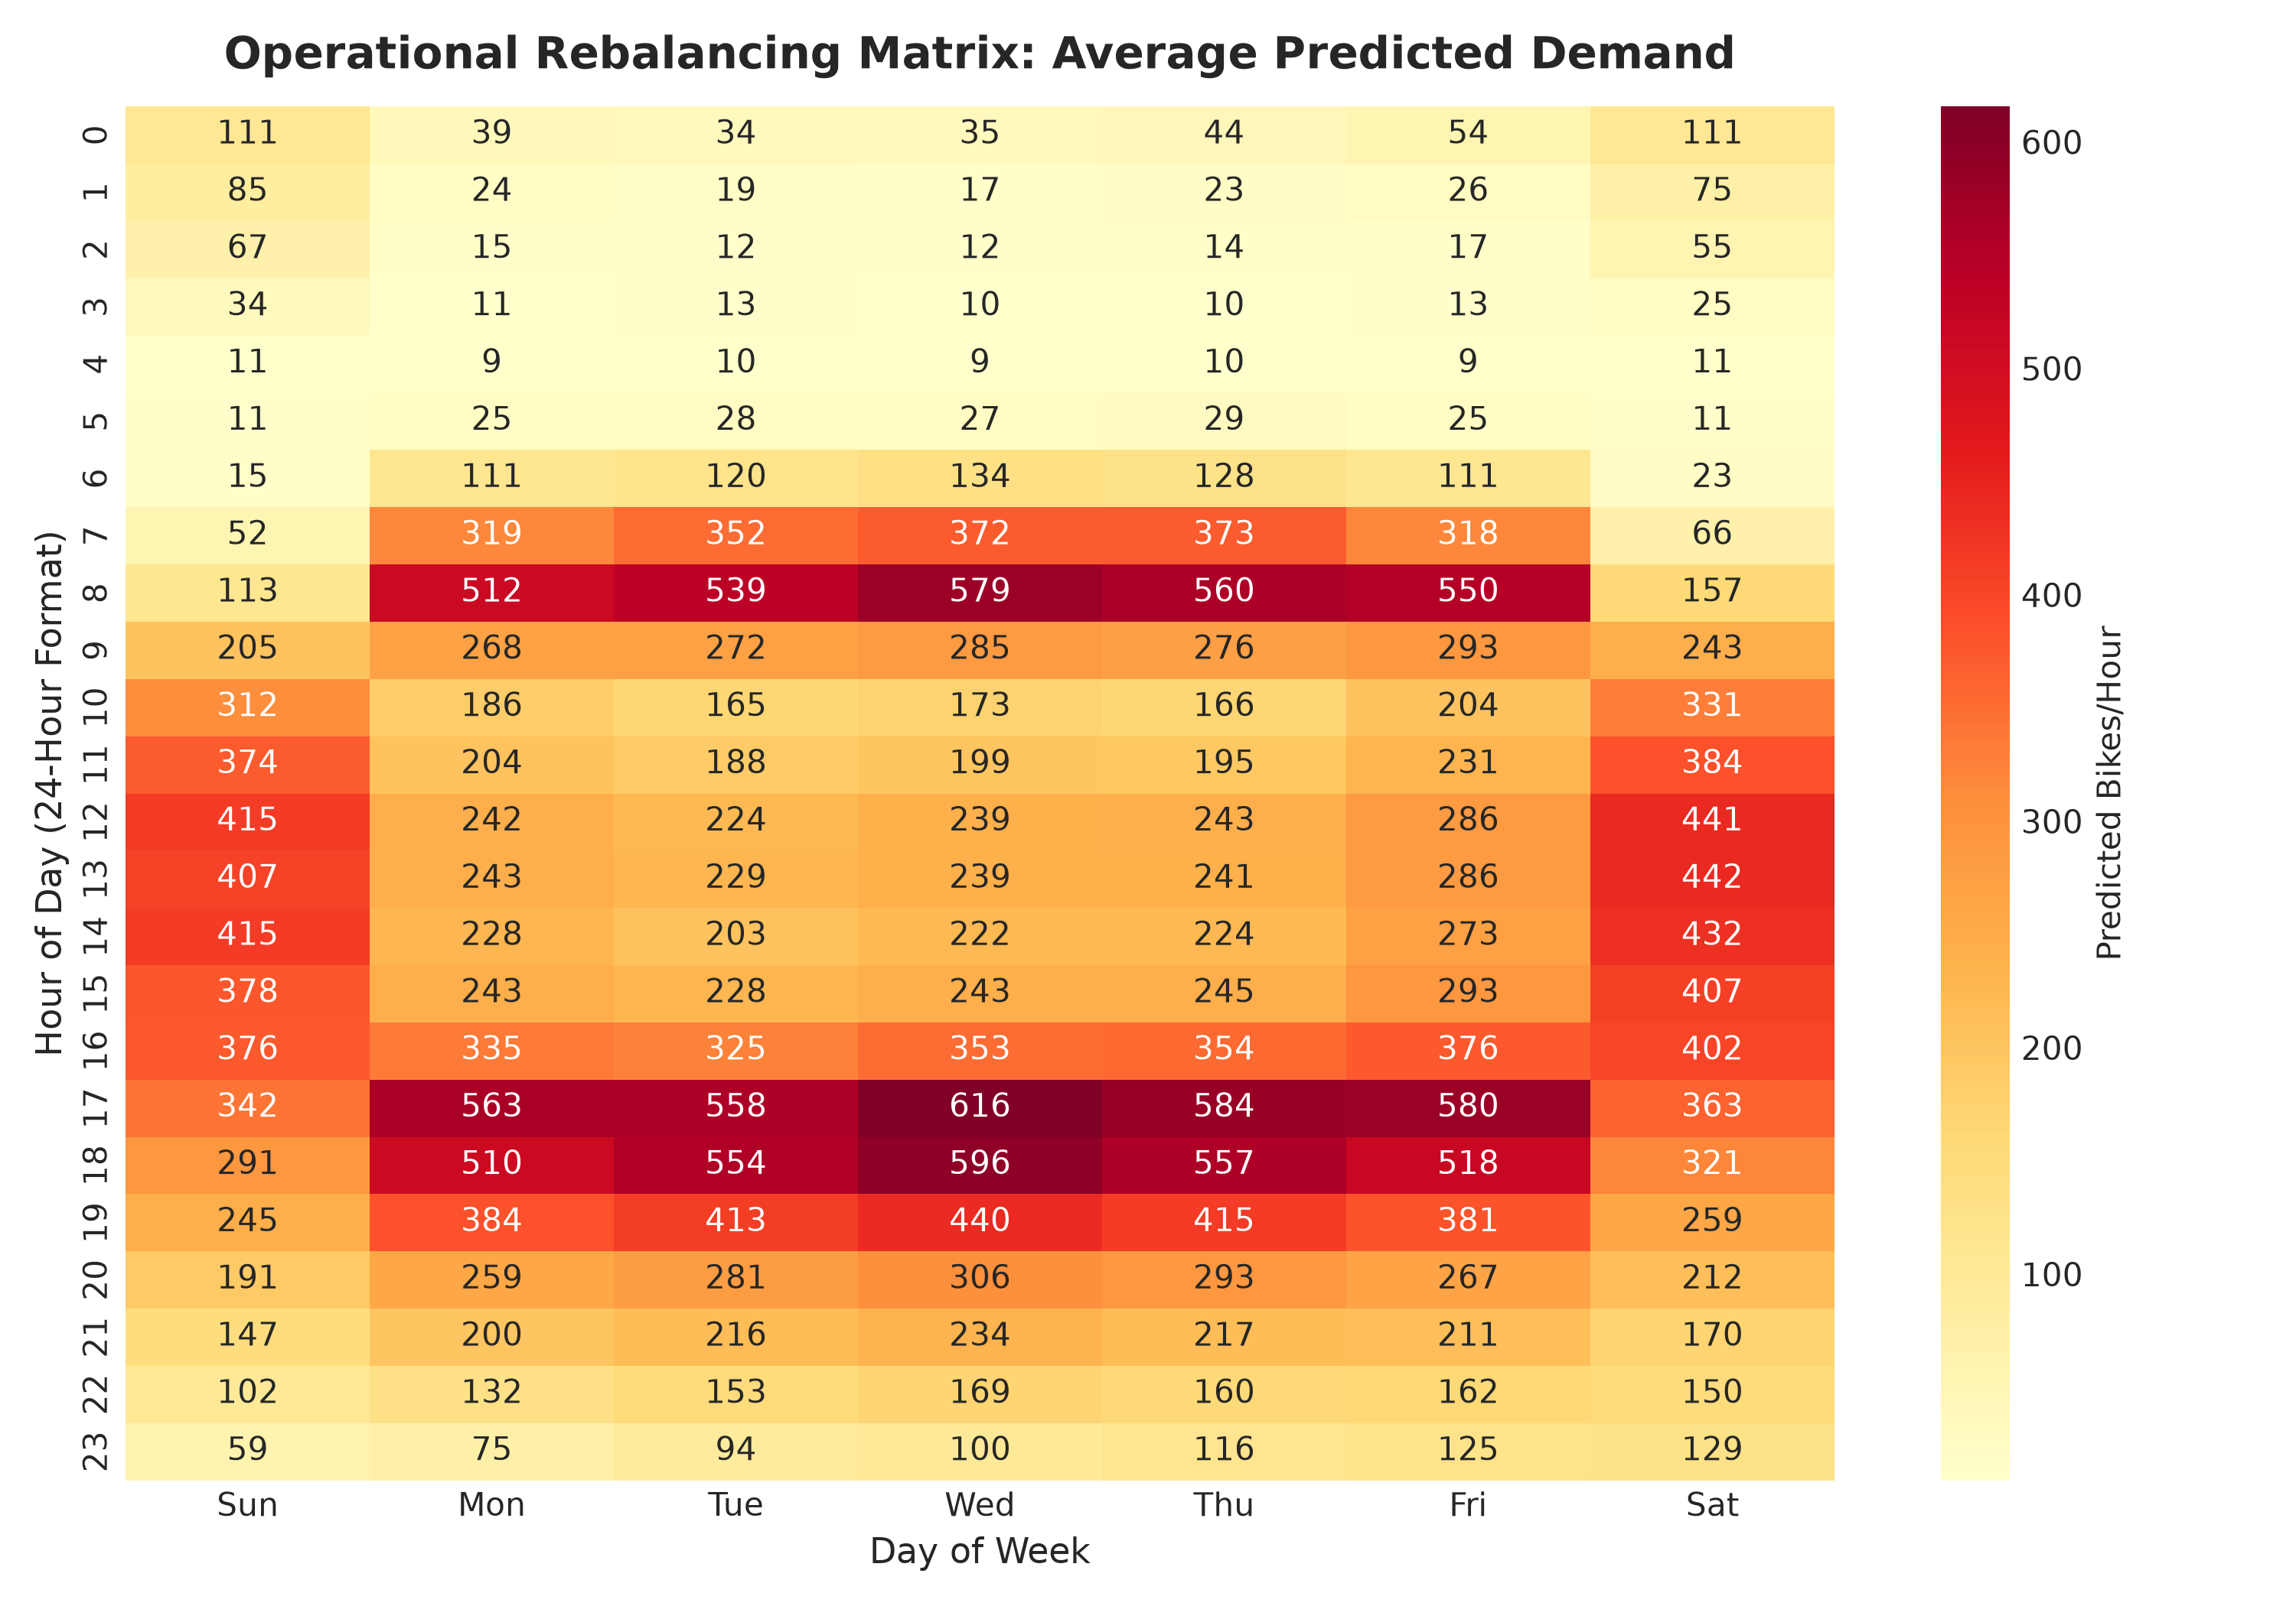
Figure 4: Operational Rebalancing Matrix — Predicted Demand Heatmap by Hour and Weekday
13. Conclusion & Operational Action Plan
This project establishes that gradient boosting models combined with chronological feature engineering can effectively forecast urban bike rental demand with high accuracy (R² = 0.8872). From an operational perspective, the forecast transitions fleet management from reactive firefighting to proactive, scheduled rebalancing. The primary operational recommendations follow:
- Pre-Shift Truck Dispatch Window: Dispatch fleet rebalancing trucks at 06:30 AM (prior to 08:00 AM rush) and 15:30 PM (prior to 17:00 PM rush) to replenish high-volume transit hub stations.
- Weather Alert Buffer: When precipitation or temperature drops below comfort thresholds, scale back truck dispatches by 45% and redirect resources toward depot bike maintenance.
- Weekend Recreational Deployment: Shift weekend truck allocations away from financial district stations toward parks, waterfront hubs, and recreational trails between 12:00 PM and 16:00 PM.
14. Future Enhancements & Project Limitations
Project Limitations
1. Aggregate City Level: The dataset reflects city-wide hourly totals rather than station-by-station dock GPS coordinates.
2. Lack of Special Event Feeds: Concerts, sports events, and transit strikes are not encoded in historical data.
3. Fixed Fleet Size Assumption: The model assumes a constant operational fleet size across 2011-2012.
Future Enhancements
Future iterations will incorporate station-level spatial coordinates for micro-rebalancing route optimization, integrate live OpenWeather API telemetry, and leverage Deep Learning architectures (LSTM / Temporal Fusion Transformers) for multi-step ahead demand forecasting.
15. References
- Fanaee-T, H., & Gama, J. (2014). Event labeling combining ensemble detectors and background knowledge. Progress in Artificial Intelligence, 2(2), 113-127.
- UCI Machine Learning Repository. Bike Sharing Dataset. https://archive.ics.uci.edu/dataset/275/bike+sharing+dataset
- Pedregosa, F., et al. (2011). Scikit-learn: Machine learning in Python. Journal of Machine Learning Research, 12, 2825-2830.
- Chen, T., & Guestrin, C. (2016). XGBoost: A scalable tree boosting system. Proceedings of the 22nd ACM SIGKDD International Conference on Knowledge Discovery and Data Mining.

