API 1: GET <http://localhost:8080/products/13860428>

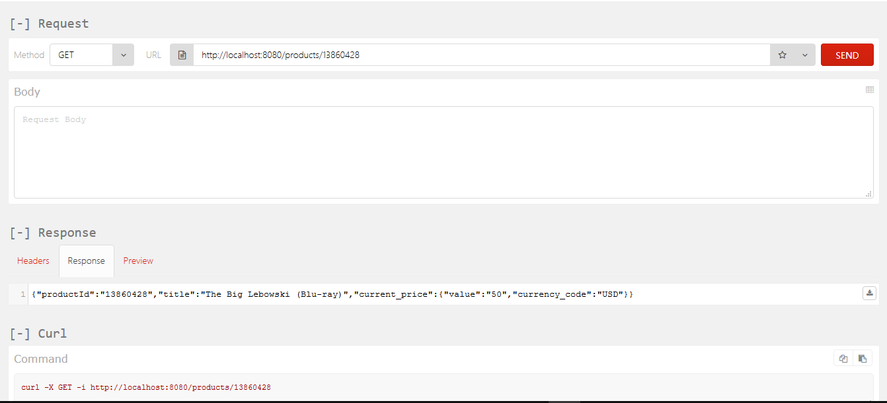

API 2: POST PUT <http://localhost:8080/products/54456119>

