ML PROJECT
heart-disease-prediction, submitted in fulfilment of the requirements for the Degree of
BACHELOR OF TECHNOLOGY
in
COMPUTER SCIENCE AND ENGINEERING

By
Susnata Das Mahapatra
Registration number
12111532
Supervisor
VED PRAKASH CHAUBEY

School of Computer Science and Engineering
Lovely Professional University
Phagwara, Punjab (India)
Month…May…Year …2024…

@ Copyright LOVELY PROFESSIONAL UNIVERSITY, Punjab (INDIA)
Month …may.., Year …2024..
ALL RIGHTS RESERVED
DECLARATION STATEMENT

I, Susnata Das Mahapatra(1211532), hereby declare that the research work reported in the dissertation/dissertation proposal entitled “HEART DISEASE PREDICTION ML PROJECT” in partial fulfilment of the requirement for the award of Degree for Bachelor of Technology in Computer Science and Engineering at Lovely Professional University, Phagwara, Punjab is an authentic work carried out under supervision of my research supervisor Mr. Ved Prakash chaubey. I have not submitted this work elsewhere for any degree.
I understand that the work presented herewith is in direct compliance with Lovely Professional University’s Policy on plagiarism, intellectual property rights, and highest standards of moral and ethical conduct. Therefore, to the best of my knowledge, the content of this dissertation represents authentic and honest research effort conducted, in its entirety, by me. I am fully responsible for the contents of my dissertation work.

Signature of Candidate
Name of the Candidate
R.No………

SUPERVISOR’S CERTIFICATE

This is to certify that the work reported in the B.Tech dissertation proposal entitled “HEART DISEASE PREDICTION”, submitted by Susnata Das Mahapatra at Lovely Professional University, Phagwara, India is a bonafide record of his / her original work carried out under my supervision. This work has not been submitted elsewhere for any other degree.

Signature of Supervisor

(Name of Supervisor)
Date:
Counter Signed by:
- Concerned HOD:
HoD’s Signature: ________________
HoD Name: ____________________
Date: ___________________
- Neutral Examiners:
External Examiner
Signature: _______________
Name: __________________
Affiliation: ______________
Date: ___________________
Internal Examiner
Signature: _______________
Name: __________________
Date: ___________________
TABLE OF CONTENTS
CONTENTS PAGE NO.

Dataset Description 4

Objective of the Project 5

Statistical Insights of Dataset 5

EDA 8
Data Preprocessing 18

Model Building 20

Model Evaluation 24

Conclusion 25

References 25

Dataset Description
This dataset likely contains information on patients used to predict their risk of heart disease. It includes various demographic, medical history, exercise test, and diagnostic test results. Here's a detailed breakdown:
Data Points:
Each row represents a single patient.
The number of rows indicates the total number of patients included in the dataset.
Features (Columns):
• Age: The age of the patient in years.
• Sex: The sex of the patient (1 = male, 0 = female).
• Chest pain type: The type of chest pain experienced by the patient (1-4, where the specific meaning of each type may vary depending on the dataset).
• BP: The patient's blood pressure in mmHg.
• Cholesterol: The patient's cholesterol level in mg/dL.
• FBS over 120: An indicator of whether the patient's fasting blood sugar level was greater than 120 mg/dL (1 = yes, 0 = no).
• EKG results: The results of the patient's electrocardiogram (ECG) test (0, 1, or 2, where the specific meaning of each value may vary depending on the dataset).
• Max HR: The maximum heart rate achieved by the patient during exercise.
• Exercise angina: An indicator of whether the patient experienced chest pain (angina) during exercise (1 = yes, 0 = no).
• ST depression: The level of ST depression observed on the patient's ECG during exercise (higher values may indicate ischemia).
• Slope of ST: The slope of the ST segment on the patient's ECG during exercise (usually coded as up, flat, or down).
• Number of vessels fluro: The number of major vessels blocked as detected by fluoroscopy.
• Thallium Heart Disease: A binary indicator of whether thallium scintigraphy revealed a perfusion defect (1 = yes, 0 = no).
• Thallium Diagnosis: The physician's diagnosis of heart disease based on thallium scintigraphy results ("Presence" or "Absence").
Possible Uses:
Training machine learning models to predict heart disease risk.
Identifying patterns and relationships between patient characteristics and heart disease.
Developing tools to aid in early detection and prevention of heart disease.
Limitations (to consider):
The specific meaning of categorical variables might depend on the dataset source.
The dataset size might limit the generalizability of models trained on it.
The dataset may not capture all factors influencing heart disease risk.
Objective of the Project
The objective of a "HEART DISEASE PREDICTION ML PROJECT" is to leverage machine learning algorithms to develop a model that can accurately predict the likelihood of a patient having heart disease. This model would be built by analyzing a dataset containing information about patients and their heart disease status.

Heart Disease Prediction

Statistical Insights of Dataset

Importing essential libraries
import numpy as np
import pandas as pd
import matplotlib.pyplot as plt
import seaborn as sns

Understanding our dataset
#Reading the file
df = pd.read_csv('Heart_Disease_Prediction.csv')
#First 5 rows of the dataset
df.head()
Age Sex Chest pain type BP Cholesterol FBS over 120 EKG results \
0 70 1 4 130 322 0 2
1 67 0 3 115 564 0 2
2 57 1 2 124 261 0 0
3 64 1 4 128 263 0 0
4 74 0 2 120 269 0 2
Max HR Exercise angina ST depression Slope of ST \
0 109 0 2.4 2
1 160 0 1.6 2
2 141 0 0.3 1
3 105 1 0.2 2
4 121 1 0.2 1
Number of vessels fluro Thallium Heart Disease
0 3 3 Presence
1 0 7 Absence
2 0 7 Presence
3 1 7 Absence
4 1 3 Absence
#Statistics about the data
df.describe()
Age Sex Chest pain type BP Cholesterol \
count 270.000000 270.000000 270.000000 270.000000 270.000000
mean 54.433333 0.677778 3.174074 131.344444 249.659259
std 9.109067 0.468195 0.950090 17.861608 51.686237
min 29.000000 0.000000 1.000000 94.000000 126.000000
25% 48.000000 0.000000 3.000000 120.000000 213.000000
50% 55.000000 1.000000 3.000000 130.000000 245.000000
75% 61.000000 1.000000 4.000000 140.000000 280.000000
max 77.000000 1.000000 4.000000 200.000000 564.000000
FBS over 120 EKG results Max HR Exercise angina ST depression \
count 270.000000 270.000000 270.000000 270.000000 270.00000
mean 0.148148 1.022222 149.677778 0.329630 1.05000
std 0.355906 0.997891 23.165717 0.470952 1.14521
min 0.000000 0.000000 71.000000 0.000000 0.00000
25% 0.000000 0.000000 133.000000 0.000000 0.00000
50% 0.000000 2.000000 153.500000 0.000000 0.80000
75% 0.000000 2.000000 166.000000 1.000000 1.60000
max 1.000000 2.000000 202.000000 1.000000 6.20000
Slope of ST Number of vessels fluro Thallium
count 270.000000 270.000000 270.000000
mean 1.585185 0.670370 4.696296
std 0.614390 0.943896 1.940659
min 1.000000 0.000000 3.000000
25% 1.000000 0.000000 3.000000
50% 2.000000 0.000000 3.000000
75% 2.000000 1.000000 7.000000
max 3.000000 3.000000 7.000000
#Number of rows and columns in the dataset
df.shape
(270, 14)
#List of columns in the dataset
df.columns
Index(['Age', 'Sex', 'Chest pain type', 'BP', 'Cholesterol', 'FBS over 120',
'EKG results', 'Max HR', 'Exercise angina', 'ST depression',
'Slope of ST', 'Number of vessels fluro', 'Thallium', 'Heart Disease'],
dtype='object')
#More information of the data
df.info()
<class 'pandas.core.frame.DataFrame'>
RangeIndex: 270 entries, 0 to 269
Data columns (total 14 columns):
# Column Non-Null Count Dtype
--- ------ -------------- -----
0 Age 270 non-null int64
1 Sex 270 non-null int64
2 Chest pain type 270 non-null int64
3 BP 270 non-null int64
4 Cholesterol 270 non-null int64
5 FBS over 120 270 non-null int64
6 EKG results 270 non-null int64
7 Max HR 270 non-null int64
8 Exercise angina 270 non-null int64
9 ST depression 270 non-null float64
10 Slope of ST 270 non-null int64
11 Number of vessels fluro 270 non-null int64
12 Thallium 270 non-null int64
13 Heart Disease 270 non-null object
dtypes: float64(1), int64(12), object(1)
memory usage: 29.7+ KB
#Checking for missing values
df.isnull().sum()
Age 0
Sex 0
Chest pain type 0
BP 0
Cholesterol 0
FBS over 120 0
EKG results 0
Max HR 0
Exercise angina 0
ST depression 0
Slope of ST 0
Number of vessels fluro 0
Thallium 0
Heart Disease 0
dtype: int64
#Count of unique values for
df['Heart Disease'].value_counts()
Heart Disease
Absence 150
Presence 120
Name: count, dtype: int64
#Number of unique values in each column
df.nunique()
Age 41
Sex 2
Chest pain type 4
BP 47
Cholesterol 144
FBS over 120 2
EKG results 3
Max HR 90
Exercise angina 2
ST depression 39
Slope of ST 3
Number of vessels fluro 4
Thallium 3
Heart Disease 2
dtype: int64
Clearly, there are many columns that have categorical data.
#Storing columns containing categorical and continuous data in seperate lists
categorical = []
continuous = []
for col in df.columns:
if len(df[col].unique()) <= 5:
categorical.append(col)
else:
continuous.append(col)
categorical
['Sex',
'Chest pain type',
'FBS over 120',
'EKG results',
'Exercise angina',
'Slope of ST',
'Number of vessels fluro',
'Thallium',
'Heart Disease']
continuous
['Age', 'BP', 'Cholesterol', 'Max HR', 'ST depression']

EDA

#Color codes
heartred = '#D76F80'
heartblue = '#C7CBE5'
heartyellow = '#FEE5B3'
heartbrown = '#450E10'

Categorical Data
sns.countplot(x = df['Heart Disease'], data = df, hue = 'Sex', palette = [heartred, heartblue])
<Axes: xlabel='Heart Disease', ylabel='count'>
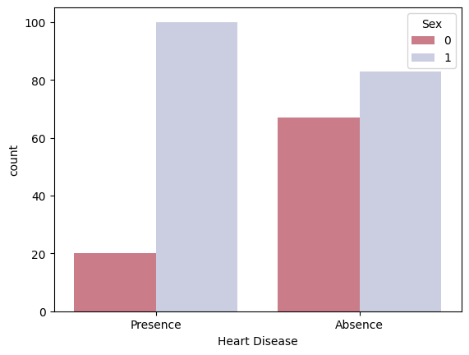
sns.countplot(x = df['Heart Disease'], data = df, hue = 'Chest pain type', palette = [heartyellow, heartred, heartbrown, heartblue])
<Axes: xlabel='Heart Disease', ylabel='count'>
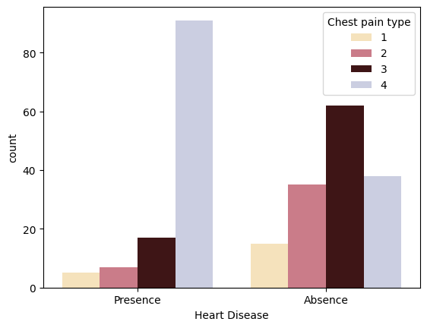
sns.countplot(x = df['Heart Disease'], data = df, hue = 'FBS over 120', palette = [heartred, heartblue])
<Axes: xlabel='Heart Disease', ylabel='count'>
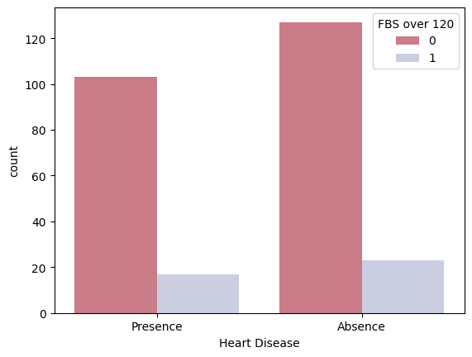
sns.countplot(x = df['Heart Disease'], data = df, hue = 'EKG results', palette = [heartyellow, heartred, heartbrown])
<Axes: xlabel='Heart Disease', ylabel='count'>
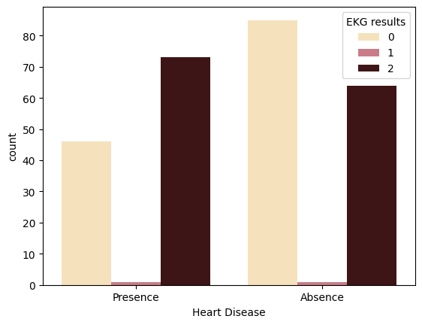
sns.countplot(x = df['Heart Disease'], data = df, hue = 'Exercise angina', palette = [heartred, heartblue])
<Axes: xlabel='Heart Disease', ylabel='count'>
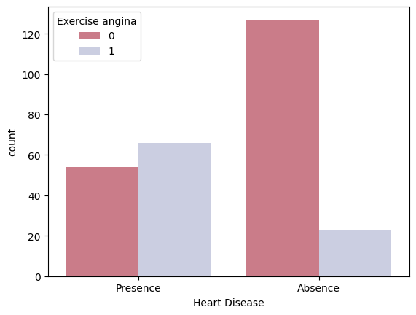
sns.countplot(x = df['Heart Disease'], data = df, hue = 'Slope of ST', palette = [heartyellow, heartred, heartbrown])
<Axes: xlabel='Heart Disease', ylabel='count'>
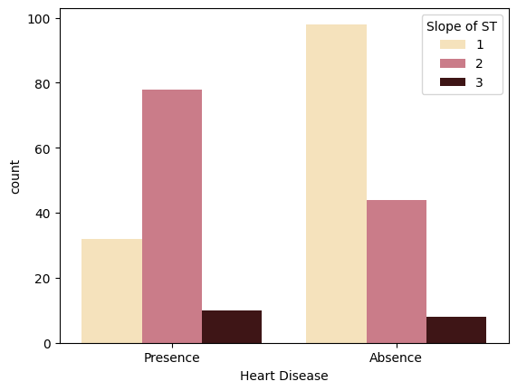
sns.countplot(x = df['Heart Disease'], data = df, hue = 'Number of vessels fluro', palette = [heartyellow, heartred, heartbrown, heartblue])
<Axes: xlabel='Heart Disease', ylabel='count'>
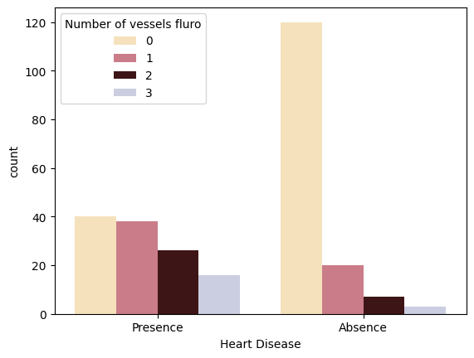
sns.countplot(x = df['Heart Disease'], data = df, hue = 'Thallium', palette = [heartyellow, heartred, heartbrown])
<Axes: xlabel='Heart Disease', ylabel='count'>
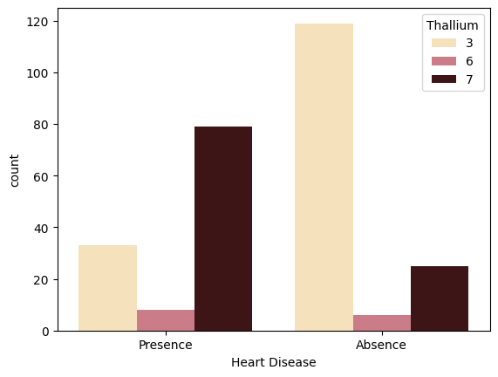

Continuous Data
#Minimum age of person diagnosed with heart disease
df.Age[df['Heart Disease'] == 'Presence'].min()
35
df.groupby('Heart Disease')['Age'].mean()
Heart Disease
Absence 52.706667
Presence 56.591667
Name: Age, dtype: float64
sns.displot(df['Age'])
C:\Users\susna\AppData\Local\Programs\Python\Python311\Lib\site-packages\seaborn\axisgrid.py:118: UserWarning: The figure layout has changed to tight
self._figure.tight_layout(*args, **kwargs)
<seaborn.axisgrid.FacetGrid at 0x2167fb7d2d0>
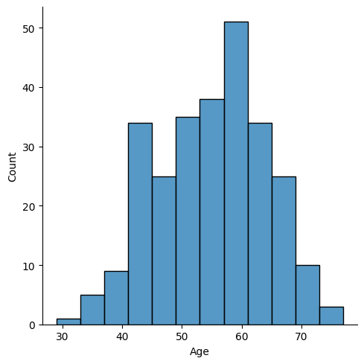
sns.barplot(x = df['Heart Disease'],y = df['BP'], data = df, palette = [heartred, heartblue])
<Axes: xlabel='Heart Disease', ylabel='BP'>
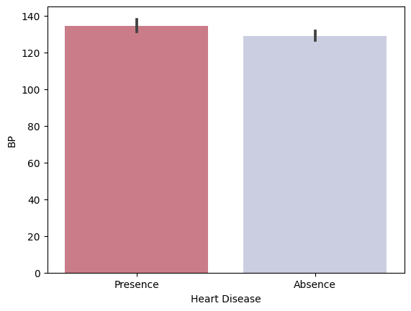
sns.barplot(x = df['Heart Disease'],y = df['Cholesterol'], data = df, palette = [heartred, heartblue])
<Axes: xlabel='Heart Disease', ylabel='Cholesterol'>
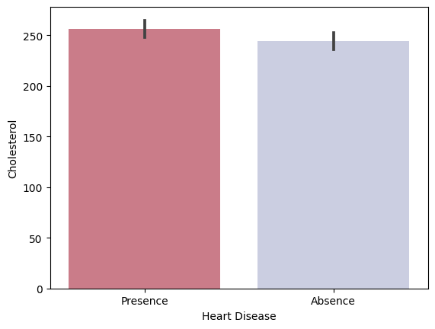
sns.barplot(x = df['Heart Disease'], y = df['Max HR'], data = df, palette = [heartred, heartblue])
<Axes: xlabel='Heart Disease', ylabel='Max HR'>
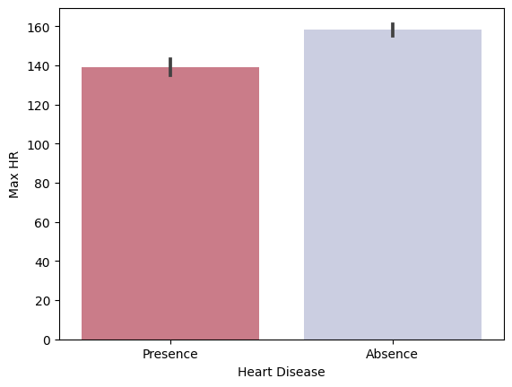
sns.barplot(x = df['Heart Disease'], y = df['ST depression'], data = df, palette = [heartred, heartblue])
<Axes: xlabel='Heart Disease', ylabel='ST depression'>
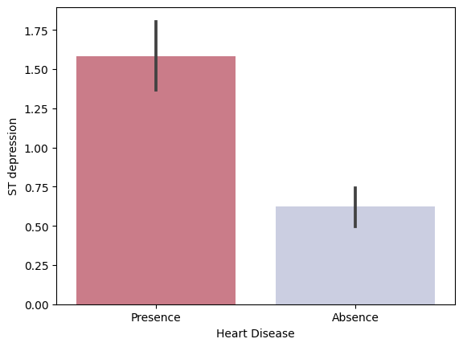

Correlation Matrix
df.head()
Age Sex Chest pain type BP Cholesterol FBS over 120 EKG results \
0 70 1 4 130 322 0 2
1 67 0 3 115 564 0 2
2 57 1 2 124 261 0 0
3 64 1 4 128 263 0 0
4 74 0 2 120 269 0 2
Max HR Exercise angina ST depression Slope of ST \
0 109 0 2.4 2
1 160 0 1.6 2
2 141 0 0.3 1
3 105 1 0.2 2
4 121 1 0.2 1
Number of vessels fluro Thallium Heart Disease
0 3 3 Presence
1 0 7 Absence
2 0 7 Presence
3 1 7 Absence
4 1 3 Absence
df["Heart Disease"].value_counts()
Heart Disease
Absence 150
Presence 120
Name: count, dtype: int64
def func(x):
if(x=='Absence'):
return 0
else:
return 1
df["Heart Disease"]=df["Heart Disease"].apply(func)
df.head()
Age Sex Chest pain type BP Cholesterol FBS over 120 EKG results \
0 70 1 4 130 322 0 2
1 67 0 3 115 564 0 2
2 57 1 2 124 261 0 0
3 64 1 4 128 263 0 0
4 74 0 2 120 269 0 2
Max HR Exercise angina ST depression Slope of ST \
0 109 0 2.4 2
1 160 0 1.6 2
2 141 0 0.3 1
3 105 1 0.2 2
4 121 1 0.2 1
Number of vessels fluro Thallium Heart Disease
0 3 3 1
1 0 7 0
2 0 7 1
3 1 7 0
4 1 3 0
plt.figure(figsize = (20,15))
sns.heatmap(df.corr(), annot = True, linewidths = 1, cmap = 'Pastel1')
plt.show()
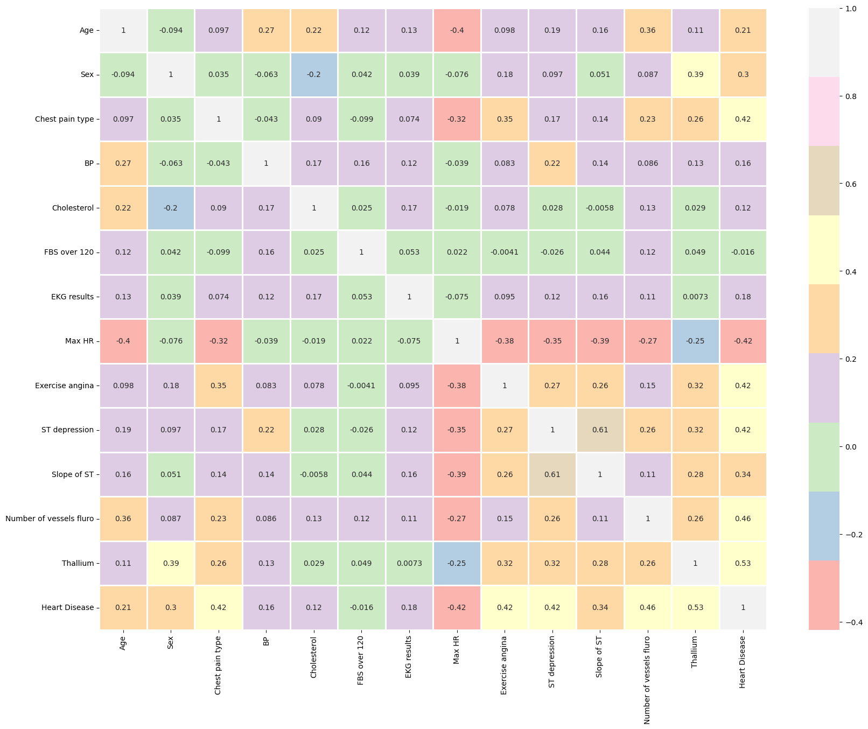

Data Preprocessing

Encoding categorical data
from sklearn.preprocessing import LabelEncoder, StandardScaler
le = LabelEncoder()
df['Heart Disease'] = le.fit_transform(df['Heart Disease'])
df['Heart Disease'].head()
0 1
1 0
2 1
3 0
4 0
Name: Heart Disease, dtype: int64
categorical.remove('Heart Disease')
data = pd.get_dummies(df, columns = categorical)
data.head()
Age BP Cholesterol Max HR ST depression Heart Disease Sex_0 Sex_1 \
0 70 130 322 109 2.4 1 False True
1 67 115 564 160 1.6 0 True False
2 57 124 261 141 0.3 1 False True
3 64 128 263 105 0.2 0 False True
4 74 120 269 121 0.2 0 True False
Chest pain type_1 Chest pain type_2 ... Slope of ST_1 Slope of ST_2 \
0 False False ... False True
1 False False ... False True
2 False True ... True False
3 False False ... False True
4 False True ... True False
Slope of ST_3 Number of vessels fluro_0 Number of vessels fluro_1 \
0 False False False
1 False True False
2 False True False
3 False False True
4 False False True
Number of vessels fluro_2 Number of vessels fluro_3 Thallium_3 \
0 False True True
1 False False False
2 False False False
3 False False False
4 False False True
Thallium_6 Thallium_7
0 False False
1 False True
2 False True
3 False True
4 False False
[5 rows x 29 columns]

Scaling continuous data
sc = StandardScaler()
scaled_col = continuous
data[scaled_col] = sc.fit_transform(data[scaled_col])
data.head()
Age BP Cholesterol Max HR ST depression Heart Disease \
0 1.712094 -0.075410 1.402212 -1.759208 1.181012 1
1 1.382140 -0.916759 6.093004 0.446409 0.481153 0
2 0.282294 -0.411950 0.219823 -0.375291 -0.656118 1
3 1.052186 -0.187590 0.258589 -1.932198 -0.743600 0
4 2.152032 -0.636310 0.374890 -1.240239 -0.743600 0
Sex_0 Sex_1 Chest pain type_1 Chest pain type_2 ... Slope of ST_1 \
0 False True False False ... False
1 True False False False ... False
2 False True False True ... True
3 False True False False ... False
4 True False False True ... True
Slope of ST_2 Slope of ST_3 Number of vessels fluro_0 \
0 True False False
1 True False True
2 False False True
3 True False False
4 False False False
Number of vessels fluro_1 Number of vessels fluro_2 \
0 False False
1 False False
2 False False
3 True False
4 True False
Number of vessels fluro_3 Thallium_3 Thallium_6 Thallium_7
0 True True False False
1 False False False True
2 False False False True
3 False False False True
4 False True False False
[5 rows x 29 columns]
X = data.drop(['Heart Disease'], axis = 1)
y = data['Heart Disease']

Splitting the dataset
from sklearn.model_selection import train_test_split
X_train, X_test, y_train, y_test = train_test_split(X, y, test_size = 0.3, random_state = 0)

Models Building
#List for model names and their respective accuracy score
models = []
scores = []
from sklearn.metrics import accuracy_score

Logistic Regression
from sklearn.linear_model import LogisticRegression
lr = LogisticRegression()
lr.fit(X_train, y_train)
lr_pred = lr.predict(X_test)
lr_score = accuracy_score(y_test, lr_pred)
lr_score
0.8395061728395061
models.append('Logistic Regression')
scores.append(lr_score)

Naive Bayes
from sklearn.naive_bayes import GaussianNB
nb = GaussianNB()
nb.fit(X_train, y_train)
nb_pred = nb.predict(X_test)
nb_score = accuracy_score(y_test, nb_pred)
nb_score
0.8271604938271605
models.append('Naive Bayes')
scores.append(nb_score)

Support Vector Classifier
from sklearn.svm import SVC
svc = SVC()
svc.fit(X_train, y_train)
svc_pred = svc.predict(X_test)
svc_score = accuracy_score(y_test, svc_pred)
svc_score
0.7901234567901234
models.append('Support Vector')
scores.append(svc_score)

K Nearest Neighbours Classifier
from sklearn.neighbors import KNeighborsClassifier
error_knn = []
for i in range(1, 30):
knn = KNeighborsClassifier(n_neighbors = i)
knn.fit(X_train, y_train)
pred_i = knn.predict(X_test)
error_knn.append(np.mean(pred_i != y_test))
plt.figure(figsize=(10, 5))
plt.plot(range(1, 30), error_knn, color = 'blue', linestyle = 'dashed', marker = 'o')
plt.title('Error vs. K Value')
plt.xlabel('K')
plt.ylabel('Error')
Text(0, 0.5, 'Error')
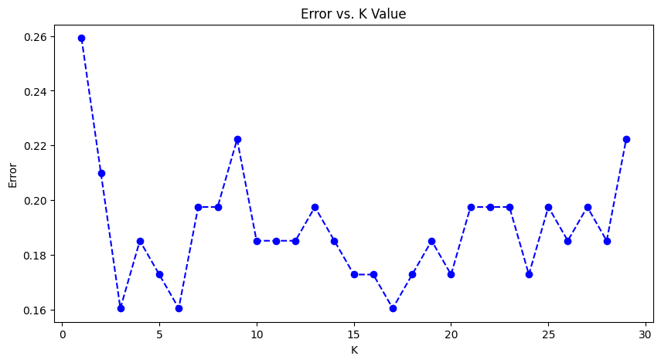
k = error_knn.index(min(error_knn)) + 1
k
3
knn = KNeighborsClassifier(n_neighbors = k)
knn.fit(X_train,y_train)
knn_pred = knn.predict(X_test)
knn_score = accuracy_score(y_test, knn_pred)
knn_score
0.8395061728395061
models.append('K Nearest Neighbours')
scores.append(knn_score)

Decision Tree Classifier
from sklearn.tree import DecisionTreeClassifier
max_accuracy = 0
#selecting random state providing the highest accuracy
for x in range(200):
dtc = DecisionTreeClassifier(random_state=x)
dtc.fit(X_train,y_train)
dtc_pred = dtc.predict(X_test)
current_accuracy = round(accuracy_score(dtc_pred,y_test)*100,2)
if(current_accuracy > max_accuracy):
max_accuracy = current_accuracy
best_x = x
dtc = DecisionTreeClassifier(random_state = best_x)
dtc.fit(X_train,y_train)
dtc_pred = dtc.predict(X_test)
dtc_score = accuracy_score(y_test, dtc_pred)
dtc_score
0.8024691358024691
models.append('Decision Tree')
scores.append(dtc_score)

Random Forest Classifier
from sklearn.ensemble import RandomForestClassifier
max_accuracy = 0
#selecting random state providing the highest accuracy
for x in range(200):
rfc = RandomForestClassifier(random_state = x)
rfc.fit(X_train,y_train)
rfc_pred = rfc.predict(X_test)
current_accuracy = round(accuracy_score(y_test, rfc_pred)*100,2)
if(current_accuracy > max_accuracy):
max_accuracy = current_accuracy
rfc_best_x = x
rfc = RandomForestClassifier(random_state = rfc_best_x)
rfc.fit(X_train,y_train)
rfc_pred = rfc.predict(X_test)
rfc_score = accuracy_score(y_test, rfc_pred)
rfc_score
0.8518518518518519
models.append('Random Forest')
scores.append(rfc_score)

XGBoost Classifier
from xgboost import XGBClassifier
xgb = XGBClassifier()
xgb.fit(X_train,y_train)
xgb_pred = xgb.predict(X_test)
xgb_score = accuracy_score(y_test, xgb_pred)
xgb_score
0.7901234567901234
models.append('XGBoost')
scores.append(xgb_score)
models
['Logistic Regression',
'Naive Bayes',
'Support Vector',
'K Nearest Neighbours',
'Decision Tree',
'Random Forest',
'XGBoost']
scores
[0.8395061728395061,
0.8271604938271605,
0.7901234567901234,
0.8395061728395061,
0.8024691358024691,
0.8518518518518519,
0.7901234567901234]

Results
percentage_scores = [score*100 for score in scores]
plt.figure(figsize=(10,5))
plt.bar(models, percentage_scores, color = heartred)
plt.ylabel('Accuracy')
plt.xlabel('Models')
plt.xticks(rotation = 90)
plt.show()
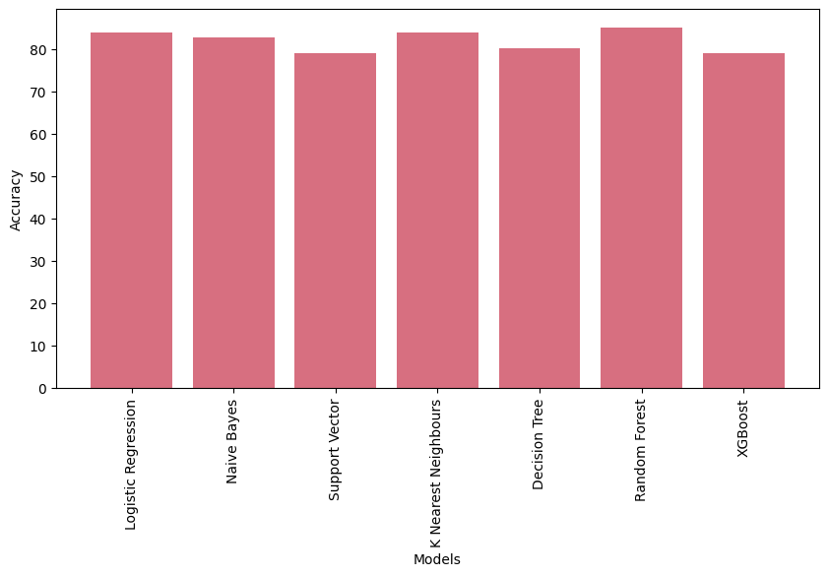
results = pd.DataFrame(list(zip(models, percentage_scores)), columns =['Models', 'Accuracy (%)'])
results
Models Accuracy (%)
0 Logistic Regression 83.950617
1 Naive Bayes 82.716049
2 Support Vector 79.012346
3 K Nearest Neighbours 83.950617
4 Decision Tree 80.246914
5 Random Forest 85.185185
6 XGBoost 79.012346
RandomForest Classifier provided the highest accuracy.

Model Evaluation
Using confusion matrix and classification report of the RandomForest Classifier to evaluate its performance.

Confusion Matrix
from sklearn.metrics import confusion_matrix, classification_report
sns.heatmap(confusion_matrix(y_test,rfc_pred), annot = True, cmap = 'Pastel1')
<Axes: >
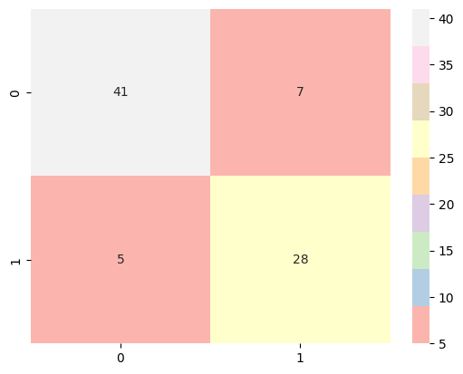

Classification Report
print(classification_report(y_test,rfc_pred))
precision recall f1-score support
0 0.89 0.85 0.87 48
1 0.80 0.85 0.82 33
accuracy 0.85 81
macro avg 0.85 0.85 0.85 81
weighted avg 0.85 0.85 0.85 81
Conclusion
In conclusion, this "HEART DISEASE PREDICTION ML PROJECT" has the potential to be a valuable asset in the fight against heart disease. By leveraging machine learning algorithms and a comprehensive dataset of patient information, the project aims to develop a model capable of accurately predicting an individual's risk of developing heart disease. Our machine learning exploration for heart disease prediction showed promise. The Random Forest model achieved the highest accuracy (85.19%) in identifying patients with and without the disease. While further improvements are possible, this project highlights the potential of machine learning for early detection and risk assessment in heart disease.
References
DATASET: https://data.world/informatics-edu/heart-disease-prediction
Sci kit references: https://scikit-learn.org/stable/
ML knowledge: https://learn.upgrad.com/courses
Checklist for Dissertation-III Supervisor
Name: ___________________________ UID: ________ Domain: _____ Registration No: ____________Name of student:__________________
Title of Dissertation: _________________________________________________

- Front pages are as per the format.
- Topic on the PAC form and title page are same.
- Front page numbers are in roman and for report, it is like 1, 2, 3…….
- TOC, List of Figures, etc. are matching with the actual page numbers in the report.
- Font, Font Size, Margins, line Spacing, Alignment, etc. are as per the guidelines.
- Color prints are used for images and implementation snapshots.
- Captions and citations are provided for all the figures, tables etc. and are numbered and center aligned.
- All the equations used in the report are numbered.
- Citations are provided for all the references.
- Objectives are clearly defined.
- Minimum total number of pages of report is 50.
- Minimum references in report are 30.

Here by, I declare that I had verified the above mentioned points in the final dissertation report.

Signature of Supervisor with UID

