PERFORMANCE REPORT: CONCURRENT VS. REGULAR MERGE SORT

Testing has been done using input of 2734 numbers.
Test Machine – AMD A8 6410 (4 cores, 2 Ghz), 3.4 GB usable RAM. Running Ubuntu 15.04

Concurrent Merge Sort using Shared Memory vs Regular Merge Sort

The Concurrent Merge Sort was failing on large amount of numbers (above 5000 on my system). It was implemented as a merge sort which forks and recursively calls merge sort, and if the number of elements are less than 5, it calls selection sort and returns.

I) Concurrent Merge Sort Profiling

Performance counter stats for './mergesortfork':

1796.436725 task-clock (msec) # 3.344 CPUs utilized
3,029 context-switches # 0.002 M/sec
1,331 cpu-migrations # 0.741 K/sec
50,229 page-faults # 0.028 M/sec
93,44,63,328 cycles # 0.520 GHz [72.75%]
0 stalled-cycles-frontend # 0.00% frontend cycles idle [92.80%]
0 stalled-cycles-backend # 0.00% backend cycles idle [97.33%]
53,55,84,337 instructions # 0.57 insns per cycle [92.87%]
8,57,13,450 branches # 47.713 M/sec [78.30%]
18,28,297 branch-misses # 2.13% of all branches [64.94%]

0.537142839 seconds time elapsed

II) Regular Merge Sort Profiling

Performance counter stats for './normalmergesort':

4.878725 task-clock (msec) # 0.760 CPUs utilized
33 context-switches # 0.007 M/sec
2 cpu-migrations # 0.410 K/sec
58 page-faults # 0.012 M/sec
65,68,439 cycles # 1.346 GHz
0 stalled-cycles-frontend # 0.00% frontend cycles idle
0 stalled-cycles-backend # 0.00% backend cycles idle
77,04,028 instructions # 1.17 insns per cycle [23.95%]
<not counted> branches
<not counted> branch-misses

0.006417530 seconds time elapsed

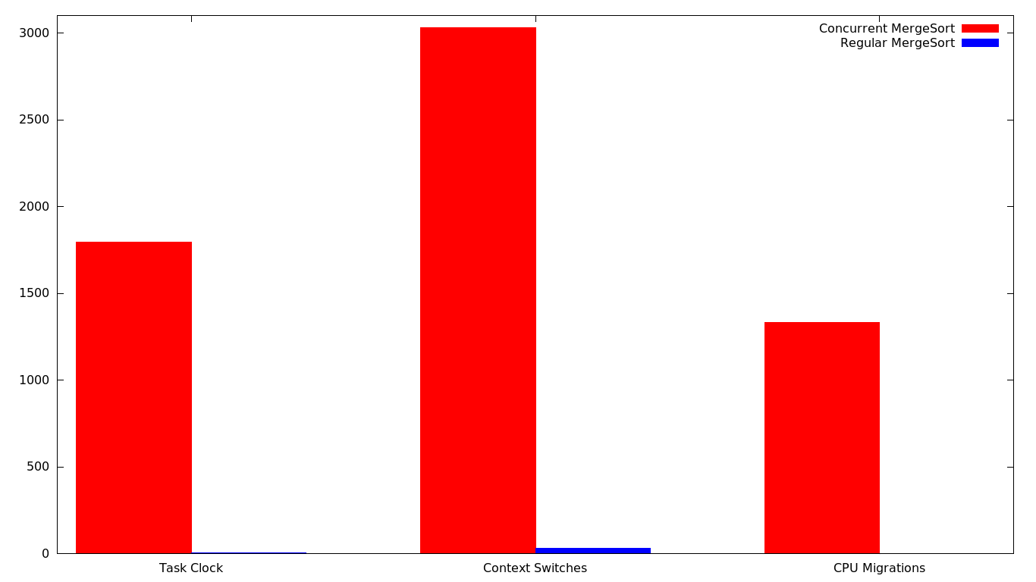
Analysis:
The execution time for the concurrent merge sort is way larger than that of normal merge sort. The number of context switches for concurrent merge sort is the reason for the contrasting result. This is because it is generating 2 processes at every depth of recursion until the base condition, and context switching so many processes adds to the total time. The making of processes to take advantage of multiprogramming and threads backfired as the number of processes were too high.

Thus we see a huge difference (factor of thousands) in Task Clock, Context-Switches, and CPU Migrations (shown in the graph).

We'd have seen better result had the sort been implemented for the number of cores of a system (i.e. number of child processes = number of cores in the system). This would form a parallel sort which would give better result than this implementation of concurrent merge sort.

