PERFORMANCE REPORT: MERGE SORT OF FILE (>1GB) USING BASH COMMAND SORT

Testing has been done using file size of 1.1 GB.
Test Machine – AMD A8 6410 (4 cores, 2 Ghz), 3.4 GB usable RAM. Running Ubuntu 15.04

I) Profiling Normal bash sort

Performance counter stats for 'sort -n -T /media/susobhan/EADA79CADA799413/Code/ random.txt':

705835.908450 task-clock (msec) # 1.455 CPUs utilized
12,36,201 context-switches # 0.002 M/sec
24,215 cpu-migrations # 0.034 K/sec
36,397 page-faults # 0.052 K/sec
13,73,18,11,43,584 cycles # 1.945 GHz [49.95%]
0 stalled-cycles-frontend # 0.00% frontend cycles idle [49.93%]
0 stalled-cycles-backend # 0.00% backend cycles idle [49.97%]
9,68,05,56,10,885 instructions # 0.70 insns per cycle [50.06%]
2,05,90,16,88,296 branches # 291.713 M/sec [50.08%]
4,06,64,63,792 branch-misses # 1.97% of all branches [50.04%]

485.257774217 seconds time elapsed

II) Profiling Custom bash script

Custom Bash Script is made to split the file until a certain threshold is reached, beyond which splitting is stopped and bash sort command is used.

In my tests, data has been collected for thresholds of 100 MB, 200 MB, 300 MB and 600 MB. The profiling results are as follows:

a) 100 MB threshold

Performance counter stats for './mergesortscript.sh random.txt sorted.txt':

673754.944672 task-clock (msec) # 1.037 CPUs utilized
30,25,590 context-switches # 0.004 M/sec
31,464 cpu-migrations # 0.047 K/sec
16,16,105 page-faults # 0.002 M/sec
13,04,84,12,00,832 cycles # 1.937 GHz [50.03%]
0 stalled-cycles-frontend # 0.00% frontend cycles idle [50.17%]
0 stalled-cycles-backend # 0.00% backend cycles idle [50.20%]
11,11,33,46,97,832 instructions # 0.85 insns per cycle [50.06%]
2,37,34,21,05,036 branches # 352.268 M/sec [49.93%]
4,63,66,53,788 branch-misses # 1.95% of all branches [49.91%]

649.468859235 seconds time elapsed

b) 200 MB threshold

Performance counter stats for './mergesortscript.sh random.txt sorted.txt':

709126.317919 task-clock (msec) # 1.107 CPUs utilized
27,75,327 context-switches # 0.004 M/sec
39,178 cpu-migrations # 0.055 K/sec
9,03,429 page-faults # 0.001 M/sec
13,66,77,16,79,144 cycles # 1.927 GHz [50.01%]
0 stalled-cycles-frontend # 0.00% frontend cycles idle [50.19%]
0 stalled-cycles-backend # 0.00% backend cycles idle [50.14%]
10,64,76,32,40,547 instructions # 0.78 insns per cycle [50.08%]
2,27,45,85,82,788 branches # 320.759 M/sec [49.88%]
4,57,13,17,295 branch-misses # 2.01% of all branches [49.95%]

640.607647192 seconds time elapsed

c) 300 MB threshold

Performance counter stats for './mergesortscript.sh random.txt sorted.txt':

693201.749195 task-clock (msec) # 1.037 CPUs utilized
26,37,512 context-switches # 0.004 M/sec
49,932 cpu-migrations # 0.072 K/sec
7,52,711 page-faults # 0.001 M/sec
13,50,43,24,14,447 cycles # 1.948 GHz [50.05%]
0 stalled-cycles-frontend # 0.00% frontend cycles idle [50.15%]
0 stalled-cycles-backend # 0.00% backend cycles idle [50.05%]
10,38,41,52,05,272 instructions # 0.77 insns per cycle [50.02%]
2,21,77,64,57,943 branches # 319.931 M/sec [49.91%]
4,54,17,71,703 branch-misses # 2.05% of all branches [50.02%]

668.397767750 seconds time elapsed

d) 600 MB threshold

Performance counter stats for './mergesortscript.sh random.txt sorted.txt':

652837.001958 task-clock (msec) # 1.336 CPUs utilized
24,07,096 context-switches # 0.004 M/sec
26,853 cpu-migrations # 0.041 K/sec
1,30,940 page-faults # 0.201 K/sec
12,82,14,41,29,204 cycles # 1.964 GHz [49.87%]
0 stalled-cycles-frontend # 0.00% frontend cycles idle [50.02%]
0 stalled-cycles-backend # 0.00% backend cycles idle [50.08%]
10,22,20,34,90,268 instructions # 0.80 insns per cycle [50.18%]
2,17,98,43,96,916 branches # 333.903 M/sec [50.04%]
4,28,26,50,891 branch-misses # 1.96% of all branches [49.98%]

488.476233113 seconds time elapsed

Analysis:

Overall the normal sort performed better than the merge sort on my system with varying thresholds. Only when the number of splits was low, the performance tended to reach normal sort times. The reason being that with a lower threshold one has to keep splitting more and more files and do I/O on the hard disk. Most of the processing is done at first to split the files to the threshold limit. This is where time is lost and splitting overhead is accounted for, and this version of merge sort performs badly.

In depth analysis is as follows:

I) Time Taken:
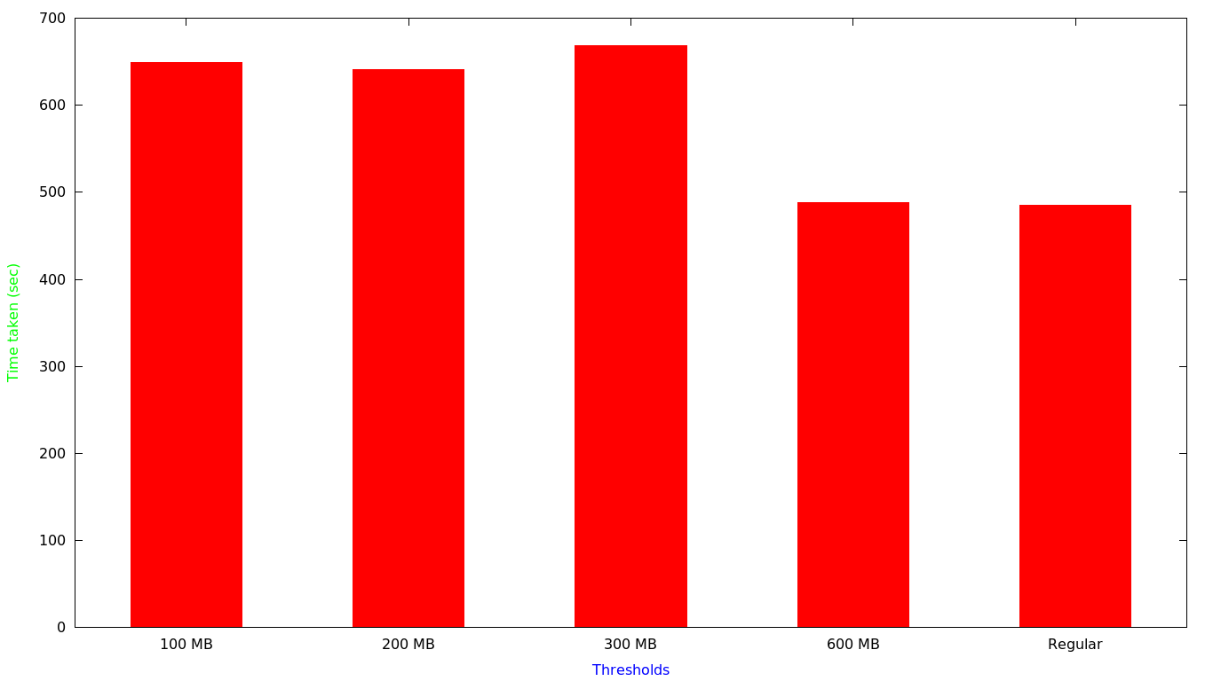
The results show us that the normal sort provided the best result and in terms of splitting, the best was the threshold which split the file into 2 parts (600 MB). This was because of time overhead accounted for writing to the disk. The other split thresholds took almost the same amount of time to complete and were considerably more compared to regular sort (I/O and read from HDD overhead).

II) Context-Switches

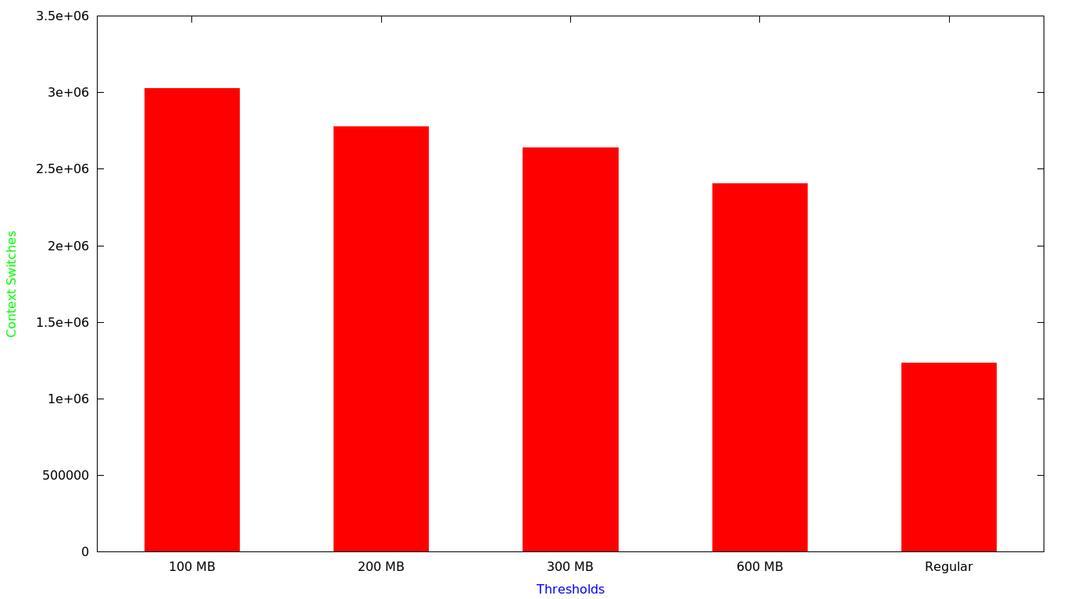
We see that the number of context-switches is increasing in terms of lower thresholds. This is because more number of sorts are called on lower file sizes, thus more concurrent processes. And switching in between concurrent processes accounts for more number of context switches. The regular bash sort call has the least number of context switches as sort is invoked just once and thus the minimum. Others invoke sort more than once and switching between them accounts for more context switches.

III) Page Faults:

We find that more page-faults are accounted for lower thresholds. This is because of the splitting and individual sorts running on smaller number of inputs. As the data is splitted multiple times in case of lowering thresholds, the page fault increases as the numbers being worked on keep on changing as more splitting is done. So more memory accesses are required and more page faults are encountered.
