SALES DATA ANALYSIS DASHBOARD

A Data Analysis and Visualization Project

Tools Used:
Microsoft Excel and Power BI

Prepared by:
Susri Rani Rauta

B.Tech – Electronics and Computer Science
NIST University

1. PROJECT OVERVIEW
This project focuses on analyzing sales data using Microsoft Excel and Power BI. The objective is to understand sales performance, profitability, order trends, customer segments, regional performance, and product-level performance through data analysis and interactive visualization.

The project demonstrates the complete process of data preparation, data quality checking, KPI calculation, exploratory analysis, data modeling, DAX calculations, and dashboard development.
2. DATASET AND DATA PREPARATION

The project uses the Sample Superstore dataset containing sales transaction records.

The dataset contains information related to orders, customers, shipping, regions, products, sales, quantity, discounts, and profit.

Data preparation was performed using Microsoft Excel. Calculated columns were created for:

• Order Year
• Order Month
• Month Number
• Profit Margin
• Shipping Days

Data quality checks were also performed for missing values and duplicate records.

This project focuses on analyzing sales data using Microsoft Excel and Power BI. The objective is to understand sales performance, profitability, order trends, customer segments, regional performance, and product-level performance through data analysis and interactive visualization.

The project demonstrates the complete process of data preparation, data quality checking, KPI calculation, exploratory analysis, data modeling, DAX calculations, and dashboard development.

3. EXCEL ANALYSIS
Microsoft Excel was used for data cleaning, quality checking, KPI calculations, PivotTables, and exploratory analysis.
The analysis includes:
• Sales by Year
• Sales by Category
• Sales by Region
• Sales by Segment
• Sales by Sub-Category
• Profit by Category

Key Performance Indicators:
Total Sales: $2,297,200.86
Total Profit: $286,397.02
Total Orders: 5,009
Average Order Value: $458.61
Profit Margin: 12.47%
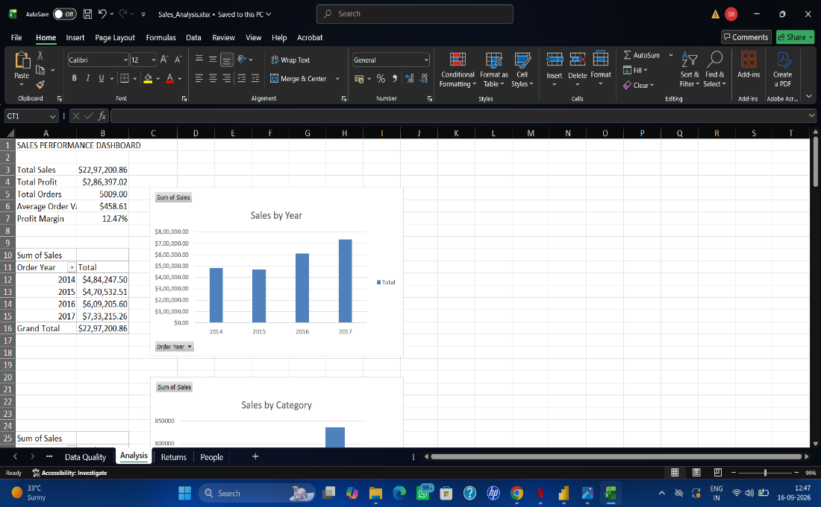

4. POWER BI DASHBOARD
An interactive dashboard was developed using Microsoft Power BI.
The dashboard contains:
• Total Sales KPI
• Total Profit KPI
• Total Orders KPI
• Average Order Value KPI
• Profit Margin KPI
• Sales Trend by Year
• Sales by Category
• Sales by Region
• Sales by Segment
• Profit by Category
• Sales by Sub-Category

Interactive slicers were added for:
• Year
• Region
• Category
• Segment
A dedicated DateTable was also created and connected to the SalesData table to support time-based analysis.
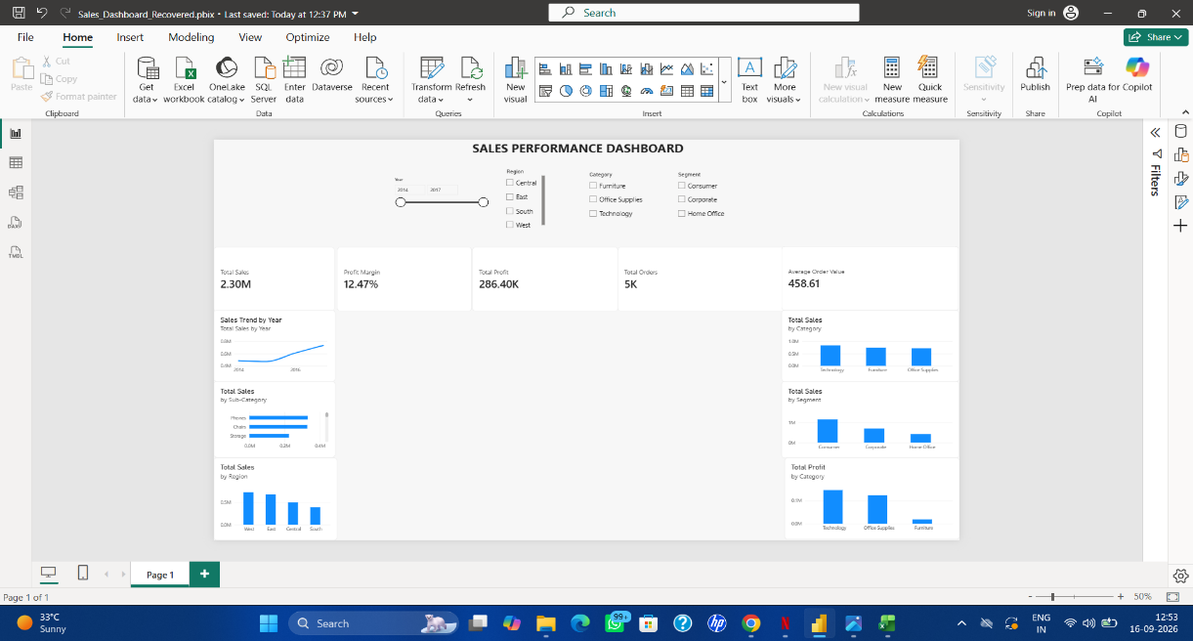
5. CONCLUSION

The Sales Data Analysis Dashboard provides an interactive view of sales and profitability performance.

The project demonstrates practical skills in Microsoft Excel, Power BI, DAX, data cleaning, data modeling, PivotTables, KPI analysis, and data visualization.

The combination of Excel analysis and Power BI visualization makes it easier to explore sales performance across different time periods, categories, regions, segments, and product sub-categories.

