Treatments for Helping Children Calm Their Nervous Systems for Rest

Stephanie Mines, Ph.D.
The TARA Approach for the Resolution of Shock and Trauma
Copyright 9/08

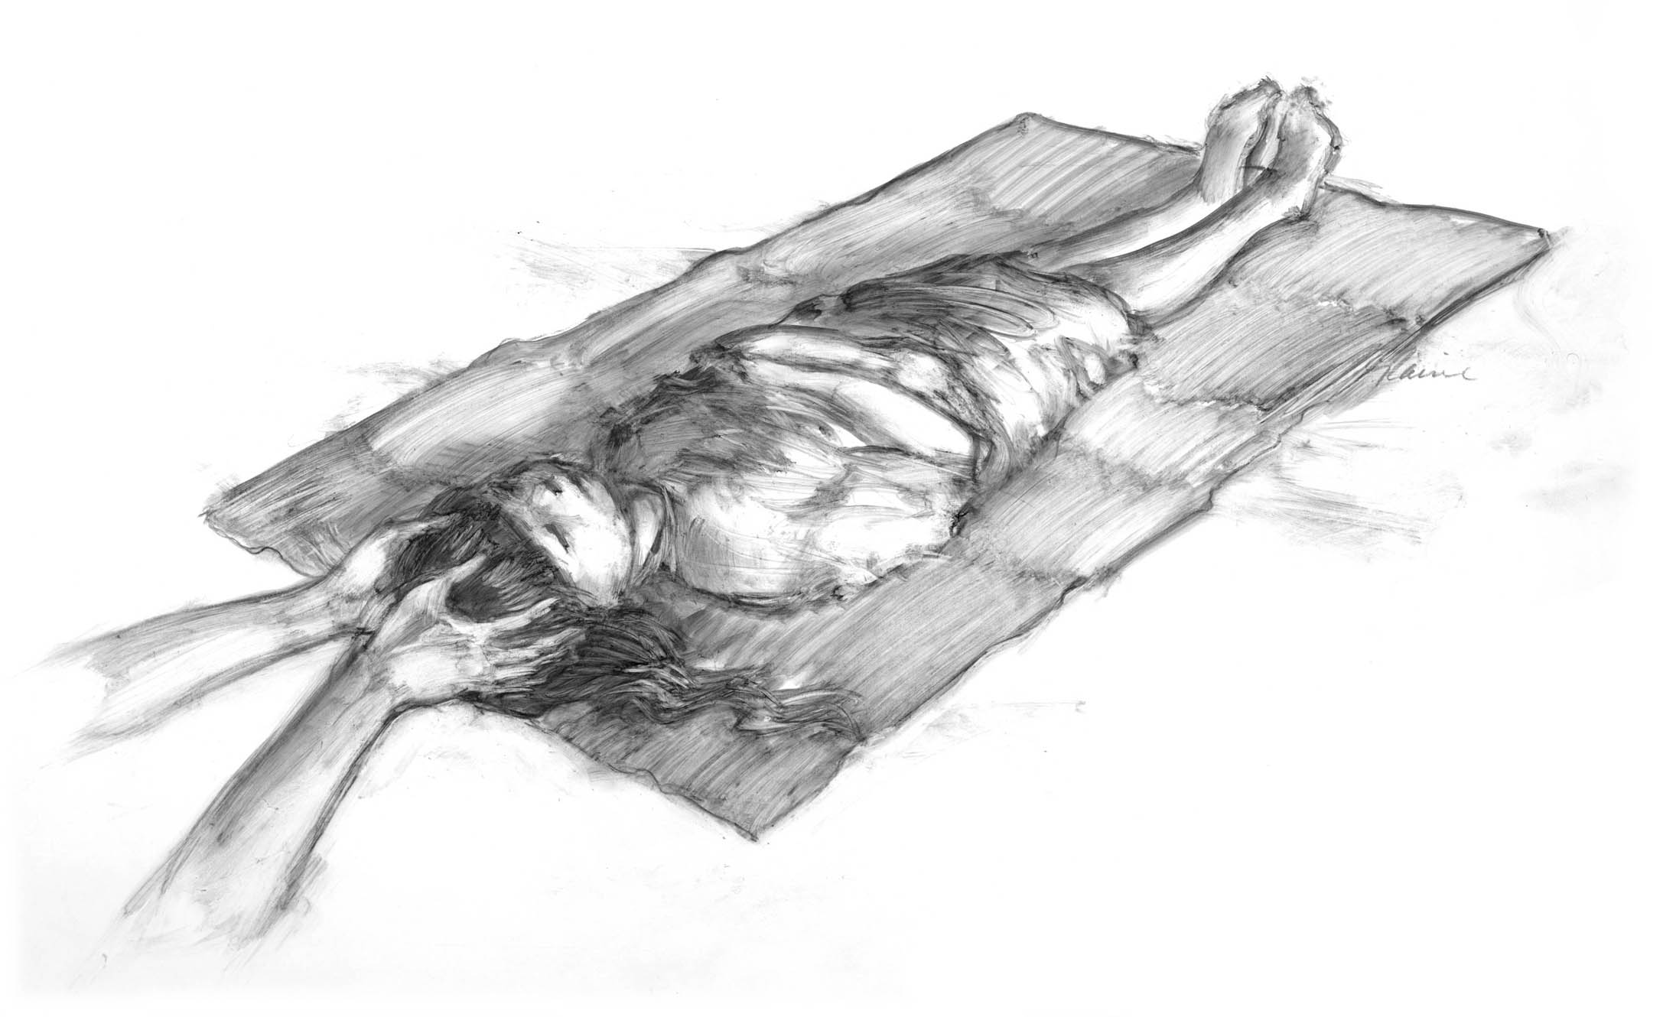

Trinity Release

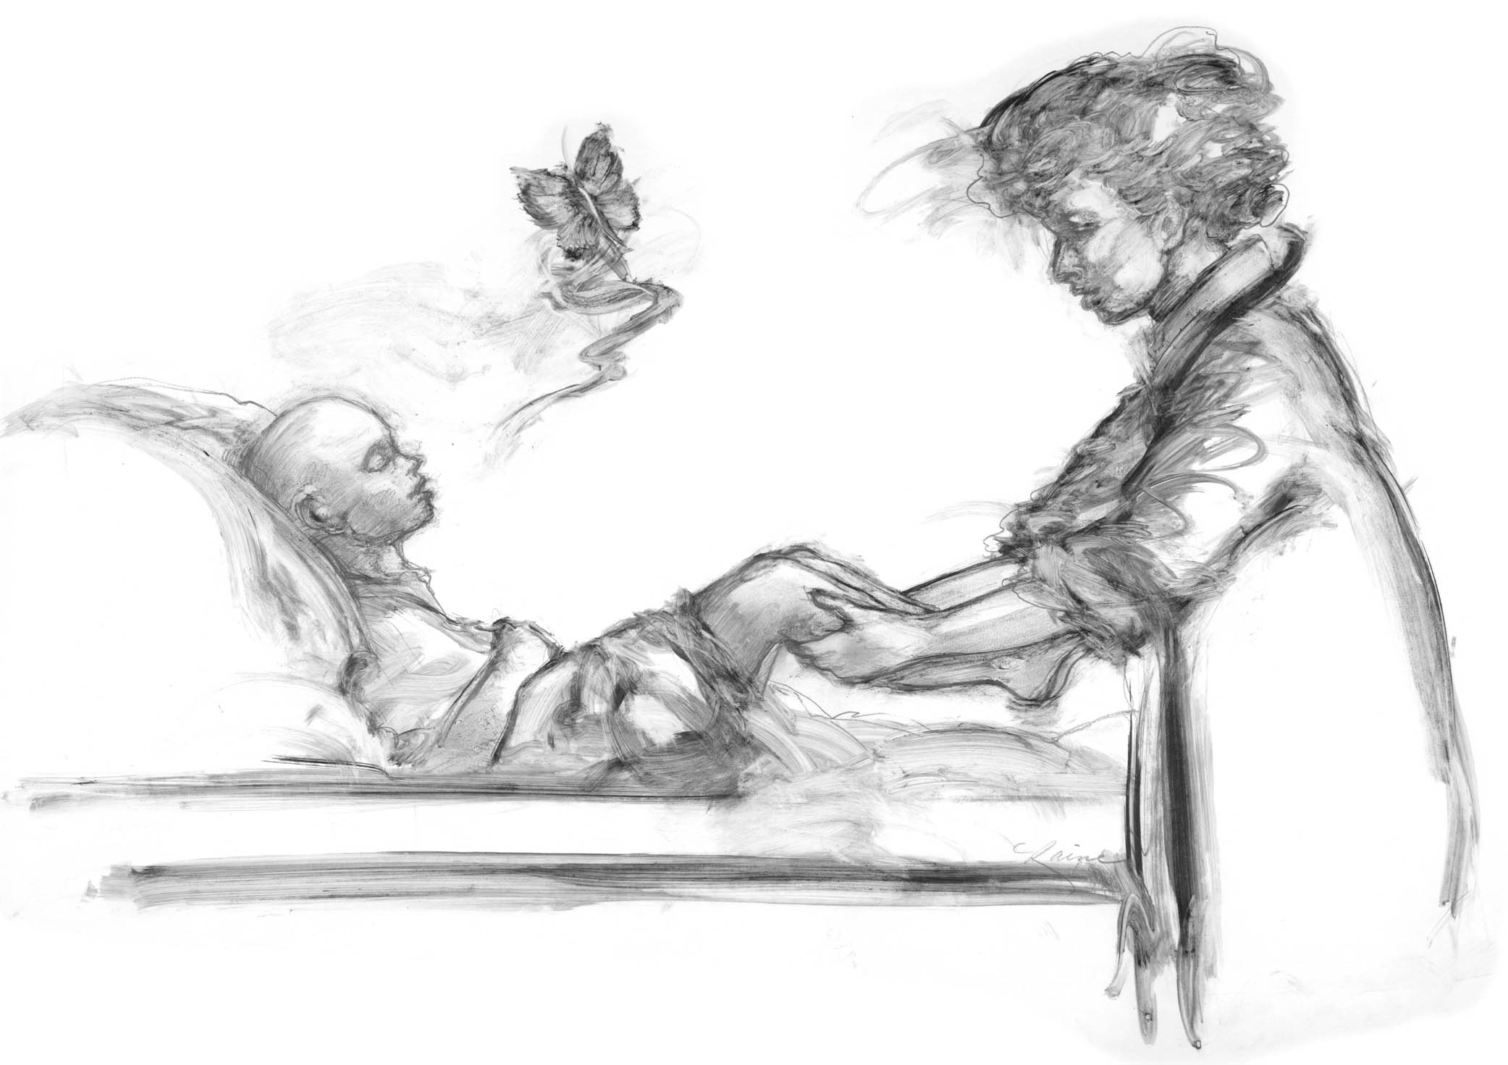

Palming Calves

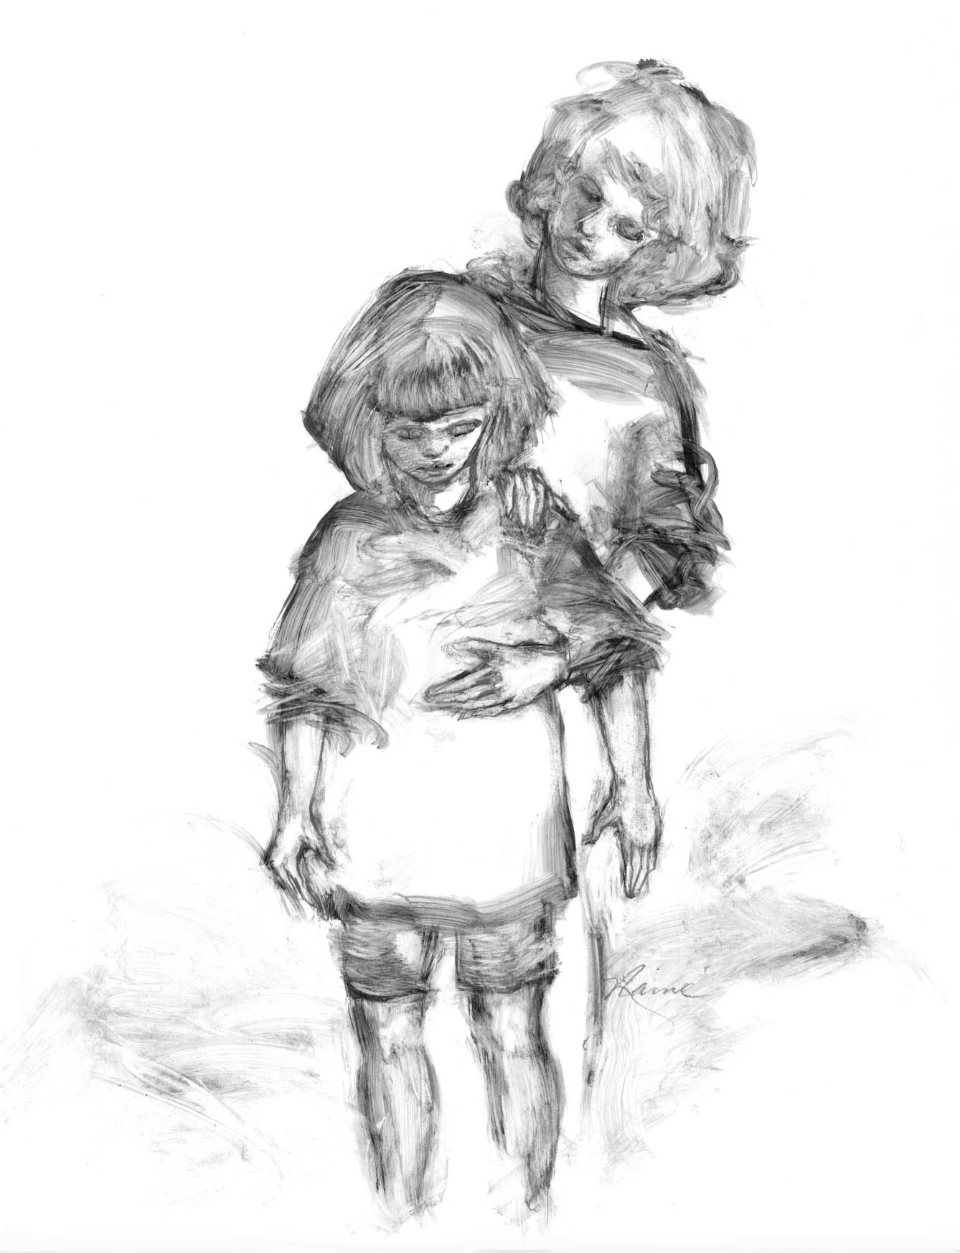
11/14 Release

