# SDGs Tool Style Guide

## Grammatical

* Do not include full stops at the end of metadata fields, unless the field has multiple sentences.
* Use ‘and’ instead of ampersands (&).
* Do not include full stops after indicators (e.g. 1.2.1 not 1.2.1.).
* Be sure to replace slashes with commas and ‘or’. The example below should be ‘Black, African, Caribbean or Black British’. **17.8.1**

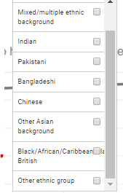

## Metadata conventions

* Remove greyed-out fields in the template, such as Global Indicator Description. A full list of the fields to be removed can be found in Jemalex under ‘SDG Tool QA - metadata fields to be removed’.
* Text link to UN Metadata should be [United Nations Sustainable Development Goals Metadata: **5.4.1**](https://unstats.un.org/sdgs/metadata/files/Metadata-05-04-01.pdf) (for example).
* The earliest available data should be the earliest shown in the graph, with the actual earliest available data shown in data source fields further down. There should be two values – one for the graph and one for the data source(s).
* Date format should be DD-MM-YYYY.
* For data sources provide by ONS, use ‘[data source] (provided by the Office for National Statistics)’.
* Express Tiers ‘1/3’ (not 1 +3, 1 and 3, etc.).
* If data has been provided we should make sure the indicator directory reflects that and put the name of the survey as the source text and leave the link blank. If Nomis was the source I would link as close as you can to where we downloaded the data in the query explorer and label the source organisation as ONS.

## Units and Categories

### Countries

* Use the full name for countries: "United Kingdom" not "UK", "England and Wales" instead of "E&W", etc.
  + This also applies for indicators based on the SID 2016 dataset (e.g. **17.9.1**), which contain the following abbreviations… Note: be sure to update only the final CSV, not the XLSX file, as this contains SUMIF functions based on the data order.



* Use ‘Geography’ if there is a single category, or the relevant breakdown (‘Country’; ‘Region’) if there’s more than one category.
* Don’t use ‘Elsewhere’, but ‘Outside [place of interest]’. **3.1.2**

### Codes and Acronyms

* In the Organisation and Custodian Agency fields, be sure to use the full name, following by the acronym in brackets: “Office for National Statistics (ONS)”.
* Use ‘gross domestic product (GDP)’ instead of GDP.

Note: If using ‘Office for National Statistics’ in a sentence, preface it with ‘the’.

* + Note: Should we create a site ‘glossary’ for commonly used acronyms, or a hover-over text box (see: [EPSRC site](https://www.epsrc.ac.uk/newsevents/news/bloodhound-prepares-to-fly/)).
* Keep codes in categories (e.g. DAC codes), but ensure they are placed after the text, in brackets.

**7.a.1** – correct **3.4.1** - incorrect

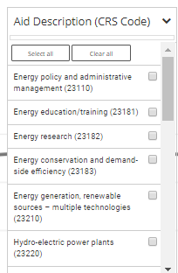 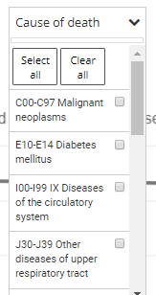

* For taxonomies, use the format ‘Category’ ‘Sub-Category’ and ‘Type’ or ‘Description’, but try to include more detail where possible (e.g. Manufaturing Sub-Category).

### Currencies

* Use the following formats for Great British Pounds in the unit field: GBP (£), GBP (£000s), GPB (£m) (e.g. **2.a.2 3.b.2**).
* Use ‘Gross Domestic Product (GDP)’ instead of GDP.

### Ages

* Age ranges shouldn’t contain dashes. Correct format…

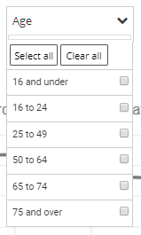

* For categories including a single age (not a range), use a single number, not ‘X years old’. **4.2.2** – incorrect

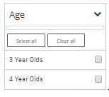

### Other Units

* In general, don’t worry about rounding CSV data.
* For weight ranges such as 3.2.2, use the same format shown for the Age ranges (i.e. no dashes or ‘<’ ‘>’ symbols).

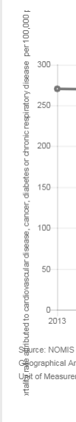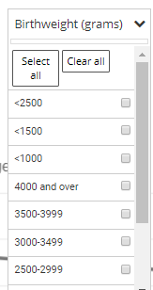

* Use ‘Percentage (%)’ instead of ‘Percentage’ or ‘%’.
* Standard deviation should be expressed as the plural ‘standard deviations’ where suitable.
* Less common units such as hectares, number of smokers, etc. should be expressed ‘000s [units]’ or ‘million [units]’. **2.3.1**
  + Note: use ‘hectares’ rather than ha for clarity, and use a similar principle for less common abbreviated unit types.



## Graph Layout

* Ensure axis titles are a suitable length. **3.4.1** – fail

## Standard format not established yet

* Periodicity – Annual or Annually? – **‘Annual’**
* Capitalisation in ‘graph title’ and ‘actual indicator’? – **Sentence case**
* Position or inclusion of units in graph title? – **no units (except for rates, e.g. per X population)**
* Procedure for Test indicators (e.g. **14.1.1**)? – **leave them be**
* Procedure for UNSD Indicator Code? – **remove**
* Should we be using 100 x [text], [text] x 100, or some other variation in the example below? **3.a.1** 
  + Note: Numerator and Denominator are greyed-out fields, and will be removed for now. If this example occurs for unit type or some other field however, it is not clear which format to use.

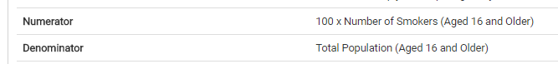

* According to [OxfordDictionaries.com](https://blog.oxforddictionaries.com/2016/04/should-you-capitalize-internet/), “The question of whether the word internet should be capitalized is so passionately debated and rife with controversy that it has its own Wikipedia article.”. Jury’s out on this one. **17.8.1**
* Use Sub-Saharan Africa, rather than Sub Saharan Africa?
  + Note: this requires an accessibility check, but we’ll most likely use the former.
  + From web search: Most screen readers are configured not to announce hyphens by default although this can be adjusted. It stands that hyphens should not be used for Age-Age categories but I think Sub-Saharan Africa should be okay.